***Solution Section* 1.4 – Quadratic Functions**

***Exercise***

For the function 

1. Find the vertex point
2. Find the line of symmetry
3. State whether there is a *maximum* or *minimum* value *and* find that value
4. Find the zeros of 
5. Find the *y*-intercept
6. Find the *range* and the *domain* of the function.
7. Graph the function
8. On what intervals is the function *increasing*? *decreasing*?

***Solution***

1. 

 ***Vertex point*** (−3, −6)

1. Line of *symmetry*: *x* = −3
2. *Minimum* point, value (−3, −6)
3. 



1. *y*-intercept 
2. *Range*: [−6, ∞) *Domain*: (−∞, ∞)





**Zero’s**

**Vertex Point / Min** (−3, −6)

**Symmetry: *x* = −3**

1. *Decreasing*: (−∞, −3) *Increasing*: (−3, ∞)

***Exercise***

For the function 

1. Find the vertex point
2. Find the line of symmetry
3. State whether there is a *maximum* or *minimum* value *and* find that value
4. Find the zeros of 
5. Find the *y*-intercept
6. Find the *range* and the *domain* of the function.
7. Graph the function
8. On what intervals is the function *increasing*? *decreasing*?

***Solution***

1.  







*Vertex point*: 

1. Axis of *symmetry*: 
2. *Minimum* point @ 
3. 



1. 
2. *Domain*:  *Range*: 

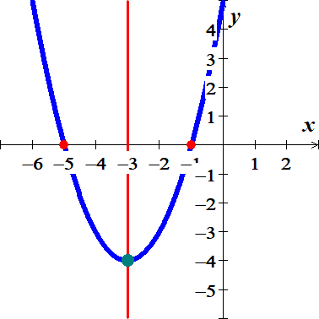

1. *Increasing: * Decreasing: 

***Exercise***

For the function 

1. Find the vertex point
2. Find the line of symmetry
3. State whether there is a *maximum* or *minimum* value *and* find that value
4. Find the zeros of 
5. Find the *y*-intercept
6. Find the *range* and the *domain* of the function.
7. Graph the function
8. On what intervals is the function *increasing*? *decreasing*?

***Solution***

1.  







*Vertex point:* 

1. Axis of *symmetry*: 
2. *Maximum* point @ 
3. 



1. 
2. *Domain*:  *Range*: 

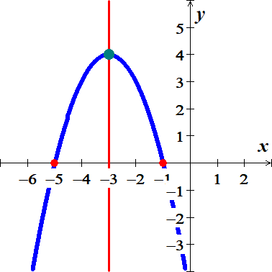

1. *Increasing:*  *Decreasing*: **

***Exercise***

For the function 

1. Find the vertex point
2. Find the line of symmetry
3. State whether there is a *maximum* or *minimum* value *and* find that value
4. Find the zeros of 
5. Find the *y*-intercept
6. Find the *range* and the *domain* of the function.
7. Graph the function
8. On what intervals is the function *increasing*? *decreasing*?

***Solution***

1.  







*Vertex point:* 

1. Axis of *symmetry*: 
2. *Minimum* point @ 
3. 





1. 
2. *Domain*:  *Range*: 

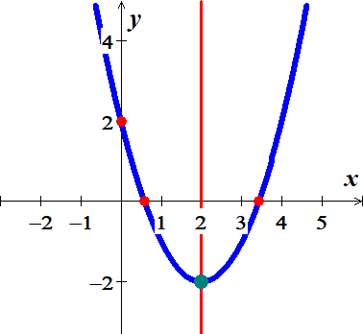

1. *Increasing: * *Decreasing*: 

***Exercise***

For the function 

1. Find the vertex point
2. Find the line of symmetry
3. State whether there is a *maximum* or *minimum* value *and* find that value
4. Find the zeros of 
5. Find the *y*-intercept
6. Find the *range* and the *domain* of the function.
7. Graph the function
8. On what intervals is the function *increasing*? *decreasing*?

***Solution***

1.  







*Vertex point:* 

1. Axis of *symmetry*: 
2. *Maximum* point @ 
3. 





1. 
2. *Domain*:  *Range*: 

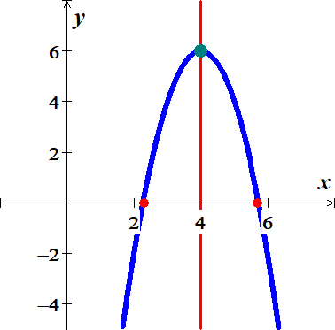

1. *Increasing:*  *Decreasing*: **

***Exercise***

For the function 

1. Find the vertex point
2. Find the line of symmetry
3. State whether there is a *maximum* or *minimum* value *and* find that value
4. Find the zeros of 
5. Find the *y*-intercept
6. Find the *range* and the *domain* of the function.
7. Graph the function
8. On what intervals is the function *increasing*? *decreasing*?

***Solution***

1.  







*Vertex point:* 

1. Axis of *symmetry*: 
2. *Minimum* point @ 
3. 





1. 
2. *Domain*:  *Range*: 

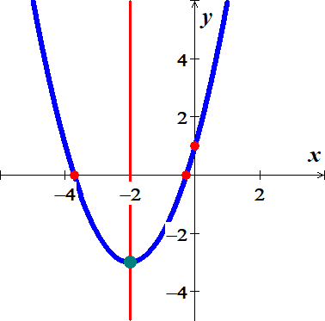

1. *Increasing: * *Decreasing*: 

***Exercise***

For the function 

1. Find the vertex point
2. Find the line of symmetry
3. State whether there is a *maximum* or *minimum* value *and* find that value
4. Find the zeros of 
5. Find the *y*-intercept
6. Find the *range* and the *domain* of the function.
7. Graph the function
8. On what intervals is the function *increasing*? *decreasing*?

***Solution***

1.  







*Vertex point:* 

1. Axis of *symmetry*: 
2. *Minimum* point @ 
3. 





1. 
2. *Domain*:  *Range*: 

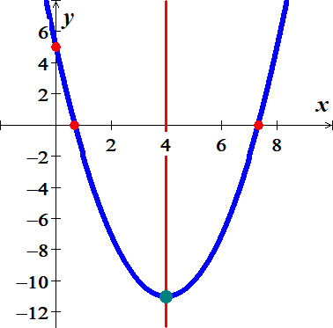

1. *Increasing: * *Decreasing*: 

***Exercise***

For the function 

1. Find the vertex point
2. Find the line of symmetry
3. State whether there is a *maximum* or *minimum* value *and* find that value
4. Find the zeros of 
5. Find the *y*-intercept
6. Find the *range* and the *domain* of the function.
7. Graph the function
8. On what intervals is the function *increasing*? *decreasing*?

***Solution***

1.  







*Vertex point:* 

1. Axis of *symmetry*: 
2. *Minimum* point @ 
3. 





1. 
2. *Domain*:  *Range*: 

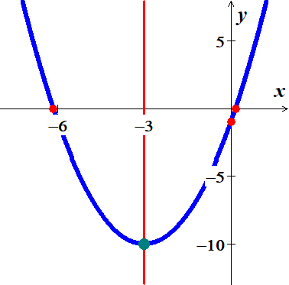

1. *Increasing: * *Decreasing*: 

***Exercise***

For the function 

1. Find the vertex point
2. Find the line of symmetry
3. State whether there is a *maximum* or *minimum* value *and* find that value
4. Find the zeros of 
5. Find the *y*-intercept
6. Find the *range* and the *domain* of the function.
7. Graph the function
8. On what intervals is the function *increasing*? *decreasing*?

***Solution***

1.  







*Vertex point:* 

1. Axis of *symmetry*: 
2. *Minimum* point @ 
3. 





1. 
2. *Domain*:  *Range*: 

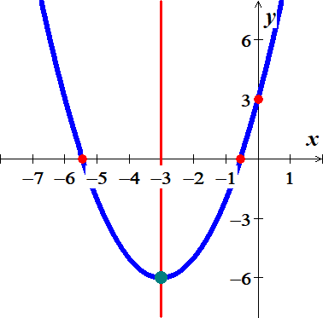

1. *Increasing: * *Decreasing*: 

***Exercise***

For the function 

1. Find the vertex point
2. Find the line of symmetry
3. State whether there is a *maximum* or *minimum* value *and* find that value
4. Find the zeros of 
5. Find the *y*-intercept
6. Find the *range* and the *domain* of the function.
7. Graph the function
8. On what intervals is the function *increasing*? *decreasing*?

***Solution***

1.  







*Vertex point:* 

1. Axis of *symmetry*: 
2. *Minimum* point @ 
3. 





1. 
2. *Domain*:  *Range*: 

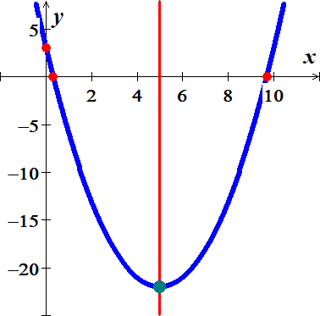

1. *Increasing: * *Decreasing*: 

***Exercise***

For the function 

1. Find the vertex point
2. Find the line of symmetry
3. State whether there is a *maximum* or *minimum* value *and* find that value
4. Find the zeros of 
5. Find the *y*-intercept
6. Find the *range* and the *domain* of the function.
7. Graph the function
8. On what intervals is the function *increasing*? *decreasing*?

***Solution***

1.  





*Vertex point:* 

1. Axis of *symmetry*: 
2. *Minimum* point @ 
3. 



1. 
2. *Domain*:  *Range*: 

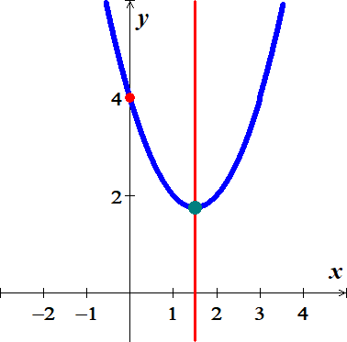

1. *Increasing: * *Decreasing*: 

***Exercise***

For the function 

1. Find the vertex point
2. Find the line of symmetry
3. State whether there is a *maximum* or *minimum* value *and* find that value
4. Find the zeros of 
5. Find the *y*-intercept
6. Find the *range* and the *domain* of the function.
7. Graph the function
8. On what intervals is the function *increasing*? *decreasing*?

***Solution***

1.  





*Vertex point:* 

1. Axis of *symmetry*: 
2. *Minimum* point @ 
3. 



1. 
2. *Domain*:  *Range*: 

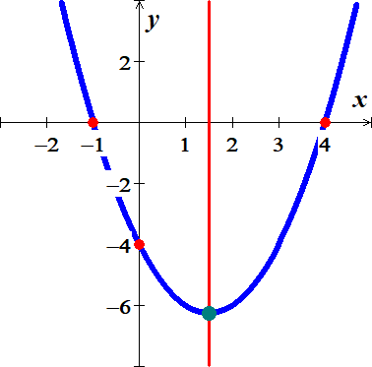

1. *Increasing: * *Decreasing*: 

***Exercise***

For the function 

1. Find the vertex point
2. Find the line of symmetry
3. State whether there is a *maximum* or *minimum* value *and* find that value
4. Find the zeros of 
5. Find the *y*-intercept
6. Find the *range* and the *domain* of the function.
7. Graph the function
8. On what intervals is the function *increasing*? *decreasing*?

***Solution***

1.  





*Vertex point:* 

1. Axis of *symmetry*: 
2. *Minimum* point @ 
3. 



1. 
2. *Domain*:  *Range*: 

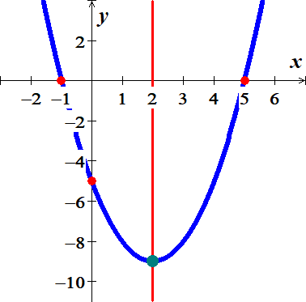

1. *Increasing: * *Decreasing*: 

***Exercise***

For the function 

1. Find the vertex point
2. Find the line of symmetry
3. State whether there is a *maximum* or *minimum* value *and* find that value
4. Find the zeros of 
5. Find the *y*-intercept
6. Find the *range* and the *domain* of the function.
7. Graph the function
8. On what intervals is the function *increasing*? *decreasing*?

***Solution***

1.  





*Vertex point:* 

1. Axis of *symmetry*: 
2. *Minimum* point @ 
3. 



1. 
2. *Domain*:  *Range*: 

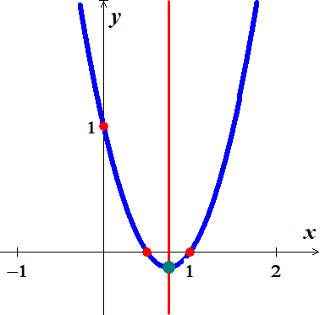

1. *Increasing: * *Decreasing*: 

***Exercise***

For the function 

1. Find the vertex point
2. Find the line of symmetry
3. State whether there is a *maximum* or *minimum* value *and* find that value
4. Find the zeros of 
5. Find the *y*-intercept
6. Find the *range* and the *domain* of the function.
7. Graph the function
8. On what intervals is the function *increasing*? *decreasing*?

***Solution***

1.  





*Vertex point:* 

1. Axis of *symmetry*: 
2. *Maximum* point @ 
3. 



1. 
2. *Domain*:  *Range*: 

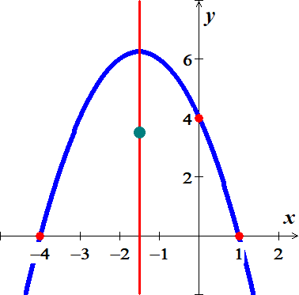

1. *Increasing:*  *Decreasing*: **

***Exercise***

For the function 

1. Find the vertex point
2. Find the line of symmetry
3. State whether there is a *maximum* or *minimum* value *and* find that value
4. Find the zeros of 
5. Find the *y*-intercept
6. Find the *range* and the *domain* of the function.
7. Graph the function
8. On what intervals is the function *increasing*? *decreasing*?

***Solution***

1.  





*Vertex point:* 

1. Axis of *symmetry*: 
2. *Maximum* point @ 
3. 



1. 
2. *Domain*:  *Range*: 

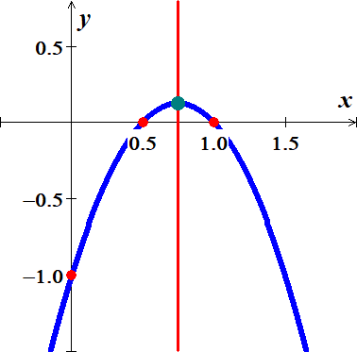

1. *Increasing:*  *Decreasing*: **

***Exercise***

For the function 

1. Find the vertex point
2. Find the line of symmetry
3. State whether there is a *maximum* or *minimum* value *and* find that value
4. Find the zeros of 
5. Find the *y*-intercept
6. Find the *range* and the *domain* of the function.
7. Graph the function
8. On what intervals is the function *increasing*? *decreasing*?

***Solution***

1.  





*Vertex point:* 

1. Axis of *symmetry*: 
2. *Maximum* point @ 
3. 



1. 
2. *Domain*:  *Range*: 

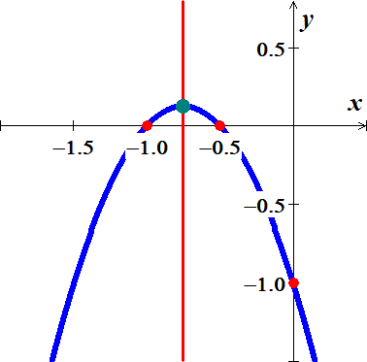

1. *Increasing:*  *Decreasing*: **

***Exercise***

For the function 

1. Find the vertex point
2. Find the line of symmetry
3. State whether there is a *maximum* or *minimum* value *and* find that value
4. Find the zeros of 
5. Find the *y*-intercept
6. Find the *range* and the *domain* of the function.
7. Graph the function
8. On what intervals is the function *increasing*? *decreasing*?

***Solution***

1.  





*Vertex point:* 

1. Axis of *symmetry*: 
2. *Maximum* point @ 
3. 



1. 
2. *Domain*:  *Range*: 

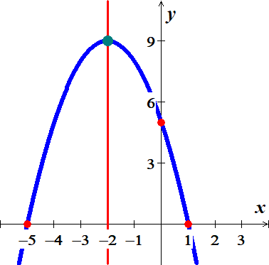

1. *Increasing:*  *Decreasing*: **

***Exercise***

For the function 

1. Find the vertex point
2. Find the line of symmetry
3. State whether there is a *maximum* or *minimum* value *and* find that value
4. Find the zeros of 
5. Find the *y*-intercept
6. Find the *range* and the *domain* of the function.
7. Graph the function
8. On what intervals is the function *increasing*? *decreasing*?

***Solution***

1.  





*Vertex point:* 

1. Axis of *symmetry*: 
2. *Maximum* point @ 
3. 





1. 
2. *Domain*:  *Range*: 

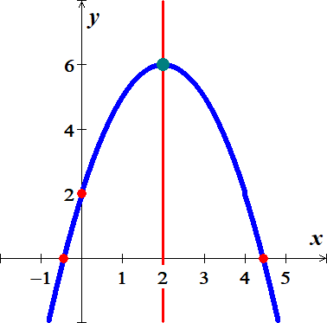

1. *Increasing:*  *Decreasing*: **

***Exercise***

For the function 

1. Find the vertex point
2. Find the line of symmetry
3. State whether there is a *maximum* or *minimum* value *and* find that value
4. Find the zeros of 
5. Find the *y*-intercept
6. Find the *range* and the *domain* of the function.
7. Graph the function
8. On what intervals is the function *increasing*? *decreasing*?

***Solution***

1.  

 

*Vertex point:* 

1. Axis of *symmetry*: 
2. *Maximum* point @ 
3. 





1. 
2. *Domain*:  *Range*: 

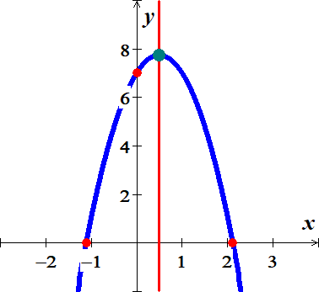

1. *Increasing:*  *Decreasing*: 

***Exercise***

For the function 

1. Find the vertex point
2. Find the line of symmetry
3. State whether there is a *maximum* or *minimum* value *and* find that value
4. Find the zeros of 
5. Find the *y*-intercept
6. Find the *range* and the *domain* of the function.
7. Graph the function
8. On what intervals is the function *increasing*? *decreasing*?

***Solution***

1.  





*Vertex point:* 

1. Axis of *symmetry*: 
2. *Maximum* point @ 
3. 



1. 
2. *Domain*:  *Range*: 

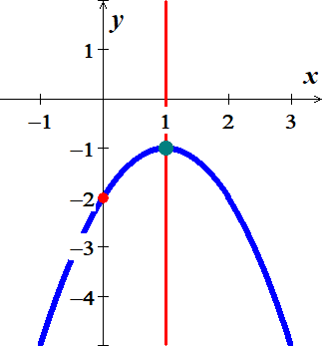

1. *Increasing:*  *Decreasing*: **

***Exercise***

Find the ***vertex***, ***focus***, and ***directrix*** of the parabola. Sketch its graph. 

***Solution***





***Vertex***: (0, 0)

***Focus*** 

***Directrix***: *x* = −5

***Exercise***

Find the ***vertex***, ***focus***, and ***directrix*** of the parabola. Sketch its graph. 

***Solution***





***Vertex***: (0, 0)

***Focus***: 

***Directrix***: 

***Exercise***

Find the ***vertex***, ***focus***, and ***directrix*** of the parabola. Sketch its graph. 

***Solution***





***Vertex***: 

***Focus***: 

***Directrix***: 



***Exercise***

Find the ***vertex***, ***focus***, and ***directrix*** of the parabola. Sketch its graph. 

***Solution***





***Vertex***: 

***Focus***: 

***Directrix***: 



***Exercise***

Find the ***vertex***, ***focus***, and ***directrix*** of the parabola. Sketch its graph. 

***Solution***





***Vertex***: 

***Focus***: 

***Directrix***: 



***Exercise***

Find the ***vertex***, ***focus***, and ***directrix*** of the parabola. Sketch its graph. 

***Solution***







***Vertex***: 



***Focus***: 

***Directrix***: 



***Exercise***

Find the ***vertex***, ***focus***, and ***directrix*** of the parabola. Sketch its graph. 

***Solution***











***Vertex***: 

***Focus***: 

***Directrix***: 



***Exercise***

Find the ***vertex***, ***focus***, and ***directrix*** of the parabola. Sketch its graph. 

***Solution***







***Vertex***: 

***Focus***: 

***Directrix***: 



***Exercise***

Find the ***vertex***, ***focus***, and ***directrix*** of the parabola. Sketch its graph. 

***Solution***





***Vertex***: 

***Focus***: 

***Directrix***: 

***Exercise***

Find the ***vertex***, ***focus***, and ***directrix*** of the parabola. Sketch its graph. 

***Solution***





***Vertex***: 

***Focus***: 

***Directrix***: 

***Exercise***

Find the ***vertex***, ***focus***, and ***directrix*** of the parabola. Sketch its graph. 

***Solution***





***Vertex***: 

***Focus***: 

***Directrix***: 



***Exercise***

Find the ***vertex***, ***focus***, and ***directrix*** of the parabola. Sketch its graph. 

***Solution***









***Vertex***: 

***Focus***: 

***Directrix***: 



***Exercise***

Find the ***vertex***, ***focus***, and ***directrix*** of the parabola. Sketch its graph. 

***Solution***









***Vertex***: 

***Focus***: 



***Directrix***: 



***Exercise***

Find the ***vertex***, ***focus***, and ***directrix*** of the parabola. Sketch its graph. 

***Solution***









***Vertex***: 

***Focus***: 

***Directrix***: 

***Exercise***

Find the ***vertex***, ***focus***, and ***directrix*** of the parabola. Sketch its graph. 

***Solution***









***Vertex***: 

***Focus***: 



***Directrix***: 



***Exercise***

Find an equation of the parabola that satisfies the given conditions 

***Solution***







***Exercise***

Find an equation of the parabola that satisfies the given conditions 

***Solution***







***Exercise***

Find an equation of the parabola that satisfies the given conditions 

***Solution***













***Vertex***: 





***Exercise***

Find an equation of the parabola that satisfies the given conditions 

***Solution***















***Exercise***

Find an equation of the parabola that satisfies the given conditions 

***Solution***















***Exercise***

Find an equation of the parabola that satisfies the given conditions 

***Solution***















***Exercise***

Find an equation of the parabola that satisfies the given conditions 

***Solution***









***Exercise***

Find an equation of the parabola that satisfies the given conditions 

***Solution***









***Exercise***

Find an equation of the parabola that satisfies the given conditions 

***Solution***







