***Section* 1.5 – Quadratic Applications and Models**

**Pythagorean Theorem**

The sum of the squares of the lengths of the legs of a right triangle equals the square of the length of thehypotenuse. If the legs have lengths *a* and *b,* and the hypotenuse has length *c*, then:

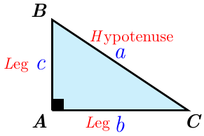



***Example***

A ladder that is 17 *feet* long is 8 *feet* from the base of a wall. How far up the wall does the ladder reach?

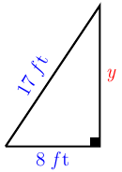***Solution***









∴ The ladder reach at 15 *feet* of the wall height.

***Example***

A pool measuring 10 *feet* by 25 *feet* is surrounded by a path of uniform width. If the area of the pool and the path combined is 496 *feet*2, what is the width of the path?

***Solution***



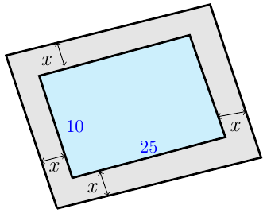













∴ The width of the path is **3** *feet*

***Maximizing Area***

***Example***

You have 120 *feet* of fencing to enclose a rectangular region. Find the dimensions of the rectangle that maximize the enclosed area. What is the maximum area?

***Solution***

















***Vertex***: 





 



***Example***

A stone mason has enough stones to enclose a rectangular patio with 60 *feet* of stone wall. If the house forms one side of the rectangle, what is the maximum area that the mason can enclose? What should the dimensions of the patio be in order to yield this area?

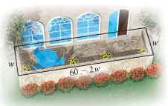***Solution***

























*Area* = (15)(30)



**Height of a Projected Object *(Position Function)***

An object that is falling or vertically projected into the air has its height above the ground, *s*(*t*), in feet, given by



 is the original velocity (initial velocity) of the object, in *feet* per *second*

*t* is the time that the object is in motion, in *second*

 is the original height (initial height) of the object, in *feet*

***Example***

If a projectile is shot vertically upward from the ground with an initial velocity of 100  , neglecting air resistance, its height *s* (in *feet*) above the ground *t* seconds after projection is given by



1. After how many seconds will it be 50 *feet*. above the ground?
2. How long will it take for the projectile to return to the ground?
3. Determine the time at which the rocket reaches its maximum height?
4. Find the maximum height?

***Solution***

1. *After how many seconds will it be 50 feet above the ground?*











 

 

 

1. *How long will it take for the projectile to return to the ground?*





 

 

1. *Determine the time at which the rocket reaches its maximum height*?

 

 

1. *Find the maximum height*?







***Example***

The towers of the Golden Gate Bridge connecting San Francisco to Marin County are 1280 *meters* apart and rise 160 *meters* above the road. The cable between the towers has the shape of a parabola and the cable just touches the sides of the road midway between the towers. What is the height of the cable 200 *meters* from a tower?

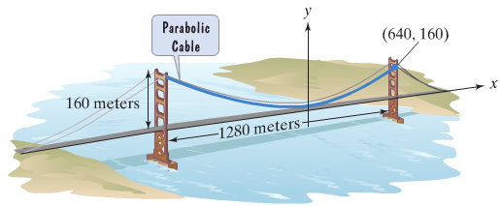

***Solution***

***Given*** the point: 

 





 





The height is 76 *meters*.

***Exercise Section* 1.4 − Quadratic Applications**

1. A rectangular park is 6 *miles* long and 2 *miles* wide. How long is a pedestrian route that runs diagonally across the park?
2. What is the width of a 25-*inch* television set whose height is 15 *inches*?
3. The length of a rectangular sign is 3 *feet* longer than the width. If the sign’s area is 54 square *feet*, find its length and width.
4. A rectangular parking lot has a length that is 3 *yards* greater than the width. The area of the parking lot is 180 square *yards*, find the length and the width.
5. Each side of a square is lengthened by 3 *inches*. The area of this new, larger square is 64 square *inches*. Find the length of a side of the original square.
6. Each side of a square is lengthened by 2 *inches*. The area of this new, larger square is 36 square *inches*. Find the length of a side of the original square.
7. One number is 5 greater than another. The product of the numbers is 36. Find the numbers.
8. One number is 6 less than another. The product of the numbers is 72. Find the numbers.
9. A vacant rectangular lot is being turned into a community vegetable garden measuring 15 *meters* by 12 *meters*. A path of uniform width is to surround the garden. If the area of the garden and path combined is 378 *square meters*, find the width of the path.

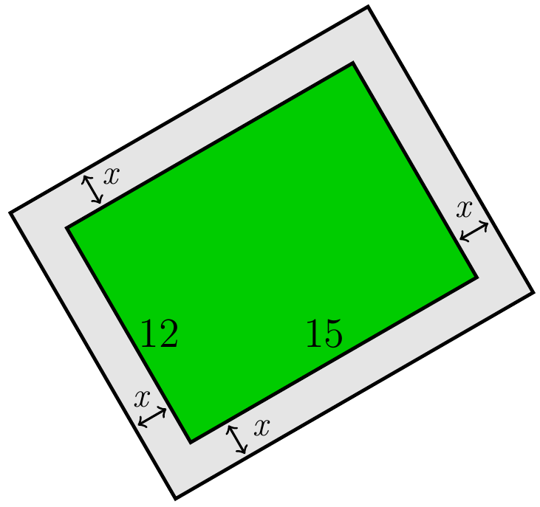

1. A pool measuring 10 *m* by 20 *m* is surrounded by a path of uniform width. If the area of the pool and the path combined is 600 *m*2, what is the width of the path?

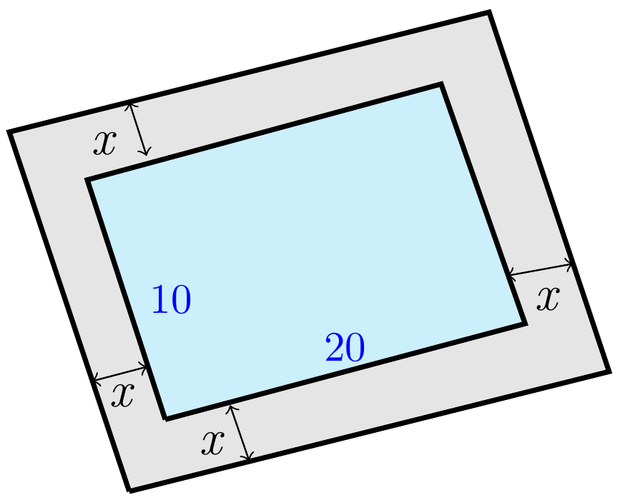

1. You put in flower bed measuring 10 *feet* by 12 *feet*. You plan to surround the bed with uniform border of low-growing plants.

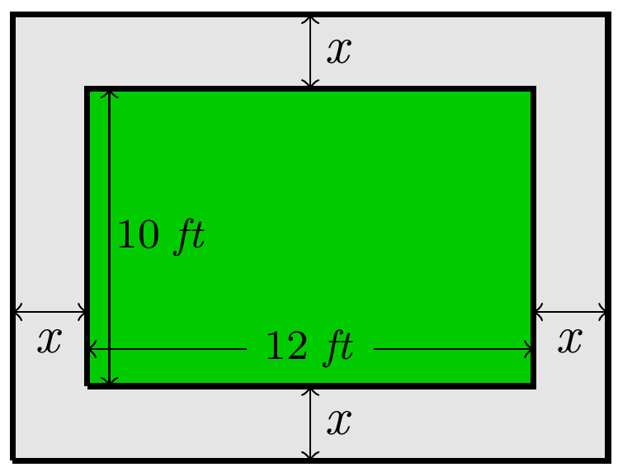

1. Write a polynomial that describes the area of the uniform border that surrounds your flowers.
2. The low growing plants surrounding the flower bed require 1 square *foot* each when mature. If you have 168 of these plants, how wide a strip around the flower bed should you prepare for the border?
3. A rectangular garden measures 80 *feet* by 60 *feet*. A large path of uniform width is to be added along both shorter sides and one longer side of the garden. The landscape designer doing the work wants to double the garden’s area with the addition of this path. How wide should the path be?

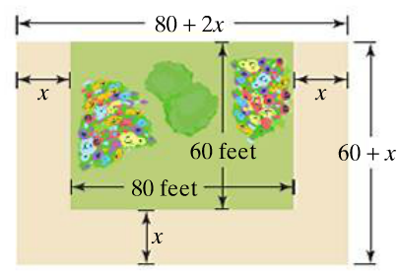

1. The length of a rectangular poster is 1 *foot* more than the width, and a diagonal of the poster is 5 *feet*. Find the length and the width.
2. One leg of a right triangle is 7 *cm* less than the length of the other leg. The length of the hypotenuse is 13 *cm*. find the lengths of the legs.
3. A tent with wires attached to help stabilize it, as shown below. The length of each wire is 8 *feet* greater than the distance from the ground to where it is attached to the tent.

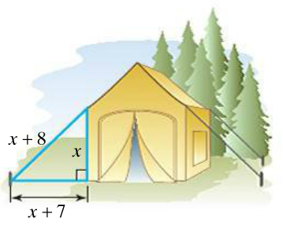

The distance from the base of the tent to where the wire is anchored exceeds this height by 7 *feet*, Find the length of each wire used to stabilize the tent.

1. A boat is being pulled into a dock with a rope attached to the boat at water level. Where the boat is 12 *feet*. from the dock, the length of the rope from the boat to the dock is 3 *feet*. longer than twice the height of the dock above the water. Find the height of the dock.

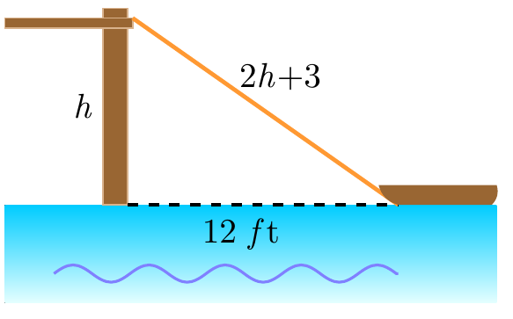

1. A piece of wire measuring 20 *feet* is attached to a telephone pole as a guy wire. The distance along the ground from the bottom of the pole to the end of the wire is 4 *feet* greater than the height where the wire is attached to the pole. How far up the pole does the guy wire reach?

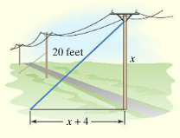

1. Logan and Cassidy leave a campsite, Logan biking due north and Cassidy biking due east. Logan bikes 7 *km/h* slower than Cassidy. After 4 *hrs*, they are 68 *km* apart. Find the speed of each bicyclist.

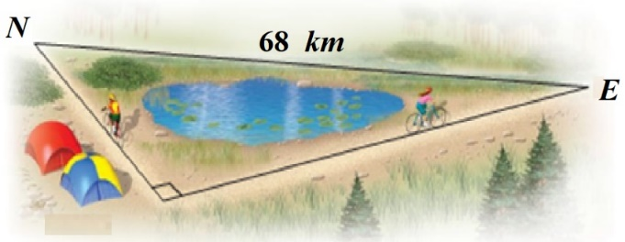

1. Two trains leave a station at the same time. One train travels due west, and the other travels due south. The train traveling west travels  faster than the train traveling south. After 2 *hr*., the trains are 200 *km* apart. Find the speed of each train.

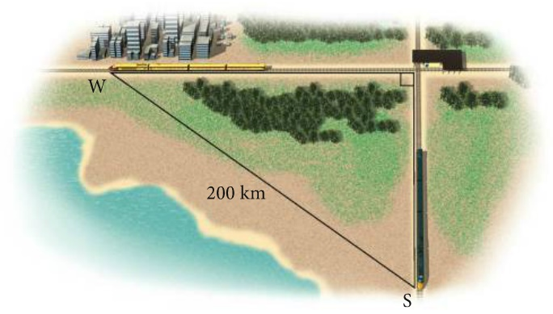

1. Towers are 1482 *feet.* tall. How long would it take an object dropped from the top to reach the ground? Given ***s*** = 16***t***2
2. The formula  models a woman's normal Point systolic blood pressure, *P*, an age *A*. Use this formula to find the age, to the nearest year, of a woman whose normal systolic blood pressure is 115 *mm* Hg.
3. A rectangular piece of metal is 10 *in*. longer than it is wide. Squares with sides 2 *in*. long are cut from the four corners, and the flaps folded upward to form an open box. If the volume of the box is 832 , what were the original dimensions of the piece of metal?
4. An astronaut on the moon throws a baseball upward. The astronaut is 6 *ft*., 6 *in*., tall, and the initial velocity of the ball is 30. The height *s* of the ball in feet is given by the equation



Where ***t*** is the number of seconds after the ball was thrown.

1. After how many seconds is the ball 12 *ft*. above the moon’s surface?
2. How many seconds will it take for the ball to return to the surface?
3. The bar graph shows of SUVs (sport utility vehicles in the US, in *millions*. The quadratic equation

 models sales of SUVs from 1992 to 2003, where *S* represents sales in *millions*, and *x* = 0 represents 1992, *x* = 1 represents 1993 and so on.

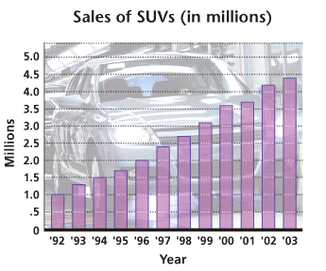

1. Use the model to determine sales in 2002 and 2003. Compare the results to the actual figures of 4.2 million and 4.4 *million* from the graph.
2. According to the model, in what year do sales reach 3.5 million? Is the result accurate?
3. Erik finds a piece of property in the shape of a right triangle. He finds that the longer leg is 20 *m* longer than twice the length of the shorter leg. The hypotenuse is 10 *m* longer than the length of the longer leg. Find the lengths of the sides of the triangular lot.
4. Cynthia wants to buy a rug for a room that is 20 *feet.* wide and 27 *feet*. long. She wants to leave a uniform strip of floor around the rug. She can afford to buy 170 square *feet* of carpeting. What dimension should the rug have?

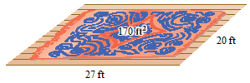

1. An open box is made from a 10-*cm* by 20-*cm* piece of tin by cutting a square from each corner and folding up the edges. The area of the resulting base is 96 . What is the length of the sides of the squares?

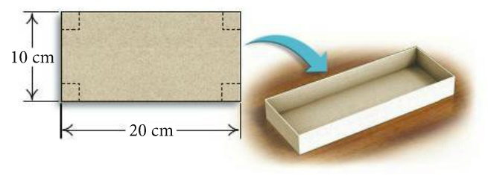

1. A square piece of cardboard is formed into a box by cutting out 3-*inch* squares from each of the corners and folding up the sides. If the volume of the box needs to be 126.75 cubic *inches*, what size square piece of cardboard is needed?

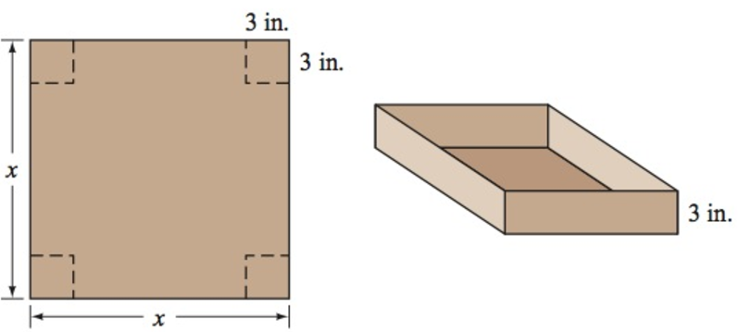

1. You want to use 132 *feet* of chain-link fencing to enclose a rectangular region and subdivide the region into two smaller rectangular regions. If the total enclosed area is 576 *square feet*, find the dimensions of the enclosed region.

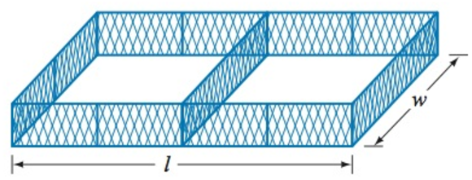

1. How far is it from home plate to second base on a baseball diamond?

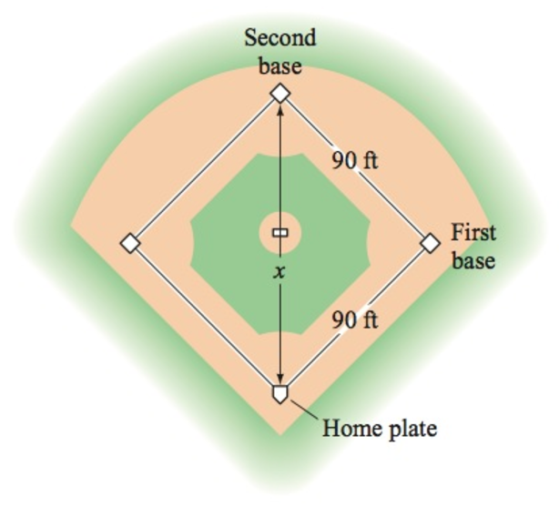

1. Two equations can be used to track the position of a baseball *t* seconds after it is hit.

For instance, suppose  gives the height, in *feet*, of a baseball *t* seconds after it is hit and  gives the horizontal distance, in *feet*, of the ball from home plate *t* seconds after it is hit.

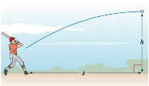

Use these equations to determine whether this particular baseball will clear a 10-*foot* fence positioned 360 *feet* from home plate.

1. A ball is thrown downward with an initial velocity of 5 *feet* per *second* from the Golden Gate Bridge, which is 220 *feet* above the water. How long will it take for the ball to hit the water?
2. A television screen measures 60 *inches* diagonally, and its aspect ratio is 16 to 9. This means that the ratio of the width of the screen to the height of the screen is 16 to 9.

Find the width and height of the screen.

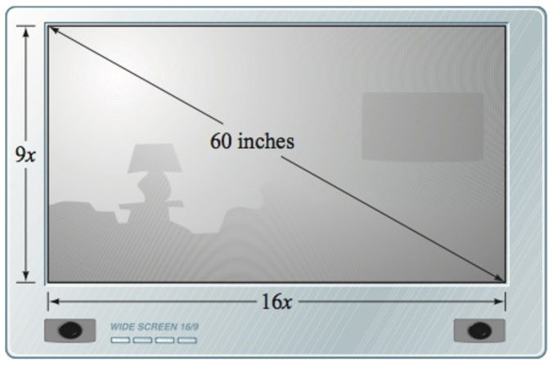

1. A company makes rectangular solid candy bars that measures 5 *inches* by 2 *inches* by 0.5 *inch*. Due to difficult financial times, the company has decided to keep the price of the candy bar fixed and reduce the volume of the bar by 20%. What should the dimensions be for the new candy bar if the company keeps the height at 0.5 *inch* and makes length of the candy bar 3 *inches* longer than the width?

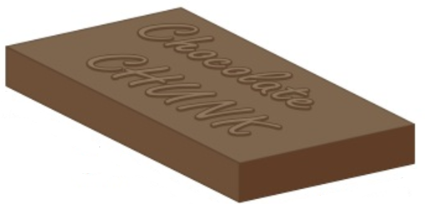

1. A company makes rectangular solid candy bars that measures 5 *inches* by 2 *inches* by 0.5 *inch*. Due to difficult financial times, the company has decided to keep the price of the candy bar fixed and reduce the volume of the bar by 20%. What should the dimensions be for the new candy bar if the company keeps the height at 0.5 *inch* and makes length of the candy bar 2.5 times as long as its width?

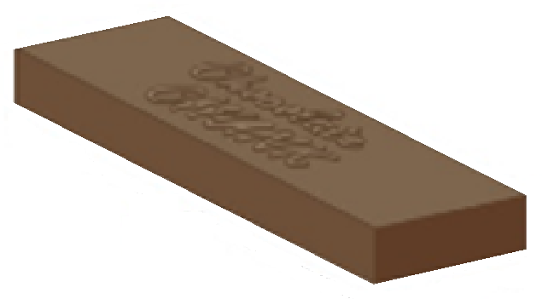

1. A picture frame measures 28 *cm* by 32 *cm* and is of uniform width. What is the width of the frame if 192 *cm*2 of the picture shows?

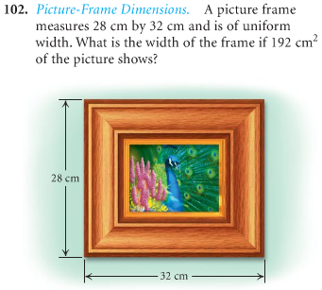

1. An open box is made from a 10-*cm* by 20-*cm* of tin by cutting a square from each corner and folding up the edges. The area of the resulting base is 96 *cm*2. What is the length of the sides of the squares?

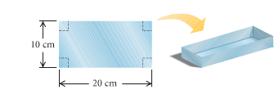

1. You have 600 *feet.* of fencing to enclose a rectangular plot that borders on a river. If you do not fence the side along the river.
2. Find the length and width of the plot that will maximize the area.
3. What is the largest area that can be enclosed?
4. You have 60 *yards* of fencing to enclosed a rectangular region.
5. Find the dimensions of the rectangle that maximize the enclosed area.
6. What is the maximum area?
7. You have 80 *yards* of fencing to enclosed a rectangular region.
8. Find the dimensions of the rectangle that maximize the enclosed area.
9. What is the maximum area?
10. The sum of the length *l* and the width *w* of a rectangle tangular area is 240 *meters*.
11. Write *w* as a function of *l*.
12. Write the area *A* as a function of *l*.
13. Find the dimensions that produce the greatest area.
14. You use 600 *feet* of chainlink fencing to enclose a rectangular region and to subdivide the region into two smallerrectangular regions by placing a fence parallel to one of the sides.

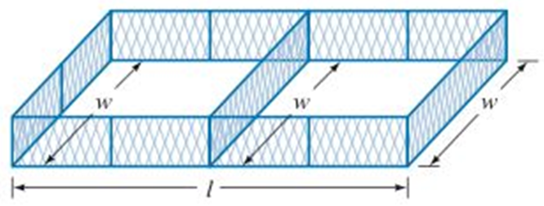

1. Write *w* as a function of *l*.
2. Write the area *A* as a function of *l*.
3. Find the dimensions that produce the greatest area.
4. You use 1,200 *feet* of chainlink fencing to enclose a rectangular region and to subdivide the region into three smallerrectangular regions by placing a fence parallel to one of the sides.

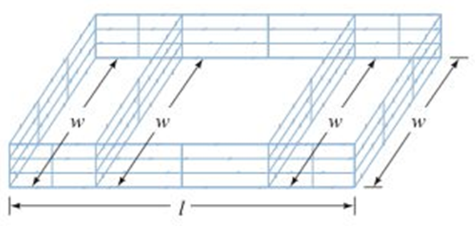

1. Write *w* as a function of *l*.
2. Write the area *A* as a function of *l*.
3. Find the dimensions that produce the greatest area.
4. A landscaper has enough stone to enclose a rectangular pond next to exiting garden wall of the house with 24 *feet* of stone wall. If the garden wall forms one side of the rectangle.

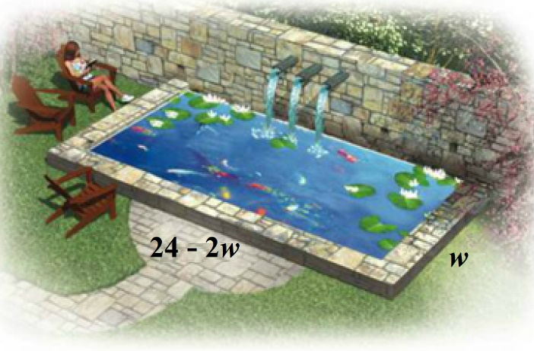

1. What is the maximum area that the landscaper can enclose?
2. What dimensions of the pond will yield this area?
3. A berry former needs to separate and enclose two adjacent rectangular fields, one for strawberries and one for blueberries. If a lake forms one side of the fields and 1,000 *feet* of fencing is available, what is the largest total area that can be enclosed?

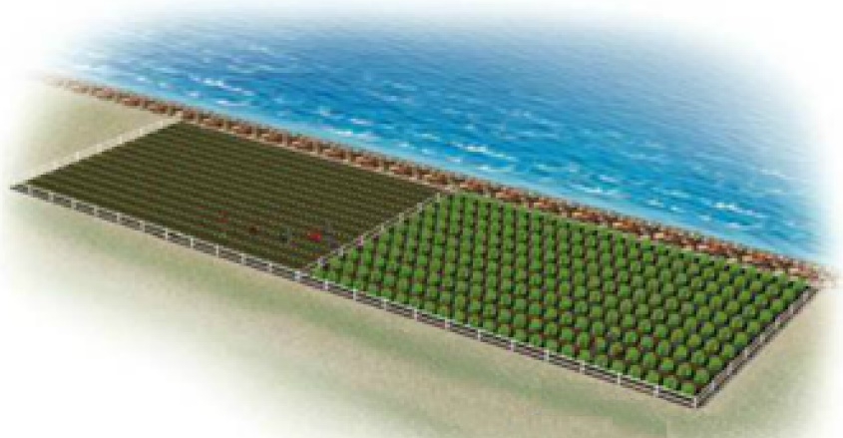

1. A fourth-grade class decides to enclose a rectangular garden, using the side of the school as one side of the rectangle. What is the maximum area that the class can enclose with 32 *feet* of fence? What should the dimensions of the garden be in order to yield this area?

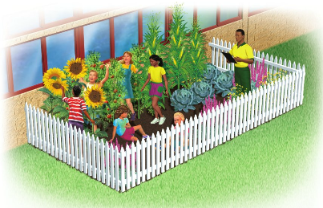

1. A rancher needs to enclose two adjacent rectangular corrals, one for cattle and one for sheep. If a river forms one side of the corrals and 240 *yard* of fencing is available, what is the largest total area that can be enclosed?

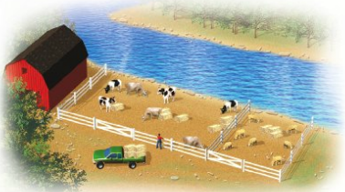

1. A Norman window is a rectangle with a semicircle on top. Sky Blue Windows is designing a Norman window that will require 24 *feet* of trim on the outer edges. What dimensions will allow the maximum amount of light to enter a house?

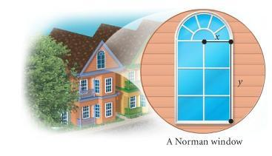

1. A Norman window has the shape of a rectangle surmounted by a semicircle. The exterior perimeter of the window is 48 *feet*.

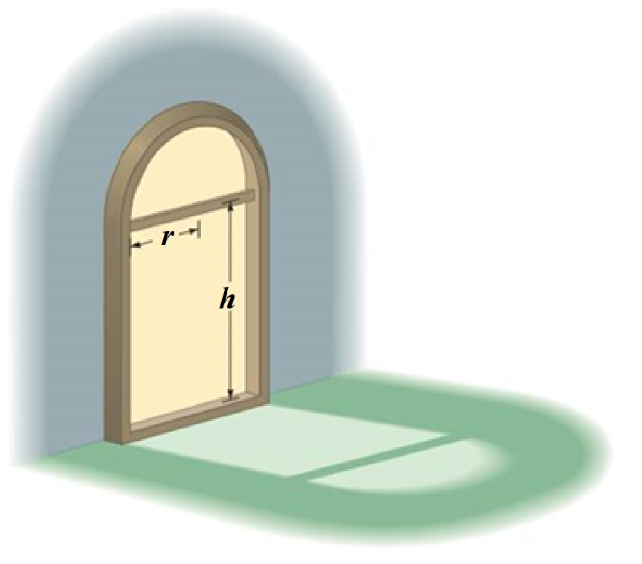

Find the height *h* and the radius *r* that will allow the maximum amount of light to enter the window?

1. A Norman window has the shape of a rectangle surmounted by a semicircle. It requires 24 *feet* of trim on the outer edges.

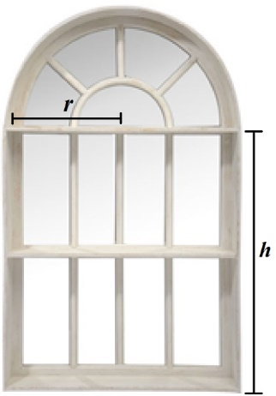

What dimensions will allow the maximum amount of light to enter a house?

1. The temperature , in degrees Fahrenheit, during the day can be modeled by the equation , where *t* is the number of hours after 6:00 *AM*.
2. At what time the temperature a maximum?
3. What is the maximum temperature?
4. When a softball player swings a bat, the amount of energy , in *joules*, that is transferred to the bat can be approximated by the function



Where  and *t* is measured in *seconds*. According to this model, what is the maximum energy of the bat?

1. Some softball fields are built in a parabolic mound shape so that water will drain off the field. A model for the shape of a certain field is given by



Where  is the height, in *feet*, of the field at a distance of *x* *feet* from one sideline. Find the maximum height of the field.

1. The fuel efficiency for a certain midsize car is given by



Where  is the fuel efficiency in *miles* per *gallon* for a car traveling *v* in *miles* per *hour*.

1. What speed will yield the maximum fuel efficiency?
2. What is the maximum fuel efficiency for this car?
3. If the initial velocity of a projectile is 128 *feet* per *second*, then the height *h*, in *feet*, is a function of time *t*, in *seconds*, given by the equation



1. Find the time *t* when the projectile achieves its maximum height.
2. Find the maximum height of the projectile.
3. Find the time *t* when the projectile hits the ground.
4. If the initial velocity of a projectile is 64 *feet* per *second* and an initial height of 80 *feet*, then the height *h*, in *feet*, is a function of time *t*, in *seconds*, given by the equation



1. Find the time *t* when the projectile achieves its maximum height.
2. Find the maximum height of the projectile.
3. Find the time *t* when the projectile hits the ground.
4. If the initial velocity of a projectile is 100 *feet* per *second* and an initial height of 20 *feet*, then the height *h*, in *feet*, is a function of time *t*, in *seconds*, given by the equation



1. Find the time *t* when the projectile achieves its maximum height.
2. Find the maximum height of the projectile.
3. Find the time *t* when the projectile hits the ground.
4. A frog leaps from a stump 3.5 *feet* high and lands 3.5 *feet* from the base of the stump.

It is determined that the height of the frog as a function of its distance, *x*, from the base of the stump is given by the function  where *h* is in *feet*.

1. How high is the frog when its horizontal distance from the base of the stump is 2 *feet*?
2. At what two distances from the base of the stump after is jumped was the frog 3.6 *feet* above the ground?
3. At what distance from the base did the frog reach its highest point?
4. What was the maximum height reached by the frog?
5. The height of an arch is given by



Where  is the horizontal distance in *feet* from the center of the arch to the ground.

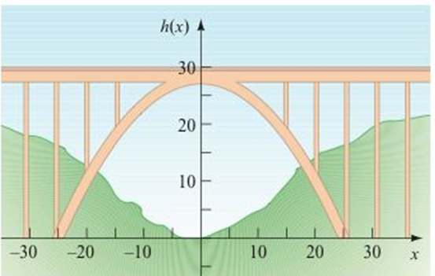

1. What is the maximum height of the arch?
2. What is the height of the arch 10 *feet* to the right of center?
3. How far from the center is the arch 8 *feet* tall?
4. A weightless environment can be created in an airplane by flying in a series of parabolic paths. This is one method that NASA uses to train astronauts for the experience of weightlessness. Suppose the height *h*, in *feet*, of NASA’s airplane is modeled by



Where *t* is the time, in *seconds,* after the plane enters its parabolic path.

Find the maximum height of the plane.

1. You drop a screwdriver from the top of an elevator shaft. Exactly 5 *seconds* later, you hear the sound of the screwdriver hitting the bottom of the shaft. The speed of sound is . How tall is the elevator shaft?

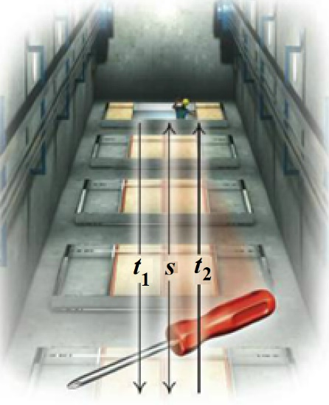

1. A company plans to produce a one- compartment vertical file by bending the long side of a 10-*in*. by 18-*in*. sheet of metal along two lines to form a − shape. How tall should the file be in order to maximize the volume that it can hold?

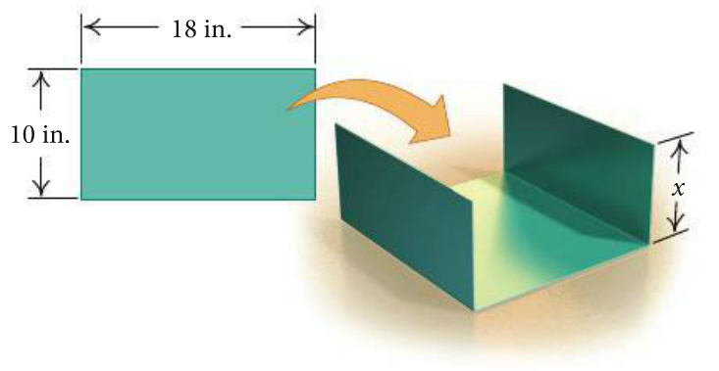

1. The sum of the base and the height of a triangle is 20 *cm*. Find the dimensions for which the area is a maximum.
2. The sum of the base and the height of a parallelogram is 14 *inches*. Find the dimensions for which the area is a maximum.
3. An arch in the shape of a parabola has the dimensions shown in the figure. How wide is the arch 9 *feet* up?

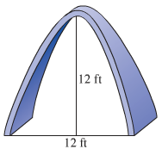

1. The cable in the center portion of a bridge is supported as shown in the figure to form a parabola. The center support is 10 *feet* high, the tallest supports are 210 *feet* high, and the distance between the two tallest supports is 400 *feet*. Find the height of the remaining supports if the supports are evenly spaced.

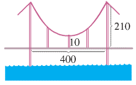

1. A headlight is being constructed in the shape of a paraboloid with depth 4 *inches* and diameter 5 *inches*. Determine the distance *d* that the bulb should be form the vertex in order to have the beam of light shine straight ahead.

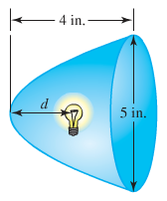

1. A satellite dish is shaped like a paraboloid of revolution. The signals that emanate from a satellite strike the surface of the dish and are reflected to a single point, where the receiver is located. If the dish is 8 *feet* across at its opening and 3 *feet* deep at its center, at what position should the receiver be placed? That is, where is the focus?

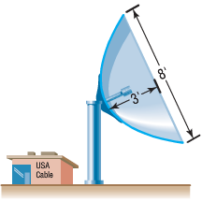

1. A cable TV receiving dish is in the shape of a paraboloid of revolution. Find the location of the receiver, which is placed at the focus, if the dish is 6 *feet* across at its opening and 2 *feet* deep.
2. The cables of a suspension bridge are in the shape of a parabola, as shown below. The towers supporting the cable are 600 *feet* apart and 80 *feet* high. If the cables touch the road surface midway between the towers, what is the height of the cable from the road at a point 150 feet from the center of the bridge?

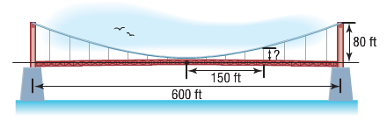

1. A bridge is built in the shape of a parabolic arch. The bridge has a span of 120 *feet* and a maximum height of 25 *feet*. Choose a suitable rectangular coordinate system and find the height of the arch at distances of 10, 30, and 50 *feet* from the center.

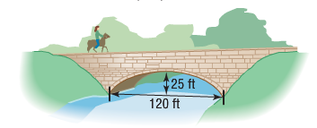

1. A mirror is shaped like a paraboloid of revolution and will be used to concentrate the rays of the sun at its focus, creating a heat source. If the mirror is 20 *feet* across at its opening and is 6 *feet* deep, where will the heat source be concentrated?

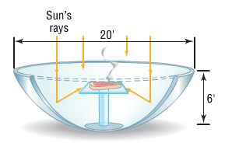

1. A reflecting telescope contains a mirror shaped a paraboloid of revolution. If the mirror is 4 *inches* across at its opening and is 3 *inches* deep, where will the collected light be concentrated?
2. Show that the graph of an equation of the form 
3. Is a parabola if 
4. Is a vertical line if 
5. Is two vertical lines if 
6. Contains no points if 
7. The towers of a suspension bridge are 800 *feet* apart and rise 160 *feet* above the road. The cable between the towers has the shape of a parabola and the cable just touches the sides of the road midway between the towers. What is the height of the cable 100 *feet* from a tower?

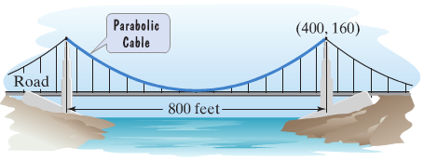

1. The cables of a suspension bridge are in the shape of a parabola. The towers supporting the cable are 400 *feet* apart and 100 *feet* high. If the cables are at a height of 10 *feet* midway between the towers, what is the height of the cable at a point 50 *feet* from the center of the bridge?
2. The focal length of the (finite) paraboloid is the distance *p* between its vertex and focus

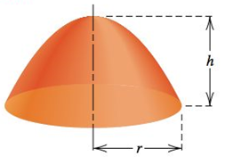

1. Express *p* in terms of *r* and *h*.
2. A reflector is to be constructed with a focal length of 10 *feet* and a depth of 5 *feet*. Find the radius of the reflector.
3. The parabolic arch is 50 *feet* above the water at the center and 200 *feet* wide at the base. Will a boat that is 30 *feet* tall clear the arch 30 *feet* from the center?

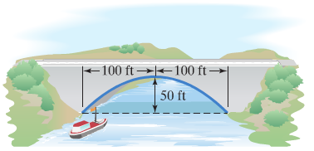

1. A satellite dish, as shown below, is in the shape of a parabolic surface. Signals coming from a satellite strike the surface of the dish and are reflected to the focus, where the receiver if located. The satellite dish shown has a diameter of 12 *feet* and a depth of 2 *feet*. How far from the base of the dish should the receiver be placed?

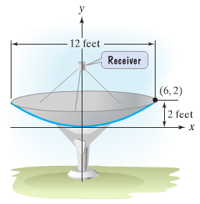

1. A searchlight is shaped like a paraboloid of revolution. If the light source is located 2 *feet* from the base along the axis of symmetry and the opening is 5 *feet* across, how deep should the searchlight be?
2. A searchlight is shaped like a paraboloid of revolution. If the light source is located 2 *feet* from the base along the axis of symmetry and the depth of the searchlight is 4 *feet* across, how deep should the opening be?
3. A searchlight is shaped like a paraboloid, with the light source at the focus. If the reflector is 3 *feet* across at the opening and 1 *foot* deep, where is the focus?
4. A mirror for a reflecting telescope has the shape of a (finite) paraboloid of diameter 8 *inches* and depth 1 *inch*. How far from the center the mirror will the incoming light collect?

