***Section* 1.7 – Inequalities**

**Notation**

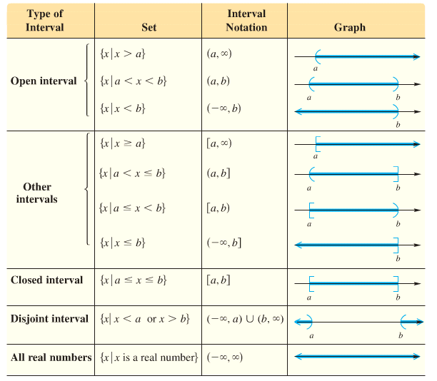

**Properties of inequality**

1. ***If a < b, then a + c < b + c***
2. ***If a < b and if c > 0, then ac < bc***
3. ***If a < b and if c < 0, then ac > bc***

***Example***

Solve 3*x* + 1 > 7*x* – 15

***Solution***

3*x* – 7*x* > –1 – 15

–4*x* > –16 *Divide by – 4 both sides*

 *or* (–∞ , 4) *or* {*x*| *x* < 4}

***Example***

Solve  *LCD*: 2, 3, 6

***Solution***













***Example***

1. 3(*x* + 1) > 3*x* + 2

3*x* + 3 > 3*x* + 2



0 > − 1 (*True statement*)

*Sol*.:  ***or*** {*x*| *All Real numbers*} ***or*** (−∞, ∞)

*b*) *x* + 1 ≤ *x* − 1



0 ≤ − 2

*Sol*.: **∅**

***Example***

Solve  Give the solution set in interval notation and graph it.

***Solution***









*Solution*: 

**Intersections of Interval **

To find the intersection, take the portion of the number line that the two graphs have in ***common***

|  |  |  |
| --- | --- | --- |
|  |  |  |
| **−∞ 1 2 3 6 ∞** | | |

***Example***

[1, 3]  (2, 6) = (2, 3]

**Unions of Interval **

To find the union, take the portion of the number line representing the total ***collection*** of numbers in the two graphs.

|  |  |  |
| --- | --- | --- |
|  |  |  |
| **−∞ 1 2 3 6 ∞** | | |

***Example***

[1, 3] (2, 6) = [1, 6)

**Solving an *Absolute Value* Inequality**:

If ***X*** is an algebraic expression and ***c*** is a positive number,

1. The solutions of **|*X*| < *c*** are the numbers that satisfy **– *c* < *X* < *c***.
2. The solutions of **|*X*| > *c*** are the numbers that satisfy ***X* < – *c*** or ***X* > *c***.

***Example***

Solve: −3|5*x* – 2| + 20 ≥ − 19

***Solution***

−3|5*x* – 2| ≥ − 39

−|5*x* – 2| ≥ − 13

|5*x* – 2| ≤ 13

−13 ≤ 5*x* – 2 ≤ 13

−11 ≤ 5*x* ≤ 15

 or 

***Example***

Solve: 

***Solution***



 

 

 

 

 

***Solution***: 

***Special Cases***

***Example***

Solve the inequality 

***Solution***



It is always ***true***

∴ The solution set is:  All real numbers 

***Example***

Solve the inequality 

***Solution***



Any absolute value can’t be less than any negative number.

∴ No solution or ∅

***Example***

Solve the inequality 

***Solution***







∴ Solution: 

***Definition* of a Polynomial Inequality**

A polynomial inequality is any inequality that can be put into one of the forms

   

Where *f*  is a polynomial function.

|  |  |
| --- | --- |
| (*x* = 1, 4) |  |

***Procedure* for Solving Polynomial Inequalities *Example***

|  |  |
| --- | --- |
| 1. Express the inequality in the form |  |
| 1. Solve |  |
| 1. Locate the boundary 2. Choose one test value | |  |  |  | | --- | --- | --- | | −3 0 4 | | | | **+** | **−** | **+** | |
| 1. Write the solution set |  |

* 
* 

***Example***

Solve 

|  |  |  |
| --- | --- | --- |
| −4 0 | | |
| **+** | **−** | **+** |

***Solution***





 

***Solution***: 

***Example***

Solve: 

***Solution***





|  |  |  |  |
| --- | --- | --- | --- |
| −3 −1 0  1 | | | |
| − | + | − | + |



 

 

 

***Solution***:  

***Rational* Inequality**

***Example***

Solve: 

***Solution***



|  |  |  |
| --- | --- | --- |
| −1 0 1 | | |
| **+** | **−** | **+** |









***Solution***:  

***Example***

Solve 

***Solution***

 *Exception:* 

|  |  |  |
| --- | --- | --- |
| −4 0 1 | | |
| **−** | **+** | **−** |







***Solution***:  

***Example***

Solve 

***Solution***

 *Restriction:* 

|  |  |  |
| --- | --- | --- |
| 0 | | |
| **−** | **+** | **−** |









***Solution***:  

***Exercises Section* 1.7 – Inequalities**

(**1 – 6**) Find:

|  |  |  |
| --- | --- | --- |
|  |  |  |

(**7 – 45**) Solve the inequality equation

|  |  |
| --- | --- |
| 2. 2 – 3*x* ≤ 5 |  |

(**46 – 85**) Solve the inequality equation

|  |  |  |
| --- | --- | --- |
|  |  | 6. |*x* – 2| < 5 |

(**86 – 107**) Solve the inequality equation

|  |  |  |
| --- | --- | --- |
|  |  |  |

(**108 – 130**) Solve the inequality equation

|  |  |  |
| --- | --- | --- |
|  |  |  |