***Section* 1.8 – More Applications and Models**

***Example***

To prepare for a triathlon, a person swims across a river to point ***P*** and then runs along a path.

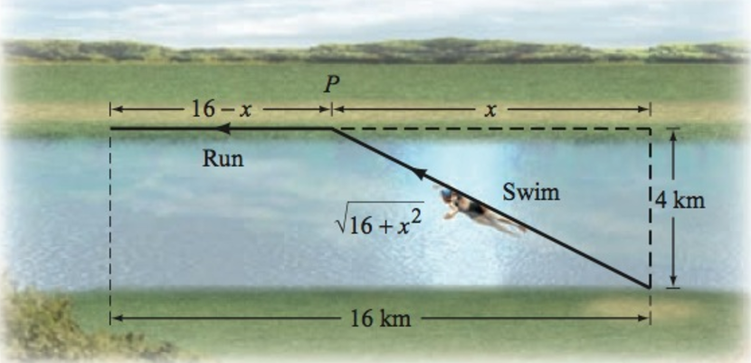

The person swims at 7  and runs at 22 . For what distance *x* is the total time for swimming and running 2 *hours*?

***Solution***



Time swimming 

Time runs 





















∴ The total distance is  *km*.

***Example***

A ball is thrown vertically upward with an initial velocity of 48 *feet* per *second*. The distance ***s*** (in *feet*) of the ball from the ground after ***t*** *seconds* is given by: .

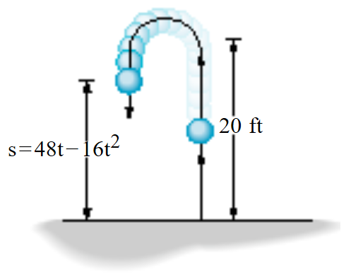

1. At what time ***t*** will the ball strike the ground?
2. For what time ***t*** is the ball more than 20 *feet* above the ground?

***Solution***

1. 



The ball will strike the ground when  *seconds*.

1. 











The ball is more than 20 feet above the ground when  *seconds*

***Example***

Suppose that the manufacturer of a gas clothes dryer has found that when the unit price is *p* dollars, the revenue *R* (in dollars) is



1. At what prices *p* is revenue zero?
2. For what range of prices will revenue exceed $500,000?

***Solution***

1. 



The revenue is zero when 

1. 









∴ The range of prices will revenue exceed 500,000 when 



***Exercise Section* 1.8 − More Applications and Models**

1. Two vertical poles of lengths 4 *feet* and 10 *feet* stand 15 *feet* apart. A cable reaches from the top of one pole to some point on the ground between the poles and then to the top of the other pole. Where should this point be located to use 24 *feet* of cable?

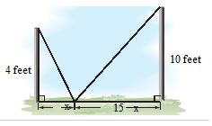

1. Towns ***A*** and ***B*** are located 6 *miles* and 3 *miles*, respectively, from a major expressway. The point on the expressway closet to town ***A*** is 12 *miles* from the point on the expressway closet to town ***B***. Two new roads are to be built from ***A*** to the expressway and then to ***B***.

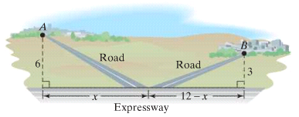

1. Express the combined lengths of the new road in terms of *x*.
2. If the combined lengths of the new roads is 15 *miles*, what distance does *x* represent?
3. A solid silver sphere has a diameter of 8 *millimeters*, and a second silver has a diameter of 12 *millimeters*. The spheres are melted down and recast to form a single cube. What is the length *s* of each edge of the cube?
4. The period *T* of the pendulum is the time it takes the pendulum to complete one swing from left to right and back. For a pendulum near the surface of Earth



Where *T* is measured in *seconds* and *L* is the length of the pendulum in feet. Find the length of a pendulum that has a period of 4 *seconds*.

1. A power station is on one side of a river that is 1 *mile* wide, and a factory is 6 *miles* down-stream on the other side of the river, the cost is $0.125 *million* per *mile* to run power lines over land and $0.2 *million* per *mile* to run power lines under water. How far over the land should the power line be run if the total cost of the project is to be $1 *million*?

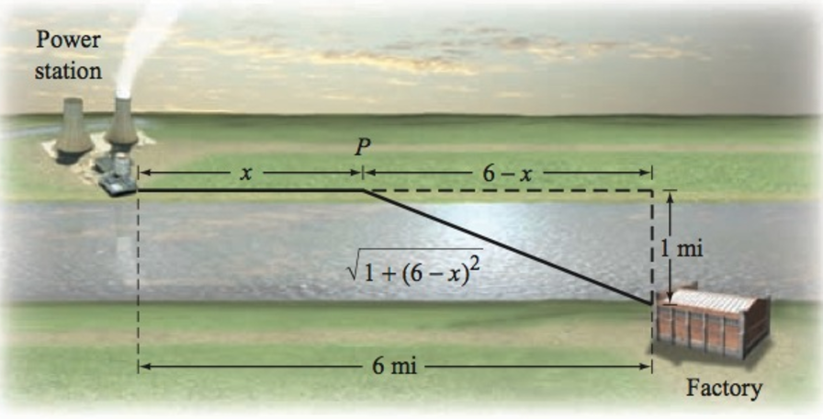

1. A cabin is located in a meadow at the end of a straight driveway 2 *km* long. A post office is located 5 *km* from the driveway along a straight road. A woman walks 2  through the meadow to point ***P*** and then 5  along the road to the post office. If it takes the woman 2.25 *hours* to reach the post office, what is the distance *x* of point ***P*** from the end of the driveway?

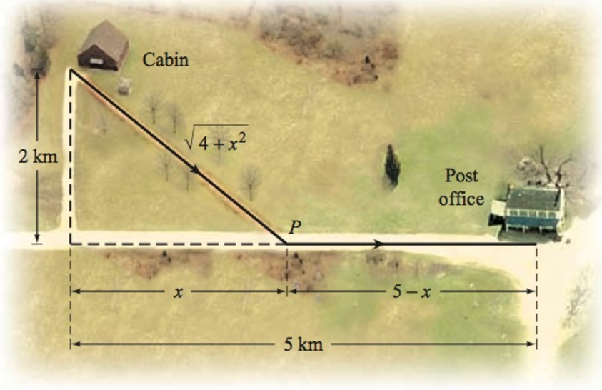

1. The depth *s* from the opening of a well to the water below can be determined by measuring the total time between the instant you drop a stone and the moment you heat it hit the water. The time, in *seconds*, it takes the stone to hit the water is given by , where s is measured in *feet*. The time, also in seconds, required for the sound of the impact to travel up to your ears is given by . Thus, the total time *T*, in *seconds*, between the instant you drop the stone and the moment you hear its impact is



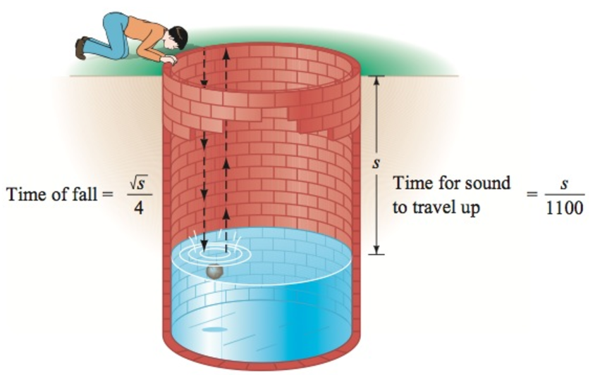

1. One of the world’s deepest water wells is 7,320 *feet* deep. Find the time between the instant you drop a stone and the time you hear it hit the water if the surface of the water if the surface of the water is 7,100 *feet* below the opening of the well.
2. Find the depth from the opening of a well to the water level if the time between the instant you drop a stone and the moment you heat its impact is 3 *seconds*.
3. On a ship, the distance *d* that you can see to the horizon is given by , where *h* is the height of your eye measured in *feet* above the sea level and *d* is measured in *miles*. How high is the eye level of a navigator who can see 14 *miles* to the horizon?
4. A car can be rented from Basic Rental for $260 per week with no extra charge for mileage.

Continental charges $80 per week plus 25 cents for each mile driven to rent the same car. How many miles must be driven in a week to make the rental cost for Basic Rental a better deal than Continental's?

1. If a projectile is launched from ground level with an initial velocity of 96 *ft.* per *sec*, its height in feet ***t*** seconds after launching is ***s*** feet, where



When will the projectile be greater than 80 *ft*. above the ground?

1. A projectile is fired straight up from ground level. After ***t*** seconds, its height above the ground is ***s*** *ft*., where



For what time period is the projectile at least 624 *ft*. above the ground?

1. Your test scores of 70 and 81 in your math class. To receive a *C* grade, you must obtain an average greater than or equal to 72 but less than 82. What range of test scores on the one remaining test will enable you to get a *C* for the course.
2. A truck can be rented from Basic Rental for $50 a day plus $0.20 per *mile*. Continental charges $20 per day plus $0.50 per *mile* to rent the same truck. How many miles must be driven in a day to make the rental cost for Basic Rental a better deal than Constiental’s?
3. You are choosing between two telephone plans. Plan ***A*** has a monthly fee of $15 with a charge of $0.08 per *minute* for all calls. Plan ***B*** has a monthly fee of $3 with a charge of $0.12 per *minute* for all calls. How many calling minutes in a month make plan ***A*** the better deal?
4. A City commission has proposed two tax bills. The first bill requires that a homeowner pay $1,800 plus 3% of the assesses home value in taxes. The second bill requires taxes of $200 plus 8% of the assessed home value. What price range of home assessment would make the first bill a better deal for the homeowner?
5. A local bank charges $8 per month plus $0.05 per check. The credit union charges $2 per month $0.08 per check. How many checks should be written each month to make the credit union a better deal?
6. A company manufactures and sells blank audiocassette tapes. The weekly fixed cost is $10,000 and it costs $0.40 to produce each tape. The selling price is $2.00 per tape. How many tapes must be produced and sold each week for the company to have a profit?
7. A company manufactures and sells stationery. The weekly fixed cost is $3,000 and it costs $3.00 to produce each package of stationery. The selling price is $5.50 per package. How many packages of stationery must be produced and sold each week for the company to have a profit?
8. An elevator at a construction site has a maximum capacity of 3,000 *pounds*. If the elevator operator weighs 200 *pounds* and each cement bag weighs 70 *pounds*, how many bags of cement can be safely lifted on the elevator in one trip?
9. An elevator at a construction site has a maximum capacity of 2,500 *pounds*. If the elevator operator weighs 160 *pounds* and each cement bag weighs 60 *pounds*, how many bags of cement can be safely lifted on the elevator in one trip?
10. You can rent a car for the day from Company ***A*** for $29.00 plus $0.12 a *mile*. Company ***B*** charges $22.00 plus $0.21 a *mile*. Find the number of miles *m* per day for which it is cheaper to rent from Company ***A***.
11. *UPS* will only ship packages for which the length is less than or equal to 108 *inches* and the length plus the girth is less than or equal to 130 *inches*. The length of a package is defined as the length of the longest side. The girth is defined as twice the width plus twice the height of the package. If a box has a length of 34 *inches* and a width of 22 *inches,* determine the possible range of heights *h* for this package if you wish to ship it by UPS.
12. The sum of three consecutive odd integers is between 63 and 81. Find all possible sets of integers that satisfy these conditions.
13. Forensic specialists can estimate the height of a deceased person from the lengths of the person’s bones. For instance, an inequality that relates the height *h*, in *cm*, of an adult female and the length *f*, in *cm*, of her femur is . Use the inequalities to estimate the possible range of heights for an adult female whose measures 32.24 *cm*.

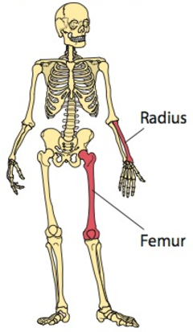

1. An inequality that is used to calculate the height *h* of an adult male from the length *r* of his radius is



Where *h* and *r* are both in *cm*. Use this inequality to estimate the possible range of heights for an adult male whose radius measures 26.36 *cm*.