***Lecture Two* − Functions**

***Section* 2.1– Functions and Graphs**

***Increasing* and *Decreasing* Functions**

* 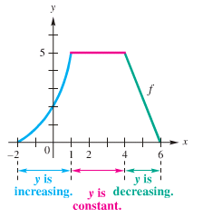A function *rises from left to right (x-coordinate)*, the function *f* is said to be ***increasing*** on an open interval ***I*** (*a, b*) (*x*-coordinate)



* A function *f* is said to be ***decreasing*** on an open interval ***I***



* A function *f* is said to be ***constant*** on an open interval ***I***



***Example***

Determine the intervals over which the function is increasing, decreasing, or constant

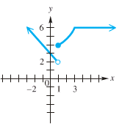

*Increasing*: [1, 3]

*Decreasing*: 

*Constant*: 

**Relative *Maxima*** *(um)* **and *Minima*** *(um)*

*f(a)* is a relative maximum if there exists an open interval I about *a* such that *f(a)* > *f(x),* for all *x* in I.

*f(a)* is a relative minimum if there exists an open interval I about *a* such that *f(a)* < *f(x),* for all *x* in I.



π/2

**−1**

**1**

−π/2

The relative minimum value of the function is −1 @ *x* = −π/2

The relative maximum value of the function is 1 @ *x* = π/2

***Example***

State the intervals on which the given function  is increasing, decreasing, or constant, and determine the extreme values



***Increasing***  ***RMIN*** 

***Decreasing***  ***RMAX*** 

***Piecewise*-Defined Functions**

Function are sometimes described by more than one expression, we call such functions ***piecewise-defined functions***.

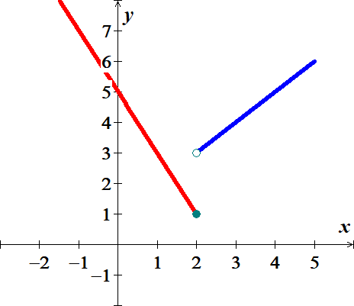***Example***

Graph function



Find: 





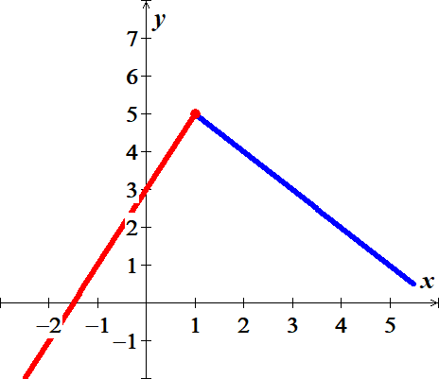

***Example***

Graph function



***Example***



Find *C*(40), *C*(80), and *C*(60)

***Solution***

1. *C*(40) = 20
2. *C*(80) = 20 + 0.40(80 – 60) = 28
3. *C*(60) = 20

***Exercise Section* 2.1– Functions and Graphs**

1.  **Find**: 
2.  **Find**: 
3.  **Find**: 
4.  **Find**: 
5.  **Find**

|  |  |  |  |  |
| --- | --- | --- | --- | --- |
|  |  |  |  | 1. Graph |

1.  **Find**

|  |  |  |  |  |
| --- | --- | --- | --- | --- |
|  |  |  |  | 1. Graph |

1.  **Find**

|  |  |  |  |  |
| --- | --- | --- | --- | --- |
|  |  |  |  | 1. Graph |

1. Graph the piecewise function defined by 
2. Sketch the graph 
3. Sketch the graph 

(**37 − 42**) Determine any ***relative maximum*** or ***minimum*** of the function, determine the intervals on which the function ***increasing*** or ***decreasing***, and then find the ***domain*** and the ***range***.

|  |  |
| --- | --- |
|  |  |
|  |  |
|  |  |
|  |  |
|  |  |
|  |  |

1. The elevation *H*, in *meters*, above sea level at which the boiling point of water is in ***t*** *degrees* *Celsius* is given by the function



At what elevation is the boiling point 99.5°.

1. A hot-air balloon rises straight up from the ground at a rate of 120 *ft./min*. The balloon is tracked from a rangefinder on the ground at point *P*, which is 400 *feet*. from the release point *Q* of the balloon. Let *d* be the distance from the balloon to the rangefinder and*t* – the time, in *minutes*, since the balloon was released. Express *d* as a function of *t*.

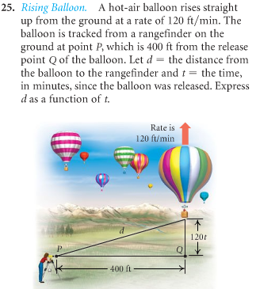

1. An airplane is flying at an altitude of 3700 *feet*. The slanted distance directly to the airport is *d* *feet*. Express the horizontal distance *x* as a function of *d*.

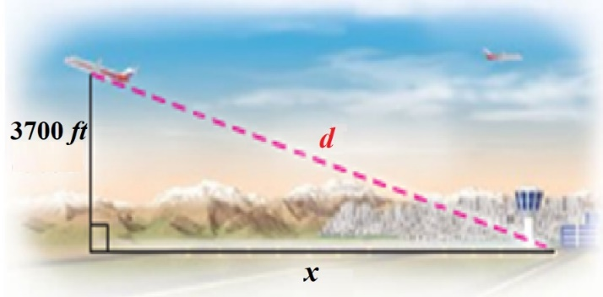

1. For the first minute of flight, a hot air balloon rises vertically at a rate of 3 *m/sec*. If *t* is the time in *seconds* that the balloon has been airborne, write the distance *d* between the balloon and a point on the ground 50 *meters* from the point to lift off as a function of *t*.

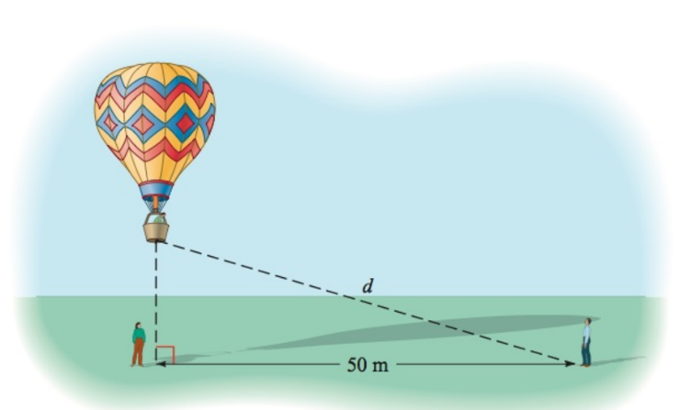

1. A light house is 2 *miles* south of a port. A ship leaves port and sails east at a rate of 7 *miles* per *hour*. Express the distance *d* between the ship and the lighthouse as a function of time, given that the ship has been sailing for *t* *hours*.

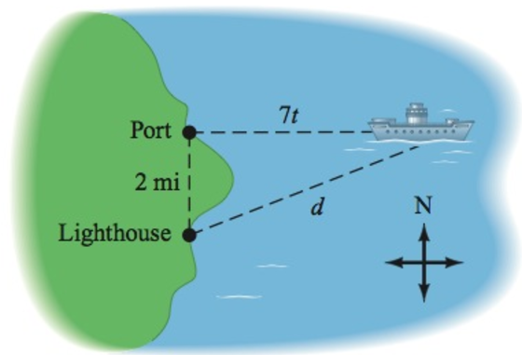

1. A cone has an altitude of 15 *cm* and a radius of 3 *cm*. A right circular cylinder of radius *r* and height *h* is inscribed in the cone. Use similar triangles to write *h* as a function of *r*.

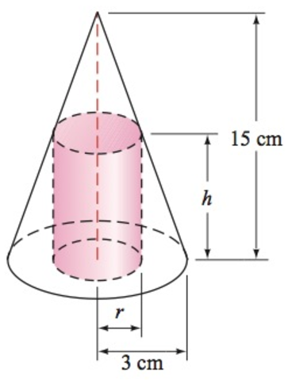

1. Water is flowing into a conical drinking cup with an altitude of 4 *inches* am a radius of 2 *inches*.

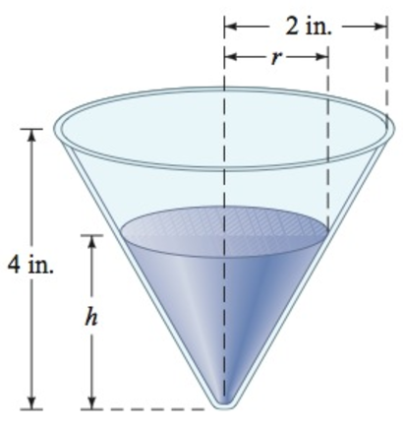

1. Write the radius *r* of the surface of the water as a function of its depth *h*.
2. Write the volume *V* of the water as a function of its depth *h*.

1. A water tank has the shape of a right circular cone with height 16 *feet* and radius 8 *feet*. Water is running into the tank so that the radius *r* (in *feet*) of the surface of the water is given by , where *t* is the time (in *minutes*) that the water has been running.

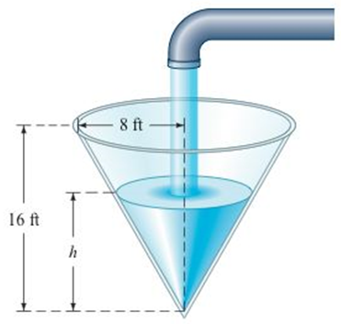

1. The area *A* of the surface of the water is . Find  and use it to determine the area of the surface of the water when .
2. The volume *V* of the water is given by . Find  and use it to determine the volume of the water when 
3. An athlete swims from point ***A*** to point ***B*** at a rate of 2 *miles* per *hour* and runs from point ***B*** to point ***C*** at a rate of 8 *miles* per *hour*. Use the dimensions in the figure to write the time *t* required to reach point ***C*** as a function of *x*.

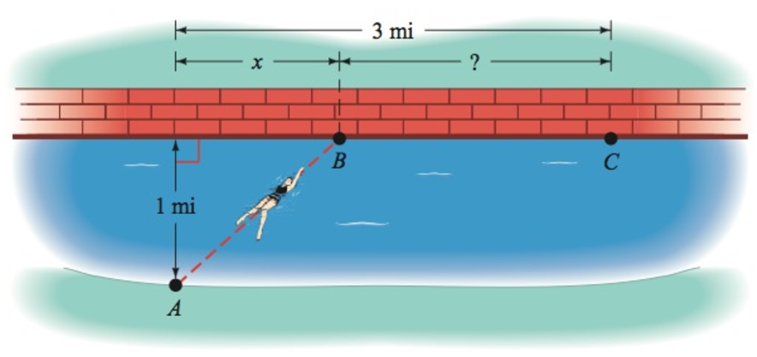

1. A device used in golf to estimate the distance ***d***, in *yards*, to a hole measures the size ***s***, in *inches*, that the 7-*feet* pin appears to be in a viewfinder. Express the distance ***d*** as a function of ***s***.

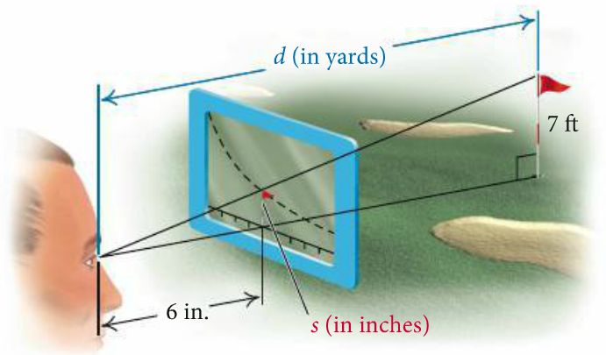

1. A rhombus is inscribed in a rectangle that is ***w*** *meters* wide with a perimeter of 40 *m*. Each vertex of the rhombus is a midpoint of a side of the rectangle. Express the area of the rhombus as a function of the rectangle’s width.

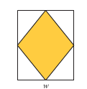

1. The surface area *S* of a right circular cylinder is given by the formula  . if the height is twice the radius, find each of the following.

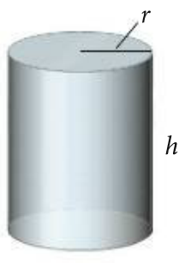

1. A function  for the surface area as a function of *r*.
2. A function  for the surface area as a function of *h*.
3. A boat is towed by a rope that runs through a pulley that is 4 *feet* above the point where the rope is tied to the boat. The length (in *feet*) of the rope from the boat to the pulley is given by , where *t* is the time in *seconds* that the boat has been in tow. The horizontal distance from the pulley to the boat is *d*.

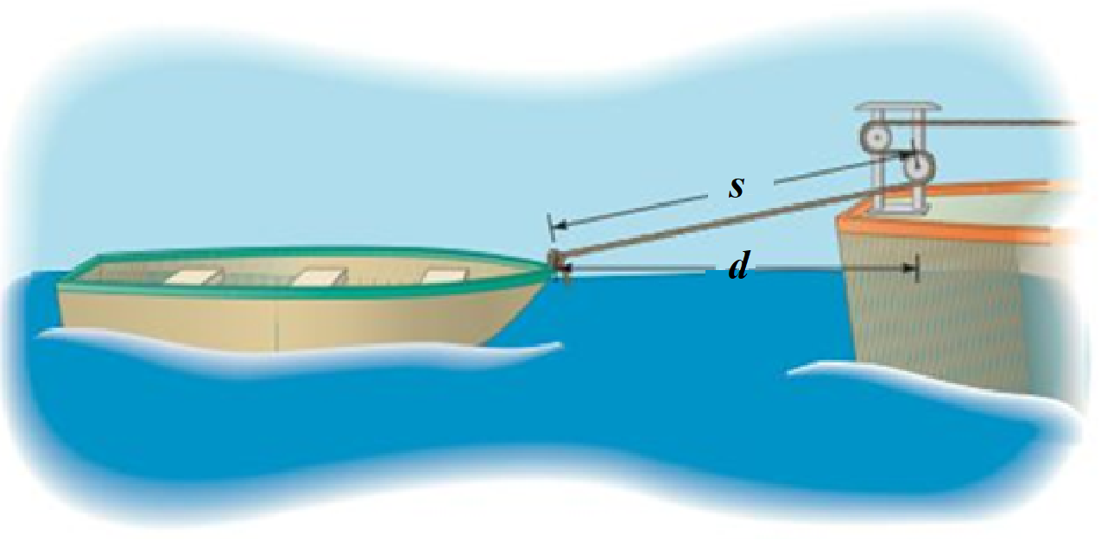

1. Find 
2. Evaluate  and 
3. The light from a lamppost casts a shadow from a ball that was dropped from a height of 22 *feet* above the ground. The distance *d*, in *feet*, the ball has dropped *t* *seconds* after it is released is given by . Find the distance *x*, in *feet*, of the shadow from the base of the lamppost as a function of time *t*.

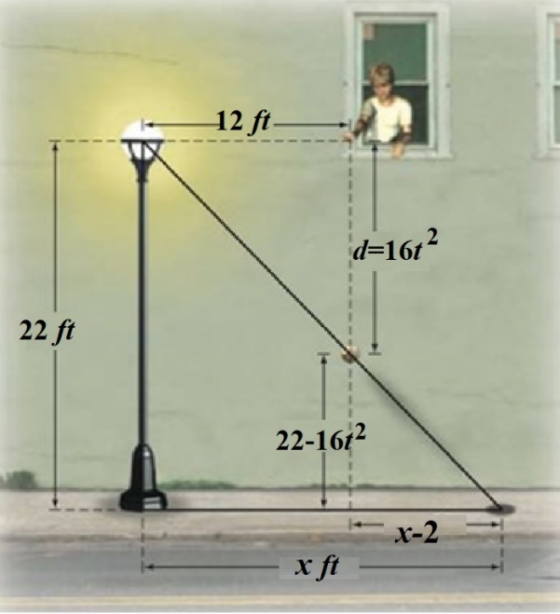

1. A right circular cylinder of height *h* and a radius *r* is inscribed in a right circular cone with a height of 10 *feet* and a base with radius 6 *feet*.

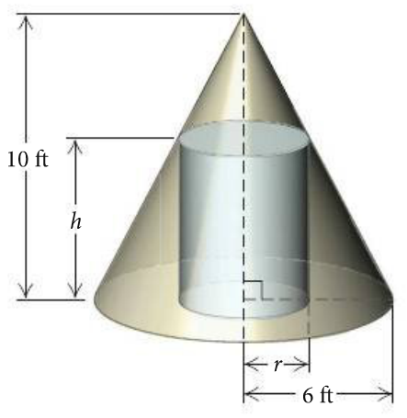

1. Express the height *h* of the cylinder as a function of *r*.
2. Express the volume *V* of the cylinder as a function of *r*.
3. Express the volume *V* of the cylinder as a function of *h*.