***Solution Section* 2.1– Functions and Graphs**

***Exercise***

 **Find**: 

***Solution***

1. 
2. 
3. 
4. 

***Exercise***

 **Find**: 

***Solution***

1. 
2. 
3. 
4. 

***Exercise***

 **Find**: 

***Solution***

1. 
2. 



1. 



1. 



***Exercise***

 Find: 

***Solution***

1. 



1. 



1. 

***Exercise***

 Find

|  |  |  |  |  |
| --- | --- | --- | --- | --- |
|  |  |  |  | 1. Graph |

***Solution***

1. 



1. 



1. 



1. 





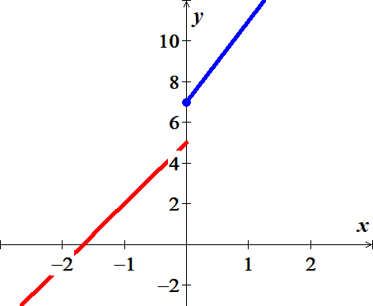

***Exercise***

 Find

|  |  |  |  |  |
| --- | --- | --- | --- | --- |
|  |  |  |  | 1. Graph |

***Solution***

1. 



1. 



1. 



1. 





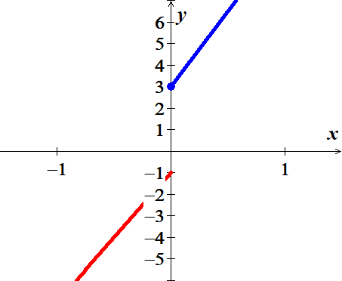

***Exercise***

 Find

|  |  |  |  |  |
| --- | --- | --- | --- | --- |
|  |  |  |  | 1. Graph |

***Solution***

1. 



1. 



1. 



1. 





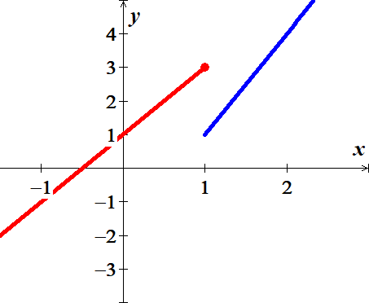

***Exercise***

Graph the piecewise function defined by 

***Solution***

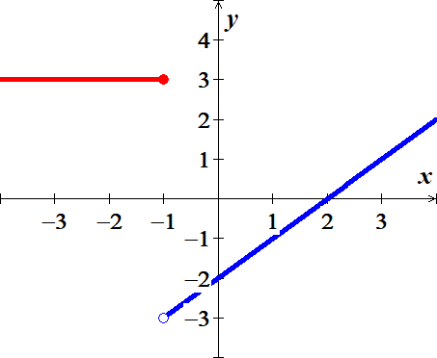

***Exercise***

Sketch the graph 

***Solution***

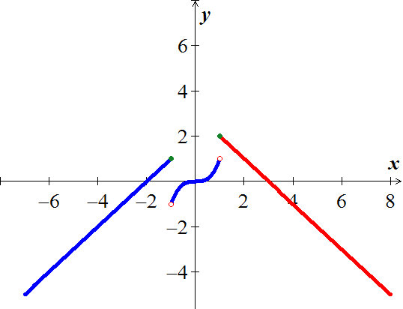

***Exercise***

Sketch the graph 

***Solution***

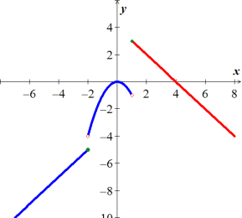

***Exercise***

Determine any ***relative maximum*** or ***minimum*** of the function, determine the intervals on which the function ***increasing*** or ***decreasing***, and then find the ***domain*** and the ***range***.



***Solution***

|  |  |
| --- | --- |
| ***Relative Maximum***: *None*  ***Minimum Point*:**  ***Increasing***:  ***Decreasing***:  ***Domain***:  ***Range***: |  |

***Exercise***

Determine any ***relative maximum*** or ***minimum*** of the function, determine the intervals on which the function ***increasing*** or ***decreasing***, and then find the ***domain*** and the ***range***.



***Solution***

|  |  |
| --- | --- |
| ***Maximum Point***:  ***Relative Minimum*:** *None*  ***Increasing***:  ***Decreasing***:  ***Domain***:  ***Range***: |  |

***Exercise***

Determine any ***relative maximum*** or ***minimum*** of the function, determine the intervals on which the function ***increasing*** or ***decreasing***, and then find the ***domain*** and the ***range***.



***Solution***

|  |  |
| --- | --- |
| ***Relative Maximum***:  ***Relative Minimum*:**  ***Increasing***:  ***Decreasing***:  ***Domain***:  ***Range***: |  |

***Exercise***

Determine any ***relative maximum*** or ***minimum*** of the function, determine the intervals on which the function ***increasing*** or ***decreasing***, and then find the ***domain*** and the ***range***.



***Solution***

|  |  |
| --- | --- |
| ***Relative Maximum***:  ***Relative Minimum*:**  ***Increasing***:  ***Decreasing***:  ***Domain***:  ***Range***: |  |

***Exercise***

Determine any ***relative maximum*** or ***minimum*** of the function, determine the intervals on which the function ***increasing*** or ***decreasing***, and then find the ***domain*** and the ***range***.



***Solution***

|  |  |
| --- | --- |
| ***Relative Maximum***:  ***Minimum Points*:**  ***Increasing***:  ***Decreasing***:  ***Domain***:  ***Range***: |  |

***Exercise***

Determine any ***relative maximum*** or ***minimum*** of the function, determine the intervals on which the function ***increasing*** or ***decreasing***, and then find the ***domain*** and the ***range***.



***Solution***

|  |  |
| --- | --- |
| ***Relative Maximum***:  ***Minimum Points*:**  ***Increasing***:  ***Decreasing***:  ***Domain***:  ***Range***: |  |

***Exercise***

The elevation *H*, in *meters*, above sea level at which the boiling point of water is in ***t*** degrees Celsius is given by the function



At what elevation is the boiling point 99.5°.

***Solution***





***Exercise***

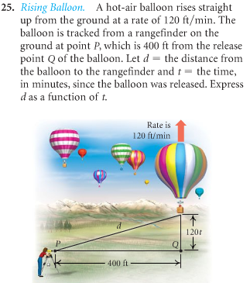A hot-air balloon rises straight up from the ground at a rate of 120 *ft./min*. The balloon is tracked from a rangefinder on the ground at point P, which is 400 *ft*. from the release point Q of the balloon. Let ***d*** = the distance from the balloon to the rangefinder and ***t*** – the time, in minutes, since the balloon was released. Express ***d*** as a function of ***t***.

***Solution***









***Exercise***

An airplane is flying at an altitude of 3700 *feet*. The slanted distance directly to the airport is *d* *feet*. Express the horizontal distance *x* as a function of *d*.

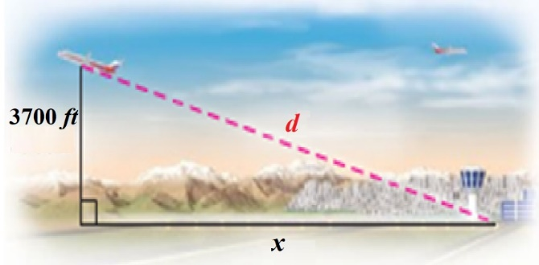***Solution***







***Exercise***

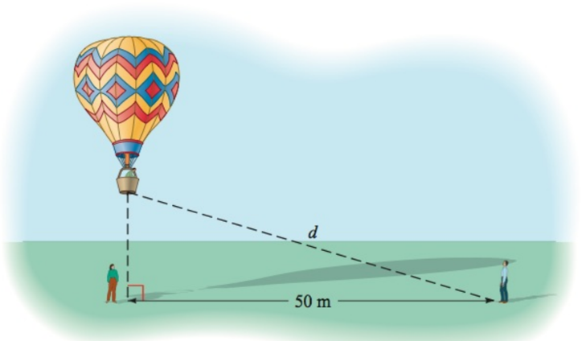For the first minute of flight, a hot air balloon rises vertically at a rate of 3 *m/sec*. If *t* is the time in *seconds* that the balloon has been airborne, write the distance *d* between the balloon and a point on the ground 50 *meters* from the point to lift off as a function of *t*.

***Solution***

 





***Exercise***

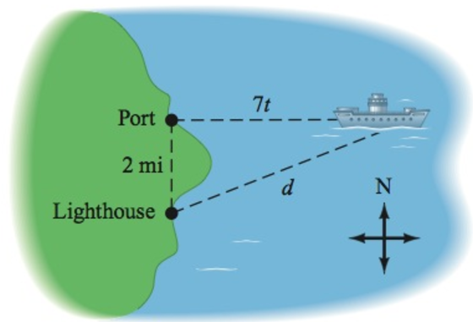A light house is 2 *miles* south of a port. A ship leaves port and sails east at a rate of 7 *miles* per *hour*. Express the distance *d* between the ship and the lighthouse as a function of time, given that the ship has been sailing for *t* hours.

***Solution***





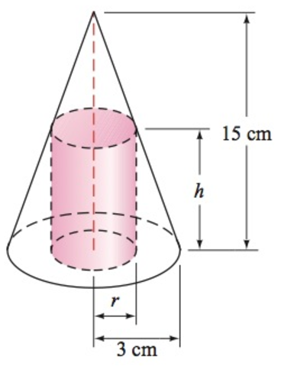***Exercise***

A cone has an altitude of 15 *cm* and a radius of 3 *cm*. A right circular cylinder of radius *r* and height *h* is inscribed in the cone. Use similar triangles to write *h* as a function of *r*.

***Solution***







***Exercise***

Water is flowing into a conical drinking cup with an altitude of 4 *inches* am a radius of 2 *inches*.

1. Write the radius *r* of the surface of the water as a function of its depth *h*.
2. Write the volume *V* of the water as a function of its depth *h*.

***Solution***

1. 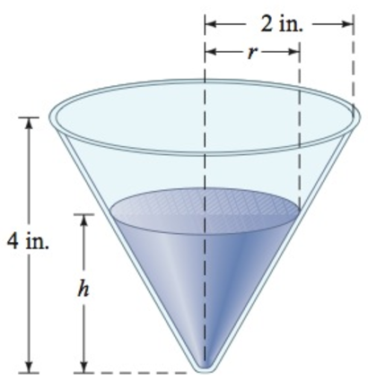



1. 







***Exercise***

A water tank has the shape of a right circular cone with height 16 *feet* and radius 8 *feet*. Water is running into the tank so that the radius *r* (in *feet*) of the surface of the water is given by , where *t* is the time (in *minutes*) that the water has been running.

1. The area *A* of the surface of the water is . Find  and use it to determine the area of the surface of the water when .
2. The volume *V* of the water is given by . Find  and use it to determine the volume of the water when 

***Solution***

1. 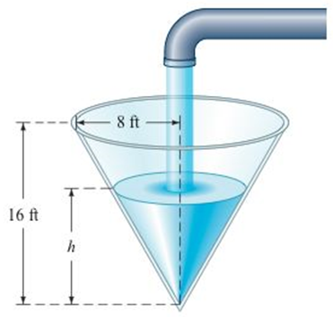





1. 













***Exercise***

An athlete swims from point ***A*** to point ***B*** at a rate of 2 *miles* per *hour* and runs from point ***B*** to point ***C*** at a rate of 8 *miles* per *hour*. Use the dimensions in the figure to write the time *t* required to reach point ***C*** as a function of *x*.

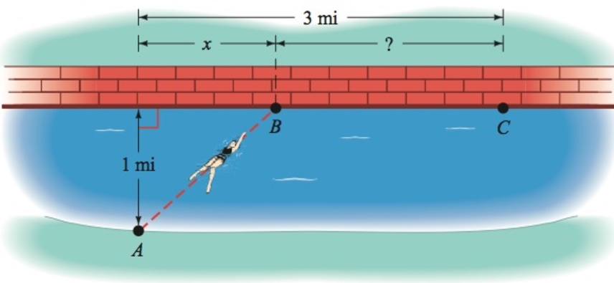

***Solution***

*Swimming distance* 

 

*Running distance* 

 



***Exercise***

A device used in golf to estimate the distance *d*, in *yards*, to a hole measures the size ***s***, in *inches*, that the 7-*foot* pin appears to be in a viewfinder. Express the distance *d* as a function of ***s***.

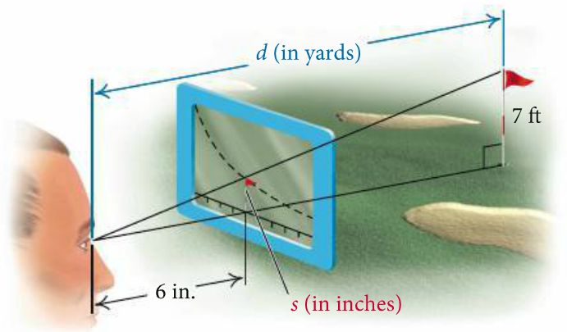***Solution***









***Exercise***

A *rhombus* is inscribed in a rectangle that is *w* *meters* wide with a perimeter of 40 *m*. Each vertex of the rhombus is a midpoint of a side of the rectangle. Express the area of the *rhombus* as a function of the rectangle’s width.

***Solution***

The area of the rhombus =  area of the rectangle, since each vertex of the rhombus is a midpoint of a side of the rectangle.

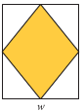  ***Divide both sides by*** **2**











***Exercise***

The surface area *S* of a right circular cylinder is given by the formula  . if the height is twice the radius, find each of the following.

1. A function  for the surface area as a function of *r*.
2. A function  for the surface area as a function of *h*.

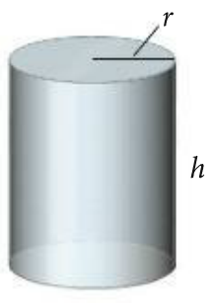***Solution***

***Given***: 

1. 







1. 







***Exercise***

A boat is towed by a rope that runs through a pulley that is 4 *feet* above the point where the rope is tied to the boat. The length (in *feet*) of the rope from the boat to the pulley is given by , where *t* is the time in *seconds* that the boat has been in tow. The horizontal distance from the pulley to the boat is *d*.

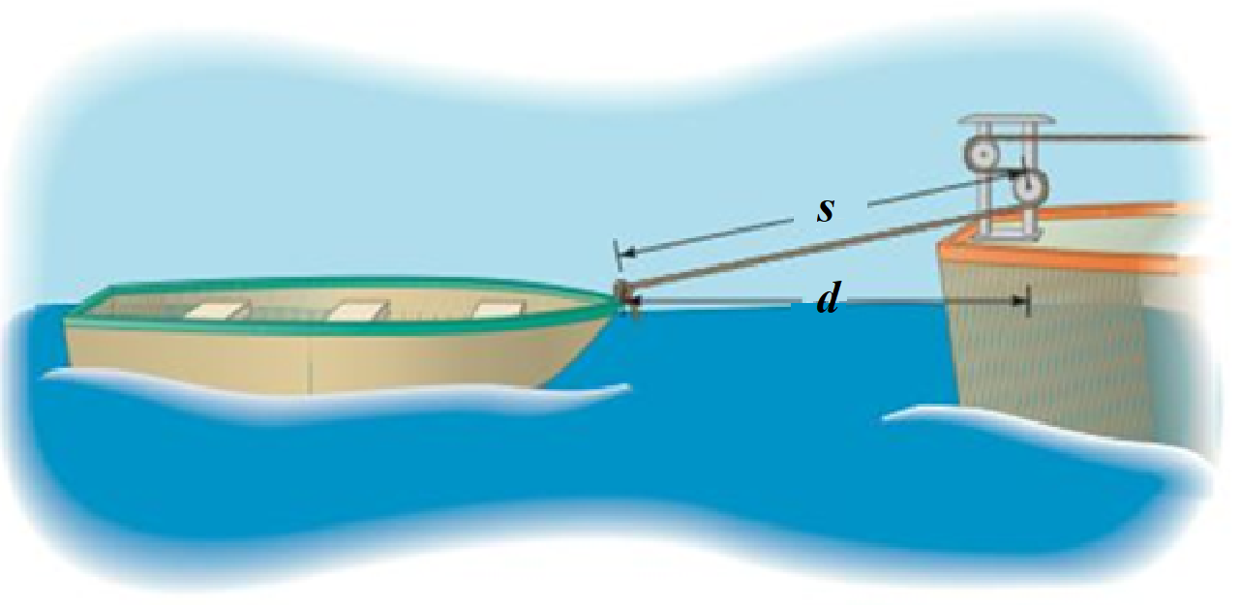

1. Find 
2. Evaluate  and 

***Solution***

1. 







1. 









***Exercise***

The light from a lamppost casts a shadow from a ball that was dropped from a height of 22 *feet* above the ground. The distance *d*, in *feet*, the ball has dropped *t* *seconds* after it is released is given by . Find the distance *x*, in *feet*, of the shadow from the base of the lamppost as a function of time *t*.

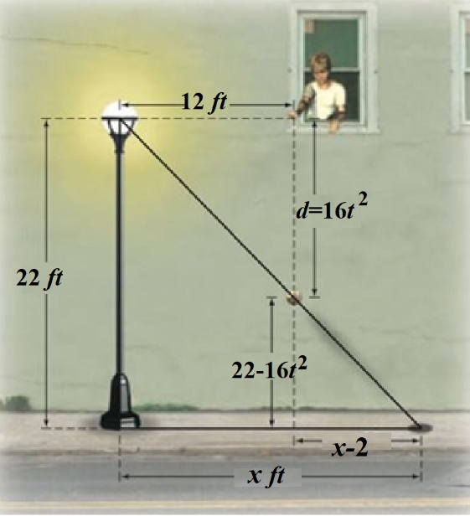***Solution***













***Exercise***

A right circular cylinder of height *h* and a radius *r* is inscribed in a right circular cone with a height of 10 *feet* and a base with radius 6 *feet*.

1. Express the height *h* of the cylinder as a function of *r*.
2. Express the volume *V* of the cylinder as a function of *r*.
3. Express the volume *V* of the cylinder as a function of *h*.

***Solution***

1. 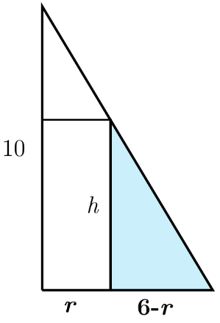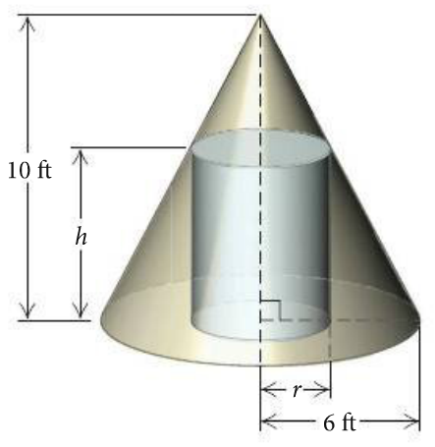



1. 





1. 







