***Section* 2.2 – Function Operations**

**The *Domain* of a Function**

1. ***Rational*** function:  ⇒ ***Domain***: 

***Example***: 

***Domain***:  

*Or*  *Interval Notation*

*Or* 

1. ***Irrational*** function:  ⇒ ***Domain***: 

***Example***: 

3 – *x* ≥ 0

– *x* ≥ −3

***Domain***:  

1. ***Otherwise***: Domain all real numbers 

***Example***: 

***Domain***: All real numbers 



**(1) *&* (2 )→**  Find the domain: 

*x* > 3

***Domain***: 

***Example***

Find the domain

1. 

***Domain***: 

1. 





***Domain:*** 

1. 





***Domain*:**  

**The *Algebra* of Functions**

**

**

**

**

***Example***

Let  and . Find each of the following , , , and 

***Solution***





























***Example***

Let and. Find each of the following and give the domain

, , , 

***Solution***

***Domain*** of *f*: 

***Domain*** of *g*:  

1. 

***Domain***:  

1. 

***Domain***:  

1. 

***Domain***:  

1. 

***Domain***:  

***Example***

Let  and 

Find  and its domain,  and its domain

***Solution***

 

1. 

−1 3

1. 
2. 



 

***Difference Quotients***



The difference quotient is given by: 

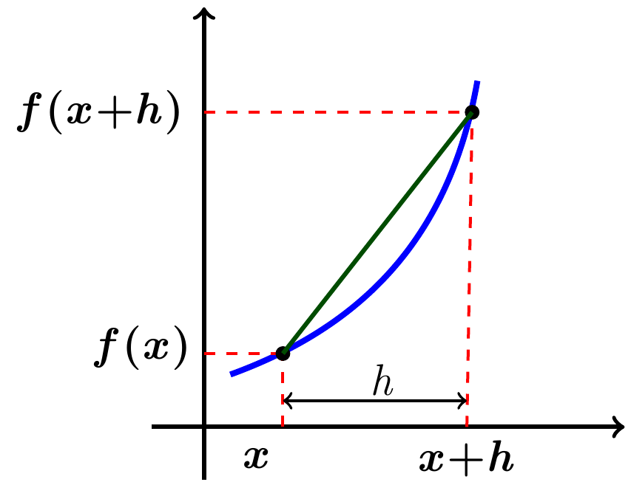

***Example***

For the function *f* given by , find the difference quotient 

***Solution***















***Example***

For the function *f* given by ****, find the difference quotient 

***Solution***

 















***Example***

Tracy and Graham drive away from a camp-ground at right angles to each other. Tracy’s speed is 65 mph and Graham’s is 55 *mph*.

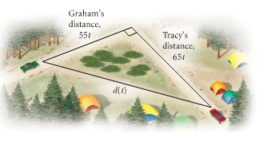

1. Express the distance between the cars as a function of time.
2. Find the domain of the function.

***Solution***

***a*)** *Distance* = *velocity* * *time*

Use Pythagorean Theorem:















***b*)** ***Domain***: *t* ≥ 0

***Example***: (storage area)

The sound Shop has 20 *feet*. of dividers with which to set off a rectangular area for the storage of overstock. If a corner of the store is used for the storage area, the partition need only form two sides of a rectangle.

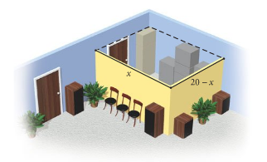

1. Express the floor area of the storage space as a function of the length of the partition.
2. Find the domain of the function.

***Solution***

Let *x* = the length

*width* + *length* = 20

*width* = 20 − *length*

***a***) ***Area*** = *length* * *width*





***b***) ***Domain***: *x* value varies from 0 to 20 ⇒ (0, 20)

***Exercises Section* 2.2 – Function Operations**

(**1 − 80**) Find the Domain

|  |  |  |
| --- | --- | --- |
|  |  |  |

|  |  |  |
| --- | --- | --- |
|  |  |  |

1. Let  and . Find each of the following and give the domain

|  |  |  |  |
| --- | --- | --- | --- |
|  |  |  |  |

1. Let  and . Find each of the following and give the domain

|  |  |  |  |
| --- | --- | --- | --- |
|  |  |  |  |

1. Let  and . Find each of the following and give the domain

|  |  |  |  |
| --- | --- | --- | --- |
|  |  |  |  |

1. Let  and . Find each of the following and give the domain

|  |  |  |  |
| --- | --- | --- | --- |
|  |  |  |  |

1. Given that  and 
2. Find 
3. Find the domain of 
4. Find: 
5. Given that  and 
6. Find  and its domain
7. Find  and its domain
8. Let  and . Find , ,, and 
9. Find  and the domain of 
10. Find  and the domain of 
11. Find  of  and 

(**88 − 103**) Find and simplify the difference quotient  for the given function

|  |  |  |
| --- | --- | --- |
|  |  |  |

1. An open box is to be made from a square piece of cardboard that measures 40 *inches* on each side, to construct the box, squares that measure *x* *inches* on each side are cut from each corner of the cardboard.

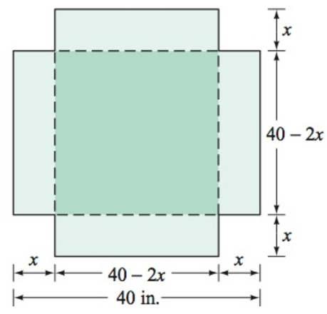 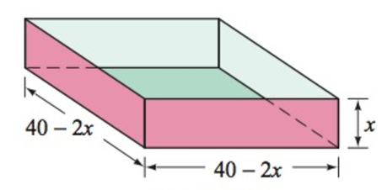

1. Express the volume *V* of the box as a function of *x*.
2. Determine the domain of *V*.
3. A child 4 *feet* tall is standing near a street lamp that is 12 *feet* high. The light from the lamp casts a shadow.

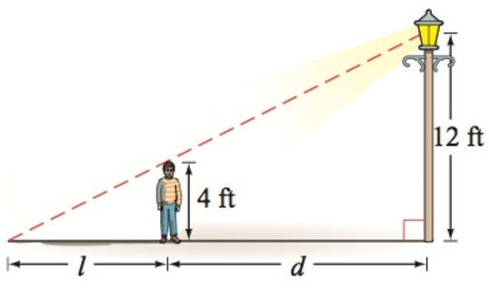

1. Find the length *l* of the shadow as a function of the distance *d* of the child from the lamppost.
2. What is the domain of the function?
3. What is the length of the shadow when the child is 8 *feet* from the base of the lamppost?
4. An open box is to be made from a square piece of cardboard with the dimensions 30 *inches* by 30 *inches* by cutting out squares of area  from each corner.

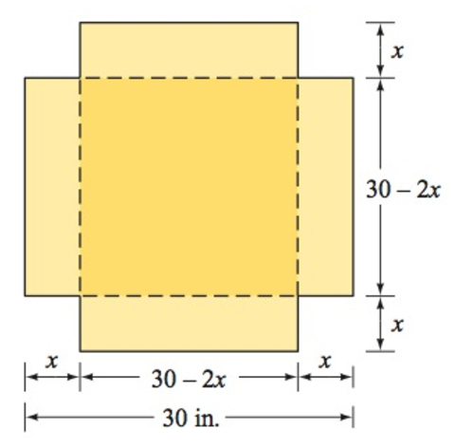

1. Express the volume *V* of the box as a function of *x*.
2. Determine the domain of *V*.
3. Two guy wires are attached to utility poles that are 40 *feet* apart.

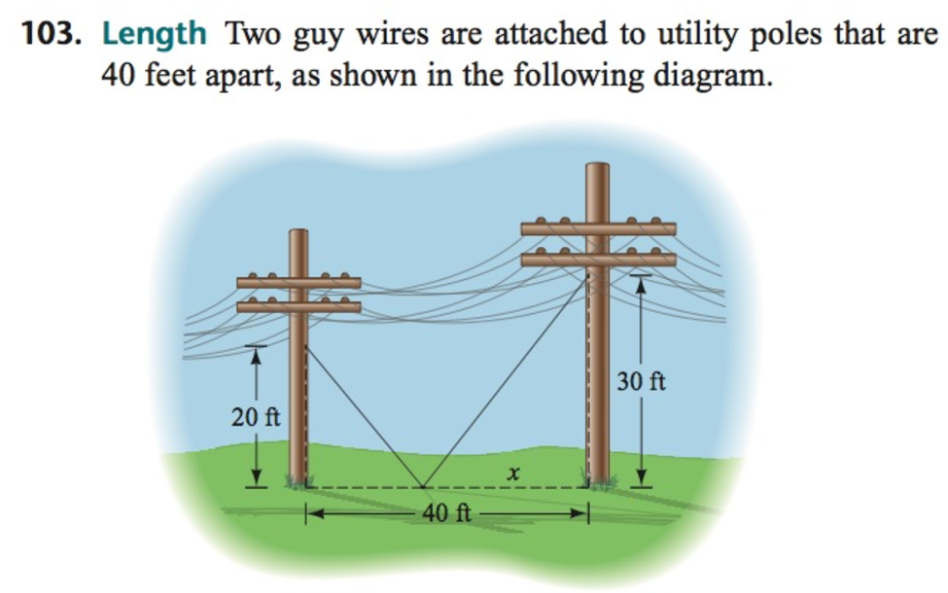

1. Find the total length of the two guy wires as a function of *x*.
2. What is the domain of this function?
3. A rancher has 360 *yard*s. of fencing with which to enclose two adjacent rectangular corrals, one for sheep and one for cattle. A river forms one side of the corrals. Suppose the width of each corral is *x* *yards*.

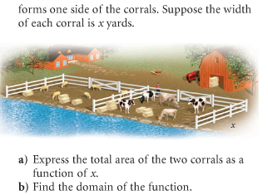

1. Express the total area of the two corrals as a function of *x*.
2. Find the domain of the function.
3. A rectangle is bounded by the *x*- and *y-axis* of 

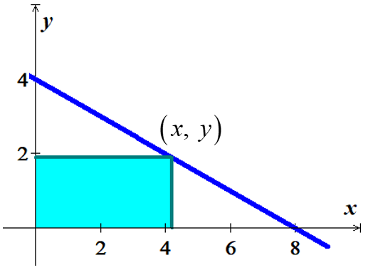

1. Find the area of the rectangle as a function of *x*.
2. What is the domain of this function.