***Section* 2.3 – Composition Functions**

***Composition* of Functions**

The composite function, the composite of *f* and *g*, is defined as



Where *x* is in the domain of *f*

andis in the domain of *f*

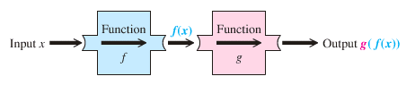

***Example***

Given that  and, find  and 

***Solution***

  ***Domain:*** All real numbers







 ***Domain:*** All real numbers



 ***Domain:*** All real numbers









 ***Domain:*** All real numbers

***Example***

Let  and , find each of the following and its domain.

1. 
2. 

***Solution***

1. 

 









***Domain:***  

1. 

 

 

***Domain:*** 

***Example***

Let  and  Find:

1. 
2. 

***Solution***

1. 









1. 











***Example***

Given that  and, find

1. 
2. Domain of 

***Solution***

1. 

=  ***Domain:***: *x* ≠ 0









 ***Domain:***: *x* ≠ 

1. Domain: 

***Exercises Section* 2.3 – Composition Functions**

1. Given that  and, find ,  and their domain then find 
2. Given that  and, find
3. 
4. 
5. 
6. Given that  and, find
7. 
8. 
9. 
10. Find : 
11. Find : 
12. Find : 

(**7 − 36**) For the given function; find:

1. Find  and the ***domain*** of 
2. Find  and the ***domain*** of 

|  |  |
| --- | --- |
|  |  |

|  |  |
| --- | --- |
|  |  |

(**37 − 48**) Evaluate each composite function, where 

|  |  |  |  |
| --- | --- | --- | --- |
|  |  |  |  |