***Section* 2.4 – Properties of Division**

***Long Division***

Divide 

*Quotient*

 *Dividend*

*Remainder*

*Divisor*





***Example***

Use the long division to find the quotient and the remainder: 

***Solution***







**Remainder *Theorem***

If a number *c* is substituted for *x* in the polynomial *,* then the result  is the remainder that would be obtained by dividing by *x* – *c*.

That is, if 

***Example***

If , use the remainder theorem to find 

***Solution***





**Factor *Theorem***

A polynomial  has a factor  if and only if 

***Example***

Show that  is a factor of .

***Solution***

Since 



From the factor theorem;  is a factor of .

***Synthetic Division***

Use synthetic division to find the quotient and the remainder of

 

***Example***

If , use the synthetic division to find .

***Solution***





***Example***

Show that −11 is a zero of the polynomial 

***Solution***

 Thus, , and −11 is a zero of .

**The Rational Zeros *Theorem***

If the polynomial  coefficients and if  is a rational zero of  such that ***c*** and ***d*** have no common prime factor, then

1. The numerator *c* of the zero is a factor of the constant term 
2. The denominator *d* of the zero is a factor of the leading coefficient 



***Example***

Find all rational solutions of the equation: 

***Solution***

|  |  |
| --- | --- |
|  |  |
|  |  |
|  |  |

Using the calculator, the result will show that −2 is a zero.



We have the factorization of: 

For 

 is another solution.



We have the factorization of: 

By applying quadratic formula to solve:  ⇒ 

Hence, the polynomial has two rational roots  and two irrational roots .

***Exercises*** ***Section* 2.4 – Properties of Division**

1. Find the quotient and remainder if  is divided by  

(**2 – 4**) Find the quotient and remainder if  is divided by 

1. 
2. 
3. 
4. Use the remainder theorem to find  
5. Use the remainder theorem to find  
6. Use the factor theorem to show that  is a factor of  
7. Use the synthetic division to find the quotient and remainder if the first polynomial is divided by the second: 
8. Use the synthetic division to find the quotient and remainder if the first polynomial is divided by the second: 
9. Use the synthetic division to find the quotient and remainder if the first polynomial is divided by the second: 

(**11 − 13**) Use the synthetic division to find 

1. 
2. 
3. 
4. Use the synthetic division to show that *c* is a zero of  
5. Use the synthetic division to show that *c* is a zero of  
6. Find all values of *k* such that  is divisible by the given linear polynomial: 

(**17 − 62**) Find all solutions of the equation

|  |  |
| --- | --- |
|  |  |

1. Glasses can be stacked to form a triangular pyramid. The total number of glasses in one of these pyramids is given by



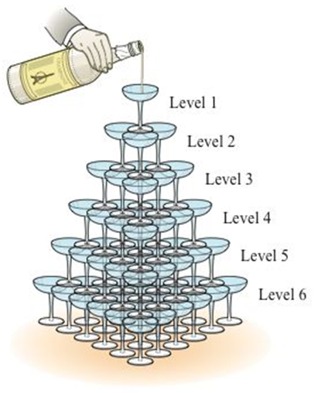

Where *k* is the number of levels in the pyramid. If 220 glasses are used to form a triangle pyramid, how many levels are in the pyramid?

1. Glasses can be stacked to form a triangular pyramid. The total number of glasses in one of these pyramids is given by





Where *k* is the number of levels in the pyramid. If 140 glasses are used to form a triangle pyramid, how many levels are in the pyramid?

1. A carbon dioxide cartridge for a paintball rifle has the shape of a right circular cylinder with a hemisphere at each end. The cylinder is 4 *inches* long, and the volume of the cartridge is .

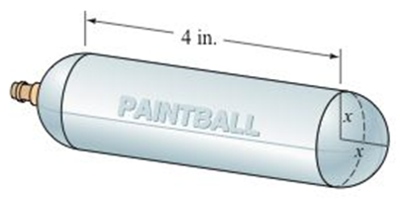

The common interior radius of the cylinder and the hemispheres is denoted by *x*. Estimate the length of the radius *x*.

1. A propane tank has the shape of a circular cylinder with a hemisphere at each end. The cylinder is 6 *feet* long and the volume of the tank is . Find the length of the radius *x*.

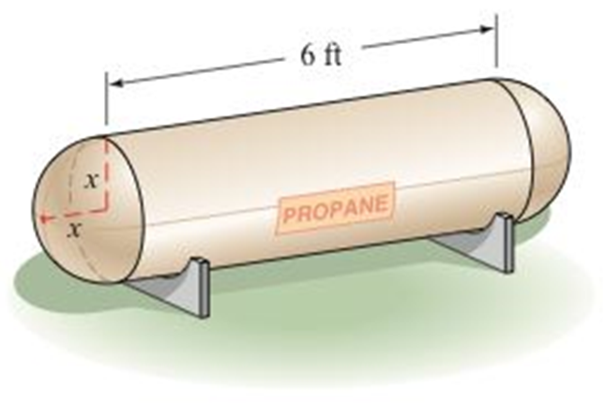

1. A cube measures *n* inches on each edge. If a slice 2 *inches* thick is cut from one face of the cube, the resulting solid has a volume of . Find *n*.

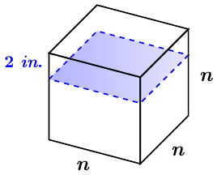

1. A cube measures *n* inches on each edge. If a slice 1 *inch* thick is cut from one face of the cube and then a slice 3 inches thick is cut from another face of the cube, the resulting solid has a volume of . Find the dimensions of the original cube.

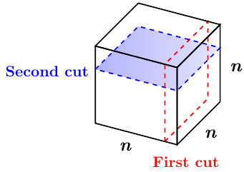

1. For what value of *x* will the volume of the following solid be 

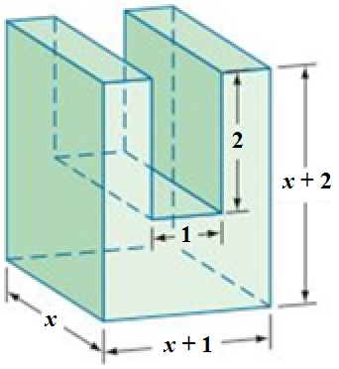

1. For what value of *x* will the volume of the following solid be 

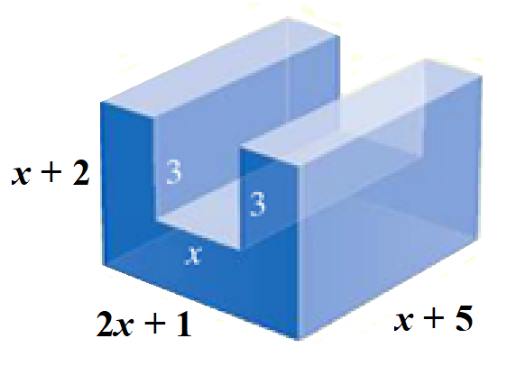

1. The length of rectangular box is 1 *inch* more than twice the height of the box, and the width is 3 *inches* more than the height. If the volume of the box is , find the dimensions of the box.

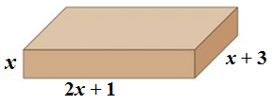

1. One straight cut through a thick piece of cheese produces two pieces. Two straight cuts can produce a maximum of four pieces. Two straight cuts can produce a maximum of four pieces. Three straight cuts can produce a maximum of eight pieces.

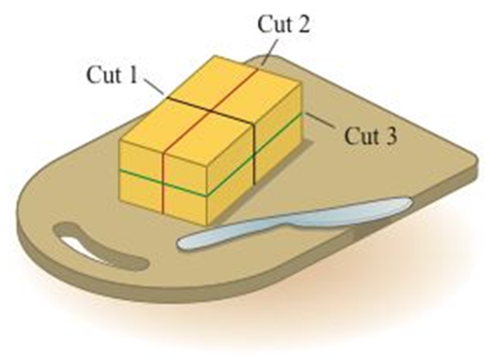

You might be inclined to think that every additional cut double numbers of pieces. However, for four straight cuts, you get a maximum of 15 pieces. The maximum number of pieces *P* that can be produced by *n* straight cuts is given by



1. Determine number of pieces that can be produces by five straight cuts.
2. What is the fewest number of straight cuts that are needed to produce 64 pieces?
3. The number of ways one can select three cards from a group of *n* cards (the order of the selection matters), where , is given by . For a certain card trick, a magician has determined that there are exactly 504 *ways* to choose three cards from a given group. How many cards are in the group?
4. A nutrition bar in the shape of a rectangular solid measure 0.75 *in*. by 1 *in*. by 5 *inches*.

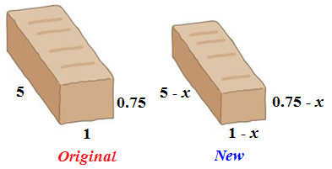

To reduce costs, the manufacturer has decided to decrease each of the dimensions of the nutrition bar by *x* *inches*, what value of *x* will produce a new bar with a volume that is  less than the present bar’s volume.

1. A rectangular box is square on two ends and has length plus girth of 81 *inches*. (Girth: distance *around* the box). Determine the possible lengths *l*  of the box if its volume is .

