***Section* 2.5 – Graphing Polynomial Functions**

**Polynomial Function**

A *Polynomial function* *P*(*x*) in *x* is a sum of the form is given by:



Where the coefficients are real numbers and the exponents are whole numbers.

***Degree***



***Leading Term***

***Leading Coefficient***

Non-polynomial Functions: 

|  |  |  |
| --- | --- | --- |
| ***Degree of f*** | ***Form of f(x)*** | ***Graph of f(x)*** |
| 0 |  | A horizontal line |
| 1 |  | A line with slope |
| 2 |  | A parabola with a vertical axis |

All polynomial functions are ***continuous functions***.

*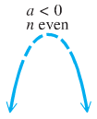****End Behavior*** 

If *n* (degree) is ***even***:

If  (in front  is negative).

Then the function falls from the left and right side

***Falls left***



***Falls right***

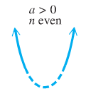 

***Rises right***

If  (in front  is positive).

***Rises left***

Then the function rises from the left and right side





***Rises left***

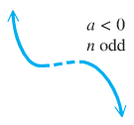If *n* (degree) is ***odd***:

If  (negative).

Then the function rises from the left side and falls from the right side



***Falls right***



***Rises right***

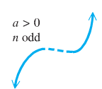If  (positive).

Then the function falls from the left side and rises from the right side



***Falls left***



***Example***

Determine the end behavior of the graph of the polynomial function 

***Solution***

Leading term:  with 5th degree (*n* is odd)

  rises left

  falls right

**The Intermediate Value *Theorem***

For any polynomial function  with real coefficients and  for , then  takes on every value between  and  in the interval .

∴  and are the ***opposite signs***. Then the function has a real zero between *a* and *b*.

***Example***

Using the intermediate value theorem, determine, if possible, whether the function has a real zero between *a* and *b*.

1. 
2. 

***Solution***

1. 









∴ ** has a zero between −4 and −2

1. 









∴ * zeros* ***can’t be determined***

***Example***

Show that  has a zero between 1 and 2.

***Solution***









Since  have opposite signs.

Therefore,  for at least one real number *c* between 1 and 2.

***Sketching***

***Example***

Let . Find all values of *x* such that and all *x* such that , and then sketch the graph of .

***Solution***









The zeros of ( *x*-intercepts) are: 

|  |  |  |  |  |
| --- | --- | --- | --- | --- |
| ***Interval*** | **0** 2 | | | |
| Sign of | **−** | **+** | **−** | **+** |
| Position | **Below *x*-axis** | **Above *x*-axis** | **Below *x*-axis** | **Above *x*-axis** |

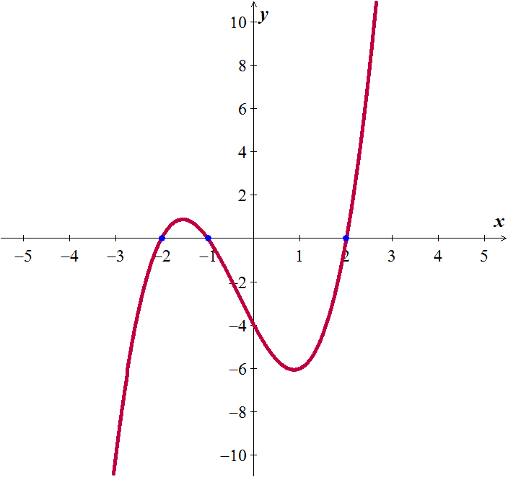

We can conclude from the chart and the graph that:





***Example***

Let . Find all values of *x* such that and all *x* such that , and then sketch the graph of .

***Solution***





The zeros are: 0, 1, 3.

Since the factor is always positive, it has no factor

|  |  |  |
| --- | --- | --- |
| 1 **2** 3 | | |
| **+** | **−** | **+** |

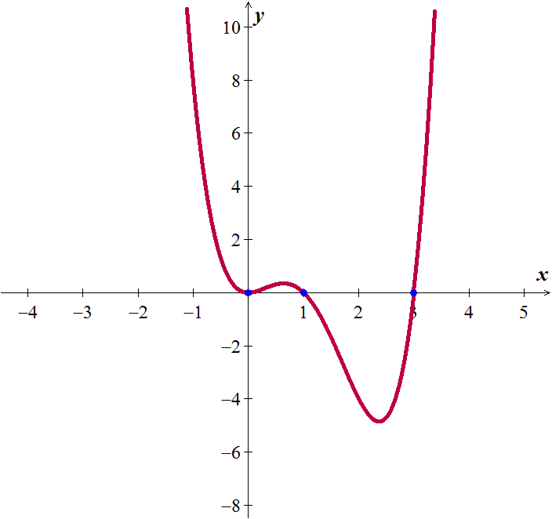





***Exercises*** ***Section* 2.5 – Polynomial Functions**

(**1 – 12**) Determine the end behavior of the graph of the polynomial function

|  |  |
| --- | --- |
|  |  |

(**13 – 32**) Use the Intermediate Value Theorem to show that each polynomial has a real zero between the given integers.

1. 
2. 
3. 
4. 
5. 
6. 
7. 
8. 
9. 
10. 
11. 
12. 
13. 
14. 
15. 
16. 
17. 
18. 
19. 
20. 

(**33 − 91**) Find all values of *x* such that and all *x* such that , and then sketch the graph of 

|  |  |
| --- | --- |
|  |  |

|  |  |
| --- | --- |
|  |  |