***Solution Section* 2.5 – Graphing Polynomial Functions**

***Exercise***

Determine the end behavior of the graph of the polynomial function 

***Solution***

Leading term:  with 3*rd* degree (*n* is ***odd***)

  falls left

  rises right

***Exercise***

Determine the end behavior of the graph of the polynomial function 

***Solution***

Leading term:  with 3*rd* degree (*n* is ***odd***)

  falls left

 rises right

***Exercise***

Determine the end behavior of the graph of the polynomial function 

***Solution***

Leading term:  with 3*rd* degree (*n* is ***odd***)

  rises left

  falls right

***Exercise***

Determine the end behavior of the graph of the polynomial function 

***Solution***

Leading term:  with 3*rd* degree (*n* is ***odd***)

  falls left

  rises right

***Exercise***

Determine the end behavior of the graph of the polynomial function 

***Solution***

Leading term:  with 4*rd* degree (*n* is ***even***)

  rises left

  rises right

***Exercise***

Determine the end behavior of the graph of the polynomial function 

***Solution***

Leading term:  with 4*rd* degree (*n* is ***even***)

  rises left

  rises right

***Exercise***

Determine the end behavior of the graph of the polynomial function 

***Solution***

Leading term:  with 4*rd* degree (*n* is ***even***)

  falls left

  falls right

***Exercise***

Determine the end behavior of the graph of the polynomial function 

***Solution***

Leading term:  with 4*rd* degree (*n* is ***even***)

  falls left

  falls right

***Exercise***

Determine the end behavior of the graph of the polynomial function 

***Solution***

Leading term:  with 5*th* degree (*n* is ***odd***)

  falls left

  rises right

***Exercise***

Determine the end behavior of the graph of the polynomial function 

***Solution***

Leading term:  with 5*th* degree (*n* is ***odd***)

  rises left

  falls right

***Exercise***

Determine the end behavior of the graph of the polynomial function 

***Solution***

Leading term:  with 6*th* degree (*n* is ***even***)

  falls left

  falls right

***Exercise***

Determine the end behavior of the graph of the polynomial function 

***Solution***

Leading term:  with 6*th* degree (*n* is ***even***)

  rises left

  rises right

***Exercise***

Use the Intermediate Value Theorem to show that each polynomial has a real zero between the given integers. 

***Solution***









Since  have opposite signs.

Therefore, the polynomial ***has a real zero*** between 1 and 2.

***Exercise***

Use the Intermediate Value Theorem to show that each polynomial has a real zero between the given integers. 

***Solution***









Since  have opposite signs.

Therefore, the polynomial ***has a real zero*** between 0 and 1.

***Exercise***

Use the Intermediate Value Theorem to show that each polynomial has a real zero between the given integers. 

***Solution***









Since  have opposite signs.

Therefore, the polynomial ***has a real zero*** between −1 and 0.

***Exercise***

Use the Intermediate Value Theorem to show that each polynomial has a real zero between the given integers. 

***Solution***









Since  have opposite signs.

Therefore, the polynomial ***has a real zero*** between 2 and 3.

***Exercise***

Use the Intermediate Value Theorem to show that each polynomial has a real zero between the given integers. 

***Solution***









Since  have opposite signs.

Therefore, the polynomial ***has a real zero*** between −2 and −3.

***Exercise***

Use the Intermediate Value Theorem to show that each polynomial has a real zero between the given integers. 

***Solution***









Since  have opposite signs.

Therefore, the polynomial ***has a real zero*** between 1 and 2.

***Exercise***

Use the Intermediate Value Theorem to show that each polynomial has a real zero between the given integers. 

***Solution***









Since  have opposite signs.

Therefore, the polynomial ***has a real zero*** between −3 and −2.

***Exercise***

Use the Intermediate Value Theorem to show that each polynomial has a real zero between the given integers. 

***Solution***









Since  have opposite signs.

Therefore, the polynomial ***has a real zero*** between 2 and 3.

***Exercise***

Use the Intermediate Value Theorem to show that each polynomial has a real zero between the given integers. 

***Solution***









Since  have same signs.

Therefore, ***cannot be determined***.

***Exercise***

Use the Intermediate Value Theorem to show that each polynomial has a real zero between the given integers. 

***Solution***









Since  have same signs.

Therefore, ***cannot be determined***.

***Exercise***

Use the Intermediate Value Theorem to show that each polynomial has a real zero between the given integers. 

***Solution***









Since  have opposite signs.

Therefore, the polynomial ***has a real zero*** between 3 and 4.

***Exercise***

Use the Intermediate Value Theorem to show that each polynomial has a real zero between the given integers. 

***Solution***







Since  have opposite signs.

Therefore, the polynomial ***has a real zero*** between 0 and 1.

***Exercise***

Use the Intermediate Value Theorem to show that each polynomial has a real zero between the given integers. 

***Solution***









Since  have opposite signs.

Therefore, the polynomial ***has a real zero*** between −3 and −2.

***Exercise***

Use the Intermediate Value Theorem to show that each polynomial has a real zero between the given integers. 

***Solution***









Since  have opposite signs.

Therefore, the polynomial ***has a real zero*** between 1 and 2.

***Exercise***

Use the Intermediate Value Theorem to show that each polynomial has a real zero between the given integers. 

***Solution***













Since  have opposite signs.

Therefore, the polynomial ***has a real zero*** between 1 and.

***Exercise***

Use the Intermediate Value Theorem to show that each polynomial has a real zero between the given integers. 

***Solution***











Since  have opposite signs.

Therefore, the polynomial ***has a real zero*** between 3 and.

***Exercise***

Use the Intermediate Value Theorem to show that each polynomial has a real zero between the given integers. 

***Solution***









Since  have opposite signs.

Therefore, the polynomial ***has a real zero*** between 1 and 2.

***Exercise***

Use the Intermediate Value Theorem to show that each polynomial has a real zero between the given integers. 

***Solution***









Since  have opposite signs.

Therefore, the polynomial ***has a real zero*** between 2 and 3.

***Exercise***

Use the Intermediate Value Theorem to show that each polynomial has a real zero between the given integers. 

***Solution***







Since  have same sign.

Therefore, ***cannot be determined***.

***Exercise***

Use the Intermediate Value Theorem to show that each polynomial has a real zero between the given integers. 

***Solution***



















Since  have opposite signs.

Therefore, the polynomial ***has a real zero*** between 2.1 and 2.2.

***Exercise***

Let . Find all values of *x* such that and all *x* such that , and then sketch the graph of .

***Solution***





The zeros are: 0, 0, 2, −2.

|  |  |  |
| --- | --- | --- |
| −2 **0,0** 2 | | |
| **+** | **−** | **+** |





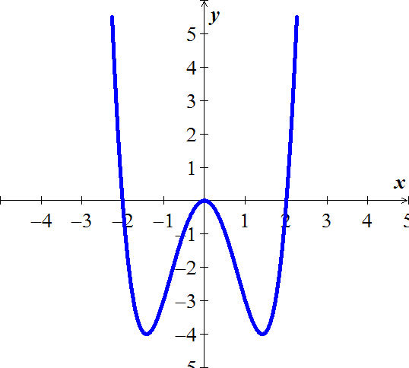

***Exercise***

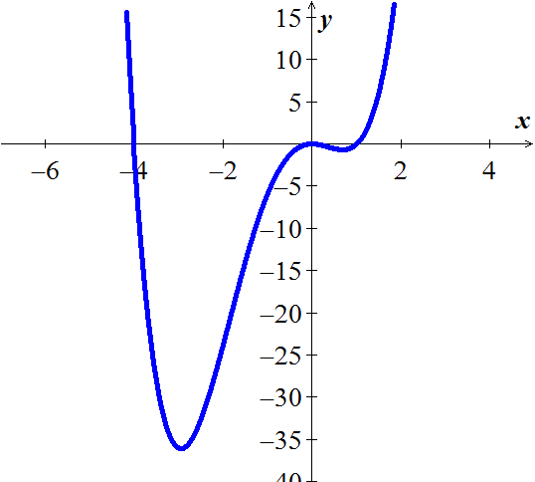Let . Find all values of *x* such that and all *x* such that , and then sketch the graph of .

***Solution***



The zeros are: 0, 0, 1, −4.

|  |  |  |
| --- | --- | --- |
| −4 **0,0** 1 | | |
| **+** | **−** | **+** |





***Exercise***

Let . Find all values of *x* such that and all *x* such that , and then sketch the graph of .

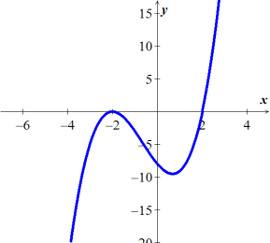***Solution***







The zeros are: 2, −2, −2

|  |  |  |
| --- | --- | --- |
| −2 02 | | |
| **−** | **−** | **+** |





***Exercise***

Let . Find all values of *x* such that and all *x* such that , and then sketch the graph of .

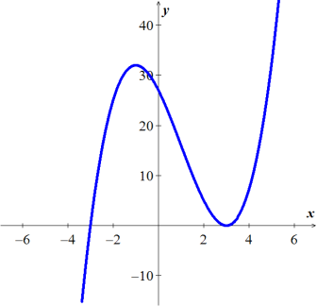***Solution***







The zeros are: −3, 3 (multiplicity)

|  |  |  |
| --- | --- | --- |
| −3 03 | | |
| **−** | **+** | **+** |





***Exercise***

Let . Find all values of *x* such that and all *x* such that , and then sketch the graph of .

***Solution***

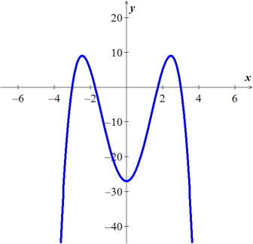





|  |  |  |  |  |
| --- | --- | --- | --- | --- |
| −3   3 | | | | |
| **−** | **+** | **−** | **+** | **−** |





***Exercise***

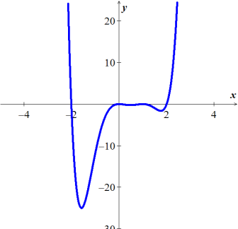Let . Find all values of *x* such that and all *x* such that , and then sketch the graph of .

***Solution***

The zeros are: −2, 2, 0, 0, 1, 1

|  |  |  |
| --- | --- | --- |
| −2 **0,0 1,1** 2 | | |
| **+** | **−** | **+** |





***Exercise***

Let . Find all values of *x* such that and all *x* such that , and then sketch the graph of .

***Solution***



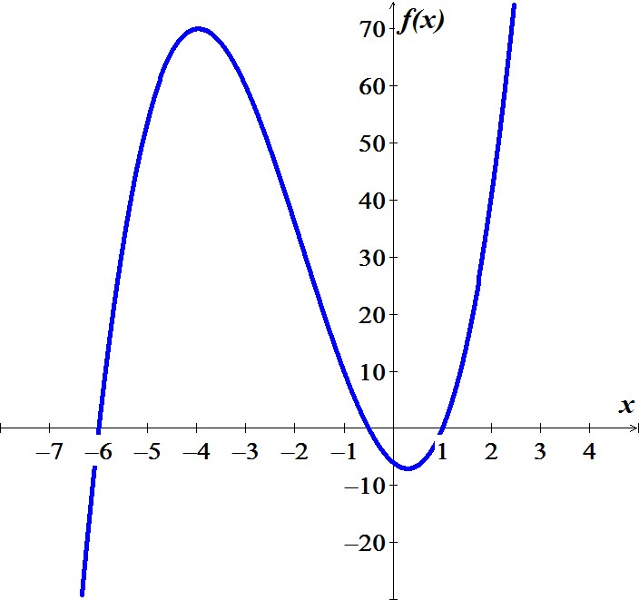 



The zeros are: 

|  |  |  |  |
| --- | --- | --- | --- |
| −6  1 | | | |
| **−** | **+** | **−** | **+** |





***Exercise***

Let . Find all values of *x* such that and all *x* such that , and then sketch the graph of .

***Solution***







The zeros are: 

|  |  |  |  |
| --- | --- | --- | --- |
| −3  2 | | | |
| **−** | **+** | **−** | **+** |





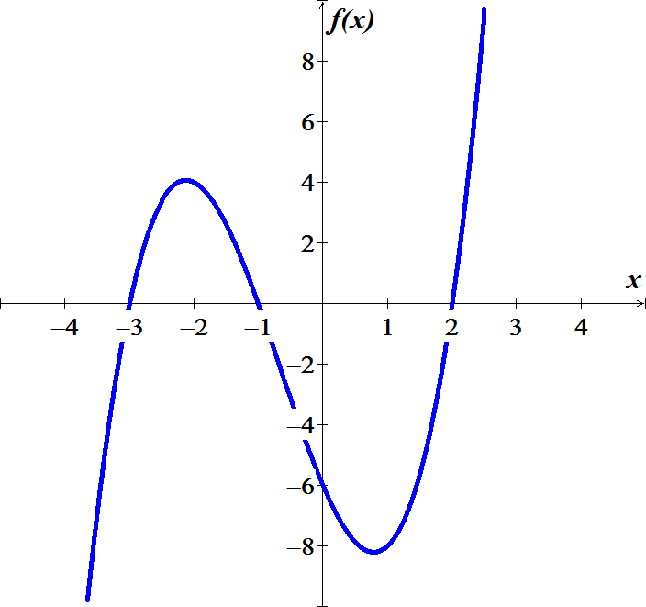

***Exercise***

Let . Find all values of *x* such that and all *x* such that , and then sketch the graph of .

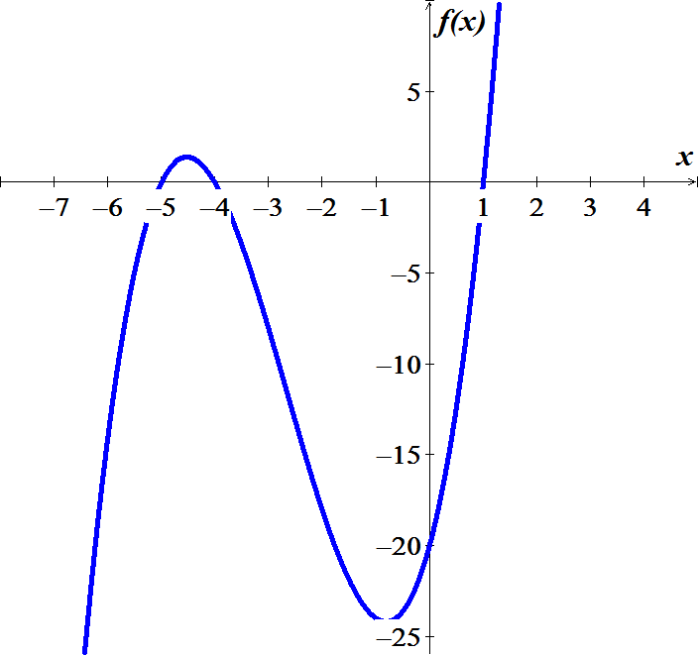***Solution***





The zeros are: 

|  |  |  |  |
| --- | --- | --- | --- |
| −5  1 | | | |
| **−** | **+** | **−** | **+** |





***Exercise***

Let . Find all values of *x* such that and all *x* such that , and then sketch the graph of .

***Solution***



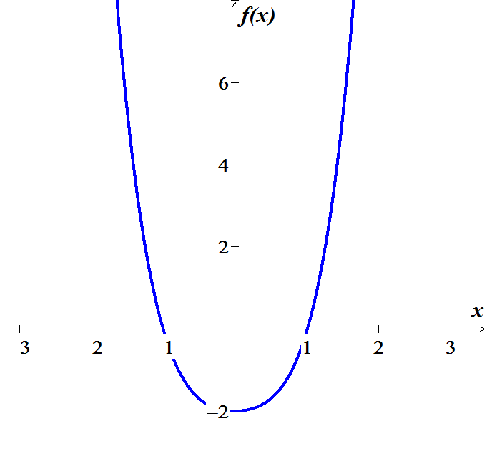



The zeros are: 

|  |  |  |
| --- | --- | --- |
| −1 1 | | |
| **+** | **−** | **+** |





***Exercise***

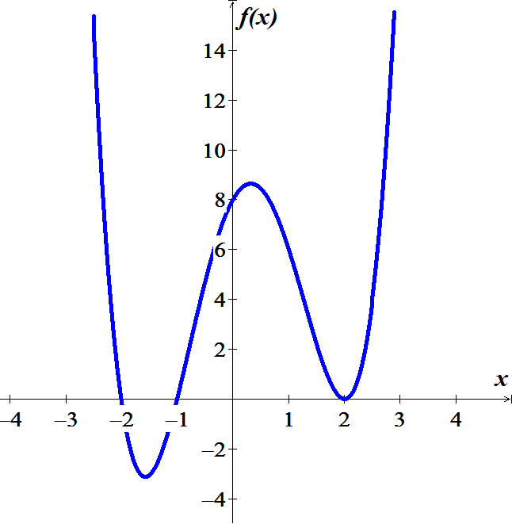Let . Find all values of *x* such that and all *x* such that , and then sketch the graph of .

***Solution***







The zeros are: 

|  |  |  |  |
| --- | --- | --- | --- |
| −2  2 | | | |
| **+** | **−** | **+** | **+** |





***Exercise***

Let . Find all values of *x* such that and all *x* such that , and then sketch the graph of .

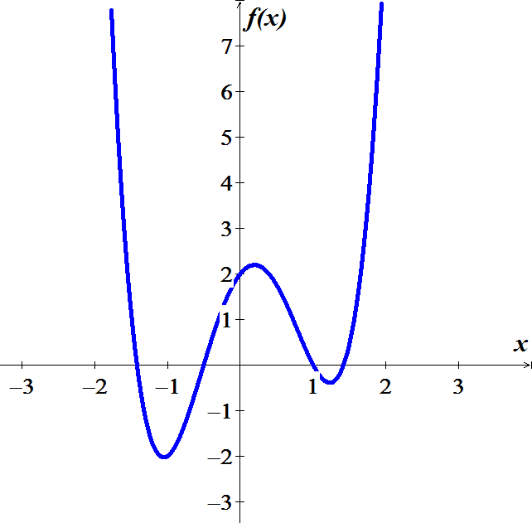***Solution***







The zeros are: 

|  |  |  |  |  |
| --- | --- | --- | --- | --- |
|  | | | | |
| **+** | **−** | **+** | **−** | **+** |





***Exercise***

Let . Find all values of *x* such that and all *x* such that , and then sketch the graph of .

***Solution***





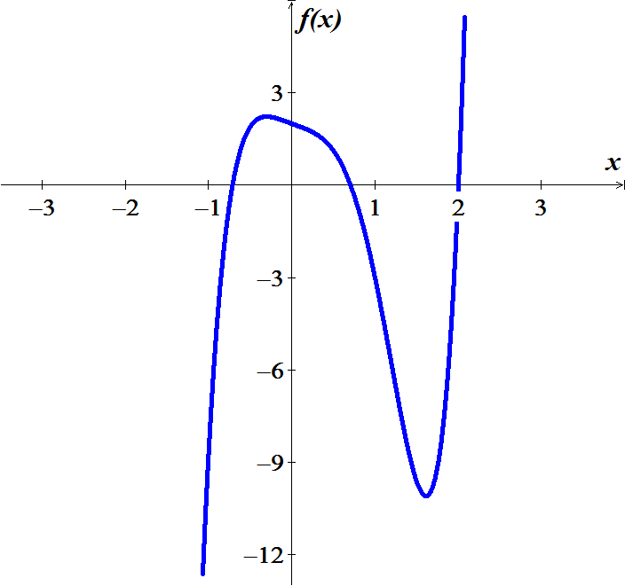

The zeros are: 

|  |  |  |  |
| --- | --- | --- | --- |
| 2 | | | |
| **−** | **+** | **−** | **+** |





***Exercise***

Let . Find all values of *x* such that and all *x* such that , and then sketch the graph of .

***Solution***



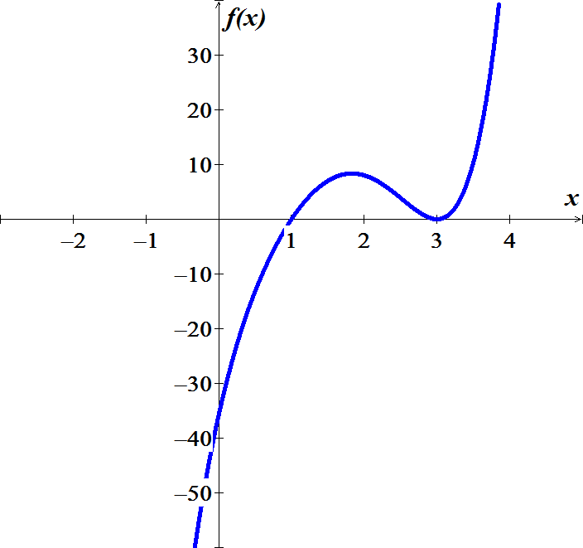



The zeros are: 

|  |  |  |
| --- | --- | --- |
| 3 | | |
| **−** | **+** | **+** |





***Exercise***

Find all values of *x* such that and all *x* such that , and then sketch the graph of 



***Solution***

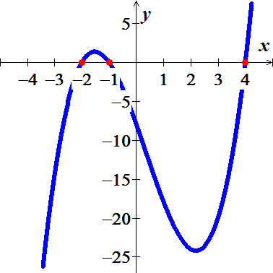





|  |  |  |  |
| --- | --- | --- | --- |
| −2  4 | | | |
| **−** | **+** | **−** | **+** |





***Exercise***

Find all values of *x* such that and all *x* such that , and then sketch the graph of 



***Solution***

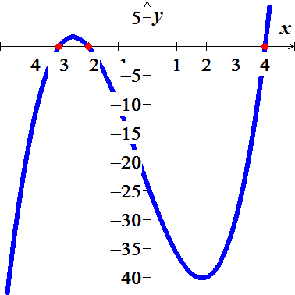





|  |  |  |  |
| --- | --- | --- | --- |
| −3 −2 4 | | | |
| **−** | **+** | **−** | **+** |





***Exercise***

Find all values of *x* such that and all *x* such that , and then sketch the graph of 



***Solution***



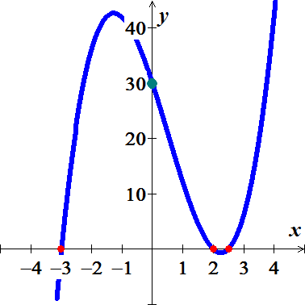



|  |  |  |  |
| --- | --- | --- | --- |
| −3 2 | | | |
| **−** | **+** | **−** | **+** |





***Exercise***

Find all values of *x* such that and all *x* such that , and then sketch the graph of 



***Solution***







|  |  |  |  |
| --- | --- | --- | --- |
|  | | | |
| **−** | **+** | **−** | **+** |





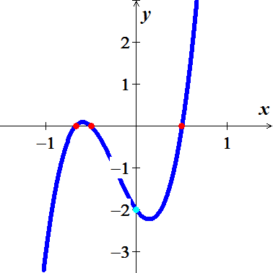

***Exercise***

Find all values of *x* such that and all *x* such that , and then sketch the graph of 



***Solution***



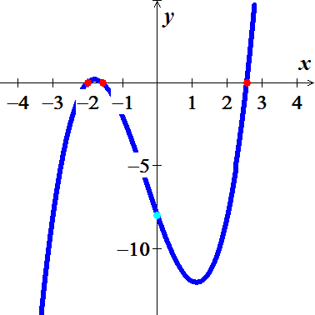





|  |  |  |  |
| --- | --- | --- | --- |
|  | | | |
| **−** | **+** | **−** | **+** |





***Exercise***

Find all values of *x* such that and all *x* such that , and then sketch the graph of 



***Solution***











|  |  |  |  |
| --- | --- | --- | --- |
|  | | | |
| **−** | **+** | **−** | **+** |





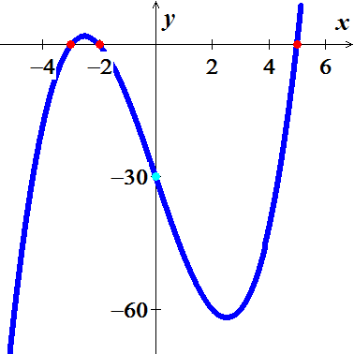

***Exercise***

Find all values of *x* such that and all *x* such that , and then sketch the graph of 



***Solution***











|  |  |  |  |
| --- | --- | --- | --- |
|  | | | |
| **−** | **+** | **−** | **+** |





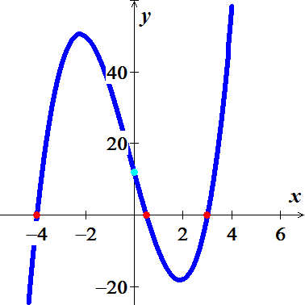

***Exercise***

Find all values of *x* such that and all *x* such that , and then sketch the graph of 



***Solution***











|  |  |  |  |
| --- | --- | --- | --- |
|  | | | |
| **−** | **+** | **−** | **+** |





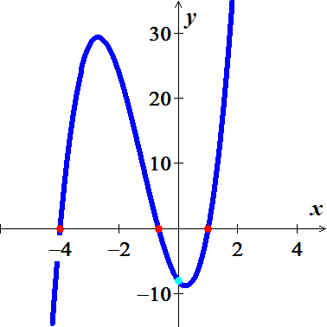

***Exercise***

Find all values of *x* such that and all *x* such that , and then sketch the graph of 



***Solution***





 



|  |  |  |  |
| --- | --- | --- | --- |
|  | | | |
| **−** | **+** | **−** | **+** |





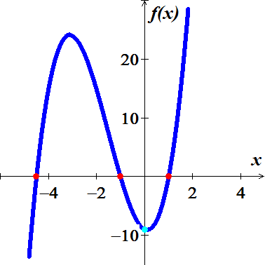

***Exercise***

Find all values of *x* such that and all *x* such that , and then sketch the graph of 



***Solution***



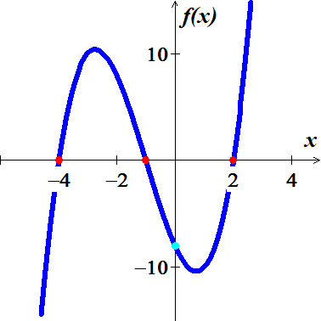







|  |  |  |  |
| --- | --- | --- | --- |
|  | | | |
| **−** | **+** | **−** | **+** |





***Exercise***

Find all values of *x* such that and all *x* such that , and then sketch the graph of 



***Solution***







|  |  |  |  |
| --- | --- | --- | --- |
|  | | | |
| **−** | **+** | **−** | **+** |





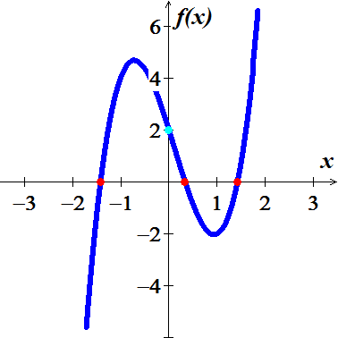

***Exercise***

Find all values of *x* such that and all *x* such that , and then sketch the graph of 



***Solution***









|  |  |  |  |
| --- | --- | --- | --- |
|  | | | |
| **−** | **+** | **−** | **+** |





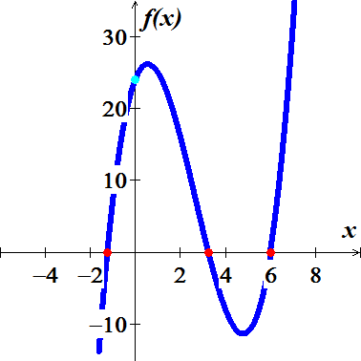

***Exercise***

Find all values of *x* such that and all *x* such that , and then sketch the graph of 



***Solution***



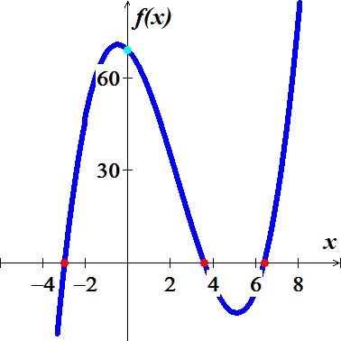







|  |  |  |  |
| --- | --- | --- | --- |
|  | | | |
| **−** | **+** | **−** | **+** |





***Exercise***

Find all values of *x* such that and all *x* such that , and then sketch the graph of 



***Solution***





 



|  |  |  |  |
| --- | --- | --- | --- |
|  | | | |
| **−** |  | **−** | **+** |





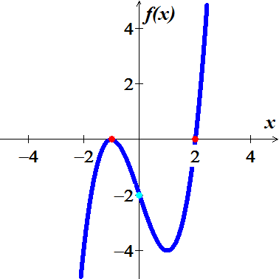

***Exercise***

Find all values of *x* such that and all *x* such that , and then sketch the graph of 



***Solution***









|  |  |  |  |
| --- | --- | --- | --- |
|  | | | |
| **−** | **+** | **−** | **+** |





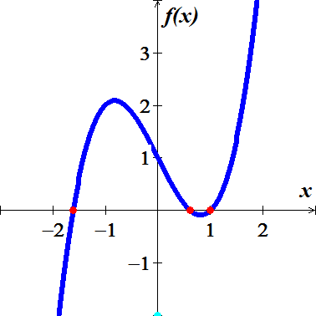

***Exercise***

Find all values of *x* such that and all *x* such that , and then sketch the graph of 



***Solution***



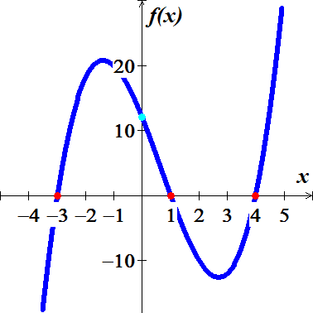







|  |  |  |  |
| --- | --- | --- | --- |
|  | | | |
| **−** | **+** | **−** | **+** |





***Exercise***

Find all values of *x* such that and all *x* such that , and then sketch the graph of 



***Solution***





 



|  |  |  |  |
| --- | --- | --- | --- |
|  | | | |
| **−** |  | **−** | **+** |





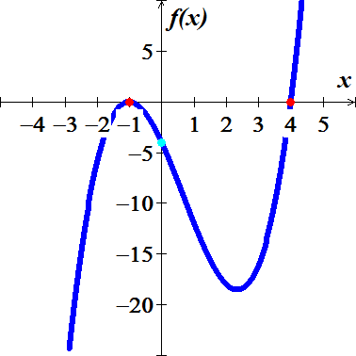

***Exercise***

Find all values of *x* such that and all *x* such that , and then sketch the graph of 



***Solution***











|  |  |  |  |
| --- | --- | --- | --- |
|  | | | |
| **−** | **+** | **−** | **+** |





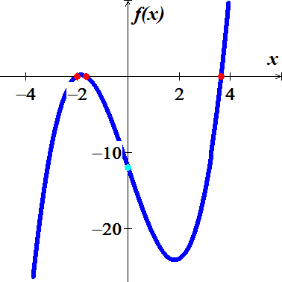

***Exercise***

Find all values of *x* such that and all *x* such that , and then sketch the graph of 

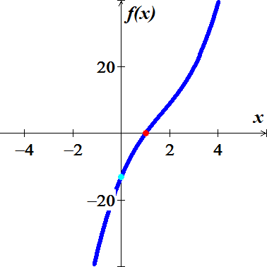

***Solution***











|  |  |
| --- | --- |
|  | |
| **−** | **+** |





***Exercise***

Find all values of *x* such that and all *x* such that , and then sketch the graph of 



***Solution***







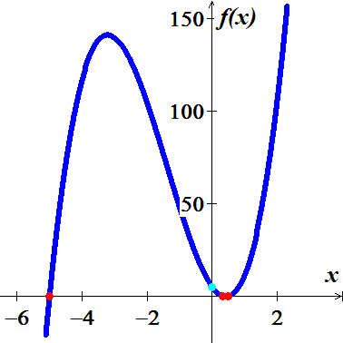 



|  |  |  |  |
| --- | --- | --- | --- |
|  | | | |
| **−** | **+** | **−** | **+** |





***Exercise***

Find all values of *x* such that and all *x* such that , and then sketch the graph of 



***Solution***







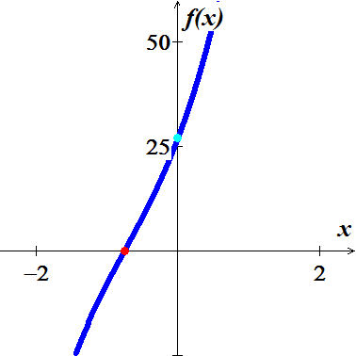

|  |  |
| --- | --- |
|  | |
| **−** | **+** |





***Exercise***

Find all values of *x* such that and all *x* such that , and then sketch the graph of 



***Solution***





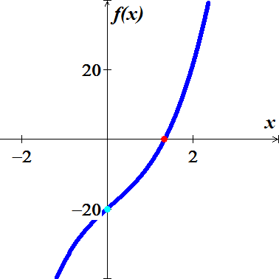





|  |  |
| --- | --- |
|  | |
| **−** | **+** |





***Exercise***

Find all values of *x* such that and all *x* such that , and then sketch the graph of 



***Solution***







|  |  |  |  |  |
| --- | --- | --- | --- | --- |
|  | | | | |
| **+** | **−** | **+** | **−** | **+** |

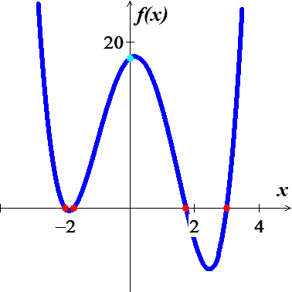





***Exercise***

Find all values of *x* such that and all *x* such that , and then sketch the graph of 



***Solution***







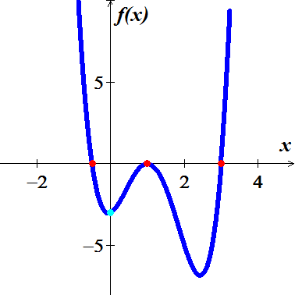 



|  |  |  |  |  |
| --- | --- | --- | --- | --- |
|  | | | | |
| **+** | **−** |  | **−** | **+** |





***Exercise***

Find all values of *x* such that and all *x* such that , and then sketch the graph of 



***Solution***



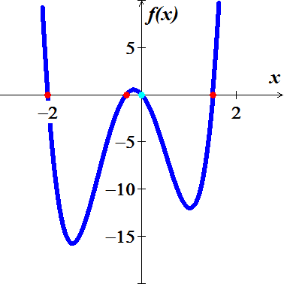





|  |  |  |  |  |
| --- | --- | --- | --- | --- |
|  | | | | |
| **+** | **−** | **+** | **−** | **+** |





***Exercise***

Find all values of *x* such that and all *x* such that , and then sketch the graph of 



***Solution***











|  |  |  |
| --- | --- | --- |
|  | | |
| **+** | **−** | **+** |





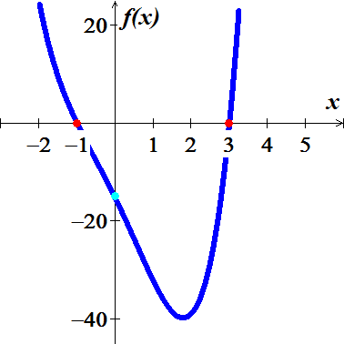

***Exercise***

Find all values of *x* such that and all *x* such that , and then sketch the graph of 



***Solution***









|  |  |  |  |  |
| --- | --- | --- | --- | --- |
|  | | | | |
| **+** | **−** | **+** | **−** | **+** |





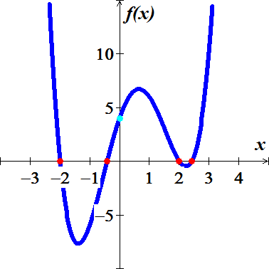

***Exercise***

Find all values of *x* such that and all *x* such that , and then sketch the graph of 



***Solution***











|  |  |  |  |  |
| --- | --- | --- | --- | --- |
|  | | | | |
| **+** | **−** |  | **−** | **+** |





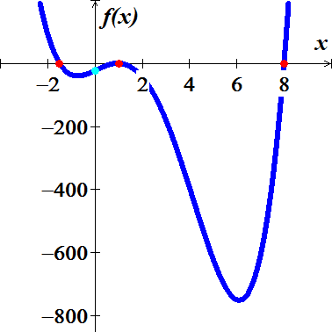

***Exercise***

Find all values of *x* such that and all *x* such that , and then sketch the graph of 



***Solution***











|  |  |  |
| --- | --- | --- |
|  | | |
| **+** | **−** | **+** |





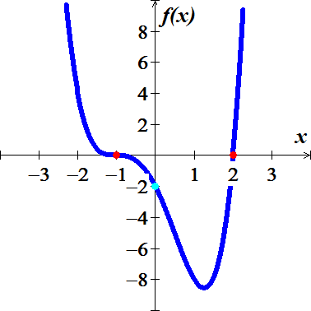

***Exercise***

Find all values of *x* such that and all *x* such that , and then sketch the graph of 



***Solution***















|  |  |  |  |  |
| --- | --- | --- | --- | --- |
|  | | | | |
| **+** | **−** | **+** | **−** | **+** |





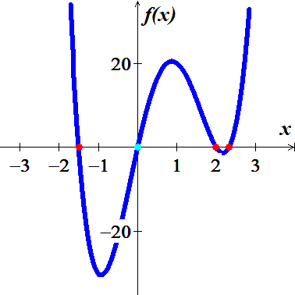

***Exercise***

Find all values of *x* such that and all *x* such that , and then sketch the graph of 



***Solution***













|  |  |  |  |  |
| --- | --- | --- | --- | --- |
|  | | | | |
| **+** | **−** | **+** | **−** | **+** |





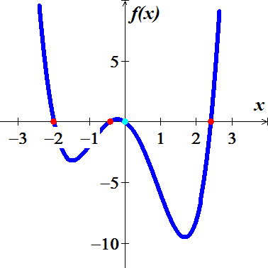

***Exercise***

Find all values of *x* such that and all *x* such that , and then sketch the graph of 



***Solution***











|  |  |  |  |  |
| --- | --- | --- | --- | --- |
|  | | | | |
| **+** | **−** | **+** | **−** | **+** |





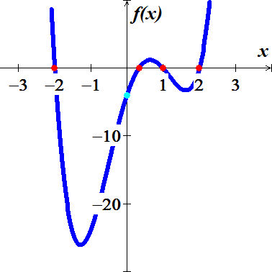

***Exercise***

Find all values of *x* such that and all *x* such that , and then sketch the graph of 



***Solution***











|  |  |  |  |  |
| --- | --- | --- | --- | --- |
|  | | | | |
| **+** |  | **+** | **−** | **+** |





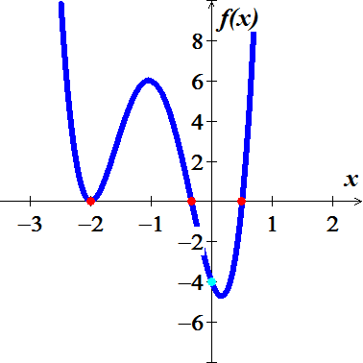

***Exercise***

Find all values of *x* such that and all *x* such that , and then sketch the graph of 



***Solution***











|  |  |  |  |  |
| --- | --- | --- | --- | --- |
|  | | | | |
| **+** | **−** | **+** | **−** | **+** |





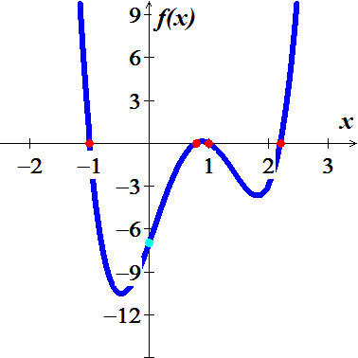

***Exercise***

Find all values of *x* such that and all *x* such that , and then sketch the graph of 



***Solution***







|  |  |  |  |  |
| --- | --- | --- | --- | --- |
|  | | | | |
| **+** | **−** | **+** | **−** | **+** |





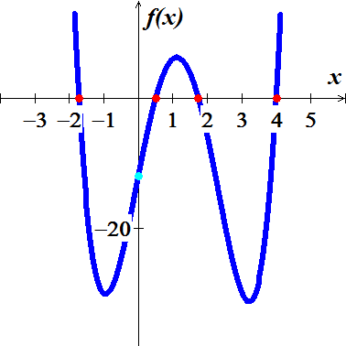

***Exercise***

Find all values of *x* such that and all *x* such that , and then sketch the graph of 



***Solution***











|  |  |  |  |  |
| --- | --- | --- | --- | --- |
|  | | | | |
| **+** | **−** | **+** | **−** | **+** |





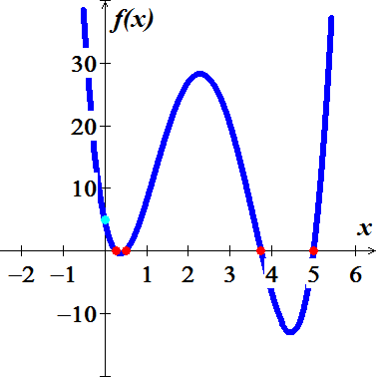

***Exercise***

Find all values of *x* such that and all *x* such that , and then sketch the graph of 



***Solution***













|  |  |  |  |  |
| --- | --- | --- | --- | --- |
|  | | | | |
| **+** | **−** | **+** | **−** | **+** |





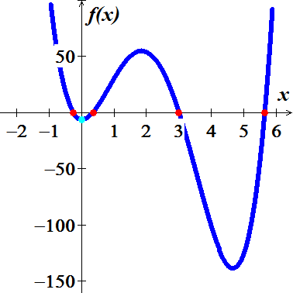

***Exercise***

Find all values of *x* such that and all *x* such that , and then sketch the graph of 



***Solution***











|  |  |  |  |  |
| --- | --- | --- | --- | --- |
|  | | | | |
| **+** | **−** | **+** | **−** | **+** |





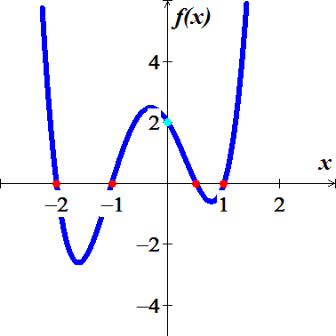

***Exercise***

Find all values of *x* such that and all *x* such that , and then sketch the graph of 



***Solution***



 



|  |  |  |  |  |
| --- | --- | --- | --- | --- |
|  | | | | |
| **+** | **−** | **+** | **−** | **+** |





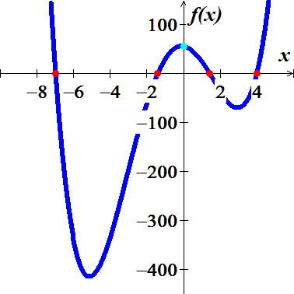

***Exercise***

Find all values of *x* such that and all *x* such that , and then sketch the graph of 



***Solution***











|  |  |  |  |  |
| --- | --- | --- | --- | --- |
|  | | | | |
| **−** | **−** | **+** | **−** | **+** |





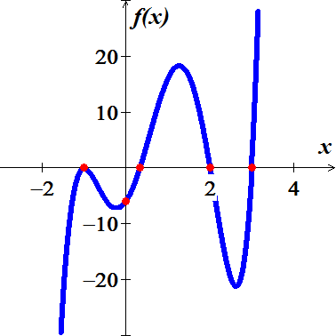

***Exercise***

Find all values of *x* such that and all *x* such that , and then sketch the graph of 



***Solution***















|  |  |  |  |  |
| --- | --- | --- | --- | --- |
|  | | | | |
| **−** | **+** | **−** | **−** | **+** |





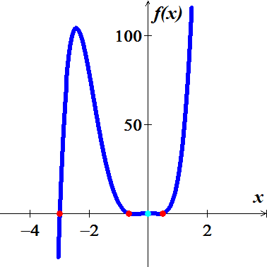 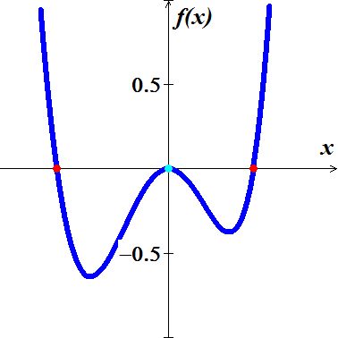

***Exercise***

Find all values of *x* such that and all *x* such that , and then sketch the graph of 



***Solution***











|  |  |  |
| --- | --- | --- |
|  | | |
| **−** |  | **+** |





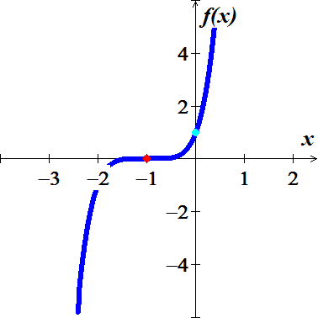

***Exercise***

Find all values of *x* such that and all *x* such that , and then sketch the graph of 



***Solution***









|  |  |  |  |  |  |
| --- | --- | --- | --- | --- | --- |
|  | | | | | |
| **−** | **+** | **−** | **+** | **−** | **+** |





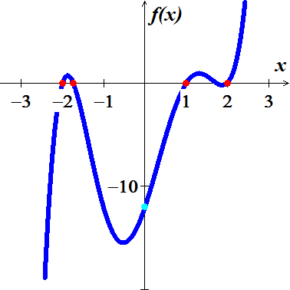

***Exercise***

Find all values of *x* such that and all *x* such that , and then sketch the graph of 



***Solution***





.









|  |  |  |  |
| --- | --- | --- | --- |
|  | | | |
| **−** | **+** | **−** | **+** |





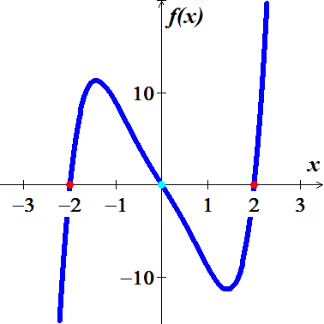

***Exercise***

Find all values of *x* such that and all *x* such that , and then sketch the graph of 



***Solution***















|  |  |  |  |  |  |  |
| --- | --- | --- | --- | --- | --- | --- |
|  | | | | | | |
| **+** | **−** | **+** | **−** | **+** | **−** | **+** |





