***Section* 2.6 – Graphing Rational Functions**

|  |  |  |
| --- | --- | --- |
|  |  |  |
|  |  |  |
|  |  |  |
|  |  |  |

**Rational Function**

A rational function is a function  that is a quotient of two polynomials, that is,



Where  and  are polynomials. The domain of  consists of all real numbers ***except*** the zeros of the denominator .

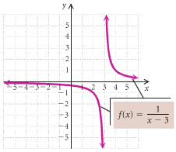**The Domain of a Rational Function**

***Example***

Consider: 

Find the domain and graph *f*.

***Solution***





Thus, the domain is: 

|  |  |  |
| --- | --- | --- |
| ***Function*** | ***Domain*** | |
|  |  |  |
|  |  |  |
|  |  |  |
|  |  |  |

***Asymptotes***

**Vertical Asymptote (*VA*) - *Think Domain***

The line  is a ***vertical asymptote*** for the graph of a function  if



As ***x*** approaches ***a*** from either the left or the right

***Example***

Find the vertical asymptote of , and sketch the graph.

***Solution***

***VA***: 





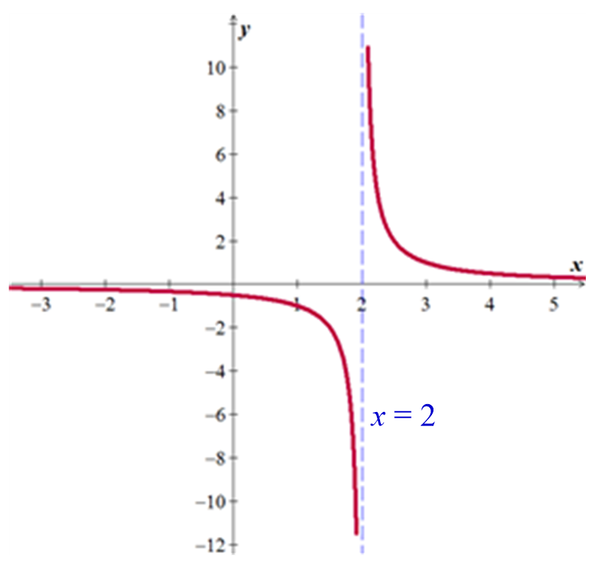

**Horizontal Asymptote (*HA*)**

The line  is a ***horizontal asymptote*** for the graph of a function  if



Let  be a rational function.

1. If the degree of numerator is less than of denominator (*n* < *m*) ⇒ y = 0



1. If the degree of numerator is equal of denominator (*n* = *m*) ⇒



1. If the degree of numerator is greater than of denominator (*n* > *m*)⇒ No horizontal asymptote



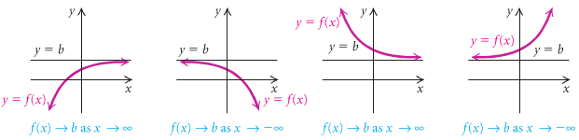

***Example***

Determine the horizontal asymptote of 

***Solution***



Therefore, the horizontal asymptote (***HA***) is: 

***Example***

Find the vertical and the horizontal asymptote for the graph of , if it exists

1. 
2. 
3. 

***Solution***

1. 



***VA***: 

***HA***: 

1. 









***VA***: 

***HA***: 

1. 



***VA***: *n/a*

***HA***: *n/a*

***Slant* or *Oblique* Asymptotes**

When the degree of the numerator is one greater than the degree of the numerator, the graph has a slant or oblique asymptote and it is a line . To find the slant asymptote, divide the fraction using long division. The quotient (not remainder) is the slant asymptote.





The ***oblique*** ***asymptote*** is the line ***y* = 3*x* − 6**

***Example***

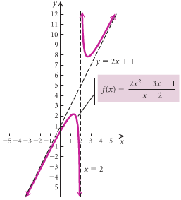Find all the asymptotes of 

***Solution***





The ***oblique*** ***asymptote*** is the line 

***VA***:: 

**Graph That Has a *Hole***

***Example***

Sketch the graph of if 

***Solution***





***VA***: 

***HA***: 

The only different between the graphs that  has a ***hole*** at 

|  |  |
| --- | --- |
| ***x*** | ***y*** |
| −4 | .6 |
| 1.3 | 0 |
| 0 | −.8 |
| 4 | 5.3 |
| 6 | 3.1 |

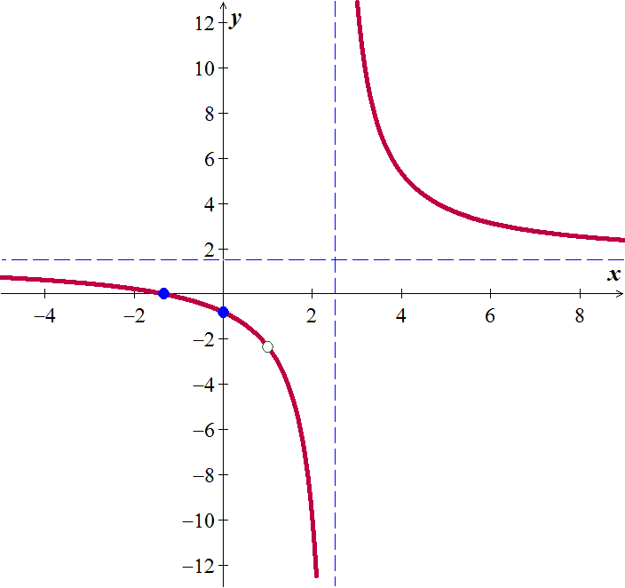

***Exercises Section* 2.6 – Rational Functions**

(**1 − 21**) Determine all asymptotes of the function

|  |  |  |
| --- | --- | --- |
|  |  |  |

(**22 − 53**) Determine all asymptotes (if any) (*Vertical Asymptote, Horizontal Asymptote*; *Hole*; *Oblique Asymptote*) and sketch the graph of

|  |  |  |
| --- | --- | --- |
|  |  |  |

|  |  |  |
| --- | --- | --- |
|  |  |  |

(**54 − 59**) Find an equation of a rational function  that satisfies the given conditions

|  |  |
| --- | --- |
|  |  |