***Lecture Three* − Exponential and Logarithmic Functions**

***Section* 3.1 – Inverse Functions**

***Inverse* Relations**

Interchanging the first and second coordinates of each ordered pair in a relation produces the inverse relation.

If a relation is defined by an equation, interchanging the variables produces an equation of the inverse relation

Given the relation: 

Inverse Relation: 

***Example***

Consider the relation g given by: 

***Solution***

The inverse relation: 

***Example***

Consider the relation given by:

***Solution***

The inverse relation: 

***One-to-One* Functions**

A function *f* is one-to-one (1 – 1) if different inputs have different outputs that is,



A function *f* is one-to-one (1 – 1) if different outputs the same, the inputs are the same – that is,



***Example***

Given the function *f* described by, prove that *f* is one-to-one.

***Solution***



 *Add 3 on both sides*

 *Divide by 2*



∴ *f*  is one-to-one

***Example***

Given the function *f* described by , prove that *f* is one-to-one.

***Solution***



 *Subtract 12 from both sides*

 *Divide by -4*



∴ *f*  is one-to-one

***Example***

Given the function *f* described by, prove that *f* is one-to-one.

***Solution***



 ⇒ 

∴ *f* is ***not*** one-to-one

**Definition of the Inverse of a Function**

Let *f* and *g* be two functions such that



 

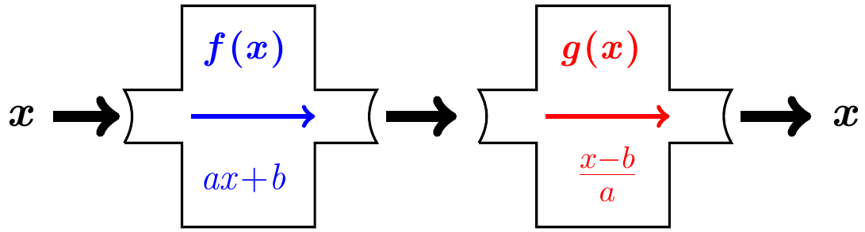

If the inverse of a function *f* is also a function, it is named  read “*f* − inverse”

**The −1 in  is not an exponent! And is not equal to **

***Domain* and *Range* of **





If a function *f* is one-to-one, then  is the unique function such that each of the following holds.

 for each *x* in the *domain* of *f*, and

 for each *x* in the *domain* of 

*The condition that f is one-to-one in the definition of inverse function is important; otherwise, g will not define a function*

***Graphing***

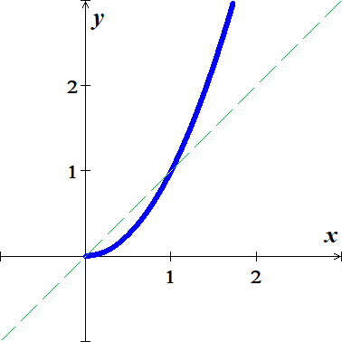 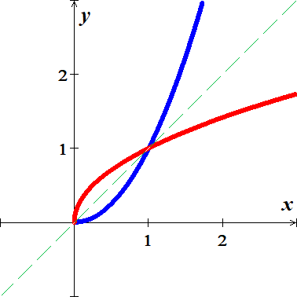

***Example***

Let  and , is *g* the inverse function of *f*?

***Solution***

|  |  |
| --- | --- |
|  |  |

*g* is the inverse function of *f*

***Example***

Show that each function is the inverse of the other: 

***Solution***

|  |  |
| --- | --- |
|  |  |

**Finding the *Inverse Function***

***Example***

Finding an Inverse Function 

1. Replace  with *y* 
2. Interchange *x* and *y* 
3. Solve for *y* 



1. Replace *y* with  

***Example***

Find the inverse of

***Solution***













***Example***

Find a formula for the inverse 

***Solution***

















***Exercise Section* 3.1 – Inverse Functions**

(**1 − 9**) Find the inverse relation of the given sets:

1. 
2. 
3. 
4. 
5. 

(**6 − 14**) Determine whether the function is one-to-one

|  |  |  |
| --- | --- | --- |
|  |  |  |

1. Given that, use composition of functions to show that 
2. Given the function 
3. Find 
4. Graph  and  in the same rectangular coordinate system
5. Find the domain and the range of  and 

(**17 − 32**) Prove that  are inverse functions of each other.

|  |  |
| --- | --- |
|  | 3. ; |

(**33 − 35**) Find the inverse of

|  |  |  |
| --- | --- | --- |
|  |  |  |

(**36 − 38**) Determine the domain and range of (Hint: first find the domain and range of *f* )

|  |  |  |
| --- | --- | --- |
|  |  |  |

(**39 − 66**) For the given functions

1. Is  one-to-one function
2. Find , if it exists
3. Find the domain and range of  and 

|  |  |  |
| --- | --- | --- |
|  |  |  |

1. The function  can be used to convert a U.S. women’s shoe size into an Italian women’s shoe size. Determine the function  that can use to convert an Italian women’s shoe size to its equivalent U.S. shoe size.



1. The function  can be used to convert a U.S. men’s shoe size into an U.K. women’s shoe size. Determine the function  that can used to convert an U.K. men’s shoe size to its equivalent U.S. shoe size.
2. A catering service use the function  to determine the amount, in *dollars*, it charges per person for a sit-down dinner, where *x* is the number of people in attendance.
3. Find  and explain what it represents
4. Find 
5. Use  to determine how many people attended a dinner for which the cost per person was $15.00
6. A landscaping service use the function  to determine the amount, in *dollars*, it charges per tree to deliver, where *x* is the number of trees.
7. Find  and explain what it represents
8. Find 
9. Use  to determine how many trees were delivered for which the cost per tree was $160.00