***Solution Section* 3.1 – Inverse Functions**

***Exercise***

Find the inverse relation of the given set: 

***Solution***



***Exercise***

Find the inverse relation of the given set: 

***Solution***



***Exercise***

Find the inverse relation of the given set: 

***Solution***



***Exercise***

Find the inverse relation of the given set: 

***Solution***



***Exercise***

Find the inverse relation of the given set: 

***Solution***



***Exercise***

Determine whether the function is one-to-one: 

***Solution***







 ***Divide both sides by* 3**



∴The function is one-to-one

***Exercise***

Determine whether the function is one-to-one: 

***Solution***

|  |  |
| --- | --- |
| Contradict the definition |  |

∴ The function is ***not*** one-to-one

***Exercise***

Determine whether the function is one-to-one: 

***Solution***





 ***Square both sides***



∴The function is one-to-one

***Exercise***

Determine whether the function is one-to-one: 

***Solution***





 ***cube both sides***



∴The function is one-to-one

***Exercise***

Determine whether the function is one-to-one: 

***Solution***







∴The function is ***not*** one-to-one

***Exercise***

Determine whether the function is one-to-one 

***Solution***











∴ *f* is one-to-one

***Exercise***

Determine whether the function is one-to-one 

***Solution***







 *Add 2 on both sides*



∴ Function is one-to-one

***Exercise***

Determine whether the function is one-to-one 

***Solution***



 *Subtract 2*





∴ Function is ***not*** a one-to-one

The inverse function doesn't exist.

***Exercise***

Determine whether the function is one-to-one 

***Solution***



 ***Cross multiplication***





 ***Divide by*** **-4**



∴ Function is one-to-one

***Exercise***

Given that, use composition of functions to show that 

***Solution***























***Exercise***

Given the function 

1. Find 
2. Graph  and  in the same rectangular coordinate system
3. Find the domain and the range of  and 

***Solution***

1.  **Replace f(*x*) with *y***

 **Interchange *x* and *y***



 ***Subtract 8 from both sides***.



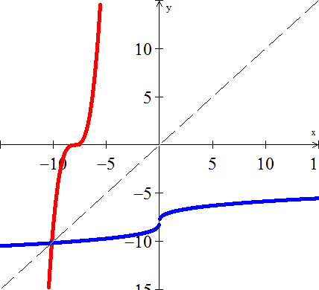

1. Domain of *f* = Range of : 

Range of *f* = Domain of : 

***Exercise***

Prove that  are inverse functions of each other 

***Solution***













∴  are inverse functions to each other

***Exercise***

Prove that  are inverse functions of each other 

***Solution***







∴  are ***not*** inverse functions to each other

***Exercise***

Prove that  are inverse functions of each other 

***Solution***

















∴  are inverse functions to each other

***Exercise***

Prove that  are inverse functions of each other 

***Solution***

















∴  are inverse functions to each other

***Exercise***

Prove that  are inverse functions of each other 

***Solution***









∴  are ***not*** inverse functions to each other

***Exercise***

Prove that  are inverse functions of each other 

***Solution***

















∴  are inverse functions to each other

***Exercise***

Prove that  are inverse functions of each other 

***Solution***





















∴  are inverse functions to each other

***Exercise***

Prove that  are inverse functions of each other 

***Solution***





















∴  are inverse functions to each other

***Exercise***

Prove that  are inverse functions of each other 

***Solution***





















∴  are inverse functions to each other

***Exercise***

Prove that  are inverse functions of each other 

***Solution***

















∴  are inverse functions to each other

***Exercise***

Prove that  are inverse functions of each other 

***Solution***

















∴  are inverse functions to each other

***Exercise***

Prove that  are inverse functions of each other ; 

***Solution***

















∴  are inverse functions to each other

***Exercise***

Prove that  are inverse functions of each other 

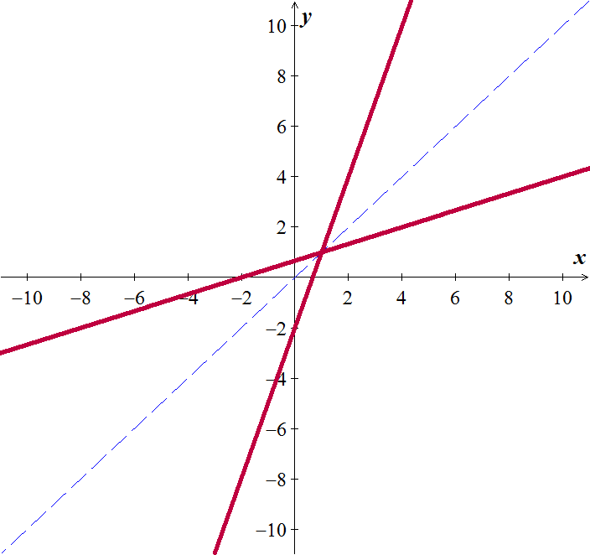***Solution***

















∴  are inverse functions to each other

***Exercise***

Prove that  are inverse functions of each other 

***Solution***





















∴  are inverse functions to each other

***Exercise***

Prove that  are inverse functions of each other 

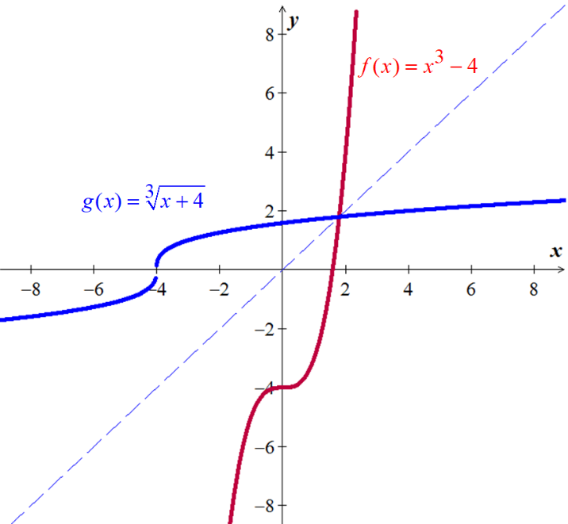***Solution***

















∴  are inverse functions to each other

***Exercise***

Find the inverse of

***Solution***













***Exercise***

Find the inverse of 

***Solution***















***Exercise***

Find the inverse of 

***Solution***











***Exercise***

Determine the domain and range of  (*Hint*: first find the domain and range of *f* )

***Solution***



Range of = Domain of *f* :  

Domain of  = Range of *f* :  

***Exercise***

Determine the domain and range of  (*Hint*: first find the domain and range of *f*)

***Solution***

Domain of  = Range of *f* :  

Range of = Domain of *f* :  

***Exercise***

Determine the domain and range of  (*Hint*: first find the domain and range of *f*)

***Solution***

Domain of  = Range of *f* :  

Range of = Domain of *f* :  

***Exercise***

For the given function 

1. Is  one-to-one function
2. Find , if it exists
3. Find the domain and range of  and 

***Solution***

1. 







 ***√***

∴  is one-to-one function.

1. 









1. Domain of  = Range of : 

Range of = Domain of : 

***Exercise***

For the given function 

1. Is  one-to-one function
2. Find , if it exists
3. Find the domain and range of  and 

***Solution***

1. 







 ***√***

∴  is one-to-one function.

1. 









1. Domain of  = Range of : 

Range of = Domain of : 

***Exercise***

For the given function 

1. Is  one-to-one function
2. Find , if it exists
3. Find the domain and range of  and 

***Solution***

1. 







 ***√***

∴  is one-to-one function.

1. 









1. Domain of  = Range of : 

Range of = Domain of : 

***Exercise***

For the given function

1. Is  one-to-one function
2. Find , if it exists
3. Find the domain and range of  and 

***Solution***

1. 







 ***√***

∴  is one-to-one function.

1. 









1. Domain of  = Range of : 

Range of = Domain of : 

***Exercise***

For the given function 

1. Is  one-to-one function
2. Find , if it exists
3. Find the domain and range of  and 

***Solution***

1. 







 ***√***

∴  is one-to-one function.

1. 









1. Domain of  = Range of : 

Range of = Domain of : 

***Exercise***

For the given function 

1. Is  one-to-one function
2. Find , if it exists
3. Find the domain and range of  and 

***Solution***

1. 







 ***√***

∴  is one-to-one function.

1. 









1. Domain of  = Range of : 

Range of = Domain of : 

***Exercise***

For the given function 

1. Is  one-to-one function
2. Find , if it exists
3. Find the domain and range of  and 

***Solution***

1. 







 ***√***

∴  is one-to-one function.

1. 









1. Domain of  = Range of : 

Range of = Domain of : 

***Exercise***

For the given function 

1. Is  one-to-one function
2. Find , if it exists
3. Find the domain and range of  and 

***Solution***

1. 







 ***√***

∴  is one-to-one function.

1. 









1. Domain of  = Range of : 

Range of  = Domain of : 

***Exercise***

For the given function 

1. Is  one-to-one function
2. Find , if it exists
3. Find the domain and range of  and 

***Solution***

1. 







 ***√***

∴  is one-to-one function.

1. 









1. Domain of  = Range of : 

Range of  = Domain of : 

***Exercise***

For the given function 

1. Is  one-to-one function
2. Find , if it exists
3. 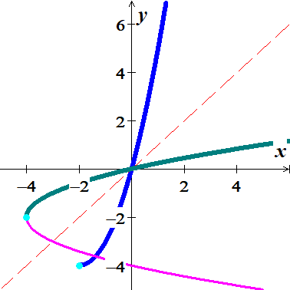Find the domain and range of  and 

***Solution***











1. Since,  is a restricted function with .

 is the line symmetry, therefore;  is one-to-one function.

1. 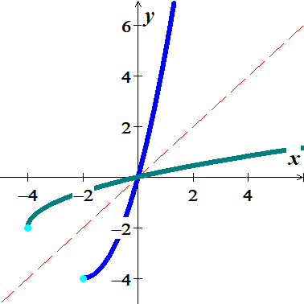













1. Domain of  = Range of : 

Range of  = Domain of : 

***Exercise***

For the given function 

1. Is  one-to-one function
2. Find , if it exists
3. Find the domain and range of  and 

***Solution***

1. 







∴ is **1−1 &**  exists

1. 

 ***Interchange x and y***

 ***Solve for y***





1. Domain of  = Range of *f* : 

Range of = Domain of *f* : 

***Exercise***

For the given function 

1. Is  one-to-one function
2. Find , if it exists
3. Find the domain and range of  and 

***Solution***

1. 









∴ is **1−1 &**  exists

1. 

 ***Interchange x and y***

 ***Solve for y***







1. Domain of  = Range of *f* : 

Range of = Domain of *f* : 

***Exercise***

For the given function 

1. Is  one-to-one function
2. Find , if it exists
3. Find the domain and range of  and 

***Solution***

1. 









∴ is **1−1 &**  exists

1. 

 ***Interchange x and y***

 ***Solve for y***





1. Domain of  = Range of *f* : 

Range of = Domain of *f* : 

***Exercise***

For the given function 

1. Is  one-to-one function
2. Find , if it exists
3. Find the domain and range of  and 

***Solution***

1. 









∴ is **1−1 &**  exists

1. 









1. Domain of  = Range of *f* : 

Range of = Domain of *f* : 

***Exercise***

For the given function 

1. Is  one-to-one function
2. Find , if it exists
3. Find the domain and range of  and 

***Solution***

1. 







 since 

∴ is **1−1 &**  exists

1. 







 ***Since x* < 0**

1. Domain of  = Range of *f* : 

Range of = Domain of *f* : 

***Exercise***

For the given function 

1. Is  one-to-one function
2. Find , if it exists
3. Find the domain and range of  and 

***Solution***

1. 







∴ is **1−1 &**  exists

1. 









1. Domain of  = Range of *f* : 

Range of = Domain of *f* : 

***Exercise***

For the given function 

1. Is  one-to-one function
2. Find , if it exists
3. Find the domain and range of  and 

***Solution***

1. 







∴ is **1−1 &**  exists

1.   ***y*** **≥**  **0**





 ***x* ≥ 0**



1. Domain of  = Range of *f* : 

Range of = Domain of *f* : 

***Exercise***

For the given function 

1. Is  one-to-one function
2. Find , if it exists
3. Find the domain and range of  and 

***Solution***

1. 







∴ is **1−1 &**  exists

1. 









1. Domain of  = Range of *f* : 

Range of = Domain of *f* : 

***Exercise***

For the given function 

1. Is  one-to-one function
2. Find , if it exists
3. Find the domain and range of  and 

***Solution***

1. 









∴ is **1−1 &**  exists

1. 











1. Domain of  = Range of *f* : 

Range of = Domain of *f* : 

***Exercise***

For the given function 

1. Is  one-to-one function
2. Find , if it exists
3. Find the domain and range of  and 

***Solution***

1. 









∴ is **1−1 &**  exists

1. 









Since  we can select 



1. Domain of  = Range of *f* : 

Range of = Domain of *f* : 

***Exercise***

For the given function 

1. Is  one-to-one function
2. Find , if it exists
3. Find the domain and range of  and 

***Solution***

1. 







∴ is **1−1 &**  exists

1. 











1. Domain of  = Range of *f* : 

Range of = Domain of *f* : 

***Exercise***

For the given function 

1. Is  one-to-one function
2. Find , if it exists
3. Find the domain and range of  and 

***Solution***

1. 









∴ is **1−1 &**  exists

1. 













1. Domain of  = Range of *f* : 

Range of = Domain of *f* : 

***Exercise***

For the given function 

1. Is  one-to-one function
2. Find , if it exists
3. Find the domain and range of  and 

***Solution***

1. 









∴ is **1−1 &**  exists

1. 









1. Domain of  = Range of *f* : 

Range of = Domain of *f* : 

***Exercise***

The function  can be used to convert a U.S. women’s shoe size into an Italian women’s shoe size. Determine the function  that can use to convert an Italian women’s shoe size to its equivalent U.S. shoe size.

***Solution***







***Exercise***

The function  can be used to convert a U.S. men’s shoe size into an U.K. women’s shoe size. Determine the function  that can used to convert an U.K. men’s shoe size to its equivalent U.S. shoe size.

***Solution***











***Exercise***

A catering service use the function  to determine the amount, in *dollars*, it charges per person for a sit-down dinner, where *x* is the number of people in attendance.

1. Find  and explain what it represents
2. Find 
3. Use  to determine how many people attended a dinner for which the cost per person was $15.00

***Solution***

1. 







Catering service will charge $22 per person to a sit-down dinner.

1. 





1. 





***Exercise***

A landscaping service use the function  to determine the amount, in *dollars*, it charges per tree to deliver, where *x* is the number of trees.

1. Find  and explain what it represents
2. Find 
3. Use  to determine how many trees were delivered for which the cost per tree was $160.00

***Solution***

1. 





Landscaping service will charge $260 per tree to deliver.

1. 









1. 



