***Section* 3.2 − Exponential Functions**

**Definition**

The exponential function *f* with base ***b*** is defined by



Base

where *b* > 0, *b* ≠ 1 and ***x*** is any real number.



***Example***

Given: , find 

***Solution***



= 0.8014

***Example***

If , find each of the following. 

***Solution***

1. 



1. 



1. 





**Graphing Exponential**

*Example*

1. Define the Horizontal Asymptote  

*y* = 0 ± d Asymptote: *y* = 0

*The exponential function always equals to 0*



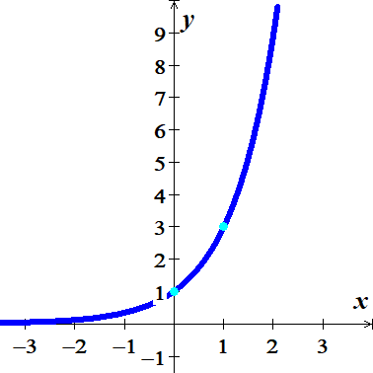

2. Define/Make a table

(Force your exponential to = 0, then solve for *x*)

|  |  |
| --- | --- |
| ***x*** | ***f(x)*** |
| *x* − 2 |  |
| *x* − 1 |  |
| ***x*** |  |
| *x* + 1 |  |
| *x* + 2 |  |

|  |  |
| --- | --- |
| *x* | *f(x)* |
| −2 | 1/9 |
| −1 | 1/3 |
| 0 | 1 |
| 1 | 3 |
| 2 | 9 |

*Domain*: 

*Range*: 

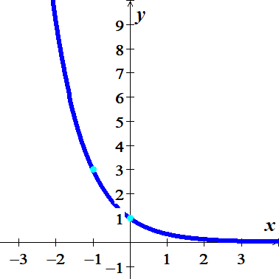 ***Example***







*Reflected across y-axis*

Asymptote: *y* = 0

*Domain*: 

*Range*: 

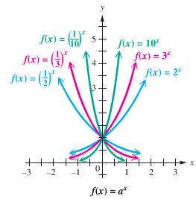

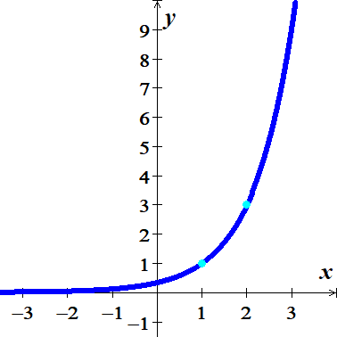

***Example***



*Shift right 1 unit*

Asymptote: *y* = 0

*Domain*: 

*Range*: 

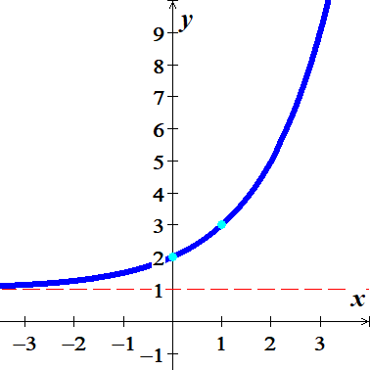

***Example***



*Shift up 1 unit*

Asymptote: *y* = 1

***Domain***: 

***Range***: 

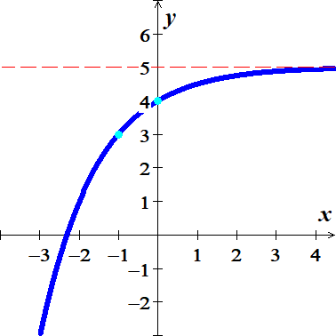***Example***



*Shifted up 5 units*

*Reflected across x-axis and y-axis*

***Asymptote***: *y* = 5

***Domain***: 

***Range***: 

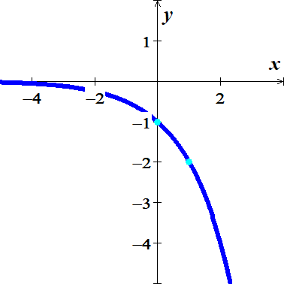

***Example***

Give the *asymptote*, *domain* and *range*.

*a*) 

***Asymptote***: *y* = 0

***Domain***: 

***Range***: 

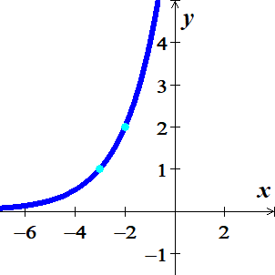

*b*) 

***Asymptote***: *y* = 0

***Domain***: 

***Range***: 

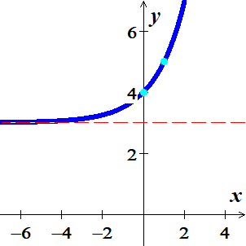

*c*) 

***Asymptote***: *y* = 3

***Domain***: 

***Range***: 

**Natural Base *e***

The irrational number *e* is called natural base

 is called natural exponential function

   

***Example***

The exponential function  models the gray wolf population of the Western Great Lakes,, in billions, *x* *years* after 1978. Project the gray population in the recovery area in 2012.

***Solution***

*x* = 2012 - 1978 = 34







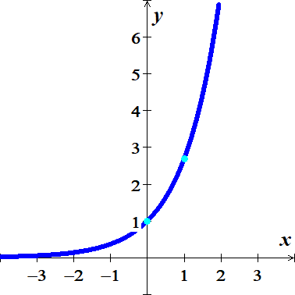***Example***

Graph 

***Solution***

***Asymptote***: *y* = 0

|  |  |
| --- | --- |
| ***x*** | ***f(x)*** |
| −1 | .4 |
| 0 | 1 |
| 1 | 2.7 |

***Domain***: 

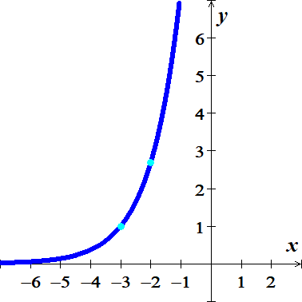***Range***: 

***Example***



***Solution***

*Shifted left 3 units*

***Asymptote***: *y* = 0

***Exercises Section* 3.2 − Exponential Functions**

(**1 − 8**) Evaluate to four decimal places using a calculator

|  |  |  |  |
| --- | --- | --- | --- |
| 1. 23.4 |  |  |  |

(**9 − 20**) Find the ***asymptote***, ***domain***, and ***range*** of the given functions. Then, sketch the graph

|  |  |  |
| --- | --- | --- |
|  |  |  |

1. The exponential function  models the gray wolf population of the Western Great Lakes,, in *billions*, *x* *years* after 1978. Project the gray population in the recovery area in 2012.
2. The function  describes world population, , in billions, *x* years after 2004 subject to a growth rate of 1.23% *annually*. Use the function to predict world population in 2050.
3. A cup of coffee is heated to  and placed in a room that maintains a temperature of . The temperature *T* of the coffee, in *degree* *Fahrenheit*, after *t* minutes is given by



1. Find the temperature of the coffee 20 *minutes* after it is placed in the room
2. Determine when the temperature of the coffee will reach 
3. A cup of coffee is heated to  and placed in a room that maintains a temperature of . The temperature *T* of the coffee, in *degree* *Fahrenheit*, after *t* minutes is given by



1. Find the temperature of the coffee 10 *minutes* after it is placed in the room
2. Determine when the temperature of the coffee will reach 
3. The percent  of the original intensity of light striking the surface of a lake that is available *x* *feet* below the surface of the lake is given by the equation



1. What percentage of the light is available 2 *feet* below the surface of the lake?
2. At what depth is the intensity of the light one-half the intensity at the surface?
3. Starting on the left side of a standard 88−*key* piano, the frequency, in *vibrations* per *second*, of the *n*th note is given by



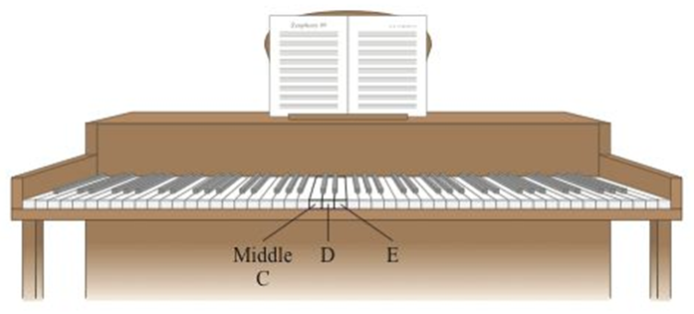

1. Determine the frequency of middle *C*, key number 40 on an 88−*key* piano.
2. Is the difference in frequency between middle *C* (key number 40) and *D* (key number 42) the same as the difference in frequency between *D* (key number 42) and *E* (key number 44)?

1. Starting on the left side of a standard 88−*key* piano, the frequency, in *vibrations* per *second*, of the *n*th note is given by





1. Determine the frequency of middle *C*, key number 40 on an 88−*key* piano.
2. Is the difference in frequency between middle *C* (key number 40) and *D* (key number 42) the same as the difference in frequency between *D* (key number 42) and *E* (key number 44)?