***Solution Section* 3.2 - Exponential Functions**

***Exercise***

Evaluate to four decimal places using a calculator 23.4

***Solution***



***Exercise***

Evaluate to four decimal places using a calculator 

***Solution***



***Exercise***

Evaluate to four decimal places using a calculator 

***Solution***



***Exercise***

Evaluate to four decimal places using a calculator: 

***Solution***



***Exercise***

Evaluate to four decimal places using a calculator: *e*2.3

***Solution***



***Exercise***

Evaluate to four decimal places using a calculator: 

***Solution***



***Exercise***

Evaluate to four decimal places using a calculator: 

***Solution***



***Exercise***

Evaluate to four decimal places using a calculator: 

***Solution***



***Exercise***

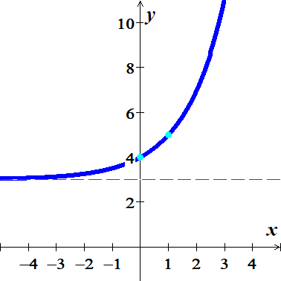Sketch the graph: 

***Solution***

***Asymptote***: 

***Domain***: 

***Range***: 

|  |  |
| --- | --- |
| *x* |  |
| −1 | 3.5 |
| 0 | 4 |
| 1 | 5 |
| 2 | 7 |

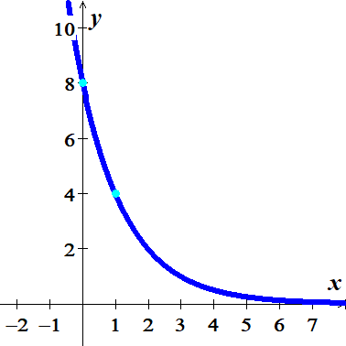***Exercise***

Sketch the graph: 

***Solution***

***Asymptote***: 

***Domain***: 

***Range***: 

|  |  |
| --- | --- |
| *x* |  |
| 1 | 4 |
| 2 | 2 |
| 0 | 8 |

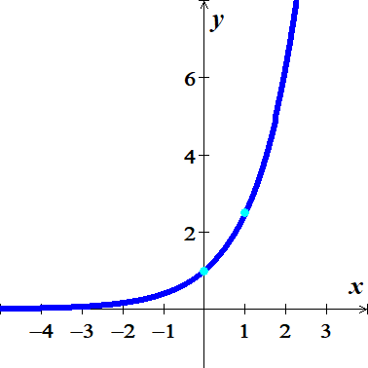***Exercise***

Sketch the graph: 

***Solution***

***Asymptote***: 

***Domain***: 

***Range***: 

|  |  |
| --- | --- |
| *x* |  |
| −1 | 0.4 |
| 0 | 1 |
| 1 | 2.5 |

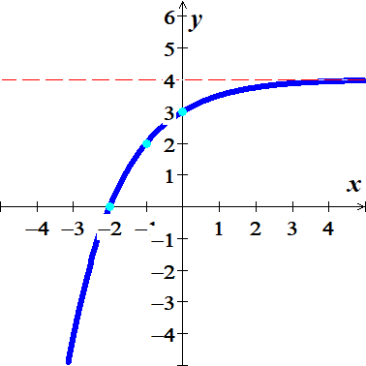***Exercise***

Sketch the graph: 

***Solution***

***Asymptote***: 

***Domain***: 

***Range***: 

|  |  |
| --- | --- |
| *x* |  |
| −2 | 0 |
| −1 | 2 |
| 0 | 3 |

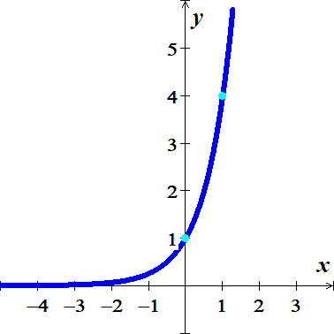***Exercise***

Sketch the graph of 

***Solution***

***Asymptote***: 

***Domain***: 

***Range***: 

|  |  |
| --- | --- |
| *x* |  |
| 0 | 1 |
| 1 | 4 |

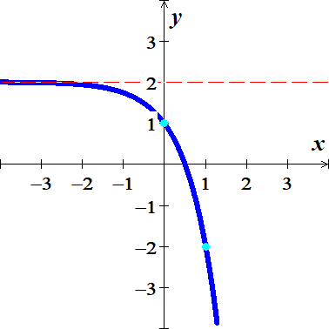***Exercise***

Sketch the graph of 

***Solution***

***Asymptote***: 

***Domain***: 

***Range***: 

|  |  |
| --- | --- |
| *x* |  |
| 0 | 1 |
| 1 | −2 |

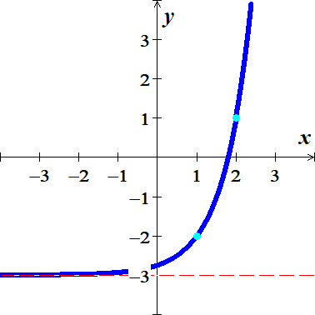***Exercise***

Sketch the graph of 

***Solution***

***Asymptote***: 

***Domain***: 

***Range***: 

|  |  |
| --- | --- |
| *x* |  |
| 1 | −2 |
| 2 | 1 |

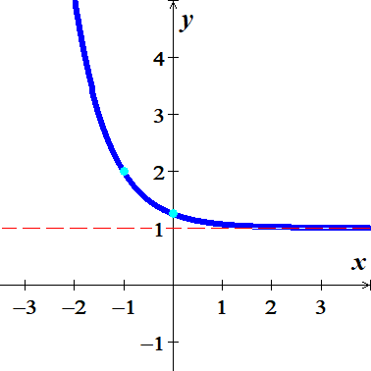***Exercise***

Sketch the graph of 

***Solution***

***Asymptote***: 

***Domain***: 

***Range***: 

|  |  |
| --- | --- |
| *x* |  |
| −1 | 2 |
| 0 |  |

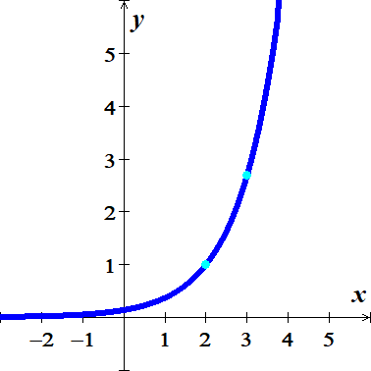

***Exercise***

Sketch the graph of 

***Solution***

***Asymptote***: 

***Domain***: 

***Range***: 

|  |  |
| --- | --- |
| *x* |  |
| 2 | 1 |
| 3 | 2.7 |

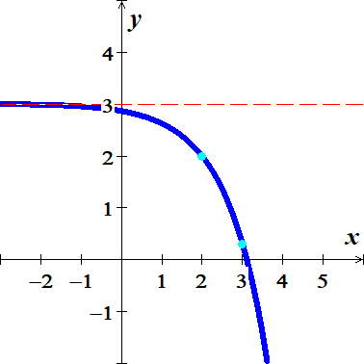

***Exercise***

Sketch the graph of 

***Solution***

***Asymptote***: 

***Domain***: 

***Range***: 

|  |  |
| --- | --- |
| *x* |  |
| 2 | 2 |
| 3 | .3 |

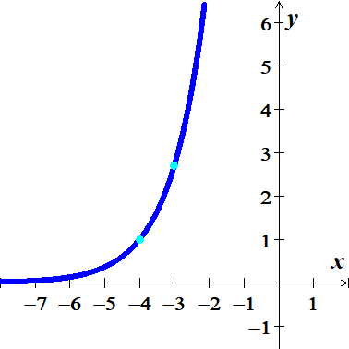***Exercise***

Sketch the graph of 

***Solution***

***Asymptote***: 

***Domain***: 

***Range***: 

|  |  |
| --- | --- |
| *x* |  |
| −4 | 1 |
| −3 | 2.7 |

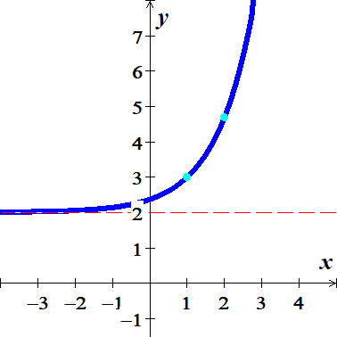***Exercise***

Sketch the graph of 

***Solution***

***Asymptote***: 

***Domain***: 

***Range***: 

|  |  |
| --- | --- |
| *x* |  |
| 1 | 3 |
| 2 | 4.7 |

***Exercise***

The exponential function  models the gray wolf population of the Western Great Lakes,, in *billions*, *x* *years* after 1978. Project the gray population in the recovery area in 2012.

***Solution***

*x* = 2012 - 1978 = 34







***Exercise***

The function  describes world population, , in billions, *x* *years* after 2004 subject to a growth rate of 1.23% annually. Use the function to predict world population in 2050.

***Solution***

*x* = 2050 - 2004 = 46





***Exercise***

A cup of coffee is heated to  and placed in a room that maintains a temperature of . The temperature *T* of the coffee, in *degree* *Fahrenheit*, after *t* minutes is given by



1. Find the temperature of the coffee 20 *minutes* after it is placed in the room
2. Determine when the temperature of the coffee will reach 

***Solution***

1. 



1. 





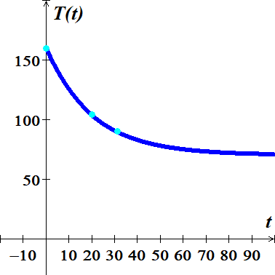

**31.01000 90.00185**

**31.02000 89.99215**

∴ The temperature of the coffee will reach  in about **31.01** *minutes*.

***Exercise***

A cup of coffee is heated to  and placed in a room that maintains a temperature of . The temperature *T* of the coffee, in *degree* *Fahrenheit*, after *t* minutes is given by



1. Find the temperature of the coffee 10 *minutes* after it is placed in the room
2. Determine when the temperature of the coffee will reach 

***Solution***

1. 



1. 





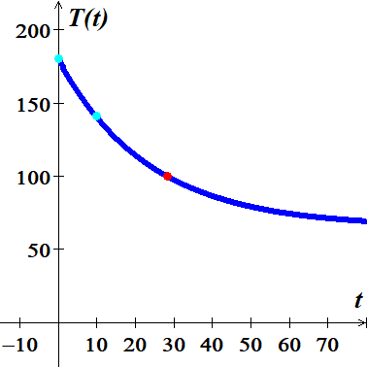

**28.32000 100.00504**

**28.34000 99.97565**

∴ The temperature of the coffee will reach  in about **31.01** *minutes*.

***Exercise***

The percent  of the original intensity of light striking the surface of a lake that is available *x* *feet* below the surface of the lake is given by the equation



1. What percentage of the light is available 2 *feet* below the surface of the lake?
2. At what depth is the intensity of the light one-half the intensity at the surface?

***Solution***

1. 



∴ The percentage of the light is available 2 *feet* below the surface of the lake is **15%**

1. 



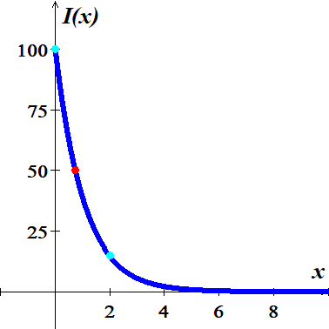

**0.72800 50.07742**

**0.73200 49.88749**

∴ The depth is **0.73** *feet* when the intensity of the light one-half the intensity at the surface

***Exercise***

Starting on the left side of a standard 88−*key* piano, the frequency, in *vibrations* per *second*, of the *n*th note is given by



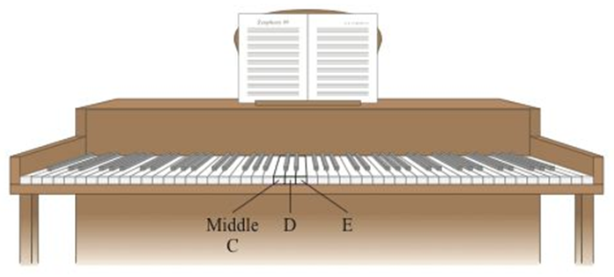

1. Determine the frequency of middle *C*, key number 40 on an 88−*key* piano.
2. Is the difference in frequency between middle *C* (key number 40) and *D* (key number 42) the same as the difference in frequency between *D* (key number 42) and *E* (key number 44)?

***Solution***

1. 



the frequency of middle *C* is  *vibrations* per *second*.

1. 



The difference between the frequency of middle *C* and *D* is:







The difference between the frequency of middle *D* and *E* is:



∴ the differences are ***not*** the same since the function is *not* linear function

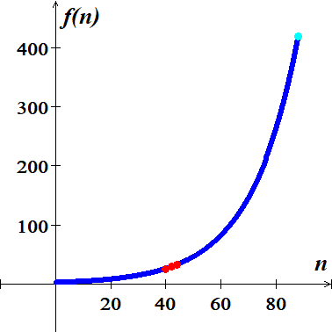 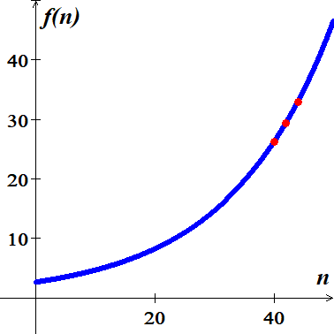

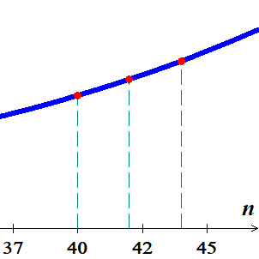

***Exercise***

Starting on the left side of a standard 88−*key* piano, the frequency, in *vibrations* per *second*, of the *n*th note is given by





1. Determine the frequency of middle *C*, key number 40 on an 88−*key* piano.
2. Is the difference in frequency between middle *C* (key number 40) and *D* (key number 42) the same as the difference in frequency between *D* (key number 42) and *E* (key number 44)?

***Solution***

1. 



the frequency of middle *C* is  *vibrations* per *second*.

1. 



The difference between the frequency of middle *C* and *D* is: 





The difference between the frequency of middle *D* and *E* is: 

∴ The differences are ***not*** the same since the function is *not* linear function.

