***Section* 3.3 − Logarithmic Functions**

***Graph***: 

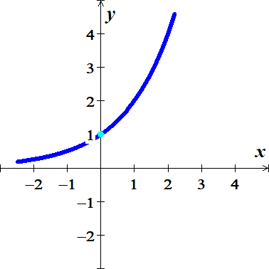 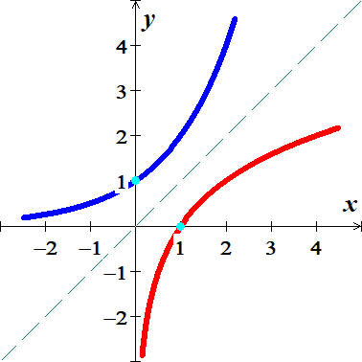

Find the inverse function of 



 *Solve for y?*

**Logarithmic Function (*Definition)***

For ***x* > 0** and *b* > 0, *b* ≠ 1

 is equivalent to 



**Base**

The function  is the logarithmic function with base *b*.

: ***read*** log base *b* of *x*

**

***Example***

Write each equation in its equivalent exponential form:

1.  
2.  

***Example***

Write each equation in its equivalent logarithmic form:

1.  
2.  

***Basic* Logarithmic Properties**

 



***Inverse* Properties**

 

 

***Example***

Evaluate each expression without using a calculator:

|  |  |
| --- | --- |
|  |  |

***Solution***

1. 





1. 



**Natural Logarithms**

**Definition**



The logarithmic function with base ***e*** is called natural logarithmic function.

 *read* "el en of *x*"

log(−1) = *doesn’t exist* ln(−1) = *doesn’t exist*

log0 = *doesn’t exist* ln0 = *doesn’t exist*

 

log1 = 0 ln1 = 0

 

log10 = 1 ln*e* = 1

**Change-of-Base Logarithmic**

 

Evaluate

 

≈ 4.02

***Or***

 





***Domain***

The domain of a logarithmic function of the form  is the set of all positive real numbers.

(*Inside* the log has to be > 0)

***Range***: 

***Example***

Find the ***domain*** of

1. 



***Domain****:* 

1. 

4 − *x* > 0

−*x* > −4

*x* < 4

***Domain***: 

1. 

*x*2 > 0 ⇒ all real numbers except 0.

***Domain***: {*x*| *x* ≠ 0}

***or*** 

***or ***

**Graphs of *Logarithmic* Functions**

***Example***

Graph 

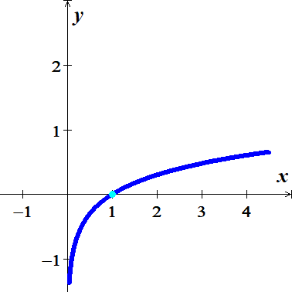***Solution***

***Asymptote***: *x* = 0

(*Force inside log to be equal to zero, then solve for x*)

***Domain****:* 

***Range***: 

|  |  |
| --- | --- |
| ***x*** | ***g*(*x*)** |
| 0 |  |
| 0.5 | −.3 |
| 1 | 0 |
| 2 | .3 |
| 3 | .5 |

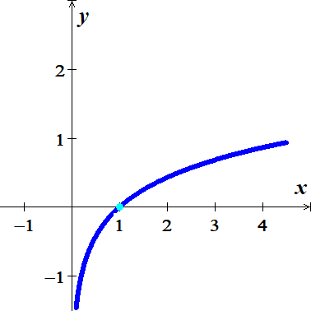

***Example***



***Solution***



***Asymptote***: *x* = 0

***Domain****:* 

***Range***: 

|  |  |
| --- | --- |
| ***x*** | ***f*(*x*)** |
| 0 |  |
|  | −1 |
| 1 | 0 |
| 5 | 1 |

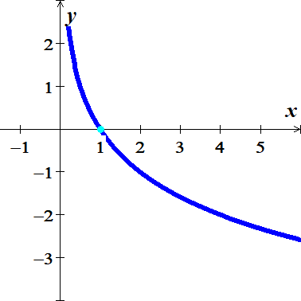***Example***

Graph: 

|  |  |
| --- | --- |
| ***x*** | ***f*(*x*)** |
| 0 |  |
| 2 | −1 |
| 1 | 0 |
|  | 1 |

***Solution***

***Asymptote***: *x* = 0

***Domain****:* 

***Range***: 

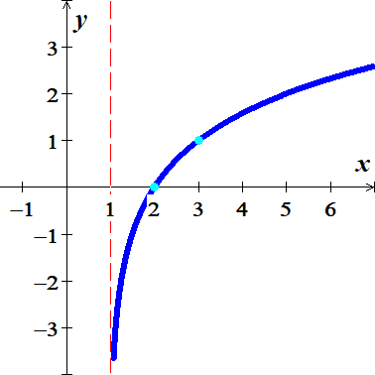

***Example***

Graph: 

|  |  |
| --- | --- |
| ***x*** | ***f*(*x*)** |
| 1 |  |
|  | −1 |
| 2 | 0 |
| 3 | 1 |

***Solution***

***Asymptote***: *x* = 1

***Domain****:* 

***Range***: 

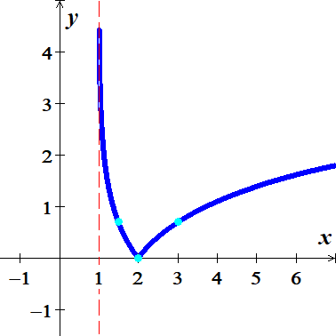***Example***

|  |  |
| --- | --- |
| ***x*** | ***f*(*x*)** |
| 1 |  |
|  | −0.7 |
| 2 | 0 |
| 3 | 0.7 |



***Solution***

***Asymptote***: *x* = 1

***Domain****:* 

***Range***: 

***Exercises Section* 3.3 − Logarithmic Functions**

(**1** − **12**) Write the equation in its equivalent logarithmic form

|  |  |  |
| --- | --- | --- |
|  |  |  |

(**13** − **24**) Write the equation in its equivalent exponential form

|  |  |  |
| --- | --- | --- |
|  |  |  |

(**25** − **31**) Evaluate the expression without using a calculator

|  |  |  |  |
| --- | --- | --- | --- |
|  |  |  |  |

(**32** − **40**) Simplify

|  |  |  |
| --- | --- | --- |
|  |  |  |

(**41** − **64**) Find the domain of

|  |  |  |
| --- | --- | --- |
|  |  | |
|  | |  |

(**65** − **73**) Find the ***asymptote***, ***domain***, and ***range*** of the given functions. Then, sketch the graph

|  |  |  |
| --- | --- | --- |
|  |  |  |

1. On a study by psychologists Bornstein and Bornstein, it was found that the average walking speed *w*, in feet per second, of a person living in a city of population *P*, in ***thousands***, is given by the function:



1. The population is 124,848. Find the average walking speed of people living in Hartford.
2. The population is 1,236,249. Find the average walking speed of people living in San Antonio.
3. The loudness of sounds is measured in a unit called a decibel. To measure with this unit, we first assign an intensity of to a very faint sound, called the threshold sound. If a particular sound has intensity *I*, then the decibel rating of this louder sound is



Find the exact decibel rating of a sound with intensity 

1. Students in an accounting class took a final exam and then took equivalent forms of the exam at monthly intervals thereafter. The average score, as a percent, after *t* months was found to be given by the function



1. What was the average score when the students initially took the test, *t* = 0?
2. What was the average score after 4 *months*? 24 *months*?
3. A model for advertising response is given by the function



Where  is the number of units sold when ***a*** is the amount spent on advertising, in thousands of dollars.

1. 
2. 