***Solution Section* 3.3 − Logarithmic Functions**

***Exercise***

Write the equation in its equivalent logarithmic form 

***Solution***



***Exercise***

Write the equation in its equivalent logarithmic form 

***Solution***



***Exercise***

Write the equation in its equivalent logarithmic form 

***Solution***



***Exercise***

Write the equation in its equivalent logarithmic form 

***Solution***





***Exercise***

Write the equation in its equivalent logarithmic form 

***Solution***



***Exercise***

Write the equation in its equivalent logarithmic form 

***Solution***



***Exercise***

Write the equation in its equivalent logarithmic form: 

***Solution***





***Exercise***

Write the equation in its equivalent logarithmic form: 

***Solution***



***Exercise***

Write the equation in its equivalent logarithmic form: 

***Solution***



***Exercise***

Write the equation in its equivalent logarithmic form: 

***Solution***



***Exercise***

Write the equation in its equivalent logarithmic form: 

***Solution***



***Exercise***

Write the equation in its equivalent logarithmic form: 

***Solution***





***Exercise***

Write the equation in its equivalent exponential form 

***Solution***



***Exercise***

Write the equation in its equivalent exponential form 

***Solution***



***Exercise***

Write the equation in its equivalent exponential form 

***Solution***



***Exercise***

Write the equation in its equivalent exponential form 

***Solution***



***Exercise***

Write the equation in its equivalent exponential form 

***Solution***



***Exercise***

Write the equation in its equivalent exponential form 

***Solution***



***Exercise***

Write the equation in its equivalent exponential form: 

***Solution***



***Exercise***

Write the equation in its equivalent exponential form: 

***Solution***



***Exercise***

Write the equation in its equivalent exponential form: 

***Solution***



***Exercise***

Write the equation in its equivalent exponential form: 

***Solution***



***Exercise***

Write the equation in its equivalent exponential form: 

***Solution***



***Exercise***

Write the equation in its equivalent exponential form: 

***Solution***



***Exercise***

Evaluate the expression without using a calculator: 

***Solution***

 



***Exercise***

Evaluate the expression without using a calculator: 

***Solution***



 



***Exercise***

Evaluate the expression without using a calculator: 

***Solution***





***Exercise***

Evaluate the expression without using a calculator: 

***Solution***



 



***Exercise***

Evaluate the expression without using a calculator: 

***Solution***

 ***Converts to exponential***







***Exercise***

Evaluate the expression without using a calculator: 

***Solution***

 



***Exercise***

Evaluate the expression without using a calculator: 

***Solution***

 



***Exercise***

Simplify 

***Solution***



***Exercise***

Simplify 

***Solution***



***Exercise***

Simplify 

***Solution***



***Exercise***

Simplify 

***Solution***



***Exercise***

Simplify 

***Solution***





***Exercise***

Simplify 

***Solution***



***Exercise***

Simplify 

***Solution***



***Exercise***

Simplify 

***Solution***



***Exercise***

Simplify 

***Solution***



***Exercise***

Find the domain of 

***Solution***

***Domain***: 

***Exercise***

Find the domain of 

***Solution***

***Domain***: 

***Exercise***

Find the domain of 

***Solution***

***Domain***: 

***Exercise***

Find the domain of 

***Solution***

***Domain***: 

***Exercise***

Find the domain of 

***Solution***

***Domain***: 



***Exercise***

Find the domain of 

***Solution***

***Domain***: 



***Exercise***

Find the domain of 

***Solution***







***Domain***: 



***Exercise***

Find the domain of 

|  |  |  |
| --- | --- | --- |
| −5 0 2 | | |
| + | − | + |

***Solution***



***Domain***: 



***Exercise***

Find the domain of 

|  |  |  |
| --- | --- | --- |
| 0 2 3 | | |
| − | + | − |

***Solution***



***Domain***:  

***Exercise***

Find the domain of 

***Solution***



***Domain***: 

***Exercise***

Find the domain of 

***Solution***







***Domain***: 

***Exercise***

|  |  |  |
| --- | --- | --- |
| 0,0 1 2 | | |
| − | − | + |

Find the domain of 

***Solution***





***Domain***: 

***Exercise***

Find the domain of 

***Solution***



***Domain***: 

***Exercise***

Find the domain of 

***Solution***



***Domain***: 

***Exercise***

Find the domain of 

***Solution***





***Domain***: 

***Exercise***

Find the domain of 

***Solution***





***Domain***: 

***Exercise***

Find the domain of 

***Solution***

 always positive.

***Domain***: 

***Exercise***

Find the domain of 

***Solution***



***Domain***: 

***Exercise***

Find the domain of 

***Solution***



***Domain***: 

***Exercise***

Find the domain of 

***Solution***



***Domain***: 

***Exercise***

Find the domain of 

***Solution***





***Domain***: 

***Exercise***

Find the domain of 

***Solution***





***Domain***: 

***Exercise***

Find the domain of 

***Solution***





***Domain***: 

***Exercise***

Find the domain of 

***Solution***





***Domain***: 

***Exercise***

Find the domain of 

***Solution***



|  |  |  |  |
| --- | --- | --- | --- |
| −1 0,0 1 2 | | | |
| + | − | − | + |







***Domain***: 

***Exercise***

Find the ***asymptote***, ***domain***, and ***range*** of the given function. Then, sketch the graph 

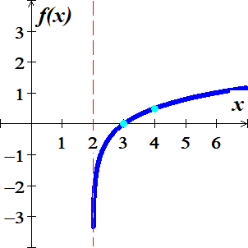***Solution***

***Asymptote***: 

***Domain****:* 

***Range***: 

|  |  |
| --- | --- |
| ***x*** | ***f*(*x*)** |
| 2 |  |
| 3 | 0 |
| 4 | .5 |

***Exercise***

Find the ***asymptote***, ***domain***, and ***range*** of the given function. Then, sketch the graph 

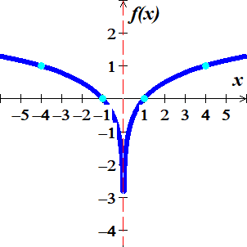***Solution***

***Asymptote***: 

***Domain****:* 

***Range***: 

|  |  |
| --- | --- |
| ***x*** | ***f*(*x*)** |
| 0 |  |
| ±1 | 0 |
| ±4 | 1 |

***Exercise***

Find the ***asymptote***, ***domain***, and ***range*** of the given function. Then, sketch the graph 

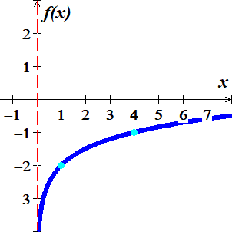***Solution***

***Asymptote***: 

***Domain****:* 

***Range***: 

|  |  |
| --- | --- |
| ***x*** | ***f*(*x*)** |
| 0 |  |
| 1 | 0 |
| 4 | −1 |

***Exercise***

Find the ***asymptote***, ***domain***, and ***range*** of the given function. Then, sketch the graph 

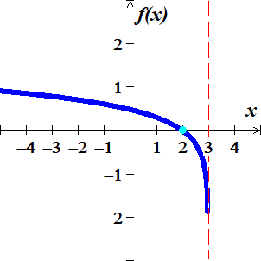***Solution***

***Asymptote***: 

***Domain****:* 

***Range***: 

|  |  |
| --- | --- |
| ***x*** | ***f*(*x*)** |
| 3 |  |
| 2 | 0 |

***Exercise***

Find the ***asymptote***, ***domain***, and ***range*** of the given function. Then, sketch the graph

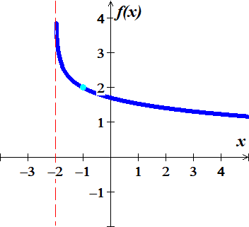***Solution***

***Asymptote***: 

***Domain****:* 

***Range***: 

|  |  |
| --- | --- |
| ***x*** | ***f*(*x*)** |
| −2 |  |
| −1 | 2 |

***Exercise***

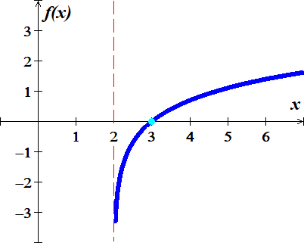Find the ***asymptote***, ***domain***, and ***range*** of the given function. Then, sketch the graph 

***Solution***

***Asymptote***: 

***Domain****:* 

***Range***: 

|  |  |
| --- | --- |
| ***x*** | ***f*(*x*)** |
| 2 |  |
| 3 | 0 |

***Exercise***

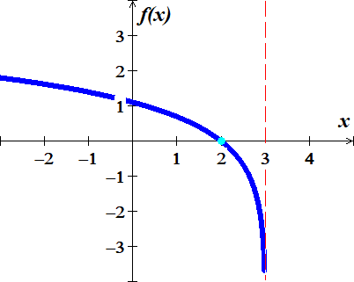Find the ***asymptote***, ***domain***, and ***range*** of the given function. Then, sketch the graph 

***Solution***

***Asymptote***: 

***Domain****:* 

***Range***: 

|  |  |
| --- | --- |
| ***x*** | ***f*(*x*)** |
| 3 |  |
| 2 | 0 |

***Exercise***

Find the ***asymptote***, ***domain***, and ***range*** of the given function. Then, sketch the graph



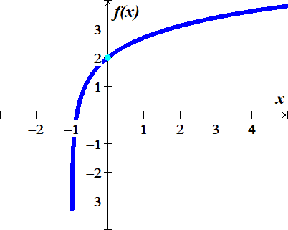***Solution***

***Asymptote***: 

***Domain****:* 

***Range***: 

|  |  |
| --- | --- |
| ***x*** | ***f*(*x*)** |
| −1 |  |
| 0 | 2 |

***Exercise***

Find the ***asymptote***, ***domain***, and ***range*** of the given function. Then, sketch the graph

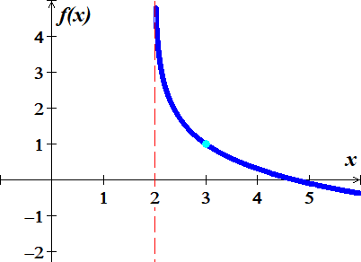

***Solution***

***Asymptote***: 

***Domain****:* 

***Range***: 

|  |  |
| --- | --- |
| ***x*** | ***f*(*x*)** |
| 2 |  |
| 3 | 1 |

***Exercise***

On a study by psychologists Bornstein and Bornstein, it was found that the average walking speed *w*, in feet per second, of a person living in a city of population *P*, in ***thousands***, is given by the function



1. The population is 124,848. Find the average walking speed of people living in Hartford.
2. The population is 1,236,249. Find the average walking speed of people living in San Antonio.

***Solution***

124,848 = 124.848 ***thousand***

1. 



1. 



***Exercise***

The loudness of sounds is measured in a unit called a decibel. To measure with this unit, we first assign an intensity of to a very faint sound, called the threshold sound. If a particular sound has intensity *I*, then the decibel rating of this louder sound is



Find the exact decibel rating of a sound with intensity 

***Solution***







***Exercise***

Students in an accounting class took a final exam and then took equivalent forms of the exam at monthly intervals thereafter. The average score *S(t)*, as a percent, after *t* months was found to be given by the function



1. What was the average score when the students initially took the test, *t* = 0?
2. What was the average score after 4 *months*? 24 *months*?

***Solution***

1. 



1. After 4 *months*





After 24 *months*





***Exercise***

A model for advertising response is given by the function



Where  is the number of units sold when a is the amount spent on advertising, in *thousands* of *dollars*.

1. 
2. 

***Solution***

1. 



1. 

