***Lecture Four Matrices***

***Section* 4.1 – System of linear Equations**

**Solving Systems of Equations**

1. Graphically
2. Substitution Method
3. Elimination Method

***Graphically***

|  |  |  |
| --- | --- | --- |
|  |  |  |
| ***One solution* (*lines intersect*)**  ***Consistent***  ***Independent*** | ***No Solution* (l*ines //* )**  ***Inconsistent***  ***Independent*** | ***Infinite solution***  ***Consistent***  ***Dependent*** |

***Substitution Method***

Solve: 

***Solution***

















*Solution*: 

***Elimination* Method**

Solve: 

***Solution***















*Solution*: 

***Matrices***



This is called Matrix (*Matrices*)

Each number in the array is an ***element*** or ***entry***

The matrix is said to be of order *m x n*

*m*: numbers of rows,

*n*: number of columns

When *m = n*, then matrix is said to be ***square***.

*Given the system equations*



The ***augmented matrix*** form is: 

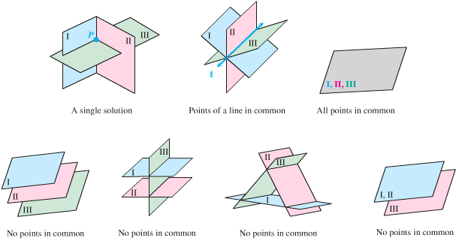

***Gaussian* Elimination**

***Example***

Use the Gaussian elimination method to solve the system



***Solution***

 

 0 1 2 13

 

 0 0 1 5

 ⇒ 

(2) ⇒ *y* = 13 − 2*z* = 13 − 2(5) = 3

(3) ⇒ *x* = 19 − *y* − 2*z* = 19 − 3 − 10 = 6

**⇒ (6, 3, 5)**

***Gauss-Jordan* Elimination**

***Example***

Use the Gauss-Jordan method to solve the system



***Solution***

 

 0 1 2 13

 

 0 0 1 5

 



***Solution*: (6, 3, 5)**

***Example***

Use the Gaussian elimination method to solve the system



***Solution***

 1  1 2

 

 



From (1): 0 = 0 is a true statement. Let ***z*** be the variable.

From (2): *y* = 1 + 2*z*

From (3): 





x = −2z + 

***Solution*: **

***Example***

Use the Gaussian elimination method to solve the system



***Solution***

 

 0 1 -8 -4

 



From Row 3: 0 = 3 is a False statement.

***No Solution*** or ***Inconsistent***

***Exercises Section* 4.1 – System of linear Equations**

(**1 − 15**) Use any method to solve the system equation (***elimination*** or ***substitution*** method)

|  |  |  |
| --- | --- | --- |
|  |  |  |

(**16 − 27**) Perform the matrix row operation (or operations) and write the new matrix.

|  |  |
| --- | --- |
|  |  |

(**28 − 34**) Use the Gauss-Jordan method to solve the system

|  |  |  |
| --- | --- | --- |
|  |  |  |

(**35 − 69**) Use augmented elimination to solve linear system

|  |  |  |
| --- | --- | --- |
|  |  |  |

|  |  |
| --- | --- |
|  |  |

1. At Snack Mix, caramel corn worth $2.50 per *pound* is mixed with honey roasted missed nuts worth $7.50 per *pound* in order to get 20 *lbs*. of a mixture worth $4.50 per *pound*. How much of each snack is used?