***Lecture Five***

***Section* 5.1 – Cramer’s Rule**

***Cramer's Rule***

Given:



  

   

***Example***

Use Cramer's rule to solve the system



***Solution***











***Solution***: 









  

***Example***

Use Cramer's rule to solve the system

*x* – 3*y* + 7*z* = 13

*x* + *y* + *z* = 1

*x* – 2*y* + 3*z* = 4

***Solution***

 

 

  

***Solution***: 

***Exercises Section* 5.1 – Determinants and Cramer’s Rule**

(**1 − 55**) Use Cramer's rule to solve the system

|  |  |  |  |  |
| --- | --- | --- | --- | --- |
|  | |  | |  |
|  |  | |  | | |

1. Find the quadratic function  for which . What is the function?
2. you wish to mix candy worth $3.44 per pound with candy worth $9.96 per pound to form 24 pounds of a mixture worth $8.33 per pound.
3. Write the system equations?
4. How many pounds of each candy should you use?
5. Anne and Nancy use a metal alloy that is 17.76% copper to make jewelry. How many ounces of a 15% alloy must be mixed with a 19% alloy to form 100 ounces of the desired alloy?
6. A company makes 3 types of cable. Cable ***A*** requires 3 black, 3 white, and 2 red wires. ***B*** requires 1 black, 2 white, and 1 red. ***C*** requires 2 black, 1 white, and 2 red. They used 95 black, 100 white and 80 red wires.
7. Write the system equations?
8. How many of each cable were made?
9. A basketball fieldhouse seats 15,000. Courtside seats sell for $8.00, end zone for $6.00, and balcony for $5.00. Total for a sell-out is $86,000. If half the courtside and balcony and all end zone seats are sold, ticket sales total $49,000.
10. Write the system equations?
11. How many of each type of seat are there?
12. A movie theater charges $9.00 for adults and $7.00 for senior citizens. On a day when 325 people paid admission, the total receipts were $2,495.
13. Write the system equations?
14. How many who paid were adults? How many were seniors?
15. A Broadway theater has 500 seats, divided into orchestra, main, and balcony seating. Orchestra seats sell for $150, main seats for $135, and balcony seats for $110. If all the seats are sold, the gross revenue to the theater is $64,250. If all the main and balcony seats are sold, but only half the orchestra seats are sold, the gross revenue is $56,750.
16. Write the system equations?
17. How many of each kind of seat are there?
18. A movie theater charges $11 for adults, $6.50 for children, and $9 for senior citizens. One day the theater sold 405 tickets and collected $3,315 in receipts. Twice as many children’s tickets were sold as adult tickets.
19. Write the system equations?
20. How many adults, children, and senior citizens went to the theater that day?
21. Emma has $20,000 to invest. As her financial planner, you recommend that she diversify into three investements: Treasure bills that yield 5% simple interest. Treasury bonds tht yield 7% simple interest, and corporate bonds that yield 10% simple interest. Emma wishes to earn $1,390 per year in income. Also, Emma wants her investment in Treasury bills to be $3,000 more than her investment in corporate bonds. How much money should Emma place in each investement?
22. A person invested $17,000 for one year, part at 10%, part at 12%, and the remainder at 15%. The total annual income from these investements was $2,110. The amount of money invested at 12% was $1,000 less than the amounts invested at 10% and 15% combined. Find the amount invested at each rate.
23. At a production, 400 tickets were sold. The ticket prices were $8, $10, and $12, and the total income from ticket sales was $3,700. How many tickets of each type were sold if the combined number of $8 and $10 tickets sold was 7 times the number of $12 tickets sold?
24. A certain brand of razor blades comes in packages if 6, 12, and 24 blades, costing $2, $3, and $4 per package, respectively. A store sold 12 packages containing a total of 162 razor blades and took in $35. How many packages of each type were sold?
25. A store sells cashews for $5.00 per pound and peanuts for $1.50 per pound. The manager decides to mix 30 pounds of peanuts with some cashews and sell the mixture for $3.00 per pound.
26. Write the system equations?
27. How many pounds of cashews should be mixed with peanuts so that the mixture will produce the same revenue as selling the nuts separately?
28. A wireless store takes presale orders for a new smartphone and tablet. He gets 340 preorders for the smartphone and 250 preorders for the tablet. The combined value of the preorders is $270,500.00. If the price of a smartphone and tablet together is $965, how much does each device cost?
29. A restaurant manager wants to purchase 200 sets of dishes. One design costs $25 per set, and another costs $45 per set. If she has only $7400 to spend, how many sets of each design should be order?
30. One group of people purchased 10 hot dogs and 5 soft drinks at a cost of $35.00. A second bought 7 hot dogs and 4 soft drinks at a cost of $25.25. What is the cost of a single hot dog and a single soft drink?
31. The sum of three times the first number, plus the second number, and twice the third number is 5. If 3 times the second number is subtracted from the sum of the first number and 3 times the third number, the result is 2. If the third number is subtracted from the sum of 2 times the first number and 3 times the second number, the result is 1. Find the three numbers.
32. The sum of three numbers is 16. The sum of twice the first number, 3 times the second number, and 4 times the third number is 46. The difference between 5 times the first number and the second number is 31. Find the three numbers.
33. Two blocks of wood having the same length and width are placed on the top and bottom of a table. Length *A* measure 32 *cm*. The blocks are rearranged. Length *B* measures 28 *cm*. Determine the height of the table.

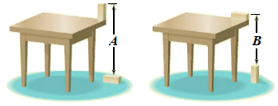

1. In the following triangle, the degree measures of the three interior angles and two of the exterior angles are represented with variables. Find the measure of each interior angle.

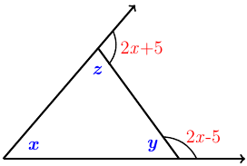

1. Three painters (Beth, Bill, and Edie), working together, can paint the exterior of a home in 10 *hours*. Bill and Edie together have painted similar house in 15 *hours*. One day, all three worked on this same kind of house for 4 *hours*, after which Edie left. Beth and Bill required 8 more *hours* to finish. Assuming no gain or loss in efficiency, how long should it take each person to complete such a job alone?

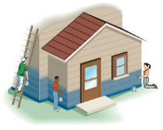

1. An application of Kirchhoff’s Rules to the circuit shown results in the following system of equations:

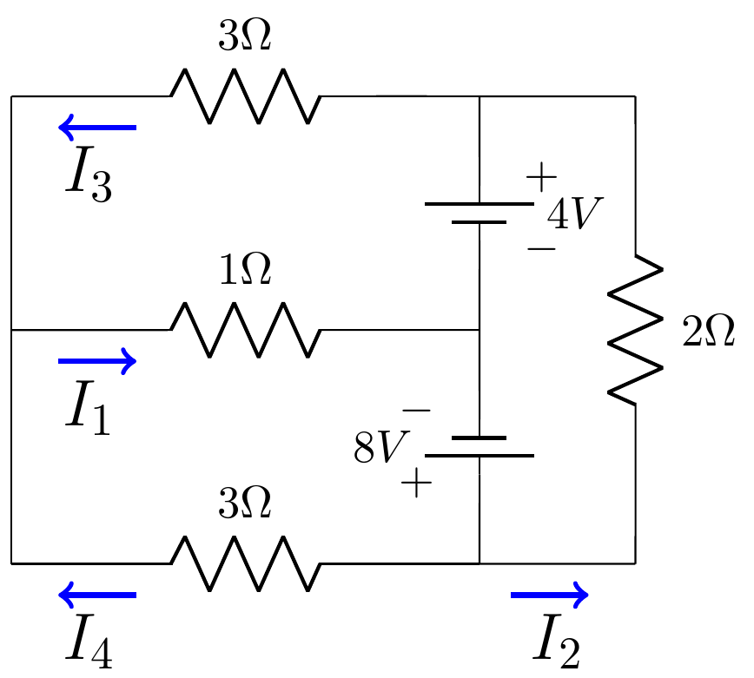

 Find the currents , , , and 

1. An application of Kirchhoff’s Rules to the circuit shown results in the following system of equations:

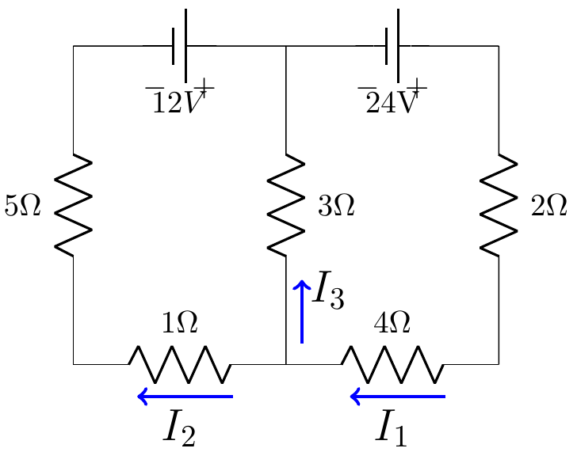

 Find the currents , , and 

1. An application of Kirchhoff’s Rules to the circuit shown results in the following system of equations:

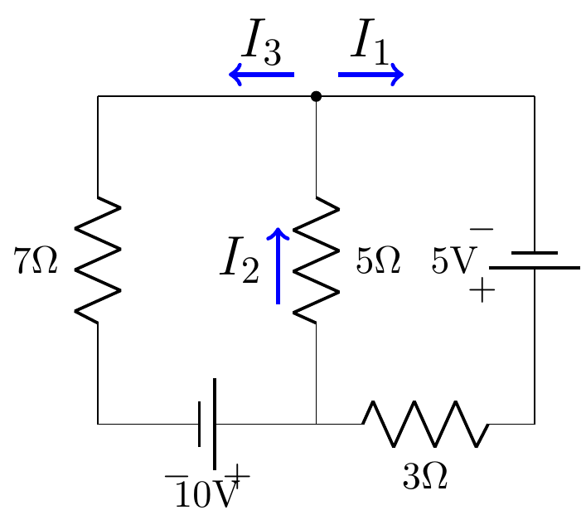

 Find the currents , , and 

1. An application of Kirchhoff’s Rules to the circuit shown results in the following system of equations:

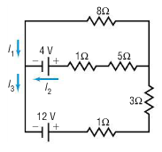 Find the currents , , and 

***Section* 5.2 – Partial Fraction Decomposition**

1. **Decompose , where *Q* has Only Non-repeated Linear Factor**

Under the assumption that *Q* has only non-repeated linear factors, the polynomial *Q* has the form



Where no 2 of the number  are equal. In this case, the partial fraction decomposition of  is of the form



Where the numbers  are to be determined.

***Example***

Write the partial fraction decomposition of 

***Solution***

First factor the denominator, 







 







Therefore; 

1. **Decompose , where *Q* has Repeated Linear Factors**

If a polynomial *Q* has a repeated linear factor, say  *n* is an integer, then in the partial fraction decomposition of , we allow for the terms



Where the numbers  are to be determined.

***Example***

Write the partial fraction decomposition of 

***Solution***

First factor the denominator, 













***Example***

Write the partial fraction decomposition of 

***Solution***





Let 



Let 

















1. **Decompose , where *Q* has a Non-repeated Irreducible Quadratic Factor**

If *Q* contains a no-repeated irreducible quadratic factor of the form , then in the partial fraction decomposition of , we allow for the term



Where the numbers *A* and *B* are to be determined.

***Example***

Write the partial fraction decomposition of 

***Solution***



















1. **Decompose , where *Q* has a Repeated Irreducible Quadratic Factor**

If *Q* contains a repeated irreducible quadratic factor of the form , *n* an integer, then in the partial fraction decomposition of , we allow for the terms



Where the numbers are to be determined.

***Example***

Write the partial fraction decomposition of 

***Solution***











***Exercises Section* 5.2 – Partial Fraction Decomposition**

Write the partial fraction decomposition of each rational expression

|  |  |  |
| --- | --- | --- |
|  |  |  |

***Section* 5.3 – Ellipses**

*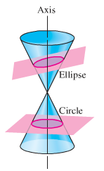****Definition* of an *Ellipse***

An ***ellipse*** is the set of all points in a plane, the sum of whose distances from two fixed points (the ***foci***) in the plane is a positive constant.

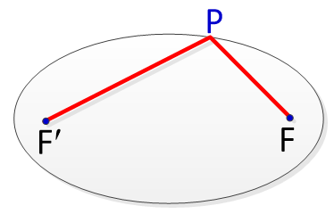

An ellipse is a curve that is the locus of all points in the plane the sum of the distances  and  from two fixed points  and  (the ***foci***) separated by a distance of 2*c*, with the center of the ellipse at the origin, is the distance length of the string and hence is constant. The constant of the distances of *P* from *F* and *F*′ will be denoted by 2*a*.

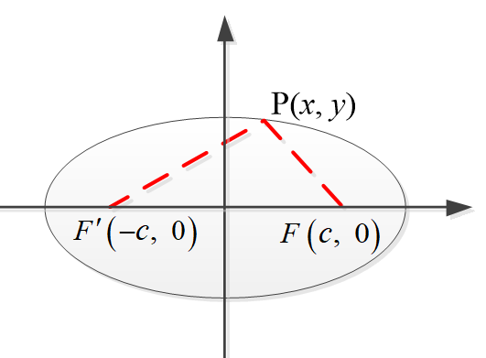





























Since , we let 



The coordinates of every point (*x*, *y*) on the ellipse satisfy the equation.

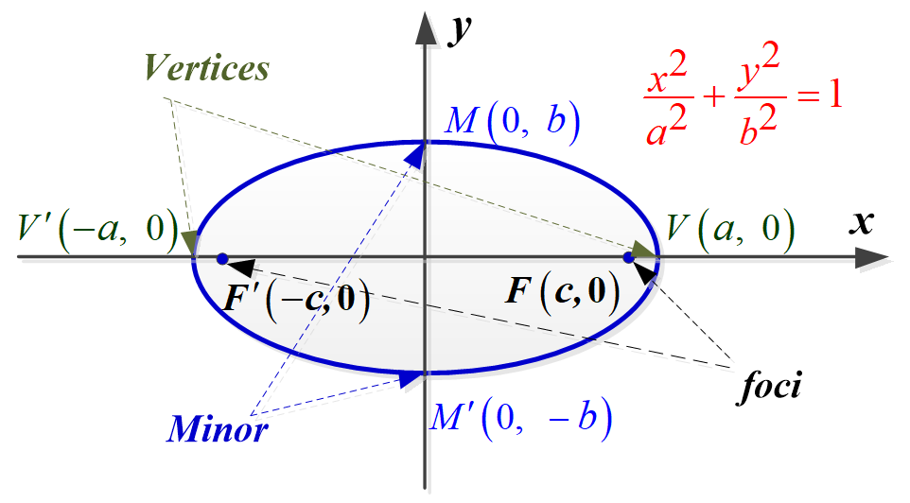

The ***x***-*intercepts* are *a* and −*a*. The corresponding points  and  are called the ***vertices*** of the ellipse. The line segment  is called the ***major*** ***axis***.

The ***y***-*intercepts* are *b* and −*b*. The corresponding points  and  are called the ***minor axis*** of the ellipse.

***Standard* Equations of an *Ellipse* with Center at the Origin**

The graph of 

Where *a* > *b* > 0, is an ellipse with center at the origin. The length of the major axis is 2*a*, and the length of the minor axis is 2*b*. The foci are the distance ***c*** from the origin where 

***Example***

Sketch the graph of , and find the foci.

***Solution***

 ***Divide each term by* 18**





The ***vertices*** are:  and 

The ***minors*** are:  and 

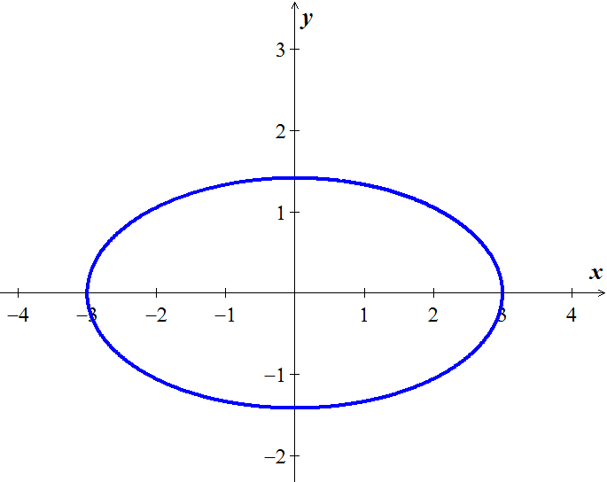



The ***foci*** are  and 

***Example***

Sketch the graph of , and find the foci.

***Solution***

 ***Divide each term by* 25**



Since , the major axis and the foci are on the *y*-axis.



The ***vertices*** are:  and 

The ***minors*** are:  and 

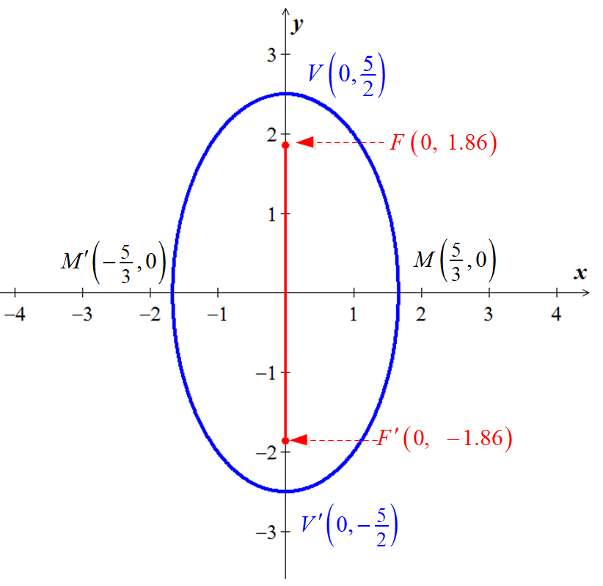











The ***foci*** are  and 

***Example***

Find an equation of the ellipse with vertices  and foci 

***Solution***

***Given***: 













***Ellipse* with *center* (*h, k*) **

***Example***

Sketch the graph of the equation 

***Solution***













The center of the ellipse is *C*(−2, 1) and major axis on the vertical line *x* = −2.



The ***vertices*** are:  and 

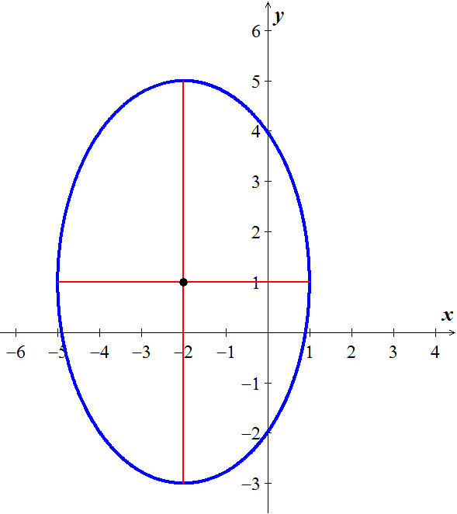The ***minors*** are:  and 

 



The ***foci*** are 

***Example***

A semielliptical archway over a one-way road has a height of 10 *feet* and a width of 40 *feet*.

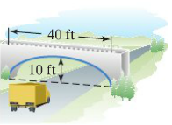

Your truck has a width of 10 *feet* and a height of 9 *feet*. Will your truck clear the opening of the archway?

***Solution***

***Given***: 

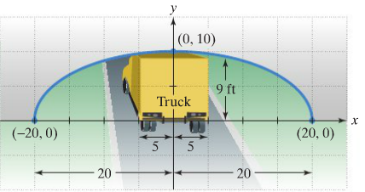

 

The edge of the 10-foot-truck corresponds to 













The truck will clear about 0.68 *feet* (8.16 *inches*)

***Exercises Section* 5.3 – Ellipses**

(**1 −17**) Find the ***center***, ***vertices, minors*** and ***foci*** of the ellipse, and then sketch the graph of

|  |  |
| --- | --- |
|  |  |

1. Find an equation for an ellipse with: 
2. Find an equation for an ellipse with: 
3. Find an equation for an ellipse with: Center ; ; major axis vertical
4. Find an equation for an ellipse with: 
5. A patient’s kidney stone is placed 12 *units* away from the source of the shock waves of a lithotripter. The lithotripter is based on an ellipse with a minor axis that measures 16 *units*. Find an equation of an ellipse that would satisfy this situation.
6. A one-way road passes under an overpass in the form of half of an ellipse 15 *feet* high at the center and 20 *feet* wide. Assuming that a truck is 12 *feet* wide, what is the height of the tallest truck that can pass under the overpass?

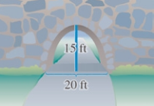

1. The basic shape of an elliptical reflector is a hemi-ellipsoid of height *h* and diameter *k*. Waves emitted from focus *F* will reflect off the surface into focus .

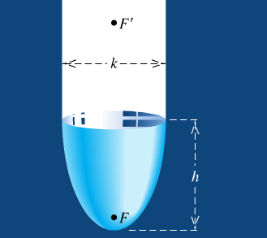

1. Express the distance  and  in terms of *h* and *k*.
2. An elliptical reflector of height 17 *cm* is to be constructed so that waves emitted from *F* are reflected to a point  that is 32 *cm* from *V*. Find the diameter of the reflector and the location of *F*.
3. A lithotripter of height 15 *cm* and diameter 18 *cm* is to be constructed. High-energy underwater shock waves will be emitted from the focus *F* that is closest to the vertex *V*.
4. Find the distance from *V* to *F*.
5. How far from *V* (in the vertical direction) should a kidney stone located?

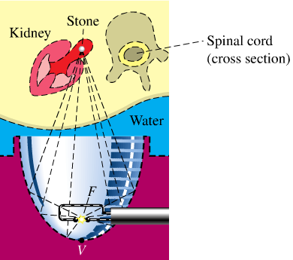

1. An Artist plans to create an elliptical design with major axis 60′′ and minor axis 24′′, centered on a door that measures 80′′ by 36′′. On a vertical line that dissects the door, approximately how far from each end of the door should the push-pins be inserted?

How long should the string be?

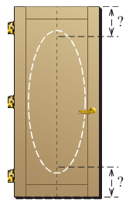

1. An arch of a bridge is semi-elliptical, with major axis horizontal. The base of the arch is 30 *feet*. across, and the highest part of the arch is 10 *feet*. above the horizontal roadway.

Find the height of the arch 6 *feet*. from the center of the base.

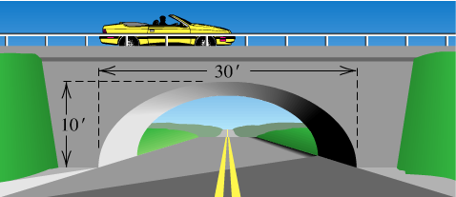

1. The whispering gallery in the Museum of Science and Industry in Chicago is 47.3 *feet* long. The distance from the center of the room to the foci is 20.3 *feet*. Find an equation that describes the shape of the room. How high is the room at its center?



1. An arch in the shape of the upper half of an ellipse is used to support a bridge that is to span a river 20 *meters* wide. The center of the arch is 6 *meters* above the center of the river. Write an equation for the ellipse in which the *x*-axis coincides with the water level and the *y*-axis passes through the center of the arch.

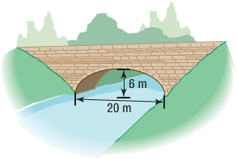

1. A bridge is built in the shape of a semielliptical arch. The bridge has a span of 120 *feet* and a maximum height of 25 *feet*. Choose a rectangular coordinate system and find the height of the arch at distances of 10, 30, and 50 feet from the center.
2. A bridge is built in the shape of a semielliptical arch. The bridge has a span of 100 *feet*. The height of the arch is 10 *feet*. Find the height of the arch at its center.
3. A racetrack is in the shape of an ellipse, 100 *feet* long and 50 feet wide. What is the width 10 *feet* from a vertex?

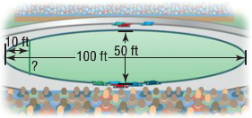

1. A homeowner is putting in a fireplace that has a 4-*inch* radius vent pipe. He needs to cut an elliptical hole in his roof to accommodate the pipe. If the pitch of his roof is  (a rise of 5, run of 4) what are the dimensions of the hole?
2. A football is in the shape of a ***prolate spheroid***, which is simply a solid obtained by rotating an ellipse about its major axis. An inflated NFL football averages 11.125 inches in length and 28.25 inches in center circumference. If the volume of a prolate spheroid is , how much air does the football contain? (Neglect material thickness)
3. The fact that the orbit of a planet about the Sun is an ellipse with the Sun at one focus. The ***aphelion*** of a planet is its greatest distance from the Sun, and the ***perihelion*** is its shortest distance. The ***mean distance*** of a planet from the Sun is the length of the semi-major axis of the elliptical orbit.

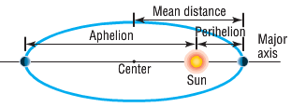

1. The mean distance of Earth from the Sun is 93 million *miles*. If the aphelion of Earth is 94.5 million miles, what is the perihelion? Write an equation for the orbit of Earth around the Sun.
2. The mean distance of Mars from the Sun is 142 million *miles*. If the perihelion of Mars is 128.5 million miles, what is the aphelion? Write an equation for the orbit of Mars about the Sun.
3. The aphelion of Jupiter is 507 million *miles*. If the distance from the center of it elliptical orbit to the Sun is 23.2 million *miles*, what is the perihelion? What is the mean distance? Write an equation for the orbit of Jupiter around the Sun.
4. The perihelion of Pluto is 4551 million *miles*, and the distance from the center of its elliptical orbit to the Sun is 897.5 million *miles*. Find the aphelion of Pluto. What is the mean distance of Pluto from the Sun? Write an equation for the orbit of Pluto about the Sun.
5. Will a truck that is 8 *feet* wide carrying a load that reaches 7 *feet* above the ground the semielliptical arch on the one-way road that passes under the bridge?

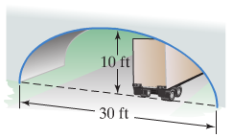

1. A semielliptic archway has a height of 20 *feet* and a width of 50 *feet* and a width of 50 *feet*. Can a truck 14 *feet* high and 10 *feet* wide drive under the archway without going into the other lane?

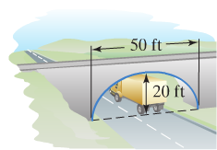

1. The elliptical ceiling in Statuary Hall is 96 *feet* long and 23 *feet* tall.

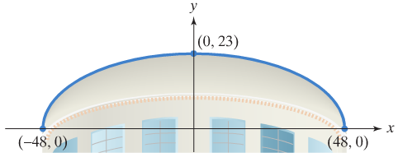

1. Using the rectangular coordinate system in the figure shown, write the standard form of the equation of the elliptical ceiling.
2. John Quincy Adams discovered that he could overhear the conversations of opposing party leaders near the left side of the chamber if he situated his desk at the focus at the right side of the chamber. How far from the center of the ellipse along the major axis did Adams situate his desk?

***Section* 5.4 – Hyperbolas**

***Definition* of a Hyperbola**

A ***hyperbola*** is the set of all points in a plane, the difference of whose distances from two fixed points (the ***foci***) in the plane is a positive constant.

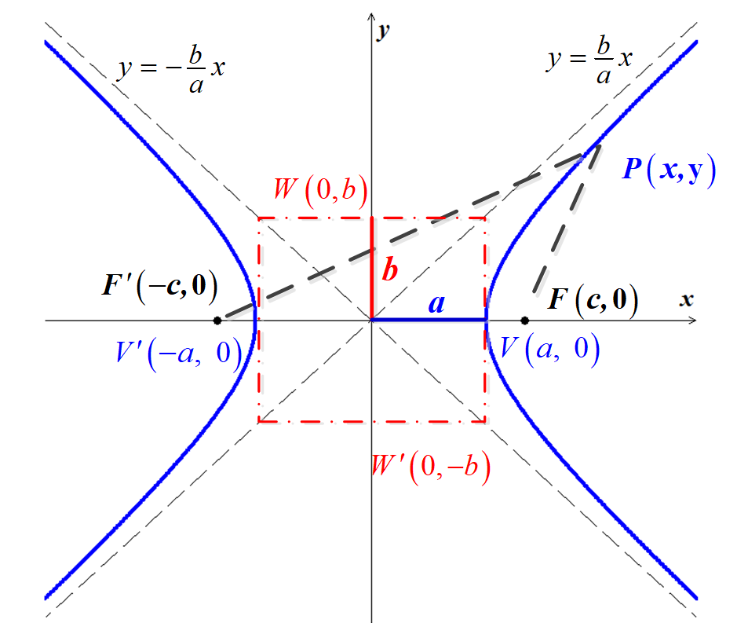

Let  be a point on the hyperbola and  and  (the ***foci***), where the midpoint of *F*′*F* (the origin) is called the *center*. The following is true:



That implies to:































Finally, if we let 



Applying the tests for symmetry, we see that the hyperbola is symmetric with the respect to both axes and the origin.

The ***x***-*intercepts* are *a* and −*a*. The corresponding points  and  are called the ***vertices*** of the ellipse. The line segment  is called the ***transverse*** ***axis***.

The graph has no ***y***-intercept, since  has the *complex* solutions . The points  and  are endpoints of the ***conjugate axis*** *W*′*W* (there are not on the hyperbola)

[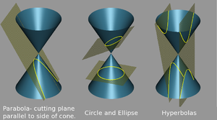](http://en.wikipedia.org/wiki/File:Conic_sections_2.png)

***Example***

Sketch the graph of . Find the foci and equations of the asymptotes.

***Solution***





 

There are no ***y−***intercepts.

The ***endpoints***:

The ***vertices***: 

The ***foci*** are 

The equations of the ***asymptotes*** are:  

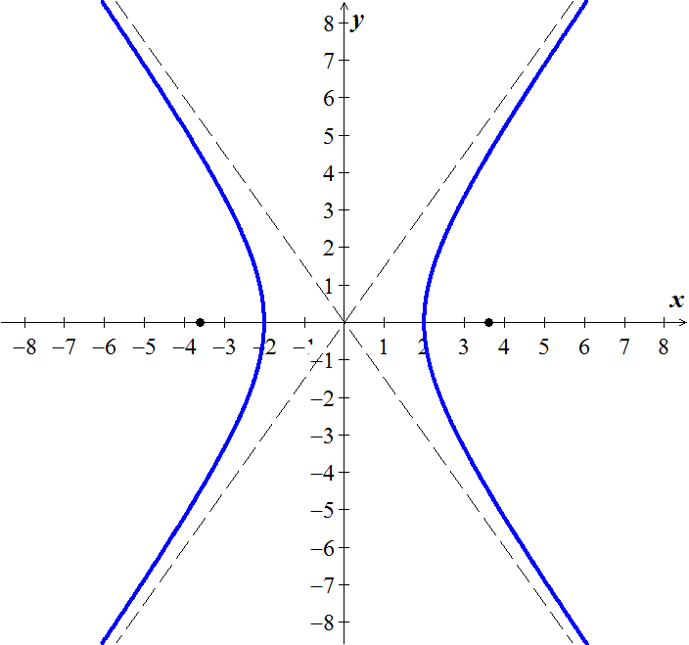

***Example***

Sketch the graph of . Find the foci and equations of the asymptotes.

***Solution***







There are no *x*-intercepts.

The ***endpoints***:

The ***vertices***: 

The ***foci*** are 

The equations of the ***asymptotes*** are:  

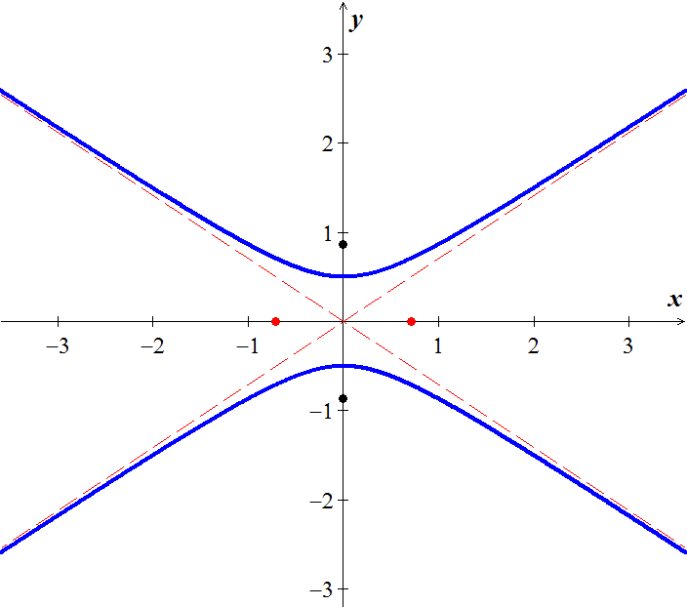

***Example***

A hyperbola has vertices  and passes through the point . Find its equation, foci and asymptotes.

***Solution***



Since  in on the hyperbola 

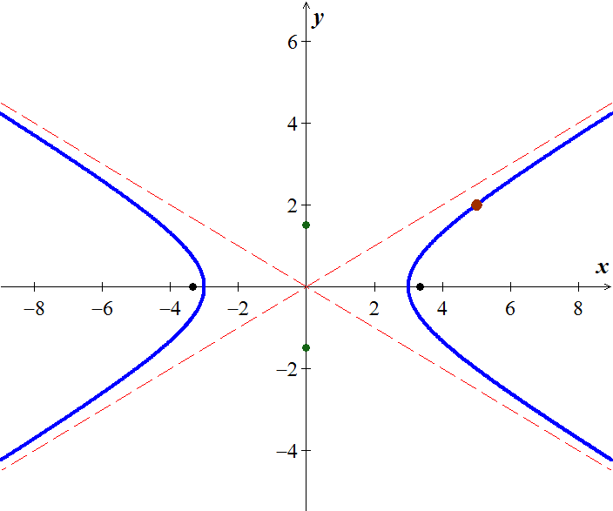













 





The ***foci***: 

The equations of the ***asymptotes*** are:  

***Example***

Coast Guard station *A* is 200 *miles* directly east of another station *B*. A ship is sailing on a line parallel to and 50 *miles* north of the line through *A* and *B*. Radio signals are sent out from *A* and *B* at the rate of  (microsecond). If, at 1:00 PM, the signal from *B* reaches the ship 400 microseconds after the signal from *A*, locate the position of the ship at that time.

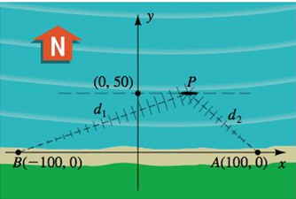

***Solution***

***Given***: 

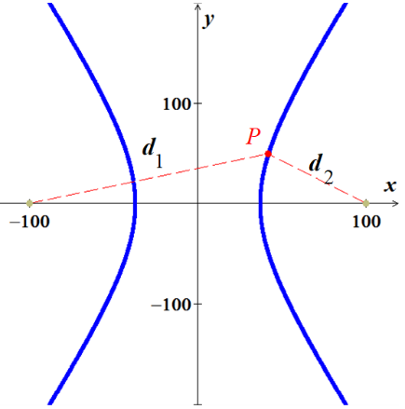





Since 





Distance from the origin to either focus is 

Then, 

 

Since 







**∴** 

***Exercises Section* 5.4 – Hyperbolas**

(**1 – 15**) Find the ***center, vertices***, the ***foci***, ***endpoints*** and the equations of the ***asymptotes*** of the hyperbola. Sketch its graph, showing the asymptotes and the foci.

|  |  |
| --- | --- |
|  |  |

1. Suppose a hyperbola has center at the origin, foci at  and , and equation . Let , and show that an equation of the hyperbola is 
2. A cooling tower is a hydraulic structure. Suppose its base diameter is 100 *meters* and its smallest diameter of 48 *meters* occurs 84 *meters* from the base. If the tower is 120 *meters* high approximate its diameter at the top.

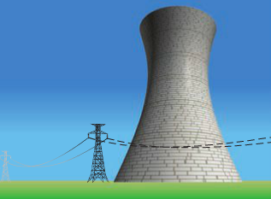

1. An airplane is flyting along the hyperbolic path. If an equation of the path is , determine how close the airplane comes to town located at (3, 0). (Hunt: Let *S* denote the square of the distance from a point (*x, y*) on the path to (3, 0), and find the minimum value of *S*.)

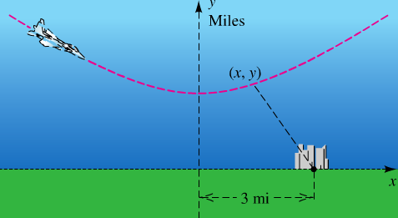

1. A ship is traveling a course that is 100 *miles* from, and parallel tom a straight shoreline. The ship sends out a distress signal that is received by two Coast Guard stations *A* and *B*, located 200 *miles* apart. By measuring the difference in signal reception times, it is determined that the ship is 160 *miles* closer to *B* than to *A*. Where is the ship?

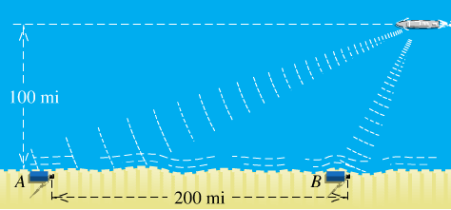

1. The Cassegrain telescope design (dating back to 1672) makes use of the reflective properties of both the parabola and the hyperbola. The figure shows a (split) parabolic mirror, with one focus at  and axis along the line *l*, and a hyperbolic mirror, with one focus also at  and transverse axis along *l*. Where do incoming light waves parallel to the common axis finally collect?

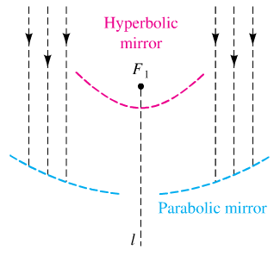

1. Suppose that two people standing 1 *mile* apart both see a flash of lightning. After a period of time, the person standing at point *A* hears the thunder. One second later, the person standing at point *B* hears the thunder. If the person at *B* is due west of the person at *A* and the lightning strike is known to occur due north of the person standing at point *A*, where did the lightning strike occur? (Sound travels at 1100 and  )
2. Ernest Rutherford published a paper that he described the motion of alpha particles as they are shot at a piece of gold foil 0.00004 *cm* thick. Before conducting this experiment, Rutherford expected that the alpha particles would shoot through the foil just as a bullet would shoot through the foil just as a bullet would shoot through snow. Instead, a small fraction of the alpha particles bounced off the foil. This led to the conclusion that the nucleus of an atom is dense, while the remainder of the atom is sparse. Only the density of the nucleus could cause the alpha particles to deviate from their path. The figure shows a diagram from Rutherford’s paper that indicates that the deflected alpha particles follow the path of one branch of a hyperbola.

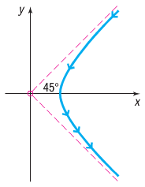

1. Find an equation of the asymptotes under this scenario.
2. If the vertex of the path of the alpha particles is 10 *cm* from the center of the hyperbola, find a model that describes the path of the particle.
3. Hyperbolas have interesting reflective properties that make them useful for lenses and mirrors. For example, if a ray of light strikes a convex hyperbolic mirror on a line that would (theoretically) pass through its rear focus, it is reflected through its rear focus, it is reflected through the front focus. This property and that of the parabola were used to develop the *Cassegrain* telescope in 1672. The focus of the parabolic mirror and the rear focus of the hyperbolic mirror are the same point. The rays are collected by the parabolic mirror, reflected toward the common focus, and thus are reflected by the hyperbolic mirror through the opening to its front focus, where the eyepiece is located. If the equation of the hyperbola is  and the focal length (distance from the vertex to the focus) of the parabola is 6, find the equation of the parabola.
4. The ***eccentricity*** ***e*** of a hyperbola is defined as the number , where *a* is the distance of a vertex from the center and *c* is the distance of a focus from the center. Because *c > a*, it follows that  . Describe the general shape of a hyperbola whose eccentricity is close to 1. What is the shape if *e* is very large?
5. An explosive is recorded by two microphone that are 1 *mile* apart. Microphone  received the sound 2 *seconds* before microphone . Assuming sound travels at 1,100 *feet* per *second*, determine the possible locations of the explosion relative to the location of the microphones.
6. Radio towers *A* and *B*, 200 *km* apart, are situated along the coast, with *A* located due west of *B*. Simultaneous radio signals are sent from each tower to a ship, with the signal from *B* received  before the signal from *A*.
7. Assuming that the radio signals travel , determine the equation of the hyperbola on which the ship is located.
8. If the ship lies due north of tower *B*, how far out at sea is it?
9. An architect designs two houses that are shaped and positioned like a part of the branches of the hyperbola whose equation is , where *x* and *y* are in yards. How far apart are the houses at their closest point?

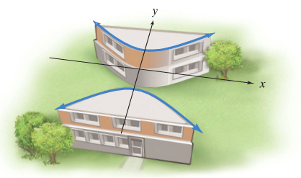

***Section* 5.5 – Infinite Sequences and Summation Notation**

An arbitrary ***infinite sequence*** may be denoted as follows:



An infinite sequence is a function whose domain is the set of positive integers.

***Example***

Find the first four terms and the tenth term of the sequence: 

***Solution***





***Example***

Find the first four terms and the tenth term of the sequence: 

***Solution***





***Example***

Find the first four terms and the tenth term of the sequence: 

***Solution***





***Example***

Find the first four terms and the tenth term of the sequence: 

***Solution***





***Example***

Find the first four terms of the recursively defined infinite sequence 

***Solution***









***Summation Notation***

To find the sum of many terms of an infinite sequence, it is easy to express using summation notation.



***Example***

Find the sum: 

***Solution***







**Theorem on the Sum of a *Constant***



***Proof***:



***Example***

Find the sum: 

***Solution***





***Theorem on Sums***

If  and  are infinite sequences, then for every positive integer ***n***,







***Proof***







***Example***

Express the sum using summation notation 

***Solution***



***Exercises*** ***Section* 5.5 – Infinite Sequences and Summation Notation**

(**1 – 13**) Find the first four terms and the eight term of the sequence:

|  |  |  |
| --- | --- | --- |
|  |  |  |

1. Graph the sequence 
2. Find the first four terms of the sequence of partial sums for the given sequence. 

(**16 – 27**) Find the first five terms of the recursively defined infinite sequence

|  |  |
| --- | --- |
|  |  |

(**28 – 37**) Express each sum using summation notation

|  |  |
| --- | --- |
|  |  |

(**38 – 52**) Find the sum

|  |  |  |
| --- | --- | --- |
|  |  |  |

(**53 – 56**) Write out each sum

|  |  |  |
| --- | --- | --- |
|  |  |  |

1. Fred has a balance of $3,000 on his card which charges 1% interest per month on any unpaid balance. Fred can afford to pay $100 toward the balance each month. His balance each month after making a $100 payment is given by the recursively defined sequence



Determine Fred’s balance after making the first payment. That is, determine 

1. A pond currently has 2,000 trout in it. A fish hatchery decides to add an additional 20 trout each month. Is it also known that the trout population is grwoing at a rate of 3% per month. The size of the population after *n* months is given bu the recursively defined sequence



How many trout are in the pond after 2 months? That is, what is ?

1. Fred bought a car by taking out a loan for $18,500 at 0.5% interest per month. Fred’s normal monthly payment is $434.47 per month, but he decides that he can afford to pay $100 extra toward the balance each month. His balance each month is given by the recursively defined sequence



Determine Fred’s balance after making the first payment. That is, determine 

1. The Environmental Protection Agency (EPA) determines that Maple Lake has 250 *tons* of pollutant as a result of industrial waste and that 10% of the pollutant present is neuttralized by solar oxidation every year. The EPA imposes new pollution control laws that result in 15 *tons* of new pollutant entering the lake each year. The amount of pollutant in the lake after *n* years is given by the recursively defined sequence



Determine the amount of pollutant in the lake after 2 years? That is, what is ?

1. Let 

Define the *n*th term of a sequence

1. Show that  and 
2. Show that 
3. Draw the conclusion that  is a Fibonacci sequence
4. Find the first ten terms of the sequence from part (*c*)

***Section* 5.6 – Arithmetic and Geometric Sequences**

***Arithmetic Sequence***

***Definition* of Arithmetic Sequence**

A sequence  is an arithmetic sequence if there is a real number ***d*** such that for every positive integer ***k***,



The number  is called the ***common difference*** of the sequence.

***Example***

Show that the sequence: 1, 4, 7, 10, … , 3*n* – 2, … is arithmetic, and find the common difference.

***Solution***

If , then for every positive integer *k*,







Hence, the given sequence is arithmetic with common difference 3.

***The nth Term of an Arithmetic Sequence***: 

***Example***

The first three terms of an arithmetic sequence are 20, 16.5, and 13. Find the fifteenth term.

***Solution***

The common difference is: 

Substituting  in the formula:







***Example***

The fourth term of an arithmetic sequence is 5, and the ninth term is 20. Find the sixth term.

***Solution***

***Given***: 

 

















***Theorem***

**Formulas for **

If  is an arithmetic sequence with common difference ***d***, then the *n*th partial sum  (that is, the sum of the first ***n*** terms) is given by either



***Proof***







 ***Using the formula of sum:*** 





***Example***

Find the sum of all even integers from 2 through 100.

***Solution***

The arithmetic sequence: 2, 4, 6, …, 2n, …

Substituting  in the formula:





***Example***

Express in terms of summation notation: 

***Solution***



Using the formula for *n*th term:





Hence the *n*th term is:



***Geometric Sequence***

**Definition of *Geometric* Sequence**

A sequence  is a geometric sequence if  and if there is a real number  such that for every positive integer *k*.



The number  is called the ***common ratio*** of the sequence.

***The formula for the nth Term of a Geometric Sequence***: 

The common ratio for:  is 

***Example***

A geometric sequence has first term 3 and common ratio . Find the first five terms and the tenth term.

***Solution***





 

 

 

 

 

***Example***

The third term of a geometric is 5, and the sixth term is −40. Find the eighth term.

***Solution***

***Given***: 





 















***Theorem*: Formula for **

The nth partial sum  of a geometric sequence with first term  and common ratio  is



***Proof***

By definition, the nth partial sum  of a geometric sequence is:







***Example***

If the sequence  is a geometric sequence, find the sum of the first five terms.

***Solution***

***Given***: 









***Theorem* on the Sum of an Infinite Geometric Series**

If , then the infinite geometric series  has the sum



***Example***

Find the sum *S* of the alternating infinite geometric series: to 

***Solution***











***Example***

Find a rational number that corresponds to 

***Solution***



















***Example***

Initially, a pendulum swings through an arc of 18 *inches*. On each successive swing, the length of the arc is 0.98 of the previous length.

1. 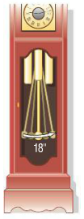What is the length of the arc of the 10th swing?
2. On which swing is the length of the arc first less than 12 inches?
3. After 15 swings, what total distance will the pendulum have swung?
4. When it stops, what total distance will the pendulum have swung?

***Solution***

1. The length of the first swing: 

The length of the second swing: 



The length of the arc of the 10th swing is:





1. 









The length of the arc of the pendulum exceeds 12 inches on the 21st swing and the first less than 12 inches on the 22nd swing.

1.  



1.  



The pendulum will have swung a total of 900 *inches* when it finally stops.

***Exercises Section* 5.6 – Arithmetic and Geometric Sequences**

1. Show that the sequence  is arithmetic, and find the common difference.

(**2 – 14**) Find the *n*th term, and the tenth term of the arithmetic sequence:

|  |  |  |
| --- | --- | --- |
|  |  |  |

(**15 – 26**) Find the common difference for the arithmetic sequence with the specified terms:

|  |  |
| --- | --- |
|  |  |

(**27 – 28**) Find the sum  of the arithmetic sequence that satisfies the conditions:

1. 
2. 
3. Find the number of integers between 32 and 390 that are divisible by 6, find their sum.
4. Find the number of integers between 32 and 390 that are divisible by 6, find their sum.

(**31 – 44**) Find each arithmetic sum

|  |  |  |
| --- | --- | --- |
|  |  | |
|  | |  | |

1. Show that the given sequence is geometric, and find the common ratio



(**46 – 61**) Find the ***n***th term, the fifth term, and the eighth term of the geometric sequence

|  |  |
| --- | --- |
|  |  |

1. Find all possible values of ***r*** for a geometric sequence with the two given terms 
2. Find the sixth term of the geometric sequence whose first two terms are 4 and 6

(**64 – 71**) Find the specified term of the geometric sequence that that has 2 given terms

|  |  |
| --- | --- |
|  |  |

(**72 – 83**) Express the sum in terms of summation notation (Answers are not unique.)

|  |  |
| --- | --- |
|  |  |

(**84 – 97**) Find the sum of the infinite geometric series if it exists:

|  |  |
| --- | --- |
|  |  |

(**98 – 117**) Find the sum:

|  |  |
| --- | --- |
|  |  |

|  |  |
| --- | --- |
|  | 6. The sum of the first 120 terms of      1. The sum of the first 46 terms of |

(**118 – 124**) Find the rational number represented by the repeating decimal

|  |  |  |  |
| --- | --- | --- | --- |
|  |  |  |  |

1. Find *x* so that , , and  are consecutive terms of an arithmetic sequence.
2. Find *x* so that , , and  are consecutive terms of an arithmetic sequence.
3. Find *x* so that , , and  are consecutive terms of a geometric sequence.
4. Find *x* so that ,  and  are consecutive terms of a geometric sequence.
5. How many terms must be added in an arithmetic sequence whose first term is 11 and whose common difference is 3 to obtain a sum of 1092?
6. How many terms must be added in an arithmetic sequence whose first term is 78 and whose common difference is −4 to obtain a sum of 702?
7. The first ten rows of seating in a certain section of a stadium have 30 seats, 32 seats, 34 seats, and so on. The eleventh through the twentieth rows each contain 50 seats. Find the total number of seats in the section.
8. The corner section of a football stadium has 15 seats in the first row and 40 rows in all. Each successive row contains two additional seats. How many seats are in this section?

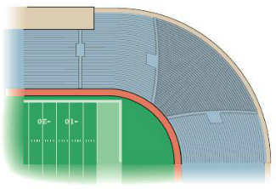

1. A gain bin is to be constructed in the shape of a frustum of a cone.

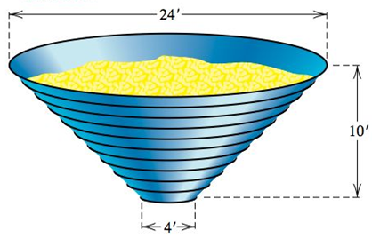

The bin is to be 10 *feet* tall with 11 metal rings positioned uniformly around it, from the 4-foot opening at the bottom to the 24-foot opening at the top. Find the total length of metal needed to make the rings.

1. A bicycle rider coasts downhill, traveling 4 *feet* the first second. In each succeeding second, the rider travels 5 *feet* farther than in the preceding second. If the rider reaches the bottom of the hill in 11 *seconds*, find the total distance traveled.
2. A contest will have five each prizes totaling $5,000, and there will be a $100 difference between successive prices. Find the first prize.
3. A Company is to distribute $46,000 in bonuses to its top ten salespeople. The tenth salesperson on the list will receive $1,000, and the difference in bonus money between successively ranked salesperson is to be constant. Find the bonus for each salesperson.
4. Assuming air resistance is negligible, a small object that is dropped from a hot air balloon falls 16 *feet* during the first second, 48 *feet* during the second second, 80 *feet* during the third second, 112 *feet* during the fourth second, and so on. Find an expression for the distance the object falls in *n* seconds.
5. A brick staircase has a total of 30 steps. The bottom step requires 100 bricks. Each successive step requires two fewer bricks than the prior step.
6. How many bricks are required for the top step?
7. How many bricks are required to build the staircase?
8. A mosaic is designed in the shape of an equilateral triangle, 20 feet on each side. Each tile in the mosaic is in the shape of an equilateral triangle, 12 inches to a side. The tiles are to alternate in color as shown below.

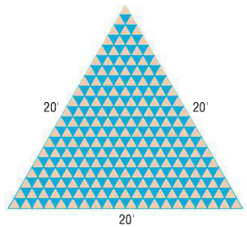

How many tiles of each color will be required?

***Section* 5.7 – Mathematical Induction**

If *n* is a positive integer and we let  denote the mathematical statement , we obtained the following ***infinite sequence*** of statements:









***Principle* of Mathematical Induction**

If with each positive integer *n* there is associated a statement  then all the statements  are true, provided the following two conditions are satisfied.

1.  is true.
2. Whenever *k* is a positive integer such that  is true, then  is also true.

***Steps in Applying the Principle of Mathematical Induction***

1. Show that  is true.
2. Assume that  is true, and then prove that  is true.

***Example***

Use the mathematical induction to prove that for every positive integer *n*, the sum of the first *n* positive integers is:



***Solution***

1. For *n* = 1 ⇒ 

 ***√***

Hence  is true.

1. Assume that  is true.

Thus, the induction hypothesis is: 

For *k* + 1: 



 ***Induction hypothesis***



 ***Factor out* k + 1**

 ***√*** ***Change form of* k + 2**

This shows that  is also true.

**∴** By the mathematical induction, the proof is completed

***Example***

Prove that for every positive integer *n*,



***Solution***

1. For ***n* = 1** ⇒ 



 ***√*** hence  is true.

1. 

For *k* + 1:















**√**

This shows that  is also true.

**∴** By the mathematical induction, the proof is completed

***Example***

Prove that 2 is a factor of  for every positive integer *n*,

***Solution***

1. For ***n* = 1** ⇒ 



 **√**

Thus, 2 is a factor of  for *n* = 1; hence  is true.

1. 2 is a factor of  

is 2 a factor of ?









 **√**

Thus, 2 is a factor of the last expression; hence  is also true.

**∴** By the mathematical induction, the proof is completed

***Steps in Applying the Extended Principle of Mathematical Induction***

1. Show that  is true.
2. Assume that  is true with , and then prove that  is true.

***Example***

Let *a* be a nonzero real number such that *a* > −1. Prove that  for every integer *n* ≥ 2.

***Solution***

For ***n* = 1** ⇒  ⇒  is false.

***Step* 1**. For ***n* = 2** ⇒ 

 **√**

⇒  is true.

***Step* 2**. Assume that  is true 

We need to prove that  is true, that is 















 **√**

Thus,  is also true.

**∴** By the mathematical induction, the proof is completed

***Exercises Section* 5.7 – Mathematical Induction**

1. Find all positive integers *n* for which the given statement is not true

   

1. Prove that the statement is true for every positive integer *n*. 
2. Prove that the statement is true for every positive integer *n*. 
3. Prove that the statement is true for every positive integer *n*. 
4. Prove that the statement is true: 
5. Prove that the statement is true: 
6. Prove that the statement is true: 
7. Prove that the statement is true: 
8. Prove that the statement is true: 
9. Prove that the statement is true: 
10. Prove that the statement is true: 
11. Prove that the statement is true: 
12. Prove that the statement is true: 
13. Prove that the statement is true: 
14. Prove that the statement is true: 
15. Prove that the statement is true: 
16. Prove that the statement is true: 
17. Prove that the statement is true: 
18. Prove that the statement is true: 
19. Prove that the statement is true for every positive integer *n*. 
20. Prove that the statement is true for every positive integer *n*. 3 is a factor of 
21. Prove that the statement is true for every positive integer *n*. 4 is a factor of 
22. Prove that the statement by mathematical induction:  (*a* and *m* are constant)
23. Prove that the statement by mathematical induction: 
24. Prove that the statement by mathematical induction: If , then 
25. Prove that the statement by mathematical induction: If , then 
26. Prove that the statement by mathematical induction: 
27. Prove that the statement by mathematical induction: 
28. Prove that the statement by mathematical induction: 
29. A pile of *n* rings, each smaller than the one below it, is on a peg on board. Two other pegs are attached to the board. In the game called the Tower of Hanoi puzzle, all the rings must moved one at a time, to a different peg with no ring ever placed on top of a smaller ring. Find the least number of moves that would be required. Prove your result by mathematical induction.

