***Lecture Five***

***Section* 5.1 – Cramer’s Rule**

***Cramer's Rule***

Given:



  

   

***Example***

Use Cramer's rule to solve the system



***Solution***











***Solution***: 









  

***Example***

Use Cramer's rule to solve the system

*x* – 3*y* + 7*z* = 13

*x* + *y* + *z* = 1

*x* – 2*y* + 3*z* = 4

***Solution***

 

 

  

***Solution***: 

***Exercises Section* 5.1 – Determinants and Cramer’s Rule**

(**1 − 55**) Use Cramer's rule to solve the system

|  |  |  |  |  |
| --- | --- | --- | --- | --- |
|  | |  | |  |
|  |  | |  | | |

1. Find the quadratic function  for which . What is the function?
2. you wish to mix candy worth $3.44 per pound with candy worth $9.96 per pound to form 24 pounds of a mixture worth $8.33 per pound.
3. Write the system equations?
4. How many pounds of each candy should you use?
5. Anne and Nancy use a metal alloy that is 17.76% copper to make jewelry. How many ounces of a 15% alloy must be mixed with a 19% alloy to form 100 ounces of the desired alloy?
6. A company makes 3 types of cable. Cable ***A*** requires 3 black, 3 white, and 2 red wires. ***B*** requires 1 black, 2 white, and 1 red. ***C*** requires 2 black, 1 white, and 2 red. They used 95 black, 100 white and 80 red wires.
7. Write the system equations?
8. How many of each cable were made?
9. A basketball fieldhouse seats 15,000. Courtside seats sell for $8.00, end zone for $6.00, and balcony for $5.00. Total for a sell-out is $86,000. If half the courtside and balcony and all end zone seats are sold, ticket sales total $49,000.
10. Write the system equations?
11. How many of each type of seat are there?
12. A movie theater charges $9.00 for adults and $7.00 for senior citizens. On a day when 325 people paid admission, the total receipts were $2,495.
13. Write the system equations?
14. How many who paid were adults? How many were seniors?
15. A Broadway theater has 500 seats, divided into orchestra, main, and balcony seating. Orchestra seats sell for $150, main seats for $135, and balcony seats for $110. If all the seats are sold, the gross revenue to the theater is $64,250. If all the main and balcony seats are sold, but only half the orchestra seats are sold, the gross revenue is $56,750.
16. Write the system equations?
17. How many of each kind of seat are there?
18. A movie theater charges $11 for adults, $6.50 for children, and $9 for senior citizens. One day the theater sold 405 tickets and collected $3,315 in receipts. Twice as many children’s tickets were sold as adult tickets.
19. Write the system equations?
20. How many adults, children, and senior citizens went to the theater that day?
21. Emma has $20,000 to invest. As her financial planner, you recommend that she diversify into three investements: Treasure bills that yield 5% simple interest. Treasury bonds tht yield 7% simple interest, and corporate bonds that yield 10% simple interest. Emma wishes to earn $1,390 per year in income. Also, Emma wants her investment in Treasury bills to be $3,000 more than her investment in corporate bonds. How much money should Emma place in each investement?
22. A person invested $17,000 for one year, part at 10%, part at 12%, and the remainder at 15%. The total annual income from these investements was $2,110. The amount of money invested at 12% was $1,000 less than the amounts invested at 10% and 15% combined. Find the amount invested at each rate.
23. At a production, 400 tickets were sold. The ticket prices were $8, $10, and $12, and the total income from ticket sales was $3,700. How many tickets of each type were sold if the combined number of $8 and $10 tickets sold was 7 times the number of $12 tickets sold?
24. A certain brand of razor blades comes in packages if 6, 12, and 24 blades, costing $2, $3, and $4 per package, respectively. A store sold 12 packages containing a total of 162 razor blades and took in $35. How many packages of each type were sold?
25. A store sells cashews for $5.00 per pound and peanuts for $1.50 per pound. The manager decides to mix 30 pounds of peanuts with some cashews and sell the mixture for $3.00 per pound.
26. Write the system equations?
27. How many pounds of cashews should be mixed with peanuts so that the mixture will produce the same revenue as selling the nuts separately?
28. A wireless store takes presale orders for a new smartphone and tablet. He gets 340 preorders for the smartphone and 250 preorders for the tablet. The combined value of the preorders is $270,500.00. If the price of a smartphone and tablet together is $965, how much does each device cost?
29. A restaurant manager wants to purchase 200 sets of dishes. One design costs $25 per set, and another costs $45 per set. If she has only $7400 to spend, how many sets of each design should be order?
30. One group of people purchased 10 hot dogs and 5 soft drinks at a cost of $35.00. A second bought 7 hot dogs and 4 soft drinks at a cost of $25.25. What is the cost of a single hot dog and a single soft drink?
31. The sum of three times the first number, plus the second number, and twice the third number is 5. If 3 times the second number is subtracted from the sum of the first number and 3 times the third number, the result is 2. If the third number is subtracted from the sum of 2 times the first number and 3 times the second number, the result is 1. Find the three numbers.
32. The sum of three numbers is 16. The sum of twice the first number, 3 times the second number, and 4 times the third number is 46. The difference between 5 times the first number and the second number is 31. Find the three numbers.
33. Two blocks of wood having the same length and width are placed on the top and bottom of a table. Length *A* measure 32 *cm*. The blocks are rearranged. Length *B* measures 28 *cm*. Determine the height of the table.

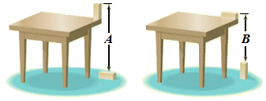

1. In the following triangle, the degree measures of the three interior angles and two of the exterior angles are represented with variables. Find the measure of each interior angle.

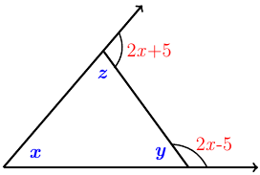

1. Three painters (Beth, Bill, and Edie), working together, can paint the exterior of a home in 10 *hours*. Bill and Edie together have painted similar house in 15 *hours*. One day, all three worked on this same kind of house for 4 *hours*, after which Edie left. Beth and Bill required 8 more *hours* to finish. Assuming no gain or loss in efficiency, how long should it take each person to complete such a job alone?

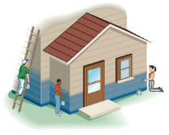

1. An application of Kirchhoff’s Rules to the circuit shown results in the following system of equations:

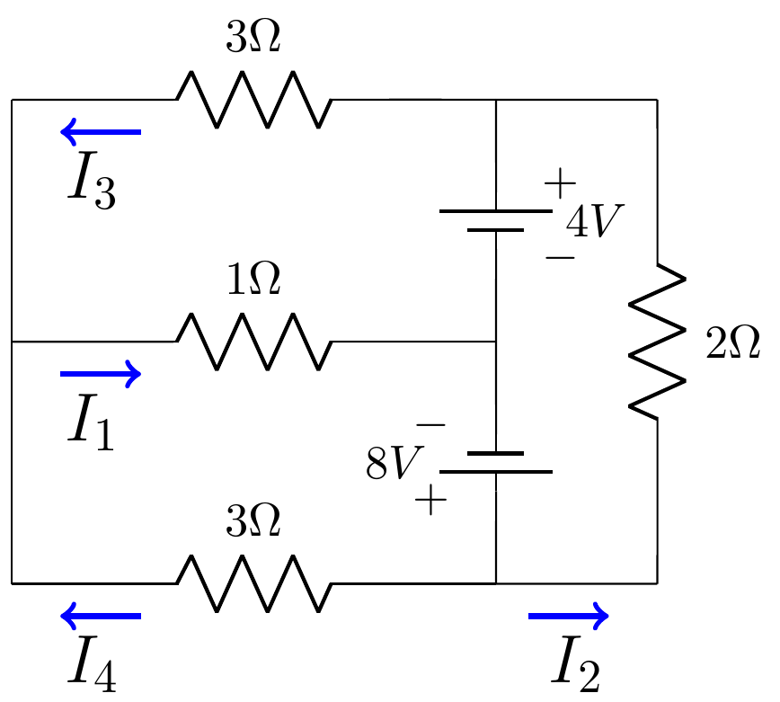

 Find the currents , , , and 

1. An application of Kirchhoff’s Rules to the circuit shown results in the following system of equations:

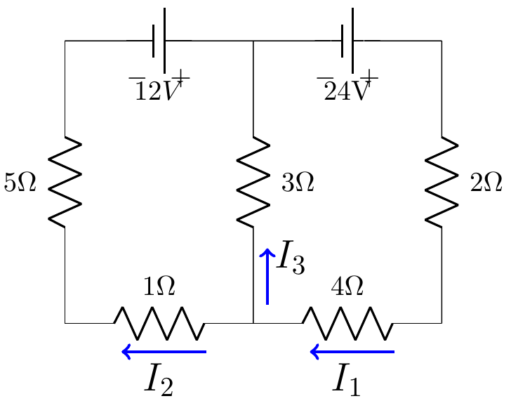

 Find the currents , , and 

1. An application of Kirchhoff’s Rules to the circuit shown results in the following system of equations:

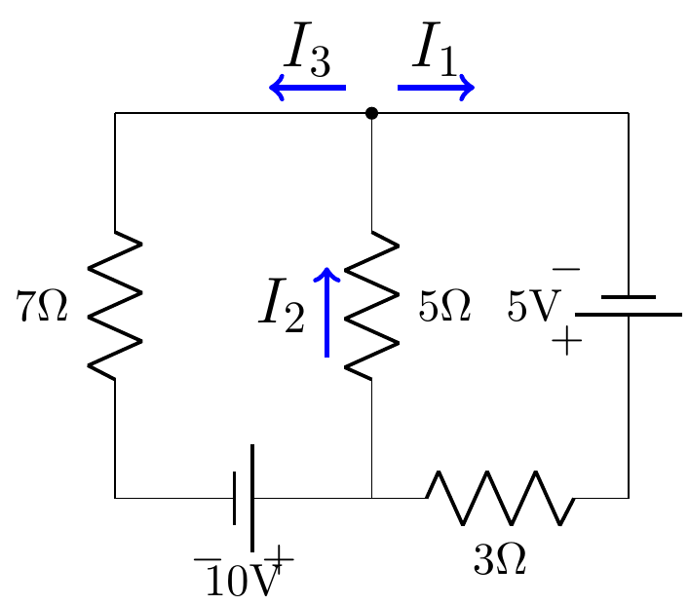

 Find the currents , , and 

1. An application of Kirchhoff’s Rules to the circuit shown results in the following system of equations:

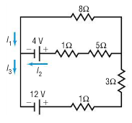

 Find the currents , , and 