***Section* 5.3 – Ellipses**

*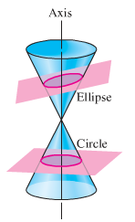****Definition* of an *Ellipse***

An ***ellipse*** is the set of all points in a plane, the sum of whose distances from two fixed points (the ***foci***) in the plane is a positive constant.

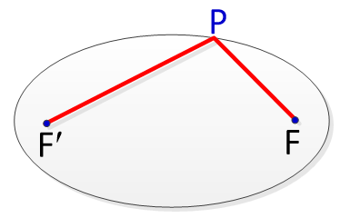

An ellipse is a curve that is the locus of all points in the plane the sum of the distances  and  from two fixed points  and  (the ***foci***) separated by a distance of 2*c*, with the center of the ellipse at the origin, is the distance length of the string and hence is constant. The constant of the distances of *P* from *F* and *F*′ will be denoted by 2*a*.

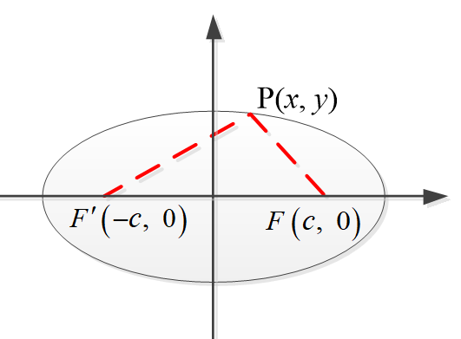





























Since , we let 



The coordinates of every point (*x*, *y*) on the ellipse satisfy the equation.

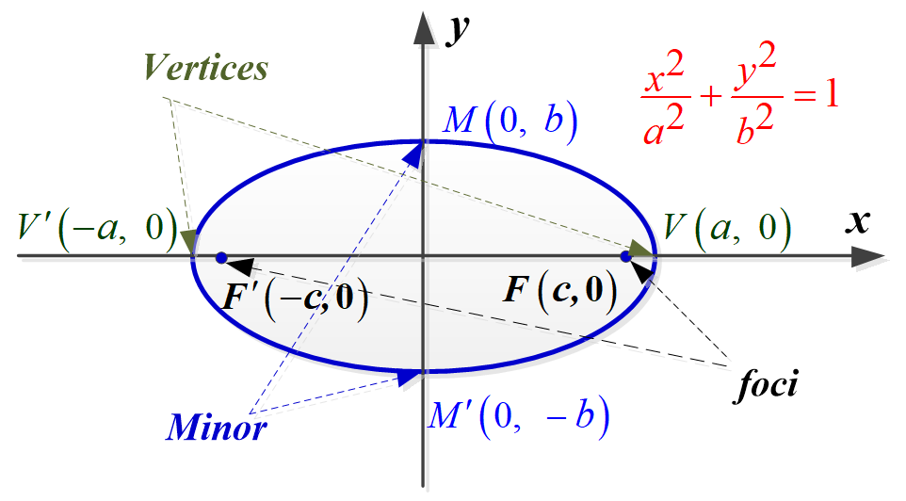

The ***x***-*intercepts* are *a* and −*a*. The corresponding points  and  are called the ***vertices*** of the ellipse. The line segment  is called the ***major*** ***axis***.

The ***y***-*intercepts* are *b* and −*b*. The corresponding points  and  are called the ***minor axis*** of the ellipse.

***Standard* Equations of an *Ellipse* with Center at the Origin**

The graph of 

Where *a* > *b* > 0, is an ellipse with center at the origin. The length of the major axis is 2*a*, and the length of the minor axis is 2*b*. The foci are the distance ***c*** from the origin where 

***Example***

Sketch the graph of , and find the foci.

***Solution***

 ***Divide each term by* 18**





The ***vertices*** are:  and 

The ***minors*** are:  and 

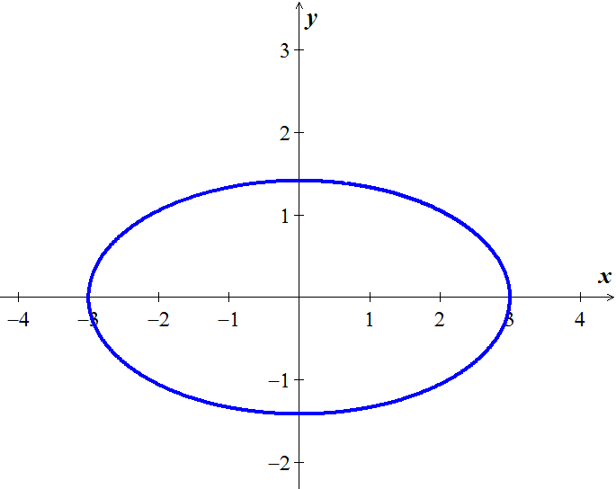



The ***foci*** are  and 

***Example***

Sketch the graph of , and find the foci.

***Solution***

 ***Divide each term by* 25**



Since , the major axis and the foci are on the *y*-axis.



The ***vertices*** are:  and 

The ***minors*** are:  and 

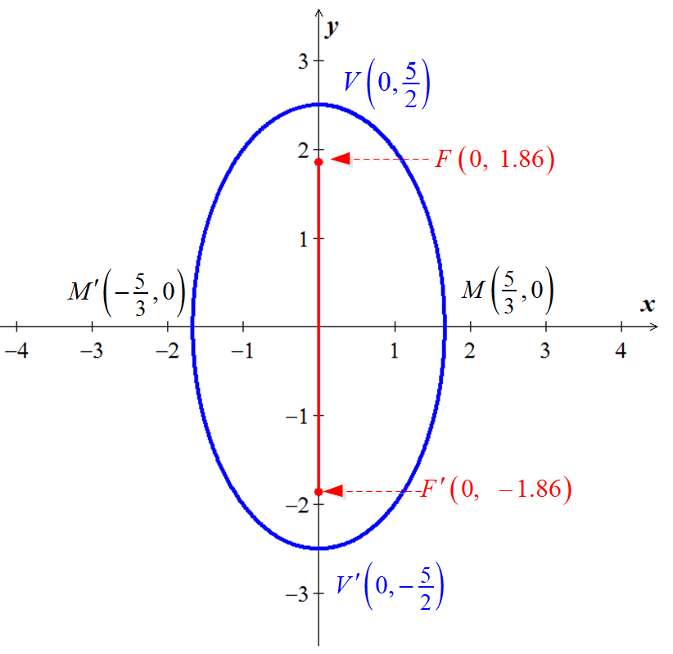

 







The ***foci*** are  and 

***Example***

Find an equation of the ellipse with vertices  and foci 

***Solution***

***Given***: 













***Ellipse* with *center* (*h, k*) **

***Example***

Sketch the graph of the equation 

***Solution***













The center of the ellipse is *C*(−2, 1) and major axis on the vertical line *x* = −2.



The ***vertices*** are:  and 

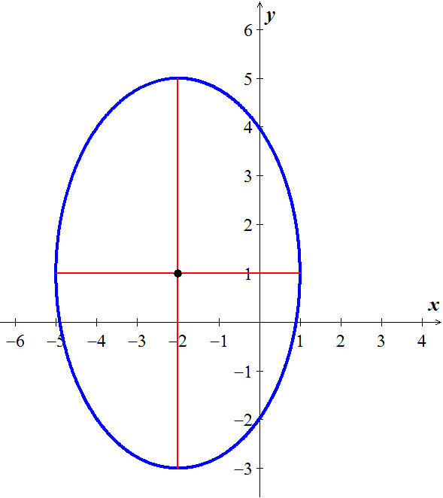The ***minors*** are:  and 

 



The ***foci*** are 

***Example***

A semielliptical archway over a one-way road has a height of 10 *feet* and a width of 40 *feet*.

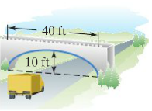

Your truck has a width of 10 *feet* and a height of 9 *feet*. Will your truck clear the opening of the archway?

***Solution***

***Given***: 

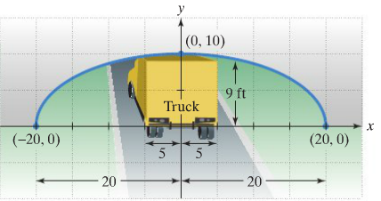

 

The edge of the 10-foot-truck corresponds to 













The truck will clear about 0.68 *feet* (8.16 *inches*)

***Exercises Section* 5.3 – Ellipses**

(**1 −17**) Find the ***center***, ***vertices, minors*** and ***foci*** of the ellipse, and then sketch the graph of

1. 
2. 
3. 
4. 
5. 
6. 
7. 
8. 
9. 
10. 
11. 
12. 
13. 
14. 
15. 
16. 
17. 
18. Find an equation for an ellipse with: 
19. Find an equation for an ellipse with: 
20. Find an equation for an ellipse with: Center ; ; major axis vertical
21. Find an equation for an ellipse with: 
22. A patient’s kidney stone is placed 12 *units* away from the source of the shock waves of a lithotripter. The lithotripter is based on an ellipse with a minor axis that measures 16 *units*. Find an equation of an ellipse that would satisfy this situation.
23. A one-way road passes under an overpass in the form of half of an ellipse 15 *feet* high at the center and 20 *feet* wide. Assuming that a truck is 12 *feet* wide, what is the height of the tallest truck that can pass under the overpass?

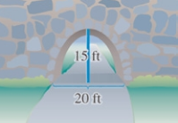

1. The basic shape of an elliptical reflector is a hemi-ellipsoid of height *h* and diameter *k*. Waves emitted from focus *F* will reflect off the surface into focus .
2. Express the distance  and  in terms of *h* and *k*.
3. An elliptical reflector of height 17 *cm* is to be constructed so that waves emitted from *F* are reflected to a point  that is 32 *cm* from *V*. Find the diameter of the reflector and the location of *F*.

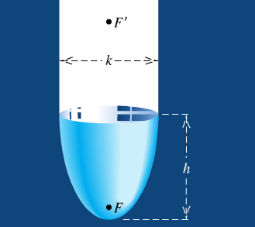

1. A lithotripter of height 15 *cm* and diameter 18 *cm* is to be constructed. High-energy underwater shock waves will be emitted from the focus *F* that is closest to the vertex *V*.
2. Find the distance from *V* to *F*.
3. How far from *V* (in the vertical direction) should a kidney stone located?

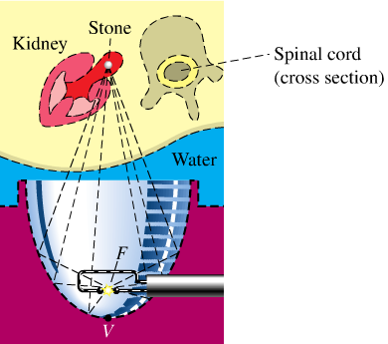

1. An Artist plans to create an elliptical design with major axis 60′′ and minor axis 24′′, centered on a door that measures 80′′ by 36′′. On a vertical line that dissects the door, approximately how far from each end of the door should the push-pins be inserted? How long should the string be?

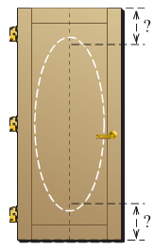

1. An arch of a bridge is semi-elliptical, with major axis horizontal. The base of the arch is 30 *feet*. across, and the highest part of the arch is 10 *feet*. above the horizontal roadway. Find the height of the arch 6 *feet*. from the center of the base.

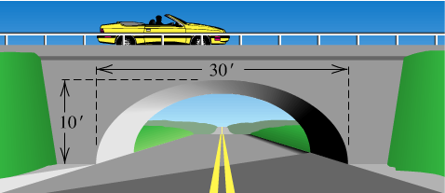

1. The whispering gallery in the Museum of Science and Industry in Chicago is 47.3 *feet* long. The distance from the center of the room to the foci is 20.3 *feet*. Find an equation that describes the shape of the room. How high is the room at its center?



1. An arch in the shape of the upper half of an ellipse is used to support a bridge that is to span a river 20 *meters* wide. The center of the arch is 6 *meters* above the center of the river. Write an equation for the ellipse in which the *x*-axis coincides with the water level and the *y*-axis passes through the center of the arch.

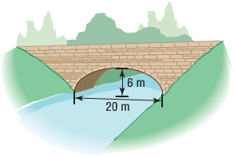

1. A bridge is built in the shape of a semielliptical arch. The bridge has a span of 120 *feet* and a maximum height of 25 *feet*. Choose a rectangular coordinate system and find the height of the arch at distances of 10, 30, and 50 feet from the center.
2. A bridge is built in the shape of a semielliptical arch. The bridge has a span of 100 *feet*. The height of the arch is 10 *feet*. Find the height of the arch at its center.
3. A racetrack is in the shape of an ellipse, 100 *feet* long and 50 feet wide. What is the width 10 *feet* from a vertex?

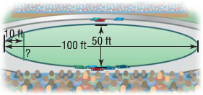

1. A homeowner is putting in a fireplace that has a 4-*inch* radius vent pipe. He needs to cut an elliptical hole in his roof to accommodate the pipe. If the pitch of his roof is  (a rise of 5, run of 4) what are the dimensions of the hole?
2. A football is in the shape of a ***prolate spheroid***, which is simply a solid obtained by rotating an ellipse about its major axis. An inflated NFL football averages 11.125 inches in length and 28.25 inches in center circumference. If the volume of a prolate spheroid is , how much air does the football contain? (Neglect material thickness)
3. The fact that the orbit of a planet about the Sun is an ellipse with the Sun at one focus. The ***aphelion*** of a planet is its greatest distance from the Sun, and the ***perihelion*** is its shortest distance. The ***mean distance*** of a planet from the Sun is the length of the semi-major axis of the elliptical orbit.

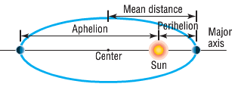

1. The mean distance of Earth from the Sun is 93 million *miles*. If the aphelion of Earth is 94.5 million miles, what is the perihelion? Write an equation for the orbit of Earth around the Sun.
2. The mean distance of Mars from the Sun is 142 million *miles*. If the perihelion of Mars is 128.5 million miles, what is the aphelion? Write an equation for the orbit of Mars about the Sun.
3. The aphelion of Jupiter is 507 million *miles*. If the distance from the center of it elliptical orbit to the Sun is 23.2 million *miles*, what is the perihelion? What is the mean distance? Write an equation for the orbit of Jupiter around the Sun.
4. The perihelion of Pluto is 4551 million *miles*, and the distance from the center of its elliptical orbit to the Sun is 897.5 million *miles*. Find the aphelion of Pluto. What is the mean distance of Pluto from the Sun? Write an equation for the orbit of Pluto about the Sun.
5. Will a truck that is 8 *feet* wide carrying a load that reaches 7 *feet* above the ground the semielliptical arch on the one-way road that passes under the bridge?

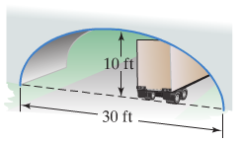

1. A semielliptic archway has a height of 20 *feet* and a width of 50 *feet* and a width of 50 *feet*. Can a truck 14 *feet* high and 10 *feet* wide drive under the archway without going into the other lane?

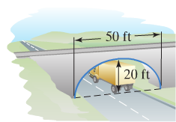

1. The elliptical ceiling in Statuary Hall is 96 *feet* long and 23 *feet* tall.

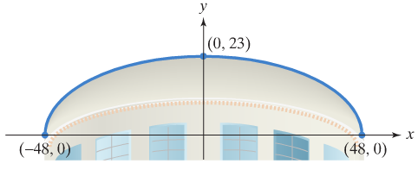

1. Using the rectangular coordinate system in the figure shown, write the standard form of the equation of the elliptical ceiling.
2. John Quincy Adams discovered that he could overhear the conversations of opposing party leaders near the left side of the chamber if he situated his desk at the focus at the right side of the chamber. How far from the center of the ellipse along the major axis did Adams situate his desk?