***Solution Section* 5.3 – Ellipses**

***Exercise***

Find the ***center,*** ***vertices, minors*** and ***foci*** of the ellipse, and then sketch the graph of 

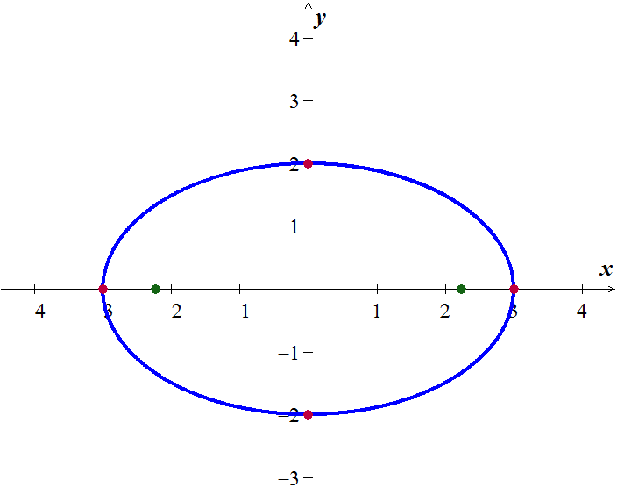***Solution***





***Center***: 

***Vertices***: 

***Minor*** 

***Foci*** 

***Exercise***

Find the ***center,*** ***vertices, minors*** and ***foci*** of the ellipse, and then sketch the graph of 

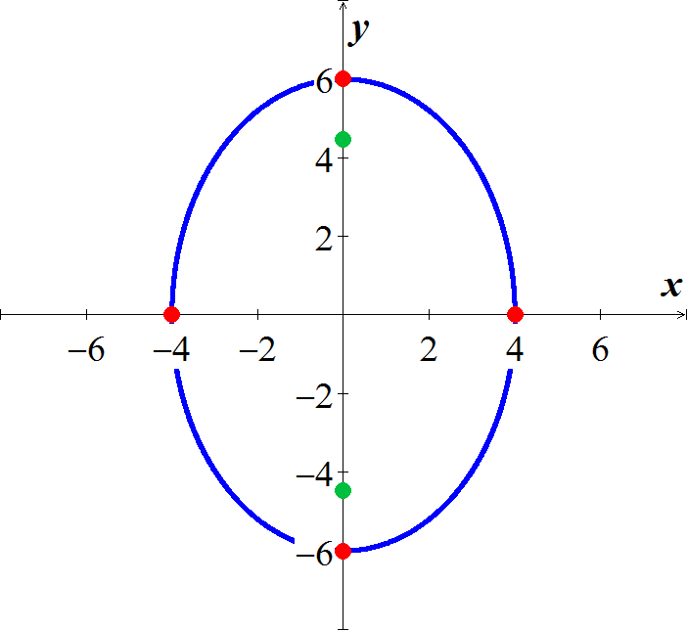***Solution***





***Center***: 

***Vertices***:

***Minors*** 

***Foci*** 

***Exercise***

Find the ***center,*** ***vertices, minors*** and ***foci*** of the ellipse, and then sketch the graph of 

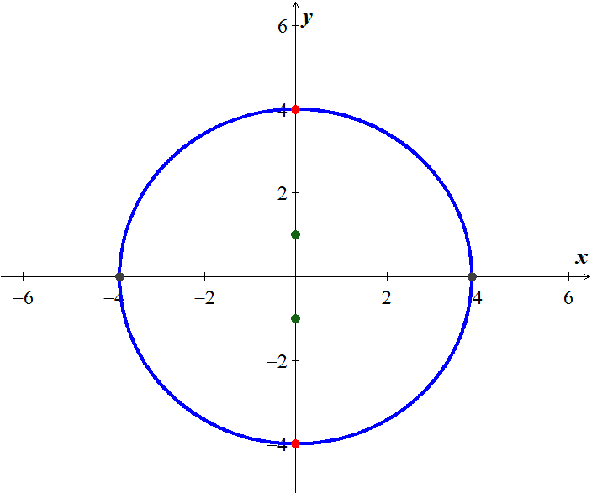***Solution***





***Center***: 

***Vertices***:

***Minors*** 

***Foci*** 

***Exercise***

Find the ***center,*** ***vertices, minors*** and ***foci*** of the ellipse, and then sketch the graph of 

***Solution***

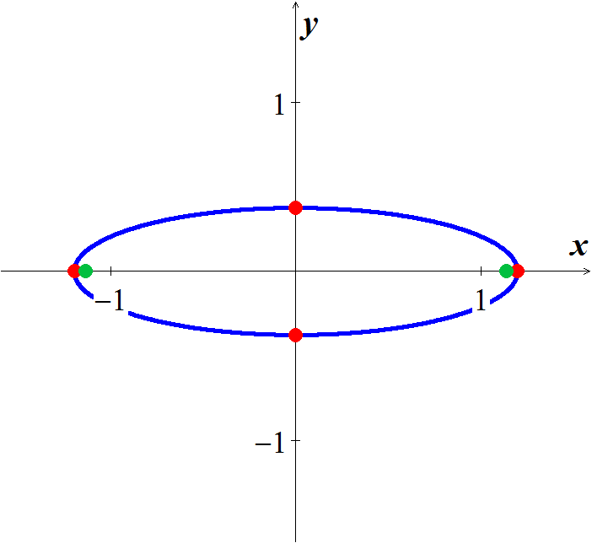





***Center***: 

***Vertices***: 

***Minor*** 

***Foci*** 

***Exercise***

Find the ***center,*** ***vertices, minors*** and ***foci*** of the ellipse, and then sketch the graph of 

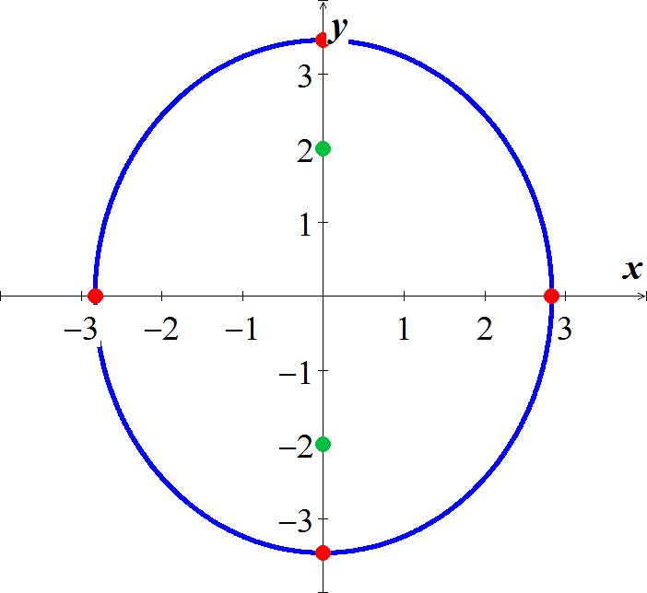***Solution***









***Center***: 

***Vertices***: 

***Minors*** 

***Foci*** 

***Exercise***

Find the ***center,*** ***vertices, minors*** and ***foci*** of the ellipse, and then sketch the graph of 

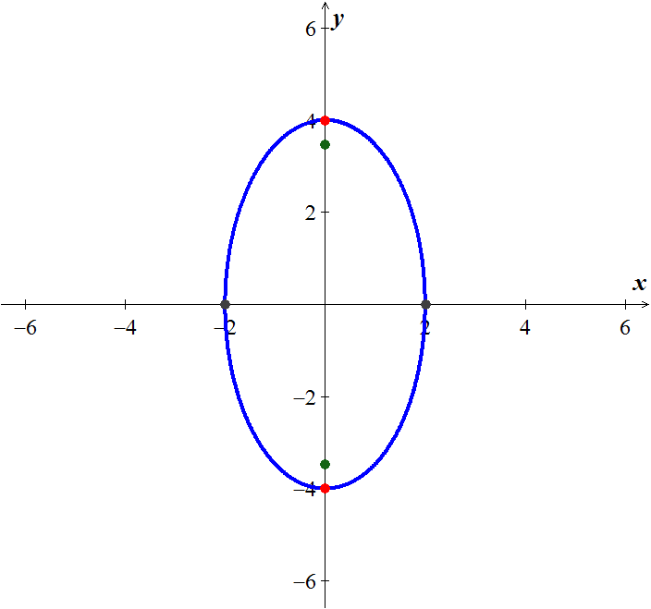***Solution***









***Center***: 

***Vertices***:

***Minors*** 

***Foci*** 

***Exercise***

Find the ***center,*** ***vertices, minors*** and ***foci*** of the ellipse, and then sketch the graph of 

***Solution***

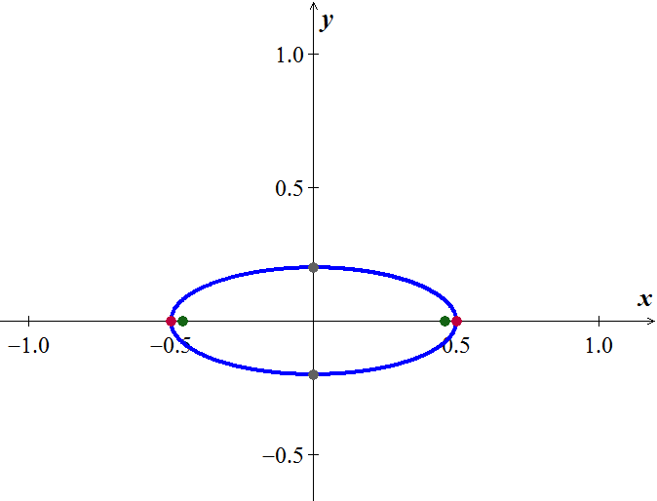





***Center***: 

***Vertices***: 

***Minor*** 

***Foci*** 

***Exercise***

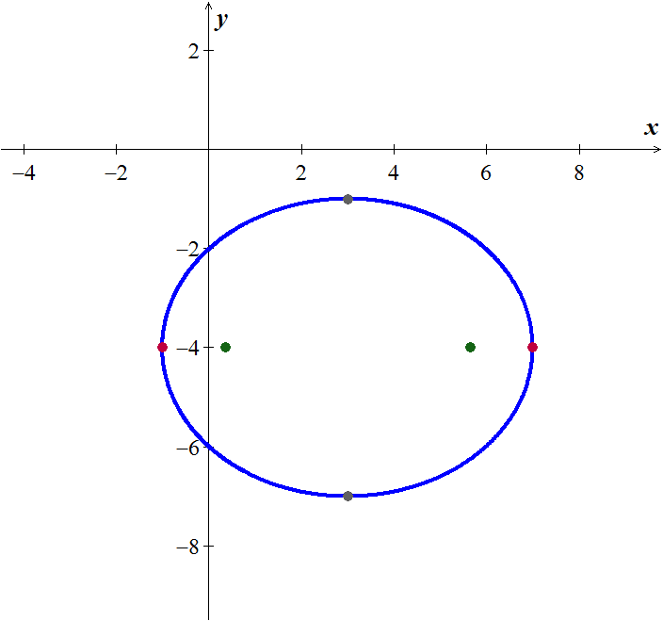Find the ***center,*** ***vertices, minors*** and ***foci*** of the ellipse, and then sketch the graph of 

***Solution***





***Center***: 

***Vertices***: 

***Minor*** 

***Foci*** 

***Exercise***

Find the ***center,*** ***vertices, minors*** and ***foci*** of the ellipse, and then sketch the graph of 

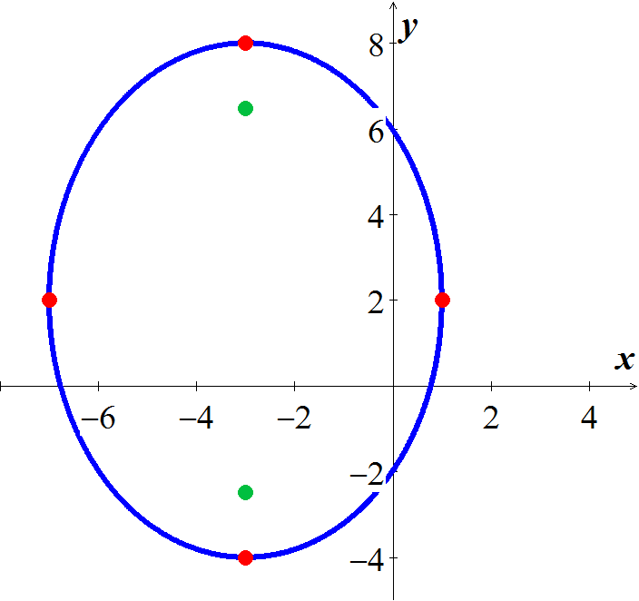***Solution***





***Center***: 

***Vertices***: 

***Minor*** 

***Foci*** 

***Exercise***

Find the ***center,*** ***vertices, minors*** and ***foci*** of the ellipse, and then sketch the graph of 

***Solution***

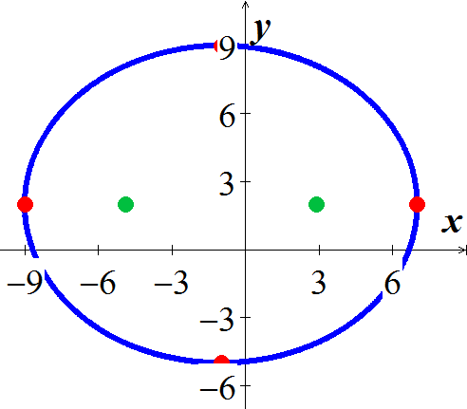



***Center***: 

***Vertices***: 

***Minor*** 

***Foci*** 

***Exercise***

Find the ***center,*** ***vertices, minors*** and ***foci*** of the ellipse, and then sketch the graph of 

***Solution***



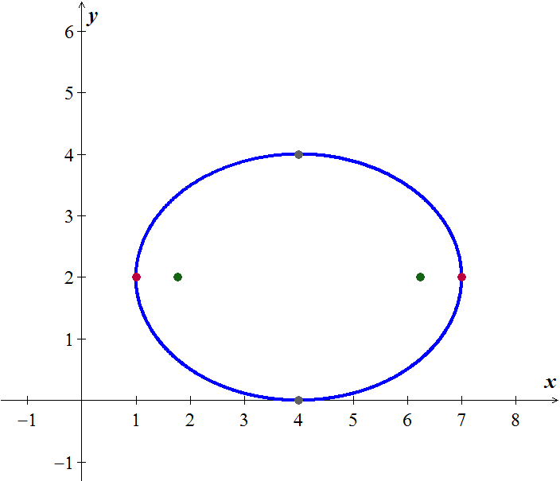







***Center***: 

***Vertices***: 

***Minor***  

***Foci*** 

***Exercise***

Find the ***center,*** ***vertices, minors*** and ***foci*** of the ellipse, and then sketch the graph of 

***Solution***











***Center***: 

***Vertices***: 

***Minor*** 

***Foci*** 

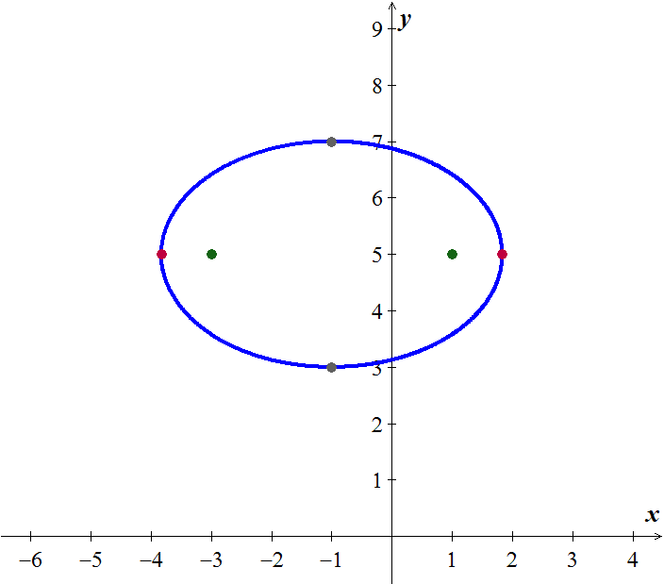

***Exercise***

Find the ***center,*** ***vertices, minors*** and ***foci*** of the ellipse, and then sketch the graph of 

***Solution***













***Center***: 

***Vertices***: 

***Minor*** 

***Foci*** 

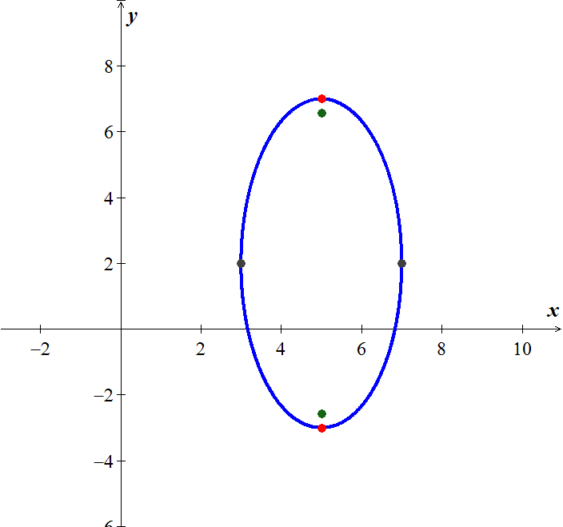

***Exercise***

Find the ***center,*** ***vertices, minors*** and ***foci*** of the ellipse, and then sketch the graph of 

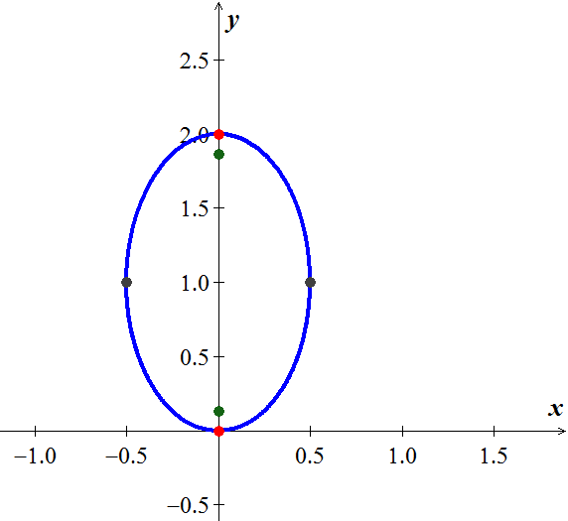***Solution***













***Center***: 

***Vertices***: 

***Minor*** 

***Foci*** 

***Exercise***

Find the ***center,*** ***vertices, minors*** and ***foci*** of the ellipse Sketch the graph:

***Solution***















***Center:*** 

***Vertices***: 

***Minor*** 

***Foci*** 

***Exercise***

Find the ***center,*** ***vertices, minors*** and ***foci*** of the ellipse, and then sketch the graph of 

***Solution***















***Center:*** 

***Vertices***: 

***Minor*** 

***Foci*** 

***Exercise***

Find the ***center,*** ***vertices, minors*** and ***foci*** of the ellipse, and then sketch the graph of 

***Solution***















***Center:*** 

***Vertices***: 

***Minor:*** 

***Foci*** 

***Exercise***

Find an equation for an ellipse with: 

***Solution***

The ellipse is centered at 

Major axis: 

Foci: 



The equation is: 

***Exercise***

Find an equation for an ellipse with: 

***Solution***

The ellipse is centered at  between the endpoint of the major axis

Major axis: 



The equation is: 

***Exercise***

Find an equation for an ellipse with: Center ; ; major axis vertical

***Solution***

The ellipse is centered at 



The equation is: 

***Exercise***

Find an equation for an ellipse with: 

***Solution***

The ellipse is centered between the foci at 

Major axis is the vertical with 

Foci: 



The equation is: 

***Exercise***

A patient’s kidney stone is placed 12 *units* away from the source of the shock waves of a lithotripter. The lithotripter is based on an ellipse with a minor axis that measures 16 *units*. Find an equation of an ellipse that would satisfy this situation.

***Solution***

The patient and the emitter are 12 units apart ⇒ these represent the foci of an ellipse, so *c* = 6.

The minor axis: 16 units ⇒ *b* = 8.

∴ .

The equation is: 

***Exercise***

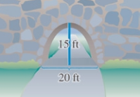A one-way road passes under an overpass in the form of half of an ellipse 15 *feet* high at the center and 20 *feet* wide. Assuming that a truck is 12 *feet* wide, what is the height of the tallest truck that can pass under the overpass?

***Solution***

Using a vertical major axis ⇒ *a* = 15.

The minor axis: 20 *ft*. ⇒ *b* = 10.

The equation is: 

Assuming the truck drives through the middle, we want to find *y* when *x* = 6









The truck must be just under 12 *feet* high to pass through.

***Exercise***

The basic shape of an elliptical reflector is a hemi-ellipsoid of height *h* and diameter *k*. Waves emitted from focus *F* will reflect off the surface into focus 

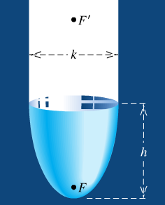

1. Express the distance  and  in terms of *h* and *k*.
2. An elliptical reflector of height 17 *cm* is to be constructed so that waves emitted from *F* are reflected to a point  that is 32 *cm* from *V*. Find the diameter of the reflector and the location of *F*.

***Solution***

***Given***: 

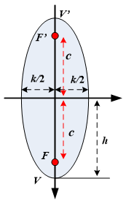

1. 







1. ***Given***: 













The location of *F* is 

***Exercise***

A lithotripter of height 15 *cm* and diameter 18 *cm* is to be constructed. High-energy underwater shock waves will be emitted from the focus *F* that is closest to the vertex *V*.

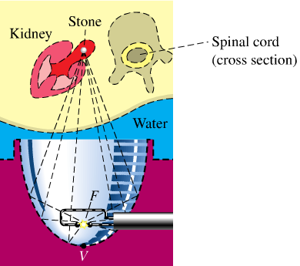

1. Find the distance from *V* to *F*.
2. How far from *V* (in the vertical direction) should a kidney stone located?

***Solution***

***Given***: 

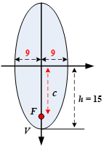





1. 





1. 



***Exercise***

An Artist plans to create an elliptical design with major axis 60′′ and minor axis 24′′, centered on a door that measures 80′′ by 36′′.

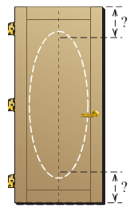

On a vertical line that dissects the door, approximately how far from each end of the door should the push-pins be inserted? How long should the string be?

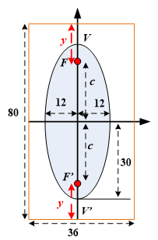***Solution***

***Given***: 















Therefore, the distance from each end of the door should the push-pins be inserted, is 

The string should be 

***Exercise***

An arch of a bridge is semi-elliptical, with major axis horizontal. The base of the arch is 30 *feet*. across, and the highest part of the arch is 10 *feet*. above the horizontal roadway. Find the height of the arch 6 *feet*. from the center of the base.

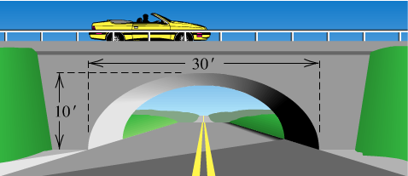

***Solution***

***Given***: 



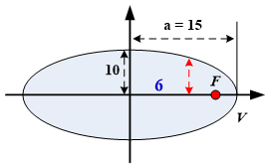 





 









***Exercise***

The whispering gallery in the Museum of Science and Industry in Chicago is 47.3 *feet* long. The distance from the center of the room to the foci is 20.3 *feet*. Find an equation that describes the shape of the room. How high is the room at its center?



***Solution***

Set up a rectangular coordinate so that the center of the ellipse is at the origin and the major axis along the *x*-axis. The equation of the ellipse is

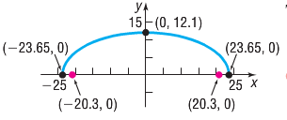

Length of the room: 47.3 *ft*.

Distance from the center of the room to each vertex:





Distance from the center of the room to each focus is 







Therefore, the equation is given: 

The Height of the room: 



***Exercise***

An arch in the shape of the upper half of an ellipse is used to support a bridge that is to span a river 20 *meters* wide. The center of the arch is 6 *meters* above the center of the river. Write an equation for the ellipse in which the *x*-axis coincides with the water level and the *y*-axis passes through the center of the arch.

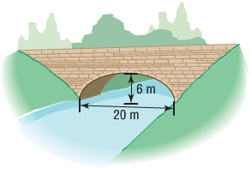

***Solution***

The center of the ellipse is . The length of the major axis is 20, so .

The length of the half minor axis is 6, so .

The ellipse is situated with its major axis on the *x-*axis.

The equation: 



***Exercise***

A bridge is built in the shape of a semielliptical arch. The bridge has a span of 120 *feet* and a maximum height of 25 *feet*. Choose a rectangular coordinate system and find the height of the arch at distances of 10, 30, and 50 *feet* from the center.

***Solution***

Since the bridge has a span of 120 feet, the length of the major axis is 

The maximum height of the bridge is 25 feet, so .

The equation: 



At distance 10 *feet*:









The height from the center is 

At distance **30** *feet*:









The height from the center is 

At distance **50** *feet*:









The height from the center is 

***Exercise***

A bridge is built in the shape of a semielliptical arch. The bridge has a span of 100 *feet*. The height of the arch is 10 *feet*. Find the height of the arch at its center.

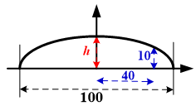***Solution***

Since the bridge has a span of 100 *feet*.

Length of the major axis is 

The maximum height of the bridge is 25 *feet*, so .

The equation: 

The height of the arch 40 *feet* from the center is 10 *feet*.

So  is a point on the ellipse.















The height of the arch at its center is 16.67 *feet*.

***Exercise***

A racetrack is in the shape of an ellipse, 100 *feet* long and 50 *feet* wide. What is the width 10 *feet* from a vertex?

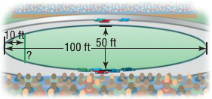

***Solution***

Length of the major axis is 

The maximum height of the bridge is .

The equation: 

We need to find y at 









The width of the ellipse at 10 *feet* from a vertex  is 

***Exercise***

A homeowner is putting in a fireplace that has a 4-*inch* radius vent pipe. He needs to cut an elliptical hole in his roof to accommodate the pipe. If the pitch of his roof is  (a rise of 5, run of 4) what are the dimensions of the hole?

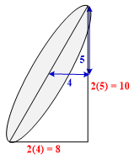***Solution***

The length of the major axis can be determined from the pitch

By using Pythagorean Theorem:



The length of the major axis 

The length of the minor axis:



***Exercise***

A football is in the shape of a ***prolate spheroid***, which is simply a solid obtained by rotating an ellipse about its major axis. An inflated NFL football averages 11.125 *inches* in length and 28.25 *inches* in center circumference. If the volume of a prolate spheroid is , how much air does the football contain? (Neglect material thickness)

***Solution***

The length of the football is 

The center circumference is 

The volume is:







The football contains approximately 471 *cubic inches* of air.

***Exercise***

The fact that the orbit of a planet about the Sun is an ellipse with the Sun at one focus. The ***aphelion*** of a planet is its greatest distance from the Sun, and the ***perihelion*** is its shortest distance. The ***mean distance*** of a planet from the Sun is the length of the semi-major axis of the elliptical orbit.

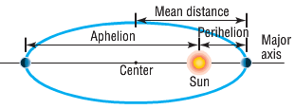

1. The mean distance of Earth from the Sun is 93 million *miles*. If the aphelion of Earth is 94.5 million *miles*, what is the perihelion? Write an equation for the orbit of Earth around the Sun.
2. The mean distance of Mars from the Sun is 142 million *miles*. If the perihelion of Mars is 128.5 million *miles*, what is the aphelion? Write an equation for the orbit of Mars about the Sun.
3. The aphelion of Jupiter is 507 million *miles*. If the distance from the center of it elliptical orbit to the Sun is 23.2 million *miles*, what is the perihelion? What is the mean distance? Write an equation for the orbit of Jupiter around the Sun.
4. The perihelion of Pluto is 4551 million *miles*, and the distance from the center of its elliptical orbit to the Sun is 897.5 million *miles*. Find the aphelion of Pluto. What is the mean distance of Pluto from the Sun? Write an equation for the orbit of Pluto about the Sun.

***Solution***

1. The mean distance is 93 million *miles* 

The length of the major axis is 186 million

The perihelion is 186 − 94.5 = 91.5 million *miles*

Distance from the ellipse center to the sun is the focus: *c* = 93 − 91.5 = 1.5 million *miles*.









Therefore: 

The equation is given by: 

Let *x* and *y* in millions miles: 

The equation of the orbit is: 

1. The mean distance is 142 million *miles* 

The length of the major axis is 284 million

The perihelion is 284 − 128.5 = 155.5 million *miles*

Distance from the ellipse center to the sun is the focus: *c* = 142 − 128.5 = 13.5 million *miles*.





Let *x* and *y* in millions miles: 

The equation of the orbit is: 

1. The mean distance is 507 − 23.2 = 483.8 million *miles* 

The perihelion is 483.8 − 23.2 = 460.6 million *miles*

Distance from the ellipse center to the sun is the focus: *c* = 23.2 million *miles*.





Let *x* and *y* in millions miles: 

The equation of the orbit is: 

1. The mean distance is 4551 + 897.5 = 5448.5 million *miles* 

The aphelion is 5448.5 + 897.5 = 6346 million *miles*

Distance from the ellipse center to the sun is the focus: *c* = 897.5 million *miles*.





Let *x* and *y* in millions miles: 

The equation of the orbit is: 

***Exercise***

Will a truck that is 8 *feet* wide carrying a load that reaches 7 *feet* above the ground the semielliptical arch on the one-way road that passes under the bridge?

***Solution***

***Given***: 

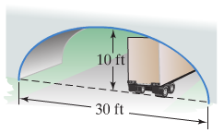 

***Given***: 









Yes, the truck will clear about .

***Exercise***

A semielliptic archway has a height of 20 *feet* and a width of 50 *feet* and a width of 50 *feet*. Can a truck 14 *feet* high and 10 *feet* wide drive under the archway without going into the other lane?

***Solution***

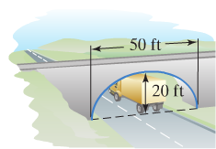***Given***: 

 

***Given***: 











Yes, the truck will clear about .

***Exercise***

The elliptical ceiling in Statuary Hall is 96 *feet* long and 23 *feet* tall.

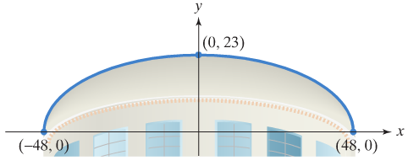

1. Using the rectangular coordinate system in the figure shown, write the standard form of the equation of the elliptical ceiling.
2. John Quincy Adams discovered that he could overhear the conversations of opposing party leaders near the left side of the chamber if he situated his desk at the focus at the right side of the chamber. How far from the center of the ellipse along the major axis did Adams situate his desk?

***Solution***

1. ***Given***: 

 



1. 









He situated desk about 42 *feet* from the center of the ellipse, along the major axis.