***Section* 5.4 – Hyperbolas**

***Definition* of a Hyperbola**

A ***hyperbola*** is the set of all points in a plane, the difference of whose distances from two fixed points (the ***foci***) in the plane is a positive constant.

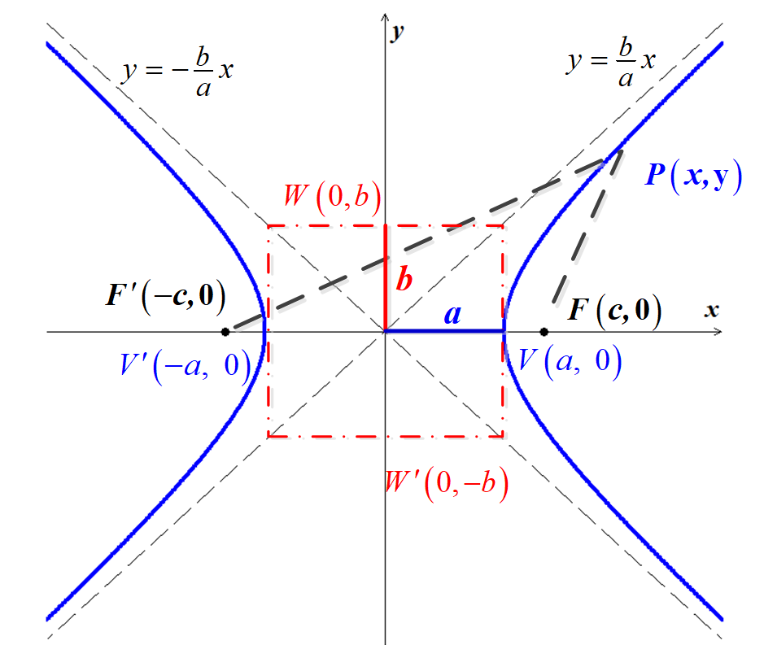

Let  be a point on the hyperbola and  and  (the ***foci***), where the midpoint of *F*′*F* (the origin) is called the *center*. The following is true:



That implies to:































Finally, if we let 



Applying the tests for symmetry, we see that the hyperbola is symmetric with the respect to both axes and the origin.

The ***x***-*intercepts* are *a* and −*a*. The corresponding points  and  are called the ***vertices*** of the ellipse. The line segment  is called the ***transverse*** ***axis***.

The graph has no ***y***-intercept, since  has the *complex* solutions . The points  and  are endpoints of the ***conjugate axis*** *W*′*W* (there are not on the hyperbola)

[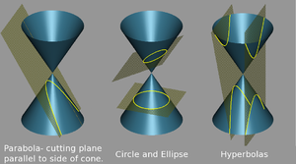](http://en.wikipedia.org/wiki/File:Conic_sections_2.png)

***Example***

Sketch the graph of . Find the foci and equations of the asymptotes.

***Solution***





 

There are no ***y−***intercepts.

The ***endpoints***:

The ***vertices***: 

The ***foci*** are 

The equations of the ***asymptotes*** are:  

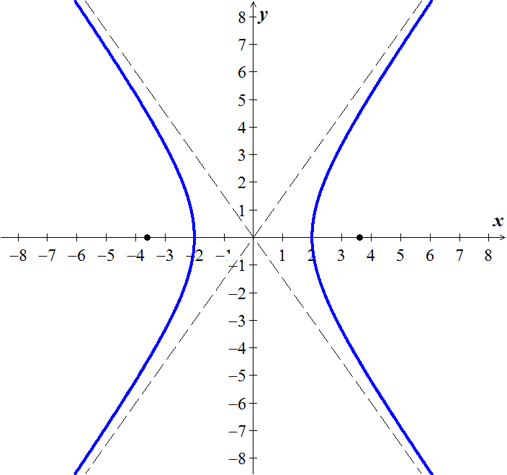

***Example***

Sketch the graph of . Find the foci and equations of the asymptotes.

***Solution***







There are no *x*-intercepts.

The ***endpoints***:

The ***vertices***: 

The ***foci*** are 

The equations of the ***asymptotes*** are:  

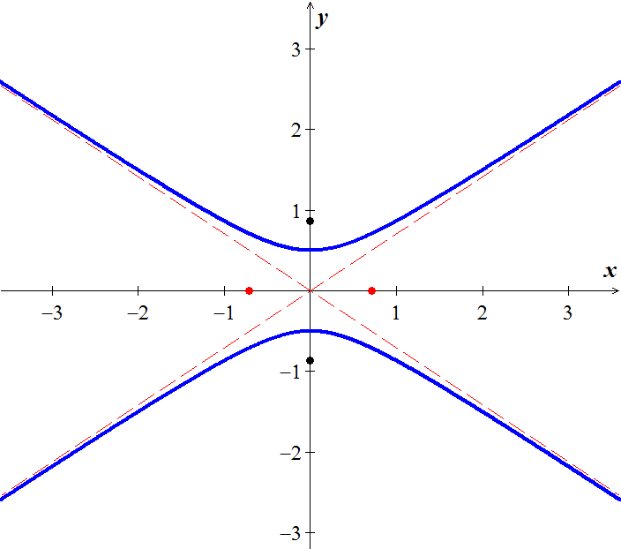

***Example***

A hyperbola has vertices  and passes through the point . Find its equation, foci and asymptotes.

***Solution***



Since  in on the hyperbola 

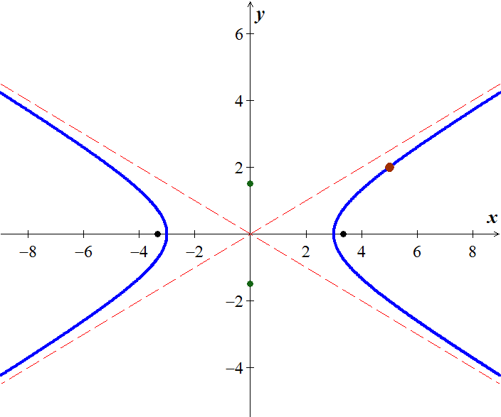













 





The ***foci***: 

The equations of the ***asymptotes*** are:  

***Example***

Coast Guard station *A* is 200 *miles* directly east of another station *B*. A ship is sailing on a line parallel to and 50 *miles* north of the line through *A* and *B*. Radio signals are sent out from *A* and *B* at the rate of  (microsecond). If, at 1:00 PM, the signal from *B* reaches the ship 400 microseconds after the signal from *A*, locate the position of the ship at that time.

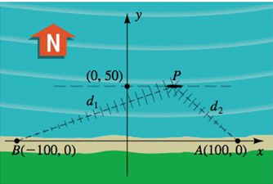

***Solution***

***Given***: 

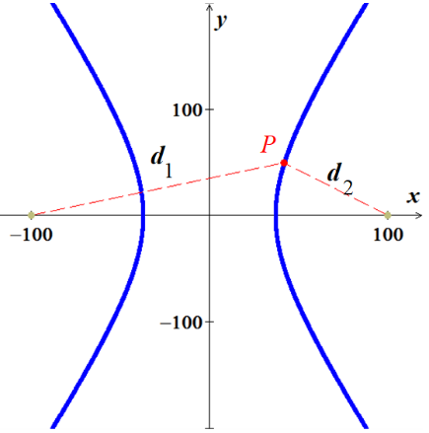





Since 





Distance from the origin to either focus is 

Then, 

 

Since 







**∴** 

***Exercises Section* 5.4 – Hyperbolas**

(**1 – 15**) Find the ***center, vertices***, the ***foci***, ***endpoints*** and the equations of the ***asymptotes*** of the hyperbola. Sketch its graph, showing the asymptotes and the foci.

1. 
2. 
3. 
4. 
5. 
6. 
7. 
8. 
9. 
10. 
11. 
12. 
13. 
14. 
15. 
16. Suppose a hyperbola has center at the origin, foci at  and , and equation . Let , and show that an equation of the hyperbola is 
17. A cooling tower is a hydraulic structure. Suppose its base diameter is 100 *meters* and its smallest diameter of 48 *meters* occurs 84 *meters* from the base. If the tower is 120 *meters* high approximate its diameter at the top.

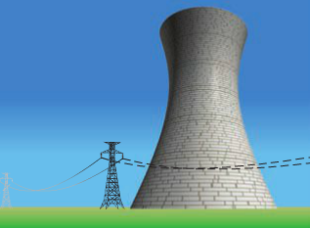

1. An airplane is flyting along the hyperbolic path. If an equation of the path is , determine how close the airplane comes to town located at (3, 0). (Hunt: Let *S* denote the square of the distance from a point (*x, y*) on the path to (3, 0), and find the minimum value of *S*.)

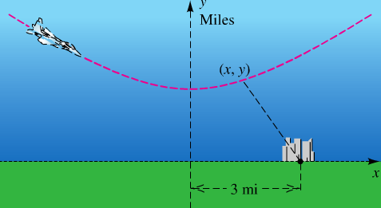

1. A ship is traveling a course that is 100 *miles* from, and parallel tom a straight shoreline. The ship sends out a distress signal that is received by two Coast Guard stations *A* and *B*, located 200 *miles* apart. By measuring the difference in signal reception times, it is determined that the ship is 160 *miles* closer to *B* than to *A*. Where is the ship?

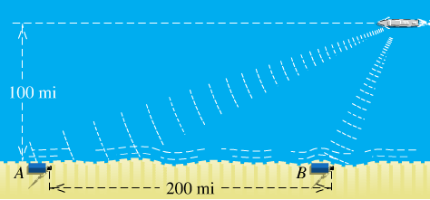

1. The Cassegrain telescope design (dating back to 1672) makes use of the reflective properties of both the parabola and the hyperbola. The figure shows a (split) parabolic mirror, with one focus at  and axis along the line *l*, and a hyperbolic mirror, with one focus also at  and transverse axis along *l*. Where do incoming light waves parallel to the common axis finally collect?

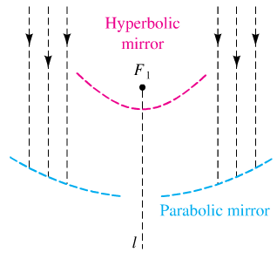

1. Suppose that two people standing 1 *mile* apart both see a flash of lightning. After a period of time, the person standing at point *A* hears the thunder. One second later, the person standing at point *B* hears the thunder. If the person at *B* is due west of the person at *A* and the lightning strike is known to occur due north of the person standing at point *A*, where did the lightning strike occur? (Sound travels at 1100 and  )
2. Ernest Rutherford published a paper that he described the motion of alpha particles as they are shot at a piece of gold foil 0.00004 *cm* thick. Before conducting this experiment, Rutherford expected that the alpha particles would shoot through the foil just as a bullet would shoot through the foil just as a bullet would shoot through snow. Instead, a small fraction of the alpha particles bounced off the foil. This led to the conclusion that the nucleus of an atom is dense, while the remainder of the atom is sparse. Only the density of the nucleus could cause the alpha particles to deviate from their path. The figure shows a diagram from Rutherford’s paper that indicates that the deflected alpha particles follow the path of one branch of a hyperbola.

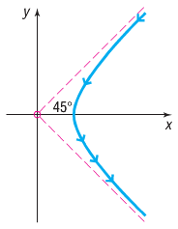

1. Find an equation of the asymptotes under this scenario.
2. If the vertex of the path of the alpha particles is 10 *cm* from the center of the hyperbola, find a model that describes the path of the particle.
3. Hyperbolas have interesting reflective properties that make them useful for lenses and mirrors. For example, if a ray of light strikes a convex hyperbolic mirror on a line that would (theoretically) pass through its rear focus, it is reflected through its rear focus, it is reflected through the front focus. This property and that of the parabola were used to develop the *Cassegrain* telescope in 1672. The focus of the parabolic mirror and the rear focus of the hyperbolic mirror are the same point. The rays are collected by the parabolic mirror, reflected toward the common focus, and thus are reflected by the hyperbolic mirror through the opening to its front focus, where the eyepiece is located. If the equation of the hyperbola is  and the focal length (distance from the vertex to the focus) of the parabola is 6, find the equation of the parabola.
4. The ***eccentricity*** ***e*** of a hyperbola is defined as the number , where *a* is the distance of a vertex from the center and *c* is the distance of a focus from the center. Because *c > a*, it follows that  . Describe the general shape of a hyperbola whose eccentricity is close to 1. What is the shape if *e* is very large?
5. An explosive is recorded by two microphone that are 1 *mile* apart. Microphone  received the sound 2 *seconds* before microphone . Assuming sound travels at 1,100 *feet* per *second*, determine the possible locations of the explosion relative to the location of the microphones.
6. Radio towers *A* and *B*, 200 *km* apart, are situated along the coast, with *A* located due west of *B*. Simultaneous radio signals are sent from each tower to a ship, with the signal from *B* received  before the signal from *A*.
7. Assuming that the radio signals travel , determine the equation of the hyperbola on which the ship is located.
8. If the ship lies due north of tower *B*, how far out at sea is it?
9. An architect designs two houses that are shaped and positioned like a part of the branches of the hyperbola whose equation is , where *x* and *y* are in yards. How far apart are the houses at their closest point?

