***Solution Section* 5.4 – Hyperbolas**

***Exercise***

Find the ***center***, **vertices**, ***foci***, ***endpoints*** and the equations of the ***asymptotes*** of the hyperbola. Sketch its graph, showing the asymptotes and the foci. 

***Solution***





***Center***: 

***Vertices***: 

***Endpoints***: 

***Foci***: 

*Equations of the* ***asymptotes***:  

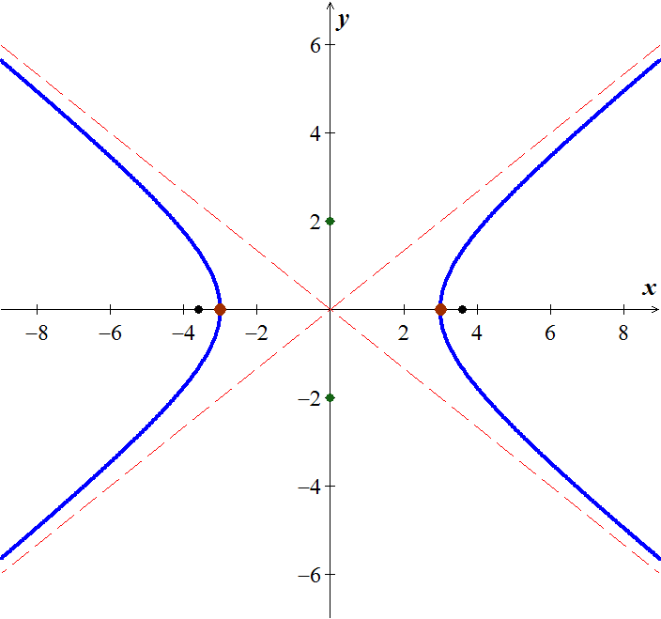

***Exercise***

Find the ***center***, **vertices**, ***foci***, ***endpoints*** and the equations of the ***asymptotes*** of the hyperbola. Sketch its graph, showing the asymptotes and the foci. 

***Solution***





***Center***: 

***Vertices***: 

***Endpoints***: 

***Foci***: 

*Equations of the* ***asymptotes***:

 

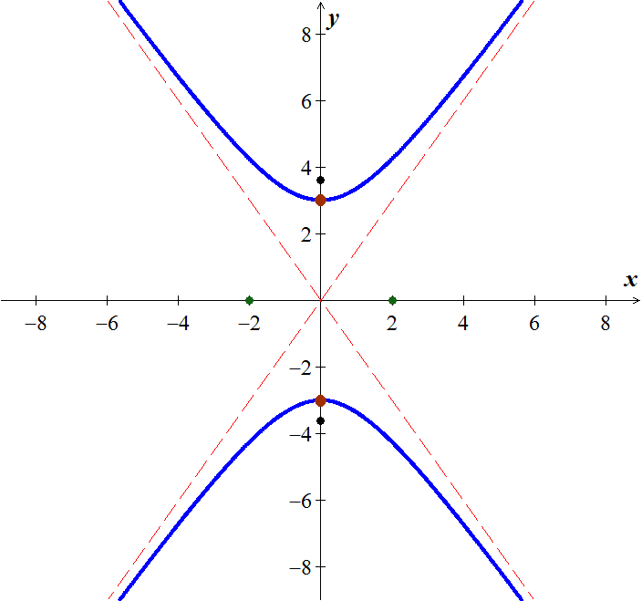

***Exercise***

Find the ***center***, **vertices**, ***foci***, ***endpoints*** and the equations of the ***asymptotes*** of the hyperbola. Sketch its graph, showing the asymptotes and the foci. 

***Solution***





***Center***: 

***Vertices***: 

***Endpoints***: 

***Foci***: 

*Equations of the* ***asymptotes***:  

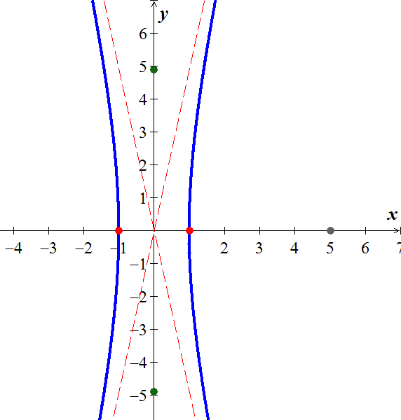

***Exercise***

Find the ***center***, ***vertices***, ***foci***, ***endpoints*** and the equations of the ***asymptotes*** of the hyperbola. Sketch its graph, showing the asymptotes and the foci. 

***Solution***







***Center***: 

***Vertices***: 

***Endpoints***: 

***Foci***: 

*Equations of the* ***asymptotes***:

 

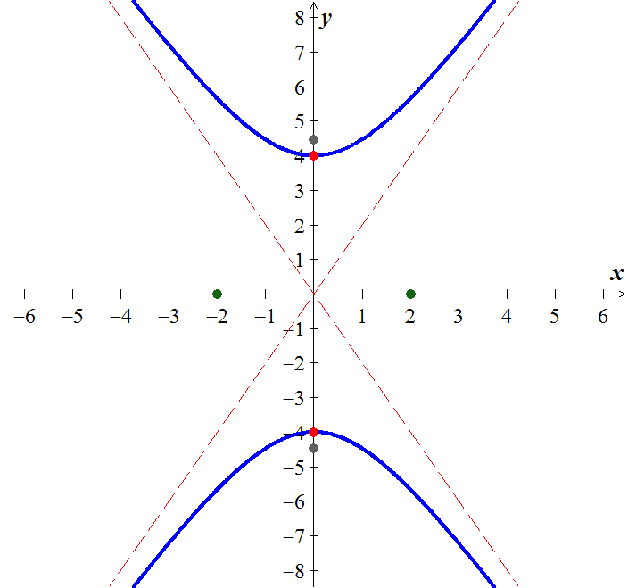

***Exercise***

Find the ***center***, ***vertices***, ***foci***, ***endpoints*** and the equations of the ***asymptotes*** of the hyperbola. Sketch its graph, showing the asymptotes and the foci. 

***Solution***







***Center***: 

***Vertices***: 

***Endpoints***: 

***Foci***: 

*Equations of the* ***asymptotes***:  

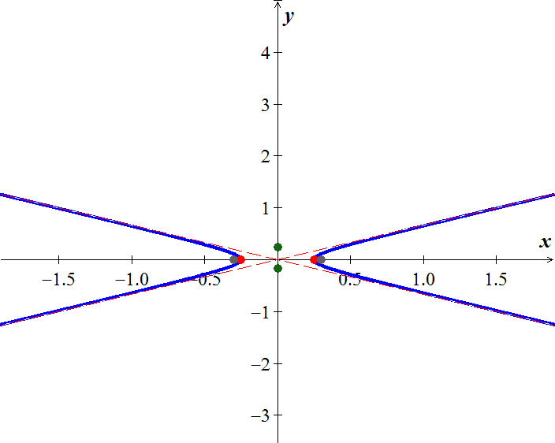

***Exercise***

Find the ***center***, ***vertices***, ***foci***, ***endpoints*** and the equations of the ***asymptotes*** of the hyperbola. Sketch its graph, showing the asymptotes and the foci. 

***Solution***





***Center***: 

***Vertices***: 

***Endpoints***: 

***Foci***: 

*Equations of the* ***asymptotes***: 

|  |  |
| --- | --- |
|  |  |

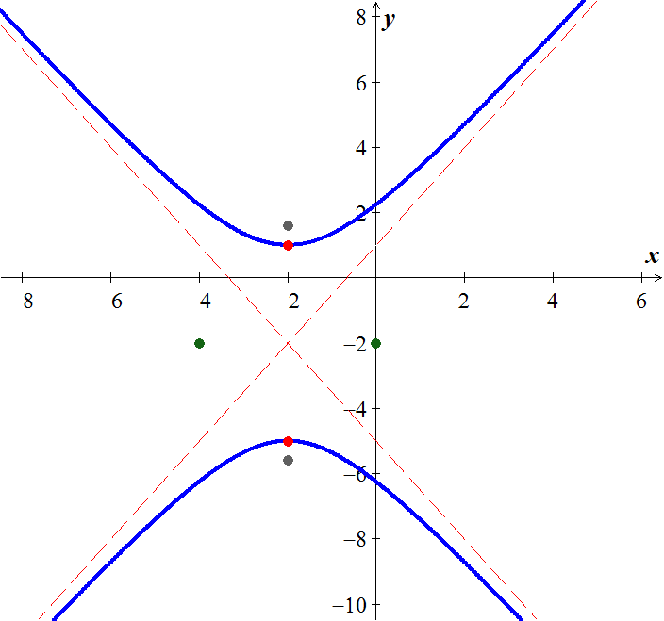

***Exercise***

Find the ***center***, **vertices**, ***foci***, ***endpoints*** and the equations of the ***asymptotes*** of the hyperbola. Sketch its graph, showing the asymptotes and the foci. 

***Solution***



***Center***: 

***Vertices***: 

***Endpoints***: 

***Foci***: 

*Equations of the* ***asymptotes***: 

|  |  |
| --- | --- |
|  |  |



***Exercise***

Find the ***center***, **vertices**, ***foci***, ***endpoints*** and the equations of the ***asymptotes*** of the hyperbola. Sketch its graph, showing the asymptotes and the foci. 

***Solution***







***Center***: 

***Vertices***: 

***Endpoints***: 

***Foci***: 

*Equations of the* ***asymptotes***: 

|  |  |
| --- | --- |
|  |  |



***Exercise***

Find the ***center***, **vertices**, ***foci***, ***endpoints*** and the equations of the ***asymptotes*** of the hyperbola. Sketch its graph, showing the asymptotes and the foci. 

***Solution***







***Center***: 

***Vertices***: 

***Endpoints***: 

***Foci***: 

*Equations of the* ***asymptotes***: 

|  |  |
| --- | --- |
|  |  |



***Exercise***

Find the ***center***, **vertices**, ***foci***, ***endpoints*** and the equations of the ***asymptotes*** of the hyperbola. Sketch its graph, showing the asymptotes and the foci. 

***Solution***



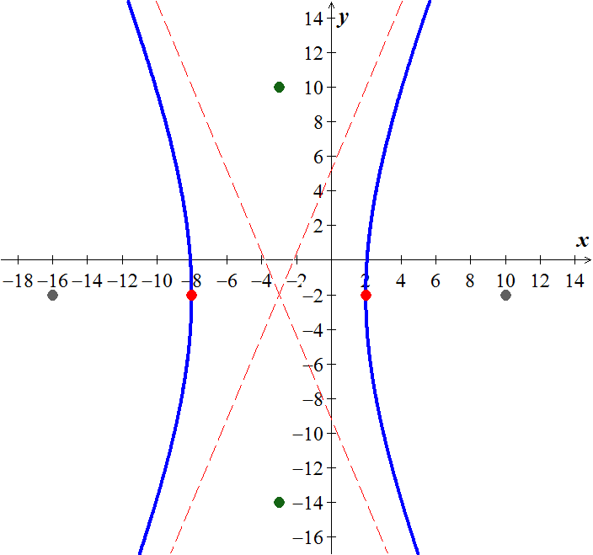









***Center***: 

***Vertices***: 

***Endpoints***: 

***Foci***: 

*Equations of the* ***asymptotes***:



|  |  |
| --- | --- |
|  |  |

***Exercise***

Find the ***center***, **vertices**, ***foci***, ***endpoints*** and the equations of the ***asymptotes*** of the hyperbola. Sketch its graph, showing the asymptotes and the foci. 

***Solution***



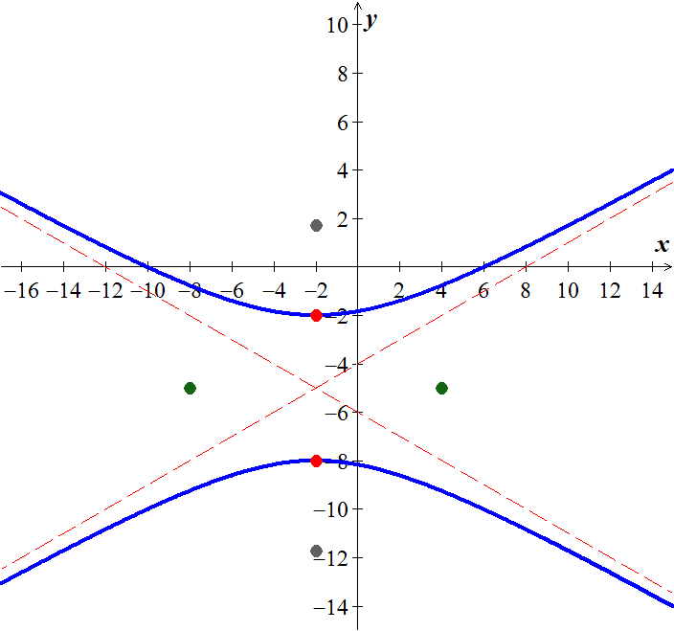











***Center***: 

***Vertices***: 

***Endpoints***: 

***Foci***: 

*Equations of the* ***asymptotes***:



|  |  |
| --- | --- |
|  |  |

***Exercise***

Find the ***center***, **vertices**, ***foci***, ***endpoints*** and the equations of the ***asymptotes*** of the hyperbola. Sketch its graph, showing the asymptotes and the foci. 

***Solution***









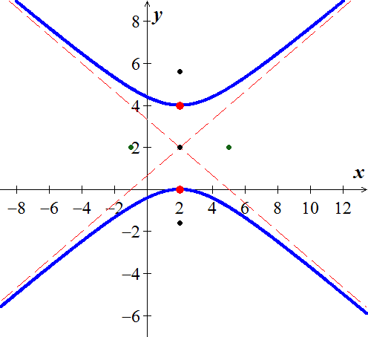













***Center***: 

The ***endpoints***:

The ***vertices***: 

The ***foci*** are 

The equations of the ***asymptotes*** are: 

***Exercise***

Find the ***center***, **vertices**, ***foci***, ***endpoints*** and the equations of the ***asymptotes*** of the hyperbola. Sketch its graph, showing the asymptotes and the foci. 

***Solution***











***Center***: 

***Vertices***: 

***Endpoints***: 

***Foci***: 

*Equations of the* ***asymptotes***: 

|  |  |
| --- | --- |
|  |  |



***Exercise***

Find the ***center***, **vertices**, ***foci***, ***endpoints*** and the equations of the ***asymptotes*** of the hyperbola. Sketch its graph, showing the asymptotes and the foci. 

***Solution***













***Center***: 

***Vertices***: 

***Endpoints***: 

***Foci***: 

*Equations of the* ***asymptotes***: 

|  |  |
| --- | --- |
|  |  |

***Exercise***

Find the ***center***, **vertices**, ***foci***, ***endpoints*** and the equations of the ***asymptotes*** of the hyperbola. Sketch its graph, showing the asymptotes and the foci. 

***Solution***















***Center***: 

***Vertices***: 

***Endpoints***: 

***Foci***: 

*Equations of the* ***asymptotes***: 

|  |  |
| --- | --- |
|  |  |

***Exercise***

Suppose a hyperbola has center at the origin, foci at  and , and equation . Let , and show that an equation of the hyperbola is 

***Solution***

 







 ***Square both sides***



 ***Divide by* 4**



 ***Square both sides***











 



***Exercise***

A cooling tower is a hydraulic structure. Suppose its base diameter is 100 *meters* and its smallest diameter of 48 *meters* occurs 84 *meters* from the base. If the tower is 120 *meters* high approximate its diameter at the top.

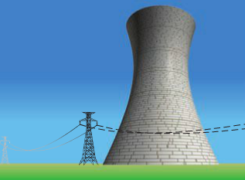***Solution***

***Given***: 



At the point :





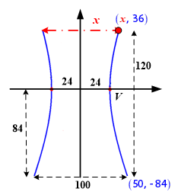





At the point :











The diameter at the top: 

***Exercise***

An airplane is flyting along the hyperbolic path. If an equation of the path is , determine how close the airplane comes to town located at (3, 0). (Hunt: Let *S* denote the square of the distance from a point (*x, y*) on the path to (3, 0), and find the minimum value of *S*.)

***Solution***











The vertex point of 











Therefore the close the town to the airplane is 

***Exercise***

A ship is traveling a course that is 100 *miles* from, and parallel tom a straight shoreline. The ship sends out a distress signal that is received by two Coast Guard stations *A* and *B*, located 200 *miles* apart. By measuring the difference in signal reception times, it is determined that the ship is 160 *miles* closer to *B* than to *A*. Where is the ship?

***Solution***

***Given***: 











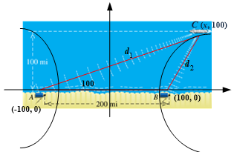

At point C(*x*, 100):











The ship position is 

***Exercise***

The Cassegrain telescope design (dating back to 1672) makes use of the reflective properties of both the parabola and the hyperbola. The figure shows a (***split***) parabolic mirror, with one focus at  and axis along the line *l*, and a hyperbolic mirror, with one focus also at  and transverse axis along *l*. Where do incoming light waves parallel to the common axis finally collect?

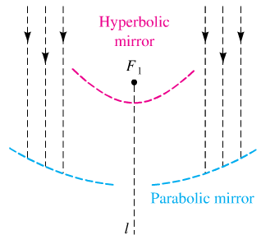

***Solution***



***Exercise***

Suppose that two people standing 1 *mile* apart both see a flash of lightning. After a period of time, the person standing at point *A* hears the thunder. One second later, the person standing at point *B* hears the thunder. If the person at *B* is due west of the person at *A* and the lightning strike is known to occur due north of the person standing at point *A*, where did the lightning strike occur?

(Sound travels at 1100 and  )

***Solution***

Person ***A*** is 1100 *feet* closer to the lightning strike than the person at point ***B***.

Distance from  to ***B*** ***minus*** distance from  to ***A*** is 1100.

The point  lies on a hyperbola whose foci are at ***A*** and ***B***.

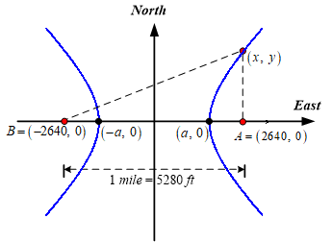











An equation of the hyperbola:

 

At point , let , and solve for *y* at that *x* value:









he lightning strike occurred 12,122 *feet.* north of the person standing at point *A*.

***Exercise***

Ernest Rutherford published a paper that he described the motion of alpha particles as they are shot at a piece of gold foil 0.00004 *cm* thick. Before conducting this experiment, Rutherford expected that the alpha particles would shoot through the foil just as a bullet would shoot through the foil just as a bullet would shoot through snow. Instead, a small fraction of the alpha particles bounced off the foil. This led to the conclusion that the nucleus of an atom is dense, while the remainder of the atom is sparse. Only the density of the nucleus could cause the alpha particles to deviate from their path. The figure shows a diagram from Rutherford’s paper that indicates that the deflected alpha particles follow the path of one branch of a hyperbola.

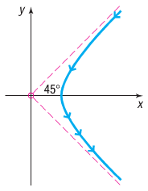

1. Find an equation of the asymptotes under this scenario.
2. If the vertex of the path of the alpha particles is 10 *cm* from the center of the hyperbola, find a model that describes the path of the particle.

***Solution***

1. Since the particles are deflected at a 45° angle, the asymptotes will be 
2. Since the vertex is 10 *cm* from the center of the hyperbola, so



The slope of the asymptotes is given by 

Therfore: 

The equation of the particle path is: 

***Exercise***

Hyperbolas have interesting reflective properties that make them useful for lenses and mirrors. For example, if a ray of light strikes a convex hyperbolic mirror on a line that would (theoretically) pass through its rear focus, it is reflected through its rear focus, it is reflected through the front focus. This property and that of the parabola were used to develop the *Cassegrain* telescope in 1672. The focus of the parabolic mirror and the rear focus of the hyperbolic mirror are the same point. The rays are collected by the parabolic mirror, reflected toward the common focus, and thus are reflected by the hyperbolic mirror through the opening to its front focus, where the eyepiece is located. If the equation of the hyperbola is  and the focal length (distance from the vertex to the focus) of the parabola is 6, find the equation of the parabola.

***Solution***

Assume the origin lies at the center of the hyperbola. The foci of the hyperbola are located on *y*-axis at , since the hyperbola has a transverse axis that is parallel to the *y*-axis.



***Given***: 





Therefore, the foci of the foci of the hyperbola are at 

Assume that he parabola opens up, the common focus is at .

The equation of the parabola: 

The focal length of the parabola is given as 

The distance focus of the parabola is located at 



The equation of the parabola becomes 



***Exercise***

The ***eccentricity*** ***e*** of a hyperbola is defined as the number  , where *a* is the distance of a vertex from the center and *c* is the distance of a focus from the center. Because *c > a*, it follows that . Describe the general shape of a hyperbola whose eccentricity is close to 1. What is the shape if *e* is very large?

***Solution***

Assume  .

If the eccentricity is close to 1, then  and .

When *b* is close to 0, the hyperbola is very narrow, because the slopes of asymptotes are close to 0.

If the eccentricity is very large, then *c* is much larger than *a* and *b*. The result is a hyperbola is very wide, because the slopes of the asymptotes are very large.

For , the opposite is true.

When the eccentricity is close to 1, the hyperbola is very wide because the slopes of the asymptotes are close to 0.

When the eccentricity is very large, the hyperbola is very narrow because the slopes of asymptotes are very large.

***Exercise***

An explosive is recorded by two microphone that are 1 *mile* apart. Microphone  received the sound 2 *seconds* before microphone . Assuming sound travels at 1,100 *feet* per *second*, determine the possible locations of the explosion relative to the location of the microphones.

***Solution***



















 

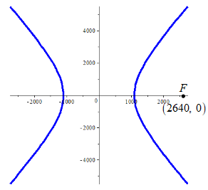

If  is located 2640 *feet* to the right of the origin on the , the explosive is located on the right branch of the hyperbola given by the driven equation.

***Exercise***

Radio towers *A* and *B*, 200 *km* apart, are situated along the coast, with *A* located due west of *B*. Simultaneous radio signals are sent from each tower to a ship, with the signal from *B* received  before the signal from *A*.

1. Assuming that the radio signals travel , determine the equation of the hyperbola on which the ship is located.
2. If the ship lies due north of tower *B*, how far out at sea is it?

***Solution***

1. 













 



1. ***Given***: 









The ship is about 58.3 *km* from the coast.

***Exercise***

An architect designs two houses that are shaped and positioned like a part of the branches of the hyperbola whose equation is , where *x* and *y* are in yards. How far apart are the houses at their closest point?

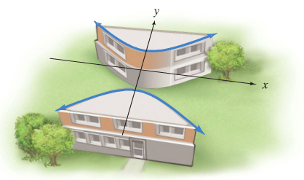

***Solution***











The houses are 40 *yards* apart at their closest point.