***Section* 5.6 – Arithmetic and Geometric Sequences**

***Arithmetic Sequence***

***Definition* of Arithmetic Sequence**

A sequence  is an arithmetic sequence if there is a real number ***d*** such that for every positive integer ***k***,



The number  is called the ***common difference*** of the sequence.

***Example***

Show that the sequence: 1, 4, 7, 10, … , 3*n* – 2, … is arithmetic, and find the common difference.

***Solution***

If , then for every positive integer *k*,







Hence, the given sequence is arithmetic with common difference 3.

***The nth Term of an Arithmetic Sequence***: 

***Example***

The first three terms of an arithmetic sequence are 20, 16.5, and 13. Find the fifteenth term.

***Solution***

The common difference is: 

Substituting  in the formula:







***Example***

The fourth term of an arithmetic sequence is 5, and the ninth term is 20. Find the sixth term.

***Solution***

***Given***: 

 

















***Theorem***

**Formulas for **

If  is an arithmetic sequence with common difference ***d***, then the *n*th partial sum  (that is, the sum of the first ***n*** terms) is given by either



***Proof***







 ***Using the formula of sum:*** 





***Example***

Find the sum of all even integers from 2 through 100.

***Solution***

The arithmetic sequence: 2, 4, 6, …, 2n, …

Substituting  in the formula:





***Example***

Express in terms of summation notation: 

***Solution***



Using the formula for *n*th term:





Hence the *n*th term is:



***Geometric Sequence***

**Definition of *Geometric* Sequence**

A sequence  is a geometric sequence if  and if there is a real number  such that for every positive integer *k*.



The number  is called the ***common ratio*** of the sequence.

***The formula for the nth Term of a Geometric Sequence***: 

The common ratio for:  is 

***Example***

A geometric sequence has first term 3 and common ratio . Find the first five terms and the tenth term.

***Solution***





 

 

 

 

 

***Example***

The third term of a geometric is 5, and the sixth term is −40. Find the eighth term.

***Solution***

***Given***: 





 















***Theorem*: Formula for **

The nth partial sum  of a geometric sequence with first term  and common ratio  is



***Proof***

By definition, the nth partial sum  of a geometric sequence is:







***Example***

If the sequence  is a geometric sequence, find the sum of the first five terms.

***Solution***

***Given***: 









***Theorem* on the Sum of an Infinite Geometric Series**

If , then the infinite geometric series  has the sum



***Example***

Find the sum *S* of the alternating infinite geometric series: to 

***Solution***











***Example***

Find a rational number that corresponds to 

***Solution***



















***Example***

Initially, a pendulum swings through an arc of 18 *inches*. On each successive swing, the length of the arc is 0.98 of the previous length.

1. 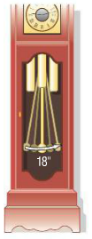What is the length of the arc of the 10th swing?
2. On which swing is the length of the arc first less than 12 inches?
3. After 15 swings, what total distance will the pendulum have swung?
4. When it stops, what total distance will the pendulum have swung?

***Solution***

1. The length of the first swing: 

The length of the second swing: 



The length of the arc of the 10th swing is:





1. 









The length of the arc of the pendulum exceeds 12 inches on the 21st swing and the first less than 12 inches on the 22nd swing.

1.  



1.  



The pendulum will have swung a total of 900 *inches* when it finally stops.

***Exercises Section* 5.6 – Arithmetic and Geometric Sequences**

1. Show that the sequence  is arithmetic, and find the common difference.

(**2 – 14**) Find the *n*th term, and the tenth term of the arithmetic sequence:

|  |  |  |
| --- | --- | --- |
|  |  |  |

(**15 – 26**) Find the common difference for the arithmetic sequence with the specified terms:

|  |  |
| --- | --- |
|  |  |

Find the sum  of the arithmetic sequence that satisfies the conditions:

1. 
2. 
3. Find the number of terms in the arithmetic sequence with the given conditions: 
4. Find the number of integers between 32 and 390 that are divisible by 6, find their sum.

(**31 – 44**) Find each arithmetic sum

|  |  |
| --- | --- |
|  |  |

1. Show that the given sequence is geometric, and find the common ratio



(**46 – 61**) Find the ***n***th term, the fifth term, and the eighth term of the geometric sequence

|  |  |
| --- | --- |
|  |  |

1. Find all possible values of ***r*** for a geometric sequence with the two given terms 
2. Find the sixth term of the geometric sequence whose first two terms are 4 and 6

(**64 – 71**) Find the specified term of the geometric sequence that that has 2 given terms

|  |  |
| --- | --- |
|  |  |

(**72 – 83**) Express the sum in terms of summation notation (Answers are not unique.)

|  |  |
| --- | --- |
|  |  |

(**84 – 97**) Find the sum of the infinite geometric series if it exists:

|  |  |
| --- | --- |
|  |  |

(**98 – 117**) Find the sum:

|  |  |  |
| --- | --- | --- |
|  |  | 5. The sum of the first 120 terms of      1. The sum of the first 46 terms of |

(**118 – 124**) Find the rational number represented by the repeating decimal

|  |  |  |  |
| --- | --- | --- | --- |
|  |  |  |  |

1. Find *x* so that , , and  are consecutive terms of an arithmetic sequence.
2. Find *x* so that , , and  are consecutive terms of an arithmetic sequence.
3. Find *x* so that , , and  are consecutive terms of a geometric sequence.
4. Find *x* so that ,  and  are consecutive terms of a geometric sequence.
5. How many terms must be added in an arithmetic sequence whose first term is 11 and whose common difference is 3 to obtain a sum of 1092?
6. How many terms must be added in an arithmetic sequence whose first term is 78 and whose common difference is −4 to obtain a sum of 702?
7. The first ten rows of seating in a certain section of a stadium have 30 seats, 32 seats, 34 seats, and so on. The eleventh through the twentieth rows each contain 50 seats. Find the total number of seats in the section.
8. The corner section of a football stadium has 15 seats in the first row and 40 rows in all. Each successive row contains two additional seats. How many seats are in this section?

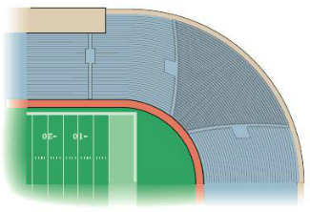

1. A gain bin is to be constructed in the shape of a frustum of a cone.

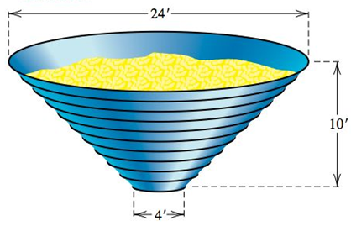

The bin is to be 10 *feet* tall with 11 metal rings positioned uniformly around it, from the 4-foot opening at the bottom to the 24-foot opening at the top. Find the total length of metal needed to make the rings.

1. A bicycle rider coasts downhill, traveling 4 *feet* the first second. In each succeeding second, the rider travels 5 *feet* farther than in the preceding second. If the rider reaches the bottom of the hill in 11 *seconds*, find the total distance traveled.
2. A contest will have five each prizes totaling $5,000, and there will be a $100 difference between successive prices. Find the first prize.
3. A Company is to distribute $46,000 in bonuses to its top ten salespeople. The tenth salesperson on the list will receive $1,000, and the difference in bonus money between successively ranked salesperson is to be constant. Find the bonus for each salesperson.
4. Assuming air resistance is negligible, a small object that is dropped from a hot air balloon falls 16 *feet* during the first second, 48 *feet* during the second second, 80 *feet* during the third second, 112 *feet* during the fourth second, and so on. Find an expression for the distance the object falls in *n* seconds.
5. A brick staircase has a total of 30 steps. The bottom step requires 100 bricks. Each successive step requires two fewer bricks than the prior step.
6. How many bricks are required for the top step?
7. How many bricks are required to build the staircase?
8. A mosaic is designed in the shape of an equilateral triangle, 20 feet on each side. Each tile in the mosaic is in the shape of an equilateral triangle, 12 inches to a side. The tiles are to alternate in color as shown below.

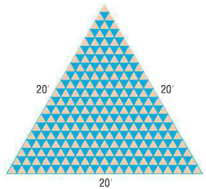

How many tiles of each color will be required?