***Lecture* *Six* – Trigonometric**

***Section* 6.1 – Introduction**

**Basic Terminology**

Two distinct points determine line *AB*.

***Line segment AB:*** portion of the line between *A* and *B*. 

***Ray AB***: portion of the line *AB* starts at *A* and continues through *B*, and past *B*.

*A B*

***Angles* in General**

An angle is formed by 2 rays with the same end point.

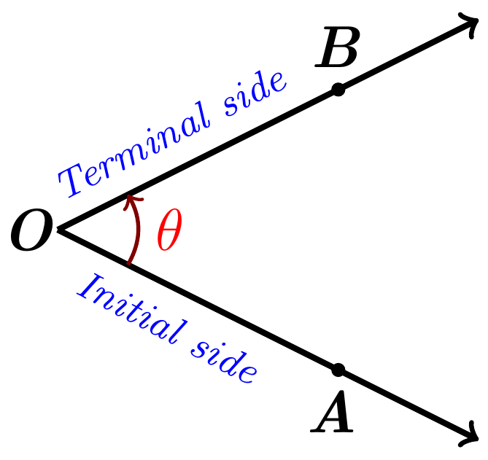

The two rays are the sides of the angle, angle *θ* = *AOB*

***O*** is the common endpoint and it is called ***vertex*** of the angle**.**

An angle is in a Counterclockwise (***CCW***) direction: positive angle.

An angle is in a Clockwise (***CW***) direction: negative angle.

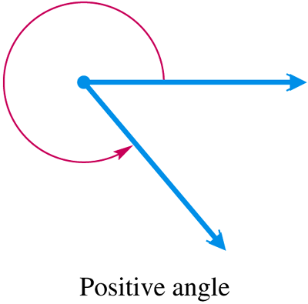 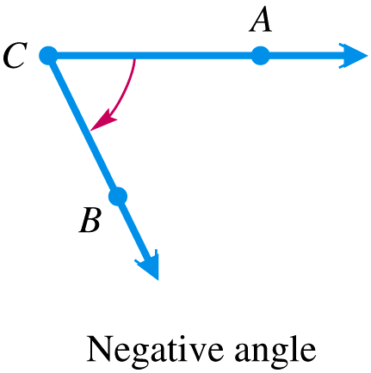

**Type of Angles: *Degree***

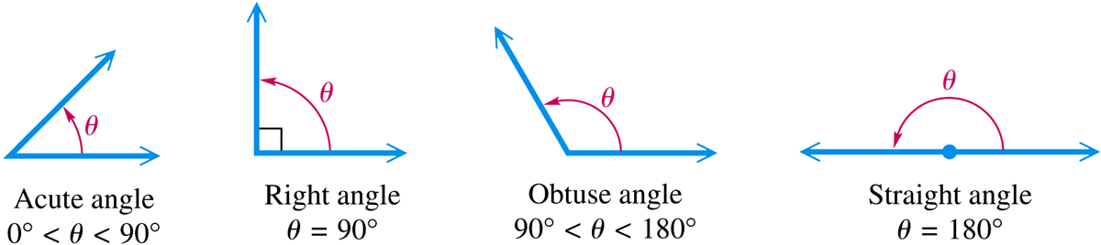

***Complementary angles***: α + β = 90°

***Supplementary angles***: α + β = 180°

***Example***

Give the complement and the supplement of each angle: 

***Solution***

1. 40° Complement: 90° − 40° = 50° Supplement:180° − 40° = 140°
2. 110° Complement: 90° − 110° = -20° Supplement:180° − 110° = 70°

***Degrees, Minutes, Seconds***

1°: 1 *degree*

: 1 *minute*

: 1 *second*

**1 *full Rotation*** or ***Revolution* = 360° ** 

***Example***

Change 27.25° to degrees and minutes

***Solution***

27.25° = 27° + .25°

= 27° + .25(**60′**)

= 27° + 15′



***Example***

Add  and 

***Solution***







***Example***

Subtract  and 

***Solution***



**Angles in Standard Position**

An angle is said to be in standard position if its initial side is along the positive *x*-axis and its vertex is at the origin. If angle *θ* is in standard position and the terminal side of *θ* lies in quadrant I, then we say *θ* lies in QI



If the terminal side of an angle in standard position lies along one of the axes (*x*-axis or *y*-axis), such as angles with measures 90°, 180°, 270°, then that called a ***quadrantal*** *angle*.

Two angles in standard position with the same terminal side are called ***coterminal*** *angles*.

**90°**

*Q* II

(− , +)

*Q* I

(+ , +)

**180°**

**0°**

**360°**

**−90°**

*Q* IV

(+ , −)

*Q* III

( − , −)

**270°**

***Example***

Find all angles that are coterminal with 120°.

***Solution***

120° + 360°*k*

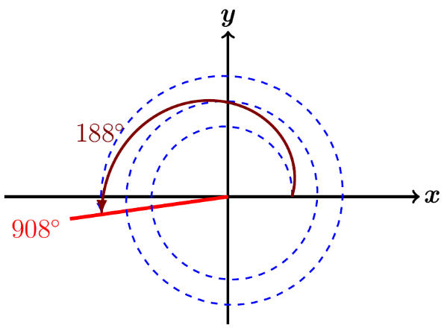***Example***

Find the angle of least possible positive measure coterminal with an angle of 908°.

***Solution***



An angle of 908° is coterminal with an angle of 188°

***Triangles***

|  |  |
| --- | --- |
| ***Equilateral*** – All angles always equal to 60°& all sides are equals | ***Isosceles***: 2 sides and angles are equals |
| ***Scalene***: No equal sides or angles | ***Right***: Has a right angle 90°. |
| ***Obtuse***: Has an angle more than 90°. | ***Acute***: All angles are less than 90°. |

***Radians***

**Degrees - Radians**

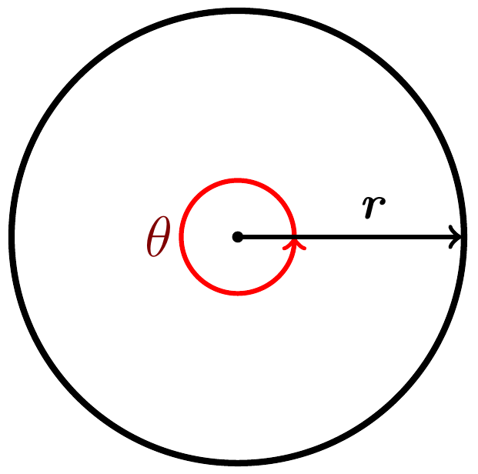





1° = 1 *degree*

***If no unit of angle measure is specified, then the angle is to be measured in radians.***





***Converting from Degrees to Radians***

 

Multiply a degree measure by  and simplify to convert to radians.

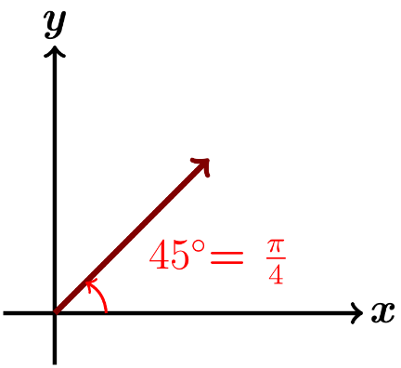

***Example***

Convert 45° to radians

***Solution***





***Example***

Convert -450° to radians

***Solution***





***Example***

Convert 249.8° to radians

***Solution***







***Converting from Radians to Degrees***

Multiply a radian measure by radian and simplify to convert to degrees.





***Example***

Convert  to *degrees*

***Solution***







***Example***

Convert  to *degrees*

***Solution***





***Example***

Convert −4.5 to *degrees*

***Solution***





***Exercises*** ***Section* 6.1– Introduction**

1. Indicate the angle if it is an acute or obtuse. Then give the complement and the supplement of each angle.

*a*) 10° *b*) 52° *c*) 90° *d*) 120° *e*) 150°

1. Change to decimal degrees.

|  |  |  |  |
| --- | --- | --- | --- |
| 1. 10° 45′ |  |  |  |

1. Convert to degrees, minutes, and seconds.

|  |  |  |  |
| --- | --- | --- | --- |
|  |  |  |  |

1. Perform each calculation

|  |  |  |  |
| --- | --- | --- | --- |
|  |  |  |  |

1. Find the angle of least possible positive measure coterminal with an angle of

|  |  |  |
| --- | --- | --- |
| 1. −75° | 1. −800° | 1. 270° |

1. Convert to radians

|  |  |  |  |  |
| --- | --- | --- | --- | --- |
|  |  |  |  |  |

1. Convert to degrees

|  |  |  |  |
| --- | --- | --- | --- |
|  |  |  |  |

1. A vertical rise of the Forest Double chair lift 1,170 *feet* and the length of the chair lift as 5,570 *feet*. To the nearest foot, find the horizontal distance covered by a person riding this lift.
2. A tire is rotating 600 times per *minute*. Through how many degrees does a point of the edge of the tire move in  second?
3. A windmill makes 90 *revolutions* per *minute*. How many revolutions does it make per second?