***Solution*** ***Section* 6.2 – Arc Length & Area − Velocity**

***Exercise***

The minute hand of a clock is 1.2 *cm* long. How far does the tip of the minute hand travel in 40 *minutes*?

***Solution***





 





***Exercise***

Find the radian measure if angle *θ*, if *θ* is a central angle in a circle of radius *r* = 4 *inches*, and *θ* cuts off an arc of length *s* = 12π *inches*.

***Solution***

 



***Exercise***

Give the length of the arc cut off by a central angle of 2 *radians* in a circle of radius 4.3 *inches*

***Solution***

***Given***: 

 



***Exercise***

A space shuttle 200 *miles* above the earth is orbiting the earth once every 6 *hours*. How long, in hours, does it take the space shuttle to travel 8,400 *miles*? (Assume the radius of the earth is 4,000 *miles*.) Give both the exact value and an approximate value for your answer.

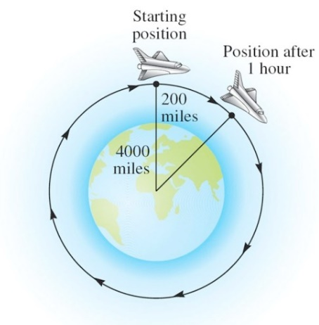***Solution***

 











***Exercise***

The pendulum on a grandfather clock swings from side to side once every second. If the length of the pendulum is 4 *feet* and the angle through which it swings is 20°. Find the total distance traveled in 1 *minute* by the tip of the pendulum on the grandfather clock.

***Solution***

Since 



The length of the pendulum swings in 1 second:





In 60 seconds, the total distance traveled



 

***Exercise***

Reno, Nevada is due north of Los Angeles. The latitude of Reno is 40°, while that of Los Angeles is 34° N. The radius of Earth is about 4000 *mi*. Find the north-south distance between the two cities.

***Solution***

The central angle between two cities: 

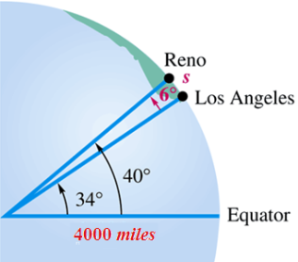



 





***Exercise***

The first cable railway to make use of the figure-eight drive system was a Sutter Street Railway. Each drive sheave was 12 *feet* in diameter.

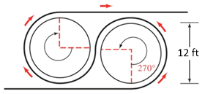

Find the length of cable riding on one of the drive sheaves.

***Solution***

Since 



The length of the cable riding on one of the drive sheaves is:

 





***Exercise***

The diameter of a model of George Ferris’s Ferris wheel is 250 *feet*, and *θ* is the central angle formed as a rider travels from his or her initial position  to position . Find the distance traveled by the rider if  and if .

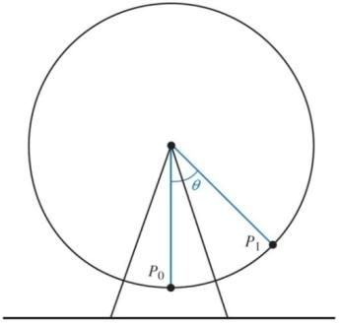***Solution***



For *θ* = 45°

 





For *θ* = 105°











***Exercise***

Two gears are adjusted so that the smaller gear drives the larger one. If the smaller gear rotates through an angle of 225°, through how many degrees will the larger gear rotate?

***Solution***

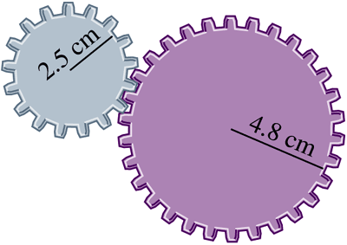











***Exercise***

If a central angle with its vertex at the center of the earth has a measure of 1′, then the arc on the surface of the earth that is cut off by this angle (knows as the great circle distance) has a measure of 1 *nautical* *mile*.

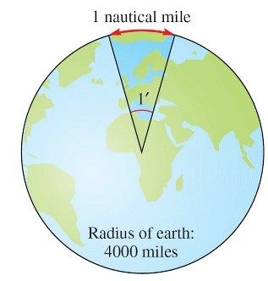***Solution***









 



 

***Exercise***

If two ships are 20 *nautical miles* apart on the ocean, how many statute miles apart are they?

***Solution***











 







***Exercise***

Two gears are adjusted so that the smaller gear drives the larger one. If the smaller gear rotates through an angle of 300°, through how many degrees will the larger rotate?

***Solution***

Both gears travel the same arc distance (*s*), therefore:

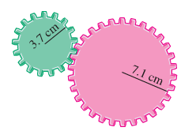









***Exercise***

The rotation of the smaller wheel causes the larger wheel to rotate. Through how many degrees will the larger wheel rotate if the smaller one rotates through 60.0°?

***Solution***

Both gears travel the same arc distance (*s*), therefore:

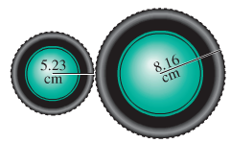







***Exercise***

Find the radius of the larger wheel if the smaller wheel rotates 80° when the larger wheel rotates 50°.

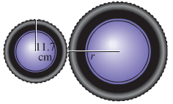***Solution***









***Exercise***

How many inches will the weight rise if the pulley is rotated through an angle of 71° 50′?

Through what angle, to the nearest minute, must the pulley be rotated to raise the weight 6 in?

***Solution***

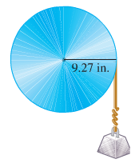****

















***Exercise***

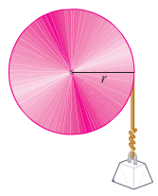Find the radius of the pulley if a rotation of 51.6° raises the weight 11.4 *cm*.

***Solution***





***Exercise***

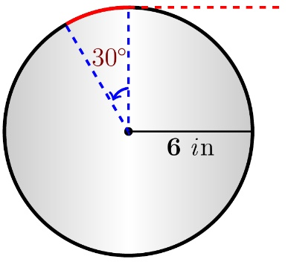A rope is being wound around a drum with radius 6 *inches*. How much rope will be wound around the drum if the drum is rotated through an angle of 30°?

***Solution***

** **



***Exercise***

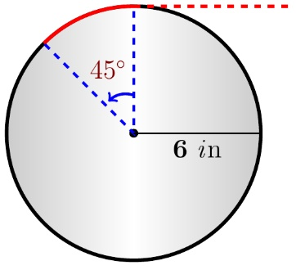A rope is being wound around a drum with radius 6 *inches*. How much rope will be wound around the drum if the drum is rotated through an angle of 45°?

***Solution***

** **



***Exercise***

The figure shows the chain drive of a bicycle. How far will the bicycle move if the pedals are rotated through 180°? Assume the radius of the bicycle wheel is 13.6 *in*.

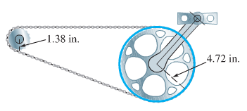***Solution***



The distance for the pedal gear:



For the smaller gear:







The wheel distance:



 

***Exercise***

The circular of a Medicine Wheel is 2500 *yrs* old. There are 27 aboriginal spokes in the wheel, all equally spaced.

1. Find the measure of each central angle in degrees and in radians.
2. The radius measure of each of the wheel is 76.0 *ft*, find the circumference.
3. Find the length of each arc intercepted by consecutive pairs of spokes.
4. Find the area of each sector formed by consecutive spokes,

***Solution***

1. The central angle: 

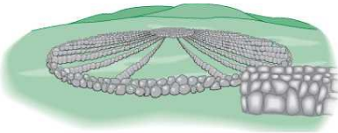 



1. 

 

1. Since 

 



1. *Area* 



 

***Exercise***

The total arm and blade of a single windshield wiper was 10 *in*. long and rotated back and forth through an angle of 95°. The shaded region in the figure is the portion of the windshield cleaned by the 7-*in*. wiper blade. What is the area of the region cleaned?

***Solution***

The total angle:





: The area of arm only (not cleaned by the blade).

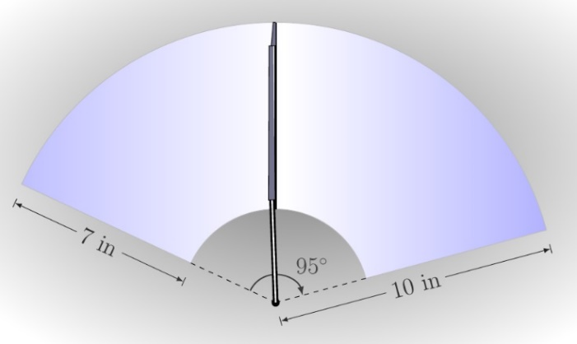



: The area of arm and the blade.





The total cleaned area:







 

***Exercise***

A frequent problem in surveying city lots and rural lands adjacent to curves of highways and railways is that of finding the area when one or more of the boundary lines is the arc of the circle. Find the area of the lot.

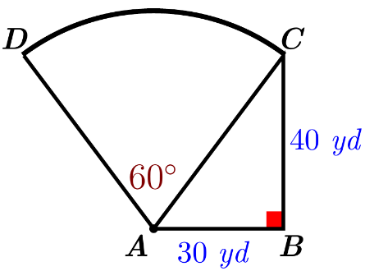***Solution***

Using the Pythagorean theorem:



Total area = Area of the sector (ADC) + Area of the triangle (ABC)

Total area 







***Exercise***

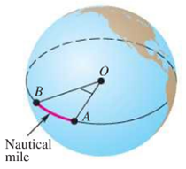Nautical miles are used by ships and airplanes. They are different from statue miles, which equal 5280 *ft*. A nautical mile is defined to be the arc length along the equator intercepted by a central angle AOB of 1 *min*. If the equatorial radius is 3963 *mi*, use the arc length formula to approximate the number of statute miles in 1 *nautical mile*.

***Solution***





The arc length:

 



There are  *statute miles* in 1 nautical mile.

***Exercise***

The distance to the moon is approximately 238,900 *mi*. Use the arc length formula to estimate the diameter *d* of the moon if angle *θ* is measured to be 0.5170°.

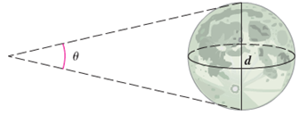***Solution***

 





***Exercise***

The minute hand of a clock is 1.2 *cm* long. To two significant digits, how far does the tip of the minute hand move in 20 *minutes*?

***Solution***

***Given***: *r* = 1.2 *cm*

*One complete rotation =* 1 *hour =* 60 *minutes =* 2π





 







***Exercise***

If the sector formed by a central angle of 15° has an area of cm2, find the radius of a circle.

***Solution***

***Given***:  











**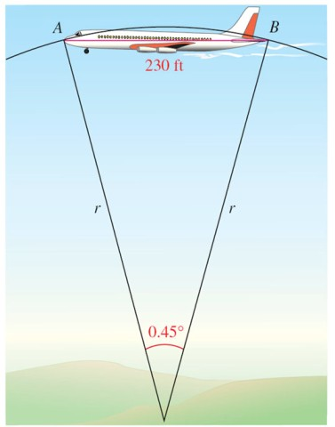*Exercise***

A person standing on the earth notices that a 747 jet flying overhead subtends an angle 0.45°. If the length of the jet is 230 *ft.*, find its altitude to the nearest thousand feet.

***Solution***

 





***Exercise***

Suppose that *P* is on a circle with radius 10 *cm*, and ray O*P* is rotating with angular speed 

1. Find the angle generated by *P* in 6 *seconds*
2. Find the distance traveled by *P* along the circle in 6 *seconds*.
3. Find the linear speed of *P* in *cm* per *sec*.

***Solution***

1.  



1.  



1.  



***Exercise***

A belt runs a pulley of radius 6 *cm* at 

1. Find the angular speed of the pulley in *radians per sec*.
2. Find the linear speed of the belt in *cm per sec*.

***Solution***

1. 



1.  

 

***Exercise***

Find the linear velocity of a point moving with uniform circular motion, if *s* = 12 *cm* and *t* = 2 *sec*.

***Solution***

 



***Exercise***

Find the distance ***s*** covered by a point moving with linear velocity *v* = 55 *mi/hr* and *t* = 0.5 *hr*.

***Solution***

 



***Exercise***

Point *P* sweeps out central angle *θ* = 12π as it rotates on a circle of radius *r* with *t* = 5π sec. Find the angular velocity of point *P*.

***Solution***

 





***Exercise***

When Lance Armstrong blazed up Mount Ventoux in the 2002 tour, he was equipped with a 150-*millimeter*-diameter chainring and a 95-*millimeter*-diameter sprocket. Lance is known for maintaining a very high cadence, or pedal rate. If he was pedaling at a rate of 90 *revolutions* per *minute*, find his speed in *kilometers* per *hour*. (1 *km* = 1,000,000 *mm* or 106 *mm*)

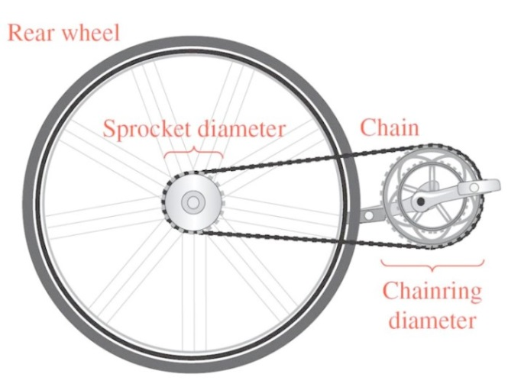***Solution***

*Chainring*:













*Sprocket*:













***Exercise***

Find the angular velocity, in radians per minute, associated with given 7.2 *rpm*.

***Solution***





 

***Exercise***

Suppose that point *P* is on a circle with radius 60 *cm*, and ray *OP* is rotating with angular speed  *radian per sec*.

1. Find the angle generated by *P* in 8 *sec*.
2. Find the distance traveled by *P* along the circle in 8 *sec*.
3. Find the linear speed of *P*.

***Solution***

1. 



1. 



1. 

***Exercise***

Tires of a bicycle have radius 13 *in*. and are turning at the rate of 215 *revolutions per min*. How fast is the bicycle traveling in miles per hour? (*Hint*: 1 *mi* = 5280 *ft*.)

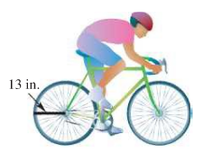***Solution***













***Exercise***

Earth travels about the sun in an orbit that is almost circular. Assume that the orbit is a circle with radius 93,000,000 *mi*. Its angular and linear speeds are used in designing solar-power facilities.

1. Assume that a year is 365 *days*, and find the angle formed by Earth’s movement in one day.
2. Give the angular speed in *radians per hour*.
3. Find the linear speed of Earth in *miles per hour*.

***Solution***

1. 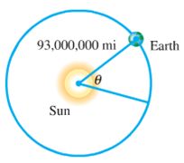



1. 



1. 



***Exercise***

Earth revolves on its axis once every 24 *hr*. Assuming that earth’s radius is 6400 *km*, find the following.

1. Angular speed of Earth in radians per day and radians per hour.
2. Linear speed at the North Pole or South Pole
3. Linear speed ar a city on the equator

***Solution***

1.  





1. At the poles, *r* = 0 so ***v*** = *rw* = 0
2. At the equator, *r* = 6400 *km*

 







***Exercise***

The pulley has a radius of 12.96 *cm*. Suppose it takes 18 *sec* for 56 *cm* of belt to go around the pulley.

1. Find the linear speed of the belt in *cm per sec*.
2. Find the angular speed of the pulley in *rad per sec*.

***Solution***

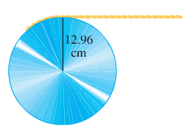***Given***: *s* = 56 *cm* in *t* = 18 sec *r* = 12.96 *cm*

1. 



1. 





***Exercise***

The two pulleys have radii of 15 *cm* and 8 *cm*, respectively. The larger pulley rotates 25 times in 36 *sec*. Find the angular speed of each pulley in *rad per sec*.

***Solution***

***Given***:  

The angular velocity of the larger pulley is:

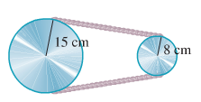 



The linear velocity of the larger pulley is:





The angular velocity of the smaller pulley is:





***Exercise***

A thread is being pulled off a spool at the rate of 59.4 *cm per sec*. Find the radius of the spool if it makes 152 *revolutions per min*.

***Solution***

***Given***:  

 







***Exercise***

A railroad track is laid along the arc of a circle of radius 1800 *feet*. The circular part of the track subtends a central angle of 40°. How long (in seconds) will it take a point on the front of a train traveling 30 *mph* to go around this portion of the track?

***Solution***

***Given***: *r* = 1800 *ft*.





The arc length:

 













***Exercise***

A 90-*horsepower* outboard motor at full throttle will rotate it propeller at exactly 5,000 r*evolutions per min*. Find the angular speed of the propeller in radians per second.

***Solution***







***Exercise***

The shoulder joint can rotate at 25 *rad/min*. If a golfer’s arm is straight and the distance from the shoulder to the club head is 5.00 *feet*., find the linear speed of the club head from the shoulder rotation.

***Solution***

***Given***: 





***Exercise***

A vendor sells two sizes of pizza by the slice. The small slice is  of a circular 18−*inch*−diameter pizza, and it sells for $2.00. The large slice is  of a circular 26−*inch*−diameter pizza, and it sells for $3.00. Which slice provides more pizza per dollar?

***Solution***

Area of 18−*inch*−diameter: 

Area of 26−*inch*−diameter: 

For the small slice: 

For the small slice: 

∴ the Large size will provide more pizza per dollar

***Exercise***

A cone−shaped tent is made from a circular piece of canvas 24 *feet* in diameter by removing a sector with central angle  and connecting the ends. What is the surface area of the tent?

***Solution***







 



***Exercise***

A conical paper cup is constructed by removing a sector from a circle of radius 5 *inches* and attaching edge *OA* to *OB*. Find angle *AOB* so that the cap has a depth of 4 *inches*.

***Solution***

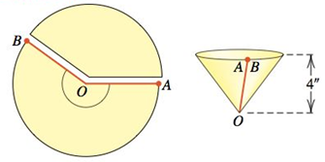

The circumference of the rim of the cone is: 







***Exercise***

The sprocket assembly for a bicycle is show in the figure. If the sprocket of radius  rotates through an angle of  radians, find the corresponding angle of rotation for the sprocket of radius 

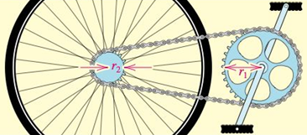***Solution***







***Exercise***

A simple model of the core of a tornado is a right circular cylinder that rotates about its axis. If a tornado has a core diameter of 200 *feet* and maximum wind speed of 180 *mi/hr*. (or 264 *ft/sec*) at the perimeter of the core, approximate the number of revolutions the core makes each minute.

***Solution***





 





***Exercise***

Earth rotates about its axis once every 23 *hours*, 56 *minutes*, and 4 *seconds*. Approximate the number of radians Earth rotates in one second.

***Solution***



Earth rotates in one second:





***Exercise***

A typical tire for a compact car is 22 *inches* in diameter. If the car is traveling at a speed of 60 *mi/hr*., find the number of revolutions the tire makes per minute.

***Solution***





 





***Exercise***

A pendulum in a grandfather clock is 4 *feet* long and swings back and forth along a 6−*inch* arc. Approximate the angle (in *degrees*) through which the pendulum passes during one swing.

***Solution***

***Given***: 







***Exercise***

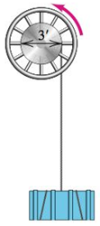A large winch of diameter 3 *feet* is used to hoist cargo.

1. Find the distance the cargo is lifted if the winch rotates through an angle measure .
2. Find the angle (in *radians*) through which the winch must rotate in order to lift the cargo *d* *feet*.

***Solution***

1. 

 

1.  

