***Section* 6.3 – Trigonometric Functions**

Let (*x, y*) be a point on the terminal side of an angle *θ* in standard position

The distance from the point to the origin is given by: 

***Six* Trigonometry Functions**

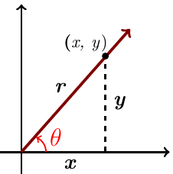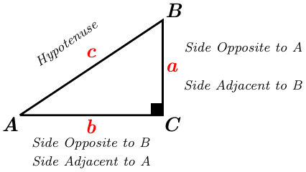

 

 

 

 

 

 

***Example***

Find the six trigonometry functions of *θ* if *θ* is in the standard position and the point (8, 15) is on the terminal side of *θ*.

***Solution***

 



|  |  |  |  |
| --- | --- | --- | --- |
|  |  |  |  |
|  |  |  |  |

***Example***

Which will be greater, tan 30° or tan 40°? How large could tan*θ* be?

***Solution***

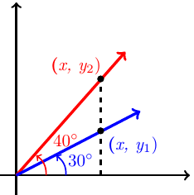 





→ tan 40° > tan 30°

***No limit*** as to how large tan*θ* can be.

***Example***

If , and *θ* is ***Q***IV, find sin*θ* and tan*θ* .

***Solution***











Since *θ* is *Q* IV 

 

 





***Reciprocal Identities***

|  |  |  |
| --- | --- | --- |
|  |  |  |
|  |  |  |

***Ratio Identities***

|  |  |
| --- | --- |
|  |  |

***Pythagorean Identities***









Solving for 







Solving for *sinθ*















|  |
| --- |
|  |
|  |
|  |
|  |
|  |

***Example***

Write  in terms of sin*θ*.

***Solution***







***Example***

Simplify the expression  as much as possible after substituting  for *x*

***Solution***













***Example***

Triangle *ABC* is a right triangle with *C* = 90°. If *a* = 6 and *c* = 10, find the six trigonometric functions of *A*.

***Solution***







|  |  |  |
| --- | --- | --- |
|  |  |  |
|  |  |  |



***Cofunction Theorem***

A trigonometric function of an angle is always equal to the cofunction of the complement of the angle.

***Example***

Write each function in terms of its cofunction

1. 

***Solution***



1. 

***Solution***



1. 

***Solution***



**30° - 60° - 90° *Triangle***

|  |  |  |
| --- | --- | --- |
| 30°  60°  *t*  *h* | 2*t*  ***h***  2*t*  *3*0°  60°  *t*  *t*  30°  60° |  |

*30°*

*60°*

1

2

*1*

*30°*

*60°*

*t*

*2t*

*1*



**45° - 45° - 90° *Triangle***

|  |  |
| --- | --- |
| *t*  45°  45°  *t* |  |

1

45°

45°

1

*t*

45°

45°

*t*

*t*





**Reference Angle**

***Definition***

The reference angle or related angle for any angle *θ* in standard position ifs the positive acute angle between the terminal side of *θ* and the *x*-axis, and it is denoted 

|  |  |
| --- | --- |
|  |  |
| *Quadrant* **I** | *Quadrant* **II** |
|  |  |
| *Quadrant* **III** | *Quadrant* **IV** |

***Example***

Find the exact value of 

***Solution***









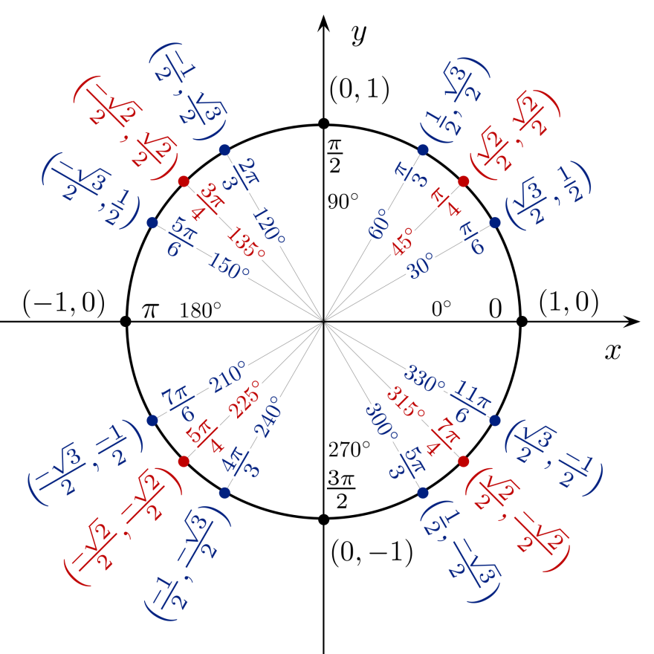

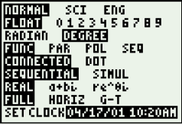***Approximation***- Simply using calculator









*To find the angle by using the inverse trigonometry functions, always enter a* ***positive*** *value.*

***Example***

Find *θ* if  and *θ* terminates in QIII with.

***Solution***



*θ* ∈ *Q*III



***Example***

Find *θ* to the nearest degree if  and *θ* terminates in *Q*II with.

***Solution***





 

*θ* ∈ QII 

***Exercise Section* 6.3 – Trigonometric Functions**

(**1 – 16**) Find the ***six*** trigonometry functions of *θ* if *θ* is in the standard position and the given point is on the terminal side of *θ*.

|  |  |  |  |
| --- | --- | --- | --- |
|  |  |  |  |

1. Find the values of the six trigonometric functions for an angle of 90°.
2. Indicate the two quadrants *θ* could terminate in if 
3. Indicate the two quadrants *θ* could terminate in if 

(**20 – 38**) Find the remaining trigonometric function of *θ* if

|  |  |
| --- | --- |
| 1. and *θ* terminates in *Q*I. 2. and *θ* terminates in *Q*II. 3. and *θ* terminates in *Q*III. 4. and *θ* terminates in *Q*IV. 5. and *θ* is terminates in *Q*IV. 6. and |  |

1. If , and *θ* is QIII, find cos*θ* and tan*θ* .
2. If , and *θ* is QIV, find sin*θ* and tan*θ* .
3. Use the reciprocal identities if  find 
4. Find , given that 
5. Find , given that 
6. Use a ratio identity to find  if  and 
7. If  and *θ* terminates in QII, find 
8. If  and *θ* terminated in QII, find  and tan*θ*.
9. Find  if  and *θ* terminates in QI
10. Find the remaining trigonometric ratios of *θ*, if  and 
11. Using the calculator and rounding your answer to the nearest hundredth, find the remaining trigonometric ratios of *θ* ifand .
12. Write  in terms of sin*θ* and cos*θ*, and then simplify if possible.
13. Write  in terms of sin*θ* and cos*θ*, and then simplify if possible.
14. Write  in terms of sin*θ* and/or cos*θ*, and then simplify if possible.
15. Write  in terms of sin*θ* and cos*θ*, and then simplify if possible.
16. Multiply 
17. Multiply 
18. Simplify the expression  as much as possible after substituting  for *x*.
19. Simplify the expression  as much as possible after substituting  for *x*

(**58 – 60**) Simplify by using the table

|  |  |  |
| --- | --- | --- |
|  |  |  |

1. Find *θ* if  and *θ* terminates in QIII with.
2. Find *θ* to the nearest degree if  and *θ* terminates in ***Q***IV with.

(**63 – 67**) Find the exact value of

|  |  |  |
| --- | --- | --- |
|  |  |  |

(**68 – 70**) Use the calculator to find the value of

|  |  |  |
| --- | --- | --- |
|  |  |  |

1. Use the calculator to find *θ* to the nearest degree if  with *θ* ∈ ***Q***IV with 
2. Use the calculator to find *θ* to the nearest degree if  with *θ* ∈ ***Q***III with 
3. Use the calculator to find *θ* to the nearest degree if  with *θ* ∈ ***Q***II with 
4. Find *θ* to the nearest tenth of a degree if  and *θ* terminates in ***Q***IV with
5. Use the calculator to find *θ* to the nearest degree if  with *θ* ∈ ***Q***II with 