***Lecture* *Seven* –Trigonometric Graphs**

***Section* 7.1 – Graphing Sine & Cosine**

We consider graphs of the equation: 

***Amplitude***

If the greatest value of *y* is *M* and the least value of ***y*** is *m*, then the amplitude of the graph of *y* is defined to be



The amplitude is |*A|.*

***Note:*** If *A* > 0, then the graph of  and  will have amplitude *A* and range [−*A*, *A*].

***Period***

→

Many things in daily life repeat with a predictable pattern, such as weather, tides, and hours of daylight.

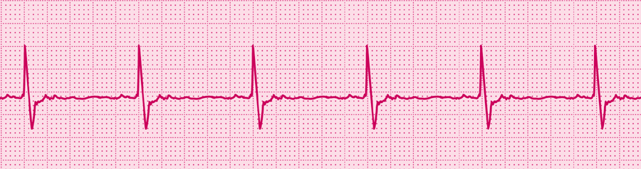

This periodic graph represents a normal heartbeat.

***Example***

Find the amplitude and the period of 

***Solution***

***Amplitude***: 



***Period***:  



***Example***

Find the amplitude and the period of 

***Solution***

***Amplitude***: 



***Period***:  



***Example***

Find the amplitude and the period of 

***Solution***

***Amplitude***: 



***Period***:  



***Even* and *Odd* Functions**

***Definition***

An *even function* is a function for which 

An *odd function* is a function for which 

|  |  |
| --- | --- |
| ***Even Functions*** | ***Odd Functions*** |
| , | ,  , |
| *Graphs are symmetric about the y-axis* | *Graphs are symmetric about the origin* |

***Phase shift***

If we add a term to the argument of the function, the graph will be translated in a ***horizontal direction***.

In the function , the expression *x* – *c* is called the ***argument***.



***Example***

Find the amplitude, the period, and the phase shift of 

***Solution***

***Amplitude***: 

***Period***:  



***Phase shift***:  



***Vertical* Translations**

For *d* > 0, ⇒The graph shifted up *d* units

⇒The graph shifted down *d* units

***Example***

Find the amplitude, the period, and the vertical shift of 

***Solution***

***Amplitude***: *A* = 2

***Period***: 

***Vertical Shifting:***  *Down 3 units*

**Graphing the *Sine* and *Cosine* Functions**

The graphs of  and, will have the following characteristics:

Amplitude = Period: 

Phase Shift:  Vertical translation: 

If *A* < 0 the graph will be reflected about the *x*-axis

***Example***

Graph 

***Amplitude***: *A* = 

|  |  |  |  |
| --- | --- | --- | --- |
| *x* |  | *x* |  |
|  |  |  | 0 |
|  |  | 0 | 1 |
|  |  |  | 0 |
|  |  |  | −1 |
|  |  |  | 0 |

***Period***: 



***Phase Shift***: 







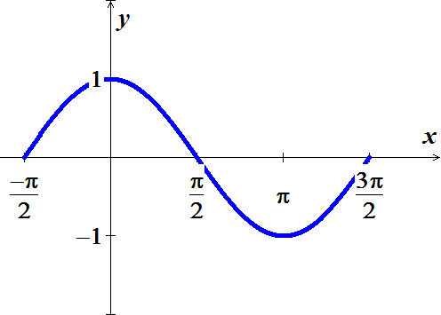

***Example***

Graph 

***Solution***

|  |  |  |  |  |  |  |  |  |  |  |  |  |  |  |  |  |  |  |  |  |
| --- | --- | --- | --- | --- | --- | --- | --- | --- | --- | --- | --- | --- | --- | --- | --- | --- | --- | --- | --- | --- |
| ***Amplitude***:  ***Period***:  ***Phase Shift***:  ***VT:*** | |  |  |  | | --- | --- | --- | |  | ***x*** |  | |  |  |  | |  |  |  | |  |  |  | |  |  |  | |  |  |  | |  |

***Example***

Graph one complete cycle 

***Solution***

|  |  |  |  |  |  |  |  |  |  |  |  |  |  |  |  |  |  |  |  |  |
| --- | --- | --- | --- | --- | --- | --- | --- | --- | --- | --- | --- | --- | --- | --- | --- | --- | --- | --- | --- | --- |
| ***Amplitude***:  ***Period***:  ***Phase Shift***:    ***VT:*** | |  |  |  | | --- | --- | --- | |  | ***x*** |  | |  |  |  | |  |  |  | |  |  |  | |  |  |  | |  |  |  | |  |

**Finding** **the *Sine* and *Cosine* Functions from the Graph**

***Example***

Find an equation  or to match the graph

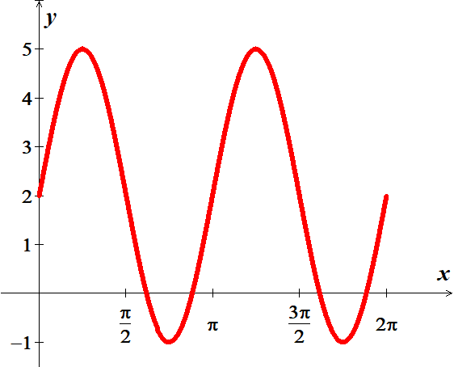







***Amplitude*** = 3

*No phase shift*: 



 

***Example***

Find an equation  or  to match the graph

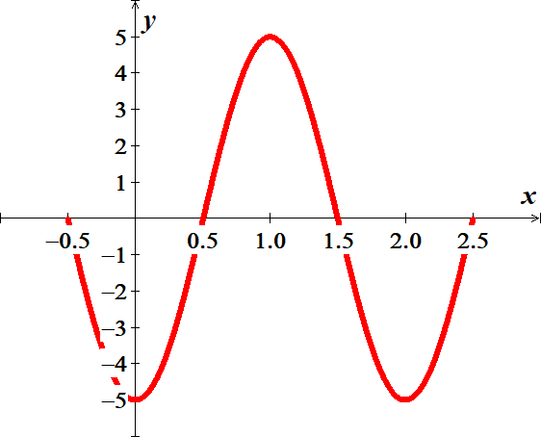







*No phase shift*: 



***Amplitude*** = 5

 

*Or*

*Phase shift* = 





 

***Exercises*** ***Section* 7.1 – Graphing Sine & Cosine**

(**1 – 28**) Find the amplitude, the period, the phase shift, and the vertical translation and sketch the graph of the equation

|  |  |  |
| --- | --- | --- |
|  |  |  |

(**29 – 31**) Graph a ***one complete*** cycle

|  |  |  |
| --- | --- | --- |
|  |  |  |

(**32 – 34**) Graph for the given interval.

1. 
2. 
3.  over two periods.
4. The maximum afternoon temperature in a given city might be modeled by 

Where *t* represents the maximum afternoon temperature in month *x*, with *x* = 0 representing January, *x* = 1 representing February, and so on. Find the maximum afternoon temperature to the nearest degree for each month.

1. Jan. *b*) Apr. *c*) May. *d*) Jun. *e*) Oct.
2. Find an equation  or to match the graph

|  |  |
| --- | --- |
|  |  |
|  |  |
| C:\Users\Fred\Math\Classes\SanJacinto\Trigonometry\Notes\Book\Image_Library\chapter4\0405Prob25.jpg |  |

1. The diameter of the Ferris wheel is 250 *feet*, the distance from the ground to the bottom of the wheel is 14 *feet.* We found the height of a rider on that Ferris wheel was given by the function:



Where *t* is the number of minutes from the beginning of a ride. Graph a complete cycle of this function.

1. The figure shows a function *f* that models the tides in feet at Clearwater Beach, *x* hours after midnight starting on Aug. 26,

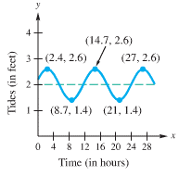

1. Find the time between high tides.
2. What is the difference in water levels between high tide and low tide?
3. The tides can be modeled by Estimate the tides when *x* = 10.
4. A mass attached to a spring oscillates upward and downward. The length *L* of the spring after *t* seconds is given by the function , where *L* is measured in cm.

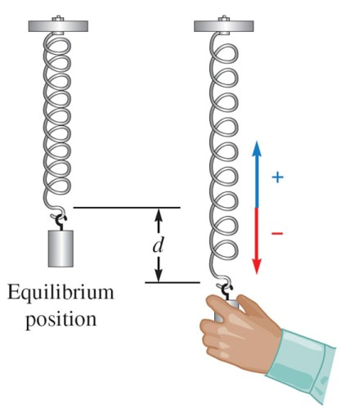

1. Sketch the graph of this function for 
2. What is the length the spring when it is at equilibrium?
3. What is the length the spring when it is shortest?
4. What is the length the spring when it is longest?
5. Based on years of weather data, the expected low temperature *T* (in ℉) in Fairbanks, Alaska, can be approximated by



1. Sketch the graph T for 
2. Predict when the coldest day of the year will occur.
3. To simulate the response of a structure to an earthquake, an engineer must choose a shape for the initial displacement of the beams in the building. When the beam has length *L* *feet* and the maximum displacement is *a* *feet*, the equation

|  |  |
| --- | --- |
|  |  |

Has been used by engineers to estimate the displacement *y*. if  and , sketch the graph of the equation for .

1. Radio stations often have more than one broadcasting tower because federal guidelines do not usually permit a radio station to broadcast its signal in all directions with equal power. Since radio waves cam travel over long distances, it is important to control their directional patterns so that radio stations do not interfere with one another. Suppose that a radio station has two broadcasting towers located along a north−south line.

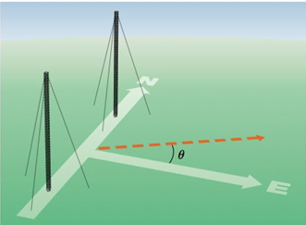

If the radio station is broadcasting at a wavelength *λ* and the distance between the two radio towers is equal to , then the intensity *I* of the signal in the direction *θ* is given by



where  is the maximum intensity.

1. Approximate *I* in terms of for each *θ*.

|  |  |  |
| --- | --- | --- |
|  |  |  |

1. Determine the direction in which *I* has maximum or minimum values.
2. Graph *I* on the interval . Graphically approximate *θ* to three decimal places, when *I* is equal **to . (Hint: let )**