***Section* 7.2 – Graphing Tangent & Cotangent**

***Vertical Asymptote***

A ***vertical asymptote*** is a vertical line that the graph approaches but does not intersect, while function values increase or decrease without bound as *x*-values get closer and closer to the line.

**Graphing the *Tangent* Functions**

The graphs of  will have the following characteristics:

***Domain***: 

***Range***: 

* The graph is discontinuous at values of *x* of the formand has ***vertical asymptotes*** at these values.
* Its ***x-intercepts*** are of the form .
* Its period is π.
* Its graph has no amplitude, since there are no minimum or maximum values.
* The graph is symmetric with respect to the origin, so the function is an odd function. For all *x* in the domain, .

***No***  *Amplitude* ***Period*** : 

***Phase Shift*** :  ***Vertical translation*: *y*** = *D*

**Vertical Asymptote** (***VA***): 

One cycle: 

***Example***

Find the period, and the phase shift and sketch the graph of 

***Solution***

|  |  |  |
| --- | --- | --- |
|  | *x* |  |
|  |  | 0 |
|  | 0 | 0.5 |
|  |  | ∞ |
|  |  | −0.5 |
|  |  | 0 |

***Period***: 

***Phase shift***: 

***Vertical translation***: *y* = 0

***Vertical Asymptote***: 







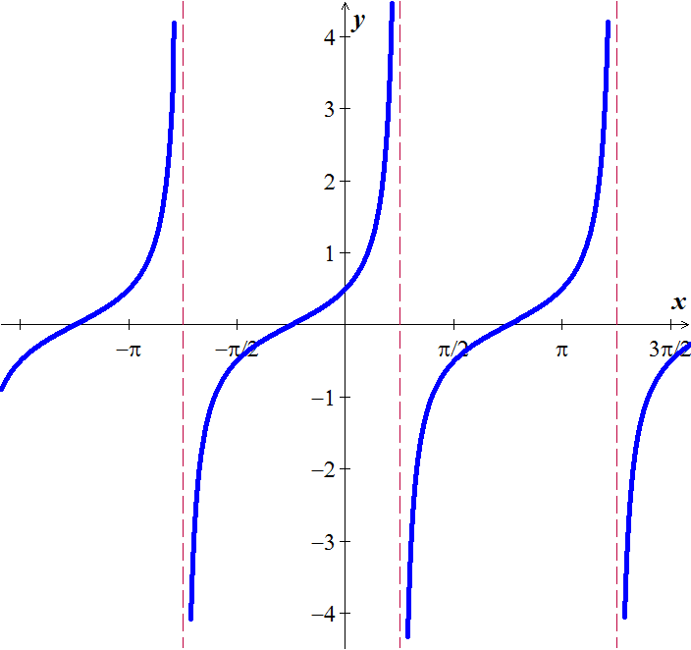

One Complete cycle can be determined by:







***Cotangent Functions***

***Domain***: 

***Range***: 

* The graph is discontinuous at values of *x* of the formand has ***vertical asymptotes*** at these values.
* Its ***x-intercepts*** are of the form .
* Its period is π.
* Its graph has no amplitude, since there are no minimum or maximum values.
* The graph is symmetric with respect to the origin, so the function is an odd function. For all *x* in the domain, .

***Example***

Find the period, and the phase shift and sketch the graph of 

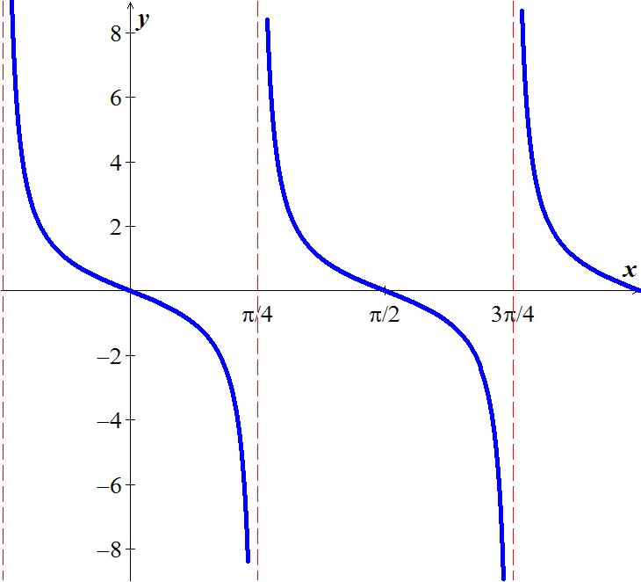***Solution***

|  |  |  |  |  |  |  |  |  |  |  |  |  |  |  |  |  |  |  |  |
| --- | --- | --- | --- | --- | --- | --- | --- | --- | --- | --- | --- | --- | --- | --- | --- | --- | --- | --- | --- |
| Period:  Phase shift:  One cycle:      *V.A*: | |  |  |  | | --- | --- | --- | |  | *x* |  | |  |  | ∞ | |  |  | 1 | |  |  | 0 | |  |  | −1 | |  |  | ∞ | |

***Exercises*** ***Section* 7.2 – Graphing Tangent & Cotangent**

(**1 – 6**) Find the period, show the asymptotes, and sketch the graph of

|  |  |  |
| --- | --- | --- |
|  |  |  |

(**7 – 10**) Graph over a **1*-****period* interval

|  |  |  |
| --- | --- | --- |
|  |  |  |

1. A fire truck parked on the shoulder of a freeway next to a long block wall. The red light on the top is 10 *feet* from the wall and rotates through one complete revolution every 2 *seconds*. Graph the function that gives the length ***d*** in terms of time *t* from *t* = 0 to *t* = 2.

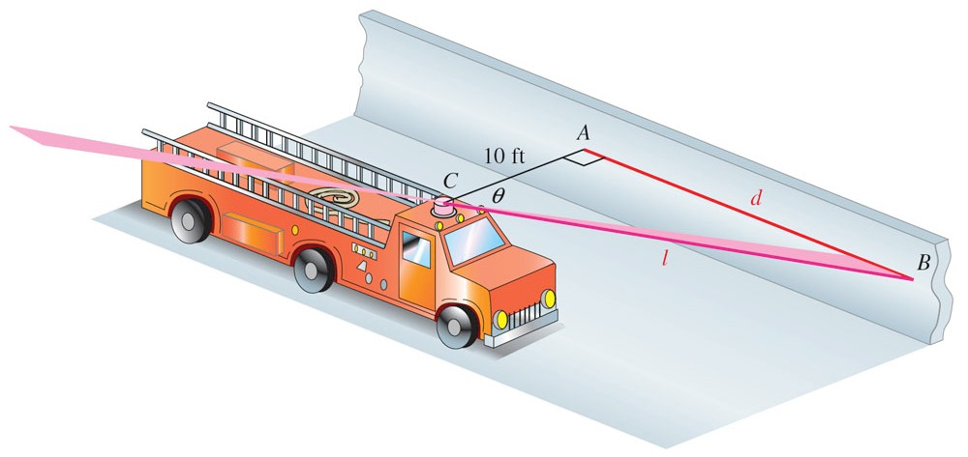

1. A rotating beacon is located 3 *m* south of point *R* on an east-west wall. *d*, the length of the light display along the wall from *R*, is given by , where *t* is time measured in seconds since the beacon started rotating. (When *t* = 0, the beacon is aimed at point *R*. When the beacon is aimed to the right of *R*, the value of *d* is positive; *d* is negative if the beacon is aimed to the left of *R*.) Find a for *t* = 0.8

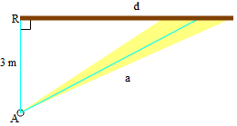

1. Let a person whose eyes are  feet from the ground stand ***d*** feet from an object  feet tall, where  feet. Let θ be the angle of elevation to the top of the object.

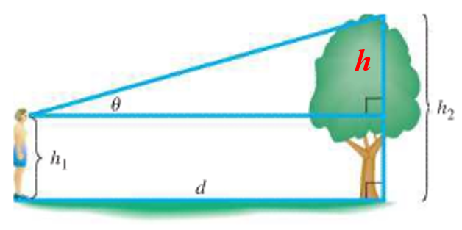

1. Show that 
2. Let  and . Graph ***d*** for the interval 