***Solution*** ***Section* 7.2 – Graphing Tangent & Cotangent**

***Exercise***

Find the period, show the asymptotes, and sketch the graph of 

***Solution***

|  |  |  |  |  |  |  |  |  |  |  |  |  |  |  |  |  |  |  |  |  |
| --- | --- | --- | --- | --- | --- | --- | --- | --- | --- | --- | --- | --- | --- | --- | --- | --- | --- | --- | --- | --- |
| ***Amplitude***:  ***Period***:  ***Phase Shift***:  ***VT:***  ***Asymptotes***: | |  |  |  | | --- | --- | --- | |  | ***x*** | ***y*** | |  |  |  | |  |  |  | |  |  |  | |  |  |  | |  |  |  | |  |

***Exercise***

Find the period, show the asymptotes, and sketch the graph of 

***Solution***

|  |  |  |  |  |  |  |  |  |  |  |  |  |  |  |  |  |  |  |  |  |
| --- | --- | --- | --- | --- | --- | --- | --- | --- | --- | --- | --- | --- | --- | --- | --- | --- | --- | --- | --- | --- |
| ***Amplitude***:  ***Period***:  ***Phase Shift***:  ***VT:***  ***Asymptotes***: | |  |  |  | | --- | --- | --- | |  | ***x*** | ***y*** | |  |  |  | |  |  |  | |  |  |  | |  |  |  | |  |  |  | |  |

***Exercise***

Find the period, show the asymptotes, and sketch the graph of 

***Solution***

|  |  |  |  |  |  |  |  |  |  |  |  |  |  |  |  |  |  |  |  |  |
| --- | --- | --- | --- | --- | --- | --- | --- | --- | --- | --- | --- | --- | --- | --- | --- | --- | --- | --- | --- | --- |
| ***Amplitude***:  ***Period***:  ***Phase Shift***:  ***VT:***  ***Asymptotes***: | |  |  |  | | --- | --- | --- | |  | ***x*** | ***y*** | |  |  |  | |  |  |  | |  |  |  | |  |  |  | |  |  |  | |  |

***Exercise***

Find the period, show the asymptotes, and sketch the graph of 

***Solution***

|  |  |  |  |  |  |  |  |  |  |  |  |  |  |  |  |  |  |  |  |  |
| --- | --- | --- | --- | --- | --- | --- | --- | --- | --- | --- | --- | --- | --- | --- | --- | --- | --- | --- | --- | --- |
| ***Amplitude***:  ***Period***:  ***Phase Shift***:  ***VT:***  ***Asymptotes***: | |  |  |  | | --- | --- | --- | |  | ***x*** | ***y*** | |  |  |  | |  |  |  | |  |  |  | |  |  |  | |  |  |  | |  |

***Exercise***

Find the period, show the asymptotes, and sketch the graph of 

***Solution***

|  |  |  |  |  |  |  |  |  |  |  |  |  |  |  |  |  |  |  |  |  |
| --- | --- | --- | --- | --- | --- | --- | --- | --- | --- | --- | --- | --- | --- | --- | --- | --- | --- | --- | --- | --- |
| ***Amplitude***:  ***Period***:  ***Phase Shift***:  ***VT:***  ***Asymptotes***: | |  |  |  | | --- | --- | --- | |  | ***x*** | ***y*** | |  |  |  | |  |  |  | |  |  |  | |  |  |  | |  |  |  | |  |

***Exercise***

Find the period, show the asymptotes, and sketch the graph of 

***Solution***

|  |  |  |  |  |  |  |  |  |  |  |  |  |  |  |  |  |  |  |  |  |
| --- | --- | --- | --- | --- | --- | --- | --- | --- | --- | --- | --- | --- | --- | --- | --- | --- | --- | --- | --- | --- |
| ***Amplitude***:  ***Period***:  ***Phase Shift***:  ***VT:***  ***Asymptotes***: | |  |  |  | | --- | --- | --- | |  | ***x*** | ***y*** | |  |  |  | |  |  |  | |  |  |  | |  |  |  | |  |  |  | |  |

***Exercise***

Graph over a 1-period interval 

***Solution***

|  |  |  |  |  |  |  |  |  |  |  |  |  |  |  |  |  |  |  |  |  |
| --- | --- | --- | --- | --- | --- | --- | --- | --- | --- | --- | --- | --- | --- | --- | --- | --- | --- | --- | --- | --- |
| ***Amplitude***:  ***Period***:  ***Phase Shift***:  ***VT:***  ***Asymptotes***: | |  |  |  | | --- | --- | --- | |  | ***x*** | ***y*** | |  |  |  | |  |  |  | |  |  |  | |  |  |  | |  |  |  | |  |

***Exercise***

Graph over a 1-period interval 

***Solution***

|  |  |  |  |  |  |  |  |  |  |  |  |  |  |  |  |  |  |  |  |  |
| --- | --- | --- | --- | --- | --- | --- | --- | --- | --- | --- | --- | --- | --- | --- | --- | --- | --- | --- | --- | --- |
| ***Amplitude***:  ***Period***:  ***Phase Shift***:  ***VT:***  ***Asymptotes***: | |  |  |  | | --- | --- | --- | |  | ***x*** | ***y*** | |  |  |  | |  |  |  | |  |  |  | |  |  |  | |  |  |  | |  |

***Exercise***

Graph one complete cycle 

***Solution***

|  |  |  |  |  |  |  |  |  |  |  |  |  |  |  |  |  |  |  |  |  |
| --- | --- | --- | --- | --- | --- | --- | --- | --- | --- | --- | --- | --- | --- | --- | --- | --- | --- | --- | --- | --- |
| ***Amplitude***:  ***Period***:  ***Phase Shift***:  ***VT:*** | |  |  |  | | --- | --- | --- | |  | ***x*** | ***y*** | |  |  |  | |  |  |  | |  |  |  | |  |  |  | |  |  |  | |  |

***Exercise***

Graph one complete cycles 

***Solution***

|  |  |  |  |  |  |  |  |  |  |  |  |  |  |  |  |  |  |  |  |  |
| --- | --- | --- | --- | --- | --- | --- | --- | --- | --- | --- | --- | --- | --- | --- | --- | --- | --- | --- | --- | --- |
| ***Amplitude***:  ***Period***:  ***Phase Shift***:  ***VT:*** | |  |  |  | | --- | --- | --- | |  | ***x*** | ***y*** | |  |  |  | |  |  |  | |  |  |  | |  |  |  | |  |  |  | |  |

***Exercise***

A fire truck parked on the shoulder of a freeway next to a long block wall. The red light on the top is 10 *feet* from the wall and rotates through one complete revolution every 2 *seconds*. Graph the function that gives the length *d* in terms of time *t* from *t* = 0 to *t* = 2.

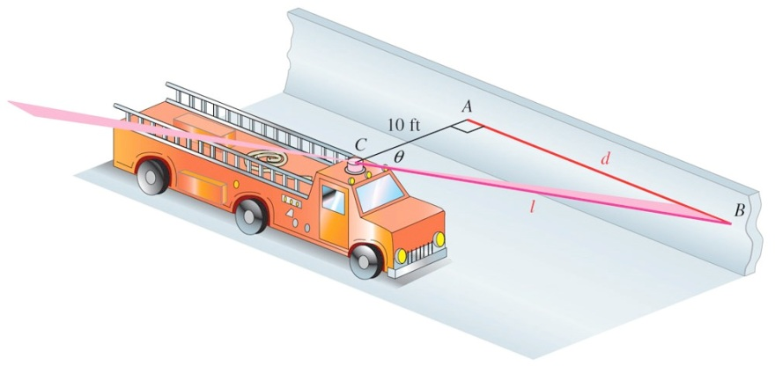***Solution***







***Period*** 

One cycle: 



|  |  |  |  |  |  |  |  |  |  |  |  |  |  |
| --- | --- | --- | --- | --- | --- | --- | --- | --- | --- | --- | --- | --- | --- |
| |  |  | | --- | --- | | *t* |  | | 0 | 0 | |  | 10 | |  | ∞ | |  | −10 | | 1 | 0 | |  |

***Exercise***

A rotating beacon is located 3 *m* south of point *R* on an east-west wall. *d*, the length of the light display along the wall from *R*, is given by , where *t* is time measured in seconds since the beacon started rotating. (When *t* = 0, the beacon is aimed at point *R*. When the beacon is aimed to the right of *R*, the value of *d* is positive; *d* is negative if the beacon is aimed to the left of *R*.) Find a for *t* = 0.8

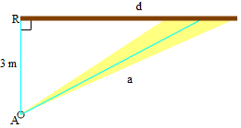

***Solution***





***Exercise***

Let a person whose eyes are  feet from the ground stand ***d*** feet from an object  feet tall, where  feet. Let θ be the angle of elevation to the top of the object.

1. Show that 
2. Let  and . Graph ***d*** for the interval 

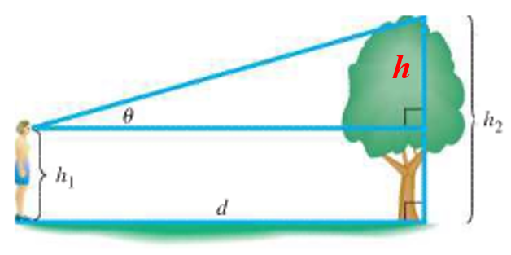***Solution***

1. 





1. 