***Section* 7.3 – Graphing Secant & Cosecant**

**Graphing the *Secant* Function**

***Domain***: 

***Range***: 

* The graph is discontinuous at values of *x* of the formand has ***vertical asymptotes*** at these values.
* There are ***no*** ***x-intercepts***.
* Its period is 2π.
* Its graph has no amplitude, since there are no minimum or maximum values.
* The graph is symmetric with respect to the *y*-axis, so the function is an even function. For all *x* in the domain, .

|  |  |
| --- | --- |
| *x* |  |
|  |  |
|  | 0 |
|  |  |
|  | 0 |
|  |  |

***Example***

Sketch the graph of 

***Solution***

***Period*** 

***First***, graph

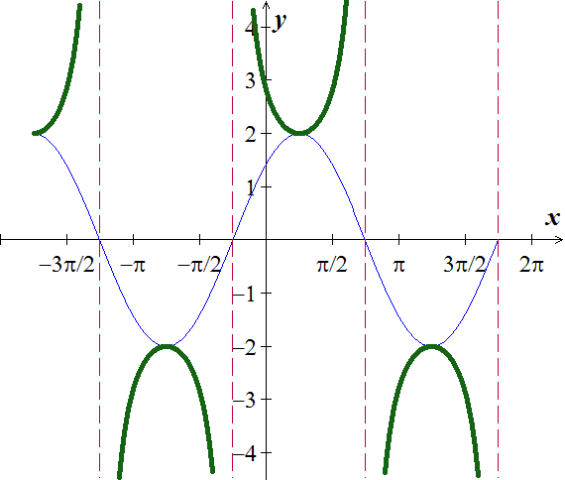***Phase shift***: 

***Vertical Asymptote***: 



**Graphing the *Cosecant* Function**

***Domain***: 

***Range***: 

* The graph is discontinuous at values of *x* of the formand has ***vertical asymptotes*** at these values.
* There are no *x*-intercepts.
* Its period is 2π.
* Its graph has no amplitude, since there are no minimum or maximum values.
* The graph is symmetric with respect to the *origin*, so the function is an odd function. For all *x* in the domain .

***Example***

|  |  |
| --- | --- |
| *x* |  |
|  | 0 |
|  | 1 |
|  |  |
|  | −1 |
|  | 0 |

Find the period and sketch the graph of 

***Solution***



***Period*** 

***First***, graph

***Phase shift***: 

***Vertical Asymptote***: 

|  |  |
| --- | --- |
|  |  |

**Finding** **the *Secant* and *Cosecant* Functions from the Graph**

***Example***

Find an equation  or  to match the graph



***Solution***

For cosine:

***A*** = 2





*y* = 2 sec(π*x*) from –1 to 2.5.

***Exercises*** ***Section* 7.3 – Graphing Secant & Cosecant**

(**1 – 12**) Find the period, show the asymptotes, and sketch the graph of

|  |  |  |
| --- | --- | --- |
|  |  |  |

(**7 – 17**) Graph over a one-period interval

|  |  |  |
| --- | --- | --- |
|  |  |  |

1. Graph  
2. Find an equation to match the graph

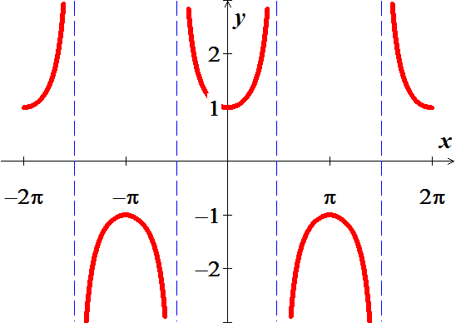

1. Find an equation to match the graph

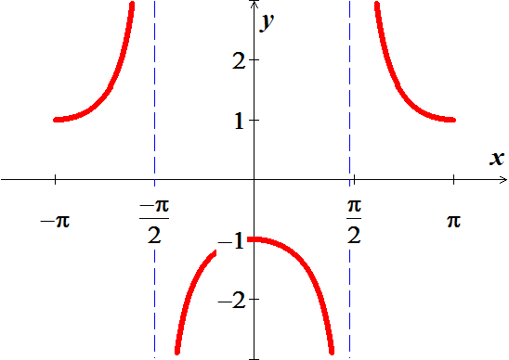

1. Find an equation to match the graph

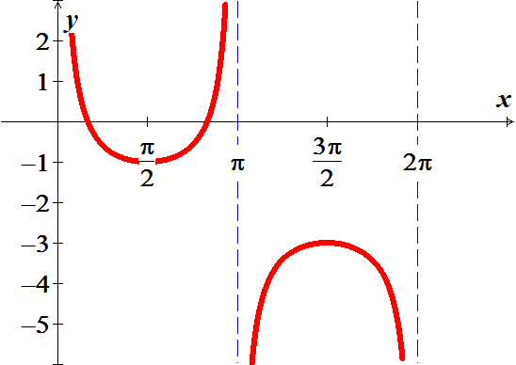

1. A rotating beacon is located at point *A* next to a long wall. The beacon is 9 *m* from the wall. The distance ***a***is given by , where *t* is time measured in seconds since the beacon started rotating. (When *t* = 0, the beacon is aimed at point *R*.) Find ***a*** for *t* = 0.45

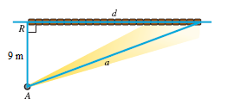

1. The shortest path for the sun’s rays through Earth’s atmosphere occurs when the sun is directly overhead. Disregarding the curvature of Earth, as the sun moves lower on the horizon, the distance that sunlight passes through the atmosphere increases by a factor of , where *θ* is the angle of elevation of the sun. This increased distance reduces both the intensity of the sun and the amount of ultraviolet light that reached Earth’s surface.

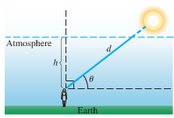

1. Verify that 
2. Determine *θ* when 
3. The atmosphere filters out the ultraviolet light that causes skin to burn, Compare the difference between sunbathing when  and when . Which measure gives less ultraviolet light?
4. Your friend is marching with a band and has asked you to film him. You have set yourself up 10 *feet* from the street where your friend will be passing from left to right. If *d* represents your distance, in feet, from your friend and *x* is the radian measure of the angle.

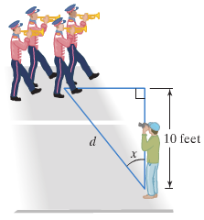

1. Express *d* in terms of a trigonometric function of *x*.
2. Graph the function for 