***Section* 8.2 – Sum and Difference Formulas**

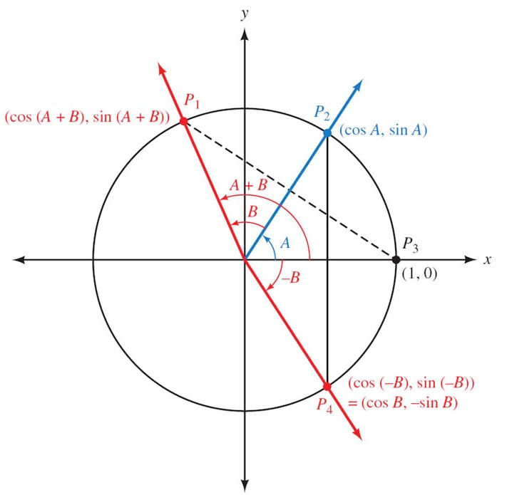



 ***Distance between points***



















***Example***

Find the exact value for 

***Solution***









***Example***

Show that 

***Solution***





 ***√***

***Example***

Simplify: 

***Solution***





***Example***

Show that 

***Solution***





 ***√***

***Example***

Find the exact value of 

***Solution***









***Example***

Find the exact value of 

***Solution***











***Example***

If  with *A* in QI, and  with *B* in QIII, find , , and 

***Solution***

 

 





































***Example***

If with *A* in Q*I*, and  with *B* in Q*III*, find 

***Solution***

 



 













***Example***

Establish the identity: 

***Solution***





 ***√***

***Example***

Establish the identity: 

***Solution***







 ***√***

***Example***

Establish the identity: 

***Solution***













 ***√***

***Exercises Section* 8.2 – Sum and Difference Formulas**

1. Write the expression as a single trigonometric function 
2. Show that 
3. If , and  , find

|  |  |  |
| --- | --- | --- |
|  |  |  |
|  |  |  |

1. If , and  , find

|  |  |  |
| --- | --- | --- |
|  |  |  |
|  |  |  |

1. If  , and  , find

|  |  |  |
| --- | --- | --- |
|  |  |  |
|  |  |  |

1. If , and  , find

|  |  |  |
| --- | --- | --- |
|  |  |  |
|  |  |  |

1. If , and  , find

|  |  |  |
| --- | --- | --- |
|  |  |  |
|  |  |  |

1. If , and  , find

|  |  |  |
| --- | --- | --- |
|  |  |  |
|  |  |  |

1. If , and  , find

|  |  |  |
| --- | --- | --- |
|  |  |  |
|  |  |  |

1. If , and  , find

|  |  |  |
| --- | --- | --- |
|  |  |  |
|  |  |  |

1. If with *A* in Q*I*, and  with *B* in Q*I*, find 

(**12−30**) Prove the identity

|  |  |
| --- | --- |
|  |  |

1. Common household current is called ***alternating current*** because the current alternates direction within the wires. The voltage *V* in a typical 115-*volt* outlet can be expressed by the function  where *ω* is the angular speed (in *radians* per *second*) of the rotating generator at the electrical plant, and *t* is time measured in seconds.
2. It is essential for electric generators to rotate at precisely 60 cycles per second so household appliances and computers will function properly. Determine *ω* for these electric generators.
3. Determine a value of *φ* so that the graph of  is the same as the graph of 