***Section* 8.3 – Double-angle and Half-Angle Formulas**





 























***Example***

If  with *A* in QII, find 

***Solution***









***Example***

Prove 

***Solution***







 ***√***

***Example***

Prove 

***Solution***











 ***√***

***Example***

Prove 

***Solution***













 ***√***







***Example***

Simplify 

***Solution***







***Example***

Prove 

***Solution***









 ***√***

***Example***

Given  and , find 

***Solution***





















***Half-Angle Formulas***









 *Divide both sides by 2*

 *Replace x with *









 *Divide both sides by 2*

 *Replace x with *



***Example***

If  with  find the six trigonometric function of *A*/2

***Solution***

Since 





 





















 



 

 

 

 

***Example***

Find the exact of 

***Solution***











***Example***

Prove 

***Solution***









 ***√***

***Exercises Section* 8.3 – Double-angle Half-Angle Formulas**

1. Let  with *A* in Q*III* and find

|  |  |  |  |  |  |
| --- | --- | --- | --- | --- | --- |
|  |  |  |  |  |  |

1. Let  with *A* in Q*II* and find

|  |  |  |  |  |  |
| --- | --- | --- | --- | --- | --- |
|  |  |  |  |  |  |

1. Let  with *A* in Q*IV* and find

|  |  |  |  |  |  |
| --- | --- | --- | --- | --- | --- |
|  |  |  |  |  |  |

1. Let  with *A* in Q*I* and find

|  |  |  |  |  |  |
| --- | --- | --- | --- | --- | --- |
|  |  |  |  |  |  |

1. Let  with *A* in Q*II* and find

|  |  |  |  |  |  |
| --- | --- | --- | --- | --- | --- |
|  |  |  |  |  |  |

1. Let  with *A* in Q*III* and find

|  |  |  |  |  |  |
| --- | --- | --- | --- | --- | --- |
|  |  |  |  |  |  |

1. Let  with *A* in Q*IV* and find

|  |  |  |  |  |  |
| --- | --- | --- | --- | --- | --- |
|  |  |  |  |  |  |

1. Let  with *A* in Q*I* and find

|  |  |  |  |  |  |
| --- | --- | --- | --- | --- | --- |
|  |  |  |  |  |  |

1. Let  with *x* in Q*IV* and find 
2. Verify: 
3. Verify: 
4. Simplify 
5. Write  in terms of 
6. Find the values of the six trigonometric functions of *θ* if 
7. Use half-angle formulas to find the exact value of 
8. Find the exact of 
9. Given: , find 
10. Use a right triangle in Q*II* to find the value of 

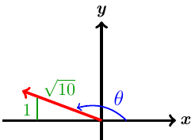

(**19 − 46**) Prove the following equation is an identity

|  |  |
| --- | --- |
|  |  |

1. A common form of cardiovascular branching is bifurcation, in which an artery splits into two smaller blood vessels. The bifurcation angle *θ* is the angle formed by the two smaller arteries. The line through *A* and *D* bisects *θ* and is perpendicular to the line through *B* and *C*.

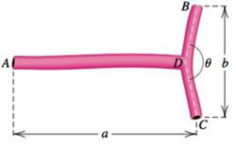

1. Show that the length  of the artery from *A* to *B* is given by .
2. Estimate the length  from the three measurements  and .
3. A proposed rail road route through three towns located at points *A, B*, and *C*. At *B*, the track will turn toward *C* at an angle .

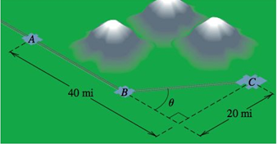

1. Show that the total distance *d* from *A* to *C* is given by 
2. Because of mountains between *A* and *C*, the turning point *B* must be at least 20 *miles* from *A*.Is there a route that avoids the mountains and measures exactly 50 *miles*?
3. Throwing events in track and field include the shot put, the discus throw, the hammer throw, and the javelin throw. The distance that the athlete can achieve depends on the initial speed of the object thrown and the angle above the horizontal at which the object leaves the hand. This angle is represented by *θ*. The distance, *d*, in *feet*, that the athlete throws is modeled by the formula



In which  is the initial speed of the object thrown, in *feet* per *second*, and *θ* is the angle, in *degrees*, at which the object leaves the hand.

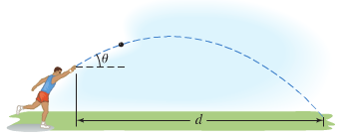

1. Use the identity to express the formula so that it contains the since function only.
2. Use the formula from part (*a*) to find the angle, *θ*, that produces the maximum distance, *d*, for a given initial speed, .
3. The speed of a supersonic aircraft is usually represented by a Mach number. A Mach number is the speed of the aircraft, in *miles* per *hour*, divided by the speed of sound, approximately 740 *mph*. Thus, a plane flying at twice the speed of sound has a speed, *M*, of Mach 2.

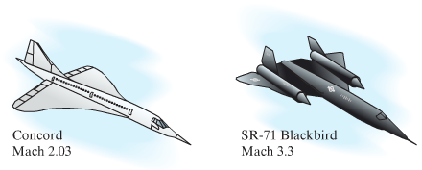

If an aircraft has a speed greater than Mach 1, a sonic boom is heard, created by sound waves that form a cone with a vertex angle *θ*.

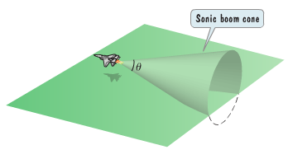

The relationship between the cone’s vertex angle *θ*, and the Mach speed, *M*, of an aircraft that is flying faster than the speed of sound is given by



1. If , determine the Mach speed, *M*, of the aircraft. Express the speed as an exact value and as decimal to the nearest tenth.
2. If , determine the Mach speed, *M*, of the aircraft. Express the speed as an exact value and as decimal to the nearest tenth.