***Section* 8.4 – Solving Trigonometry Equations**

***Example***

Find the solutions of the equation  if

1. *θ* is in the interval 
2. *θ*  is any real number

***Solution***

1. 



1. Since the sine function has period 2π.



***Example***

Solve the equation 

***Solution***





 



 

 

 

The solutions are:  for every integer *n*.

***Example***

Solve the equation , and express the solutions both in radians and degrees.

***Solution***



 



 ***Multiply by* −1**

 ***Factor or use quadratic formula***



 

 



** **

** **



***Example***

Solve the equation  in the interval .

***Solution***



 ***Factor out* tan*x***

 



  

  

***Example***

Find the solutions of 

***Solution***



 

 







***Example***

Approximate to the nearest degree, the solutions of the following equation in the interval :



***Solution***







 

  ***θ* ∈ QII, QIV**





***Exercises*** ***Section* 8.4 – Trigonometric Equations**

(**1 − 9**) Find all solutions of the equation

|  |  |
| --- | --- |
|  |  |

(**10 − 24**) Find the solutions of the equation that are in the interval 

|  |  |
| --- | --- |
|  |  |

(**25 − 35**) Find the solutions of the equation that are in the interval 

|  |  |
| --- | --- |
|  |  |

1. Solve 
2. Solve 
3. If a projectile (such as a bullet) is fired into the air with an initial velocity ***v*** at an angle of elevation *θ*, then the height *h* of the projectile at time *t* is given by: 

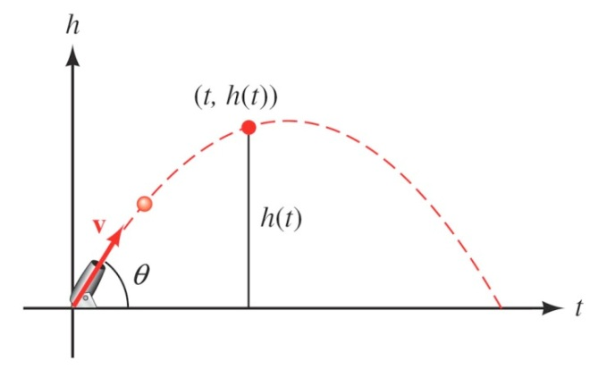

1. Give the equation for the height, if ***v*** is 600 *ft./sec* and *θ* = 45°.
2. Use the equation in part (*a*) to find the height of the object after  seconds.
3. Find the angle of elevation of *θ* of a rifle barrel, if a bullet fired at 1,500 *ft./sec* takes 3 seconds to reach a height of 750 *feet*. Give your answer in the nearest of a degree.