***Solutions*** ***Section* 8.4 – Solving Trigonometric Equations**

***Exercise***

Find all solutions of the equation: 

***Solution***





 





***Exercise***

Find all solutions of the equation: 

***Solution***

 has ***no solution*** 

***Exercise***

Find all solutions of the equation: 

***Solution***



 





***Exercise***

Find all solutions of the equation: 

***Solution***



 





***Exercise***

Find all solutions of the equation: 

***Solution***









***Exercise***

Find all solutions of the equation: 

***Solution***

















***Exercise***

Find all solutions of the equation: 

***Solution***













***Exercise***

Find all solutions of the equation: 

***Solution***







*Or*



***Exercise***

Find all solutions of the equation: 

***Solution***









|  |  |
| --- | --- |
|  |  |

***Exercise***

Find all solutions of the equation: 

***Solution***







***Exercise***

Find the solutions of the equation that are in the interval : 

***Solution***



|  |  |
| --- | --- |
|  |  |

***Exercise***

Find the solutions of the equation that are in the interval : 

***Solution***





|  |  |
| --- | --- |
|  |  |

***Exercise***

Find the solutions of the equation that are in the interval : 

***Solution***













|  |  |  |  |
| --- | --- | --- | --- |
| ***√*** | |  |  | | --- | --- | |  | ***√*** | |

The solutions are: 

***Exercise***

Find the solutions of the equation that are in the interval : 

***Solution***

 ***Multiply by* sinx *both sides ***



 **(*True*)**

The solutions are:  except 0 and π.

***Exercise***

Find the solutions of the equation that are in the interval : 

***Solution***

 ***Factor by grouping***



|  |  |
| --- | --- |
|  |  |

***Exercise***

Find the solutions of the equation that are in the interval : 

***Solution***







|  |  |
| --- | --- |
| (*impossible*) |  |

***Exercise***

Solve  

***Solution***









***Exercise***

Solve  

***Solution***

 











***Exercise***

Solve  

***Solution***



 

 







***Exercise***

Solve  

***Solution***

 







 







***The solutions are:*** 

***Exercise***

Solve 

***Solution***

*is negative → cosine is in QII or QIII*.

 

 

 

 

 

***Exercise***

Solve:  

***Solution***

















***The solutions are:*** 

***Exercise***

Solve:  

***Solution***







 

 

***The solutions are:*** 

***Exercise***

Solve:  

***Solution***





 













*Check*

|  |  |  |
| --- | --- | --- |
| ***√*** | ***√*** | **(*False statement*)** |

***The solutions are:*** 

***Exercise***

Solve:  

***Solution***

 



















***The solutions are:*** 

***Exercise***

Solve:  

***Solution***





 

 

 

 



*Negative sign → cosine is in QII or QIII*

 

 

***The solutions are:*** 

***Exercise***

Solve  

***Solution***





 

 



***The solutions are:*** 

***Exercise***

Solve  

***Solution***



 

  



***The solutions are:*** 

***Exercise***

Solve  

***Solution***

















|  |  |
| --- | --- |
| ***False*** |  |

***The solutions are:*** 

***Exercise***

Solve  

***Solution***









***Exercise***

Solve  

***Solution***















***Exercise***

Solve  

***Solution***



 

 







***Exercise***

Solve  

***Solution***









 





***Exercise***

Solve 

***Solution***

*is negative → cosine is in QII or QIII*.

 

 

 

 

 

***Exercise***

Solve:  

***Solution***

 













***The solutions are:*** 

***Exercise***

Solve:  

***Solution***







 

 

***The solutions are:*** 

***Exercise***

Solve:  

***Solution***





 







 

 

***Check***

|  |  |  |
| --- | --- | --- |
|  |  | **(*False statement*)** |

***The solutions are:*** 

***Exercise***

Solve:  

***Solution***

 























***The solutions are:*** 

***Exercise***

Solve:  

***Solution***





 

 

 

 



*Negative sign → cosine is in QII or QIII*

 

 

***The solutions are:*** 

***Exercise***

Solve  

***Solution***





 

 



***The solutions are:*** 

***Exercise***

Solve  

***Solution***



 

  



***The solutions are:*** 

***Exercise***

Solve  

***Solution***



















|  |  |
| --- | --- |
| ***False*** |  |

***The solutions are:*** 

***Exercise***

If a projectile (such as a bullet) is fired into the air with an initial velocity ***v*** at an angle of elevation *θ*, then the height *h* of the projectile at time *t* is given by:



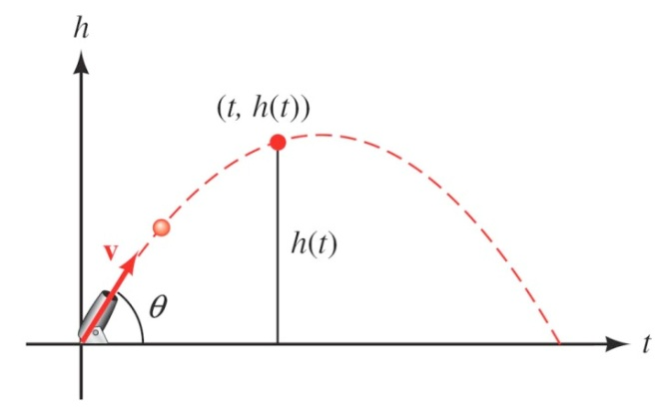

1. Give the equation for the height, if ***v*** is 600 *ft./sec* and *θ* = 45°.
2. Use the equation in part (*a*) to find the height of the object after  *seconds*.
3. Find the angle of elevation of *θ* of a rifle barrel, if a bullet fired at 1,500 *ft./sec* takes 3 *seconds* to reach a height of 750 *feet*. Give your answer in the nearest of a degree.

***Solution***

1. 





1. 



1. 











