***Section* 8.5 – Inverse Trigonometry Functions**

**Relationships Between  *and* **

*  if and only if , where ***x*** is in the domain of and ***y*** is in the domain of 
* Domain of  = Range of 
* Range of  = Domain of 
*  for every *x* in the domain of 
*  for every *y* in the domain of 
* The point (*a*, *b*) is on the graph of  ***iff*** the point (*b*, *a*) is on the graph of .
* The graphs of  and  are reflections of each other through the line *y* = *x*.

**The Inverse *Sine* Function**

 ***iff*** 

**Properties of **





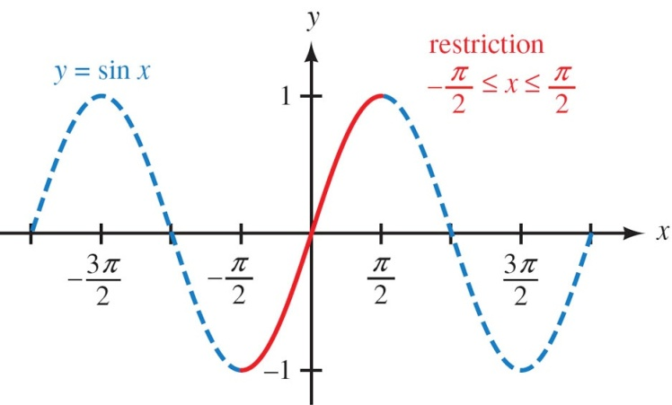 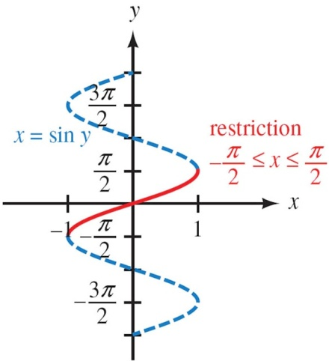

***Example***

Find the exact value: , 

***Solution***

 Since 

 Since 

**The Inverse *Cosine* Function**

***Definition***

The inverse cosine function, denoted by , is defined by

 *for *

|  |  |
| --- | --- |
| ***Notation*** | ***Meaning*** |
|  |  |

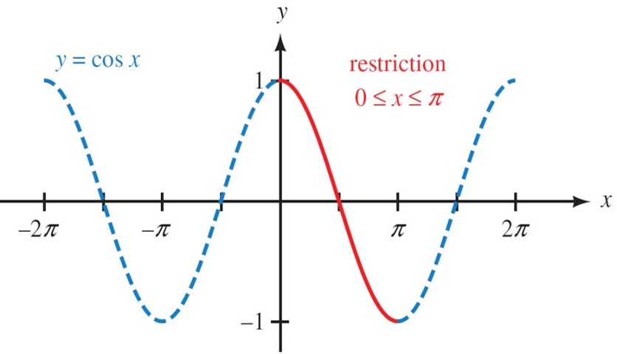 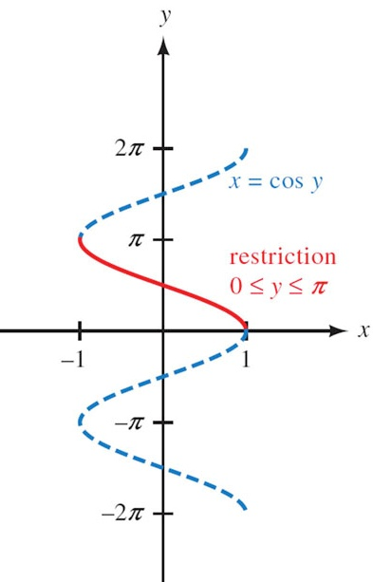

**Properties of **





***Example***

Find the exact value: 

***Solution***

 Since 

 Since 



***Example***

Find the exact value of 

***Solution***

 





**The Inverse *Tangent*  Function**

***Definition***

The inverse cosine function, denoted by , is defined by

 for any real number *x* and for  **



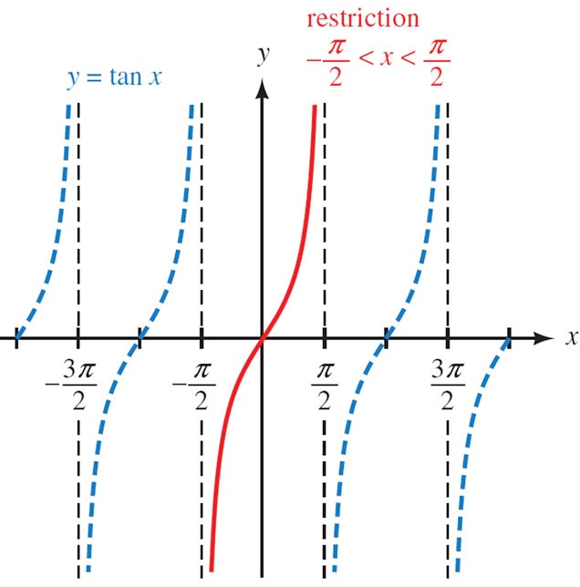 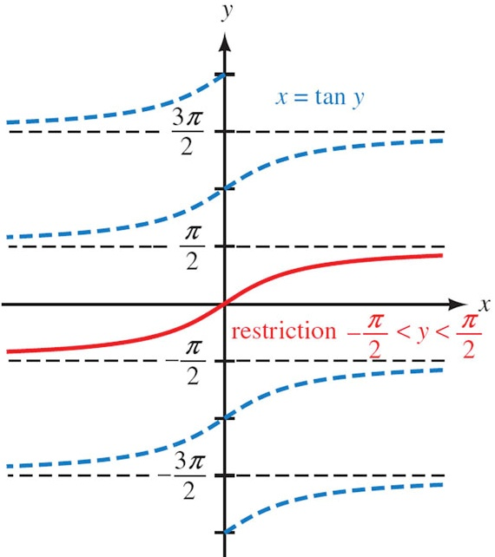

**Properties of **





***Example***

Find the exact value: 

***Solution***



 Since 

 

***Example***

Evaluate in radians without using a calculator or tables.

1. 





1. 





1. 





***Example***

Use a calculator to evaluate each expression to the nearest tenth of a degree

1. 



1. 



1. 



1. 



1. 



1. 



***Example***

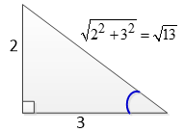Find the exact value: 

***Solution***







***Example***

Find the exact value: 

***Solution***

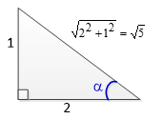



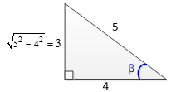









***Example***

If , rewrite  as an algebraic expression in *x*.

***Solution***

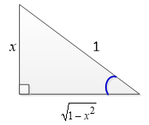







***Exercises Section* 8.5 – Inverse Trigonometric Functions**

(**1 – 18**) Find the exact value of the expression whenever it is defined

|  |  |  |
| --- | --- | --- |
|  |  |  |

(**19 – 28**) Evaluate without using a calculator

|  |  |  |
| --- | --- | --- |
|  |  |  |

(**29 – 41**) Write an equivalent expression that involves *x* only for

|  |  |
| --- | --- |
|  |  |
|  |  |

(**42 – 44**) Sketch the graph of the equation:

|  |  |  |
| --- | --- | --- |
|  |  |  |

1. Evaluate without using a calculator
2. Evaluate  as an equivalent expression in *x* only