***Solution Section* 8.5 – Inverse Trigonometric Functions**

***Exercise***

Find the exact value of the expression whenever it is defined: 

***Solution***



***Exercise***

Find the exact value of the expression whenever it is defined: 

***Solution***



***Exercise***

Find the exact value of the expression whenever it is defined: 

***Solution***





***Exercise***

Find the exact value of the expression whenever it is defined: 

***Solution***







***Exercise***

Find the exact value of the expression whenever it is defined: 

***Solution***



***Exercise***

Find the exact value of the expression whenever it is defined: 

***Solution***



***Exercise***

Find the exact value of the expression whenever it is defined: 

***Solution***

 

***Exercise***

Find the exact value of the expression whenever it is defined: 

***Solution***



***Exercise***

Find the exact value of the expression whenever it is defined: 

***Solution***



***Exercise***

Find the exact value of the expression whenever it is defined: 

***Solution***



***Exercise***

Find the exact value of the expression whenever it is defined: 

***Solution***



***Exercise***

Find the exact value of the expression whenever it is defined: 

***Solution***







***Exercise***

Find the exact value of the expression whenever it is defined: 

***Solution***





|  |  |
| --- | --- |
|  |  |





***Exercise***

Find the exact value of the expression whenever it is defined: 

***Solution***







***Exercise***

Find the exact value of the expression whenever it is defined: 

***Solution***













***Exercise***

Find the exact value of the expression whenever it is defined: 

***Solution***















***Exercise***

Find the exact value of the expression whenever it is defined: 

***Solution***

















***Exercise***

Find the exact value of the expression whenever it is defined: 

***Solution***



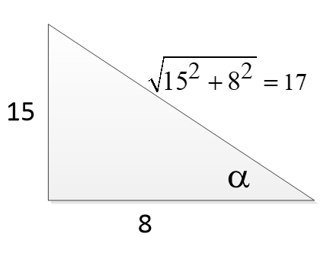











***Exercise***

Evaluate without using a calculator: 

***Solution***



***Exercise***

Evaluate without using a calculator: 

***Solution***





***Exercise***

Evaluate without using a calculator: 

***Solution***

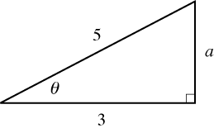







***Exercise***

Evaluate without using a calculator: 

***Solution***

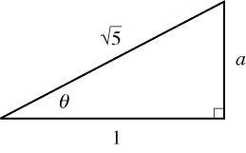











***Exercise***

Evaluate without using a calculator: 

***Solution***











***Exercise***

Evaluate without using a calculator: 

***Solution***



***Exercise***

Evaluate without using a calculator: 

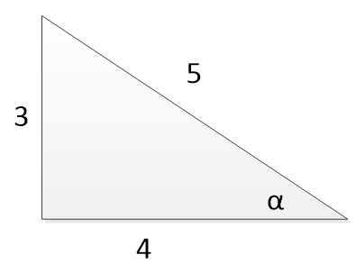***Solution***









***Exercise***

Evaluate without using a calculator: 

***Solution***





***Exercise***

Evaluate without using a calculator: 

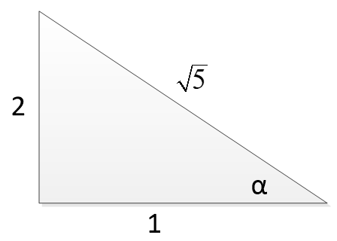***Solution***









***Exercise***

Evaluate without using a calculator: 

***Solution***









***Exercise***

Write an equivalent expression that involves *x* only for 

***Solution***









***Exercise***

Write an equivalent expression that involves *x* only for 

***Solution***

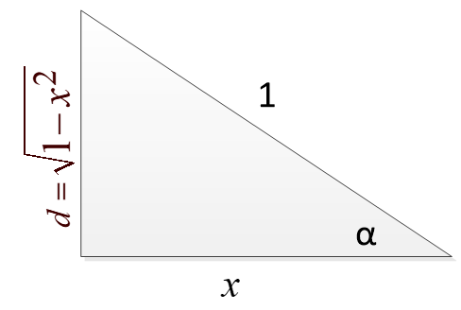











***Exercise***

Write an equivalent expression that involves *x* only for 

***Solution***









***Exercise***

Write the expression as an algebraic expression in *x* for *x* > 0: 

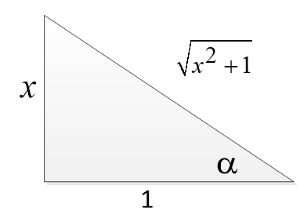***Solution***











***Exercise***

Write the expression as an algebraic expression in *x* for *x* > 0: 

***Solution***

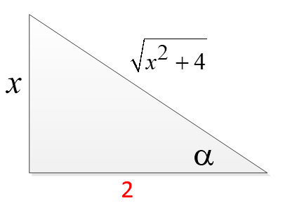









***Exercise***

Write the expression as an algebraic expression in *x* for *x* > 0: 

***Solution***

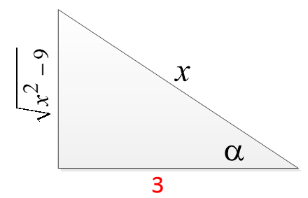







***Exercise***

Write the expression as an algebraic expression in *x* for *x* > 0: 

***Solution***





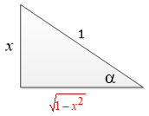





***Exercise***

Write the expression as an algebraic expression in *x* for *x* > 0: 

***Solution***





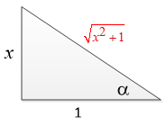









***Exercise***

Write the expression as an algebraic expression in *x* for *x* > 0: 

***Solution***











***Exercise***

Write the expression as an algebraic expression in *x* for *x* > 0: 

***Solution***



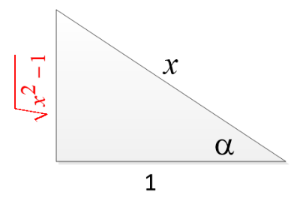











***Exercise***

Write the expression as an algebraic expression in *x*: 

***Solution***

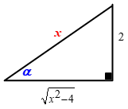





***Exercise***

Write the expression as an algebraic expression in *x*: 

***Solution***

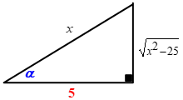





***Exercise***

Write the expression as an algebraic expression in *x*: 

***Solution***

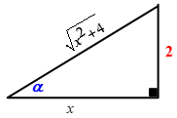





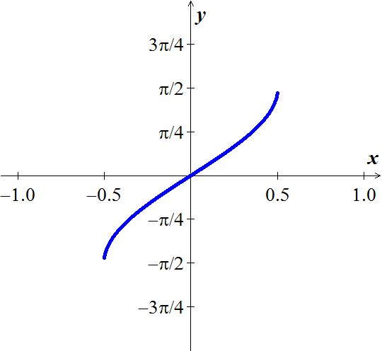***Exercise***

Sketch he graph of the equation: 

***Solution***





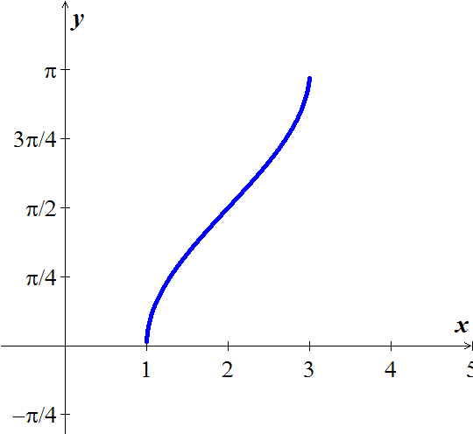***Exercise***

Sketch he graph of the equation: 

***Solution***





***Exercise***

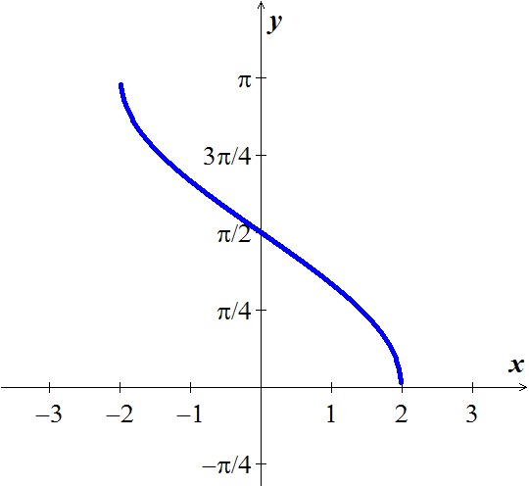Sketch he graph of the equation: 

***Solution***





***Exercise***

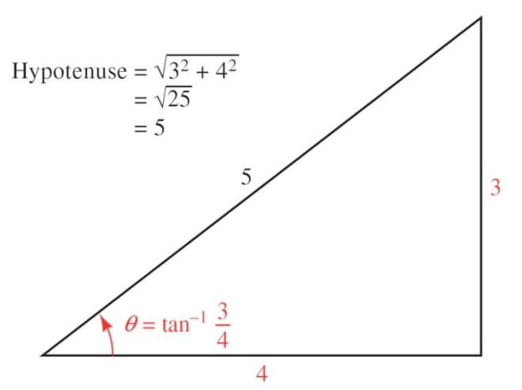Evaluate without using a calculator

***Solution***









***Exercise***

Evaluate  as an equivalent expression in *x* only

***Solution***