**Section 8.6 − Polar Coordinates**

To reach the point whose address is (2, 1), we start from origin and travel 2 units right and then 1 unit up. Another way to get to that point, we can travel  units on the terminal side of an angle in standard position and this type is called *Polar Coordinates*.

***Definition* of Polar Coordinates**

To define polar coordinates, let an ***origin*** *O* (called the ***pole***) and an ***initial ray*** from *O*. Then each point *P* can be located by assigning to it a ***polar coordinate pair***  in which r gives the directed from *O* to *P* and *θ* gives the directed angle from the initial ray to yay *OP*.

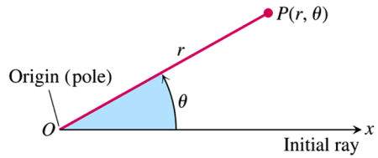

***Polar Coordinates***

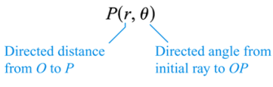

***Definition* – Relationships between Rectangular and Polar Coordinates**

The rectangular coordinates (*x*, *y*) and polar coordinates  of a point P are related as follows:

1. 
2. 

***Graphing Polar Coordinates***

|  |  |  |
| --- | --- | --- |
|  |  | |
|  | |  |

***Example***

If  are polar coordinates of a point *P*, find the rectangular coordinates of *P*.

***Solution***

















The rectangular coordinates of *P* are 

***Example***

If  are rectangular coordinates of a point *P*, find three different pairs the polar coordinates of *P*.

***Solution***























The polar coordinates of *P* are: , , , and 

***Example***

Find a polar equation of an arbitrary line.

***Solution***

An equation of a line can be written in the form: .









***Example***

Find a polar equation of the hyperbola .

***Solution***













***Example***

Find an equation in *x* and *y* that has the same graph as the polar equation . Sketch the graph.

***Solution***





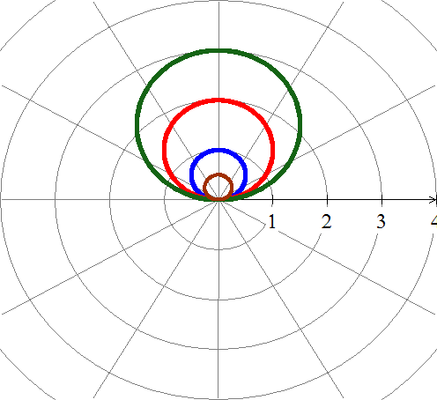

***Example***

Sketch the graph of the polar equation .

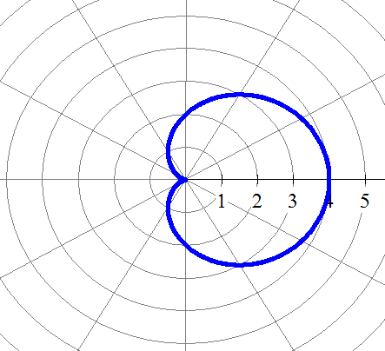***Solution***

|  |  |
| --- | --- |
| ***θ*** | ***r*** |
| 0 | 4 |
|  |  |
|  | 2 |
|  |  |
|  | 0 |
|  | 2 |
|  | 4 |

***Exercises Section* 8.6 – Polar Coordinates**

(**1 – 6**) Convert to rectangular coordinates

|  |  |  |
| --- | --- | --- |
|  |  |  |

1. Change the polar coordinates to rectangular coordinates 
2. Change the polar coordinates to rectangular coordinates 
3. Change the polar coordinates to rectangular coordinates 

(**10 – 16**) Convert to polar coordinates

|  |  |
| --- | --- |
|  |  |

1. Change the rectangular coordinates to polar coordinates 
2. Change the rectangular coordinates to polar coordinates 
3. The point in rectangular coordinates is equivalent to  in polar coordinates.
4. The point in rectangular coordinates is equivalent to  in polar coordinates.
5. A point lies at (4, 4) on a rectangular coordinate system. Give its address in polar coordinates 

(**22 – 34**) Write the equation in rectangular coordinates

|  |  |  |
| --- | --- | --- |
|  |  |  |

(**35 – 38**) Find a polar equation that has the same graph as the equation in *x* and *y*

|  |  |
| --- | --- |
|  |  |

(**39 – 42**) Write the equation in polar coordinates

|  |  |  |
| --- | --- | --- |
|  |  |  |

(**44 – 54**) Sketch the graph of the polar equation

|  |  |  |
| --- | --- | --- |
|  |  |  |