***Solution Section* 8.6 − Polar Coordinates**

***Exercise***

Convert to rectangular coordinates. 

***Solution***

















∴ The pointin rectangular coordinates is equivalent to  in polar coordinates.

***Exercise***

Convert to rectangular coordinates .

***Solution***













∴ The point in rectangular coordinates is equivalent to  in polar coordinates.

***Exercise***

Convert to rectangular coordinates .

***Solution***













∴ The point  in polar coordinates is equivalent to  in rectangular coordinates.

***Exercise***

Convert to rectangular coordinates 

***Solution***













∴ The point  in polar coordinates is equivalent to  in rectangular coordinates.

***Exercise***

Convert to rectangular coordinates 

***Solution***













∴ The point  in polar coordinates is equivalent to  in rectangular coordinates.

***Exercise***

Convert to rectangular coordinates 

***Solution***













∴ The point  in polar coordinates is equivalent to  in rectangular coordinates.

***Exercise***

Change the polar coordinates to rectangular coordinates 

***Solution***













∴ The point  in polar coordinates is equivalent to  in rectangular coordinates.

***Exercise***

Change the polar coordinates to rectangular coordinates 

***Solution***

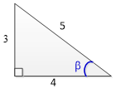













∴ The point  in polar coordinates is equivalent to  in rectangular coordinates.

***Exercise***

Change the polar coordinates to rectangular coordinates 

***Solution***

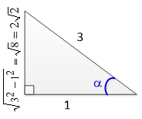













∴ The point  in polar coordinates is equivalent to  in rectangular coordinates.

***Exercise***

Convert to polar coordinates .

***Solution***













∴ The point  in rectangular coordinates is equivalent to  in polar coordinates.

***Exercise***

Convert to polar coordinates .

***Solution***









∴ The point  in rectangular coordinates is equivalent to  in polar coordinates.

***Exercise***

Convert to polar coordinates .

***Solution***









∴ The point  in rectangular coordinates is equivalent to  in polar coordinates.

***Exercise***

Convert to polar coordinates 

***Solution***











The angle is in quadrant III

Therefore, 



∴ The point  in rectangular coordinates is equivalent to  in polar coordinates.

***Exercise***

Convert to polar coordinates 

***Solution***











The angle is in quadrant *IV*

Therefore, 



∴ The point  in rectangular coordinates is equivalent to  in polar coordinates.

***Exercise***

Convert to polar coordinates 

***Solution***











∴ The point  in rectangular coordinates is equivalent to  in polar coordinates.

***Exercise***

Convert to polar coordinates 

***Solution***









The angle is in quadrant *III*

Therefore, 



∴ The point  in rectangular coordinates is equivalent to  in polar coordinates.

***Exercise***

Change the rectangular coordinates to polar coordinates 

***Solution***











The angle is in quadrant *IV*; therefore,





∴ The point  in rectangular coordinates is equivalent to  in polar coordinates.

***Exercise***

Change the rectangular coordinates to polar coordinates 

***Solution***











The angle is in quadrant *III*; therefore,





∴ The point  in rectangular coordinates is equivalent to  in polar coordinates.

***Exercise***

The point in rectangular coordinates is equivalent to  in polar coordinates.

***Solution***









The polar point is 

***Exercise***

The point  in rectangular coordinates is equivalent to  in polar coordinates.

***Solution***













***Exercise***

A point lies at (4, 4) on a rectangular coordinate system. Give its address in polar coordinates 

***Solution***













∴ The point  in rectangular coordinates is equivalent to  in polar coordinates.

***Exercise***

Write the equation in rectangular coordinates 

***Solution***





***Exercise***

Write the equation in rectangular coordinates 

***Solution***









***Exercise***

Write the equation in rectangular coordinates 

***Solution***



 





 



***Exercise***

Write the equation in rectangular coordinates 

***Solution***

 







***Exercise***

Write the equation in rectangular coordinates 

***Solution***

 

 





 



***Exercise***

Find an equation in *x* and *y* that has the same graph as polar equation. 

***Solution***

 



***Exercise***

Find an equation in *x* and *y* that has the same graph as polar equation. 

***Solution***







***Exercise***

Find an equation in *x* and *y* that has the same graph as polar 

***Solution***

 







***Exercise***

Find an equation in *x* and *y* that has the same graph as polar 

***Solution***

 







***Exercise***

Find an equation in *x* and *y* that has the same graph as polar 

***Solution***

 







***Exercise***

Find an equation in *x* and *y* that has the same graph as polar 

***Solution***

 









***Exercise***

Find an equation in *x* and *y* that has the same graph as polar 

***Solution***

 



 



***Exercise***

Find an equation in *x* and *y* that has the same graph as polar 

***Solution***









***Exercise***

Find a polar equation that has the same graph as the equation in *x* and *y*. 

***Solution***

 







***Exercise***

Find a polar equation that has the same graph as the equation in *x* and *y*. 

***Solution***

 





***Exercise***

Find a polar equation that has the same graph as the equation in *x* and *y*. 

***Solution***







 



 ***Divide by r***



***Exercise***

Find a polar equation that has the same graph as the equation in *x* and *y*. 

***Solution***

 



 





***Exercise***

Write the equation in polar coordinates 

***Solution***



 





***Exercise***

Write the equation in polar coordinates 

***Solution***

 



***Exercise***

Write the equation in polar coordinates 

***Solution***

  







***Exercise***

Write the equation in polar coordinates 

***Solution***

 





***Exercise***

Write the equation in polar coordinates 

***Solution***



 





***Exercise***

Sketch the graph of the polar equation 

***Solution***

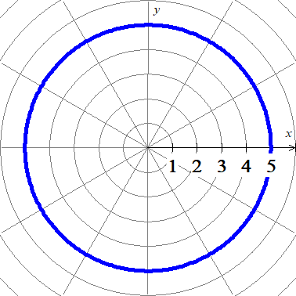

***Exercise***

Sketch the graph of the polar equation 

***Solution***

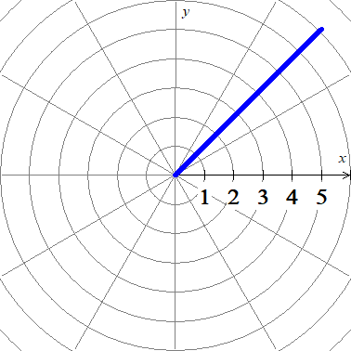

***Exercise***

Sketch graph 

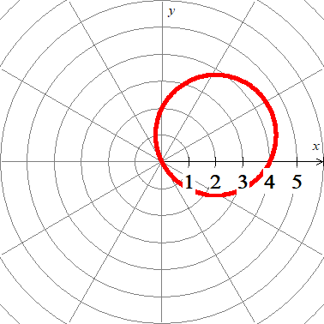***Solution***

|  |  |
| --- | --- |
| *𝜽* | ***r*** |
| 0 | 4 |
|  |  |
|  | 2 |
|  |  |
|  |  |
|  |  |

***Exercise***

Sketch the graph of the polar 

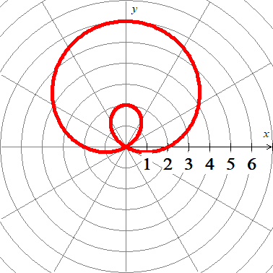***Solution***

|  |  |
| --- | --- |
| *𝜽* | ***r*** |
| 0 | 2 |
|  | 4 |
|  |  |
|  | 6 |
|  |  |
|  |  |
|  | 0 |
|  |  |
|  | 0 |

***Exercise***

Sketch the graph 

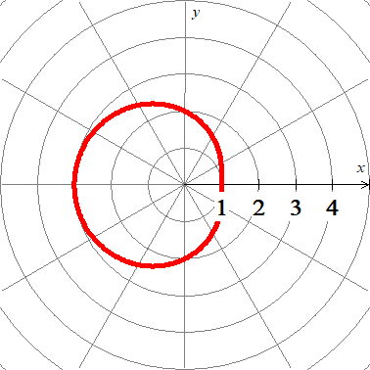***Solution***

|  |  |
| --- | --- |
| *𝜽* | ***r*** |
| 0 | 1 |
|  |  |
|  | 2 |
|  |  |
|  |  |
|  |  |
|  |  |
|  |  |

***Exercise***

Sketch the graph 

***Solution***

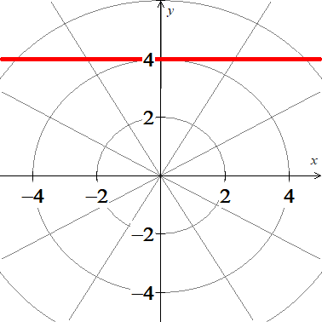





***Exercise***

Sketch the graph 

***Solution***

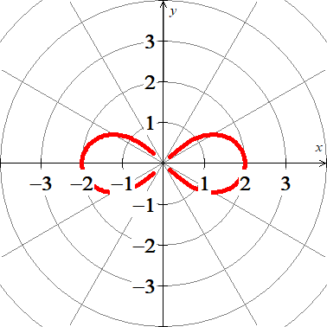





|  |  |
| --- | --- |
| *𝜽* | ***r*** |
| 0 | 2 |
|  |  |
|  | 0 |
|  | 0 |
|  |  |
|  |  |
|  | 0 |

***Exercise***

Sketch the graph 

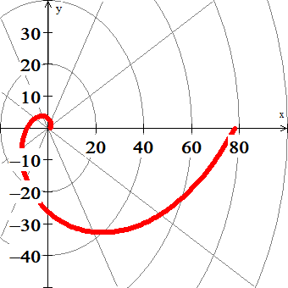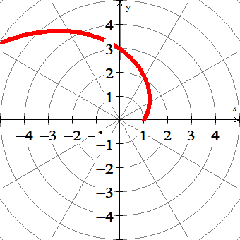***Solution***

|  |  |
| --- | --- |
| *𝜽* | ***r*** |
| 0 | 1 |
|  |  |

***Exercise***

Sketch the graph of the polar equation 

***Solution***

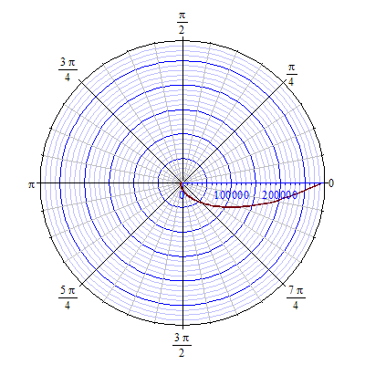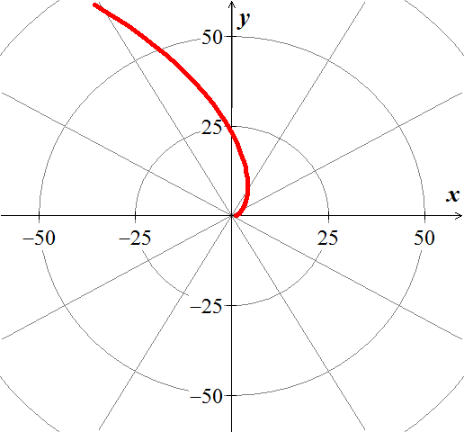

***Exercise***

Sketch the graph of the polar equation 

***Solution***

 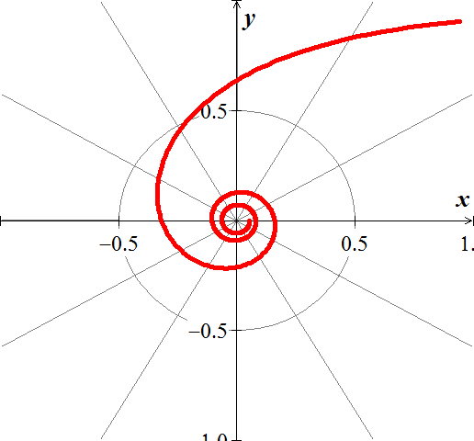

***Exercise***

Sketch the graph of the polar equation 

***Solution***

