***Section* 8.7 – Trigonometric Form**



The graph of the complex number *x* = *yi* is a vector (arrow) that extends from the origin out to the point (*x, y*)

* Horizontal axis: ***real******axis***
* Vertical axis: ***imaginary******axis***

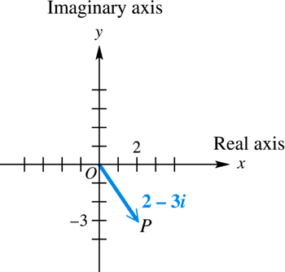

***Example***

Graph each complex number: , , and 

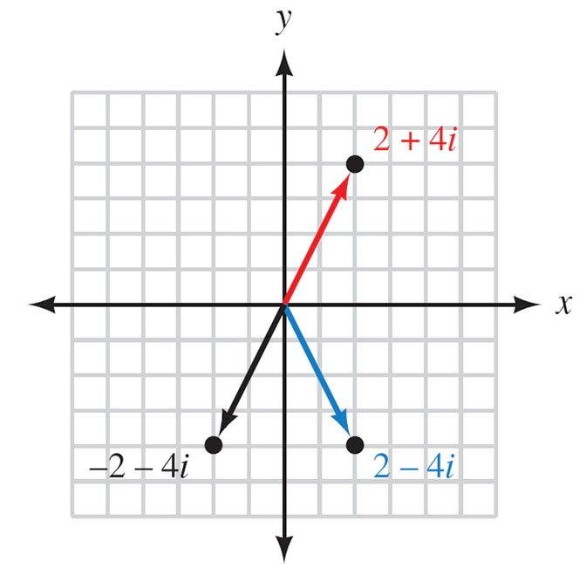

***Example***

Graph each complex number: 

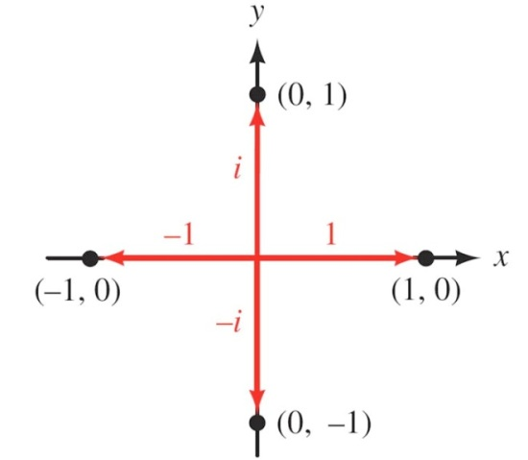

***Example***

Find the sum of 6 – 2*i* and –4 – 3*i*. Graph both complex numbers and their resultant.

***Solution***

(6 – 2*i*) + (–4 – 3*i*) = 6 – 4 – 2*i* – 3*i*



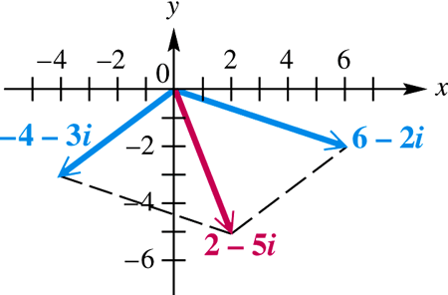

***Definition***

The *absolute value* or ***modulus*** of the complex number  is the distance from the origin to the point (*x, y*). If this distance is denoted by *r*, then

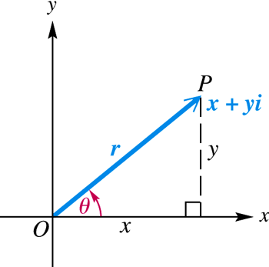





The ***argument***of the complex number  denoted is the smallest possible angle *θ* from the positive real axis to the graph of *z*.

 

 





 → is called the *trigonometric* from of *z*.

***Definition***

If  is a complex number in standard form then the ***trigonometric form*** for *z* is given by



Where ***r*** is the modulus or absolute value of *z* and

***θ***  is the argument of *z*.

We can convert back and forth between standard form and trigonometric form by using the relationships that follow

For 





***Example***

Write  in trigonometric form

***Solution***

The modulus *r*:















In radians: 

***Example***

Write  in rectangular form.

***Solution***









***Example***

Express  in rectangular form.

***Solution***





***Example***

Find the modulus of each of the complex numbers *5i*, 7, and 3 + 4*i*

***Solution***

For *z* = 5*i*

= 0 + 5*i*







For *z* = 7

= 7 + 0*i*







For 3 + 4*i*





***Product Theorem***

If  and  are any two complex numbers, then









***Example***

Find the product of and . Write the result in rectangular form.

***Solution***











***Quotient Theorem***

If  and  are any two complex numbers, then





***Example***

Find the quotient . Write the result in rectangular form.

***Solution***











**De Moivre’s *Theorem***

If  is a complex number, then





***Example***

Find  and express the result in rectangular form.

***Solution***







θ is in QI, that implies: 



Apply De Moivre’s theorem:





 







***n*th Root Theorem**

For a positive integer *n*, the complex number *a* + *bi* is an ***nth* root** of the complex number *x* + *iy* if



If *n* is any positive integer, *r* is a positive real number, and *θ* is in degrees, then the nonzero complex number has exactly *n* distinct *n*th roots, given by

 ***or*** 

Where  

 

***Example***

Find the two square root of **4*i***. Write the roots in rectangular form.

***Solution***













The absolute value: 

Argument: 





Since there are ***two*** square root, then *k* = 0 and 1.









The square roots are: 













***Example***

Find all fourth roots of . Write the roots in rectangular form.

***Solution***















The fourth roots have absolute value: 





Since there are ***four*** roots, then *k* = 0, 1, 2, and 3.









The fourth roots are: 

























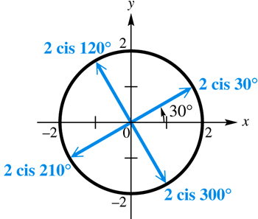

***Example***

Find all complex number solutions of . Graph them as vectors in the complex plane.

***Solution***



There is one real solution, 1, while there are five complex solutions.













The fifth roots have absolute value: 







Since there are ***fifth*** roots, then *k* = 0, 1, 2, 3, and 4.











*Solution*: 











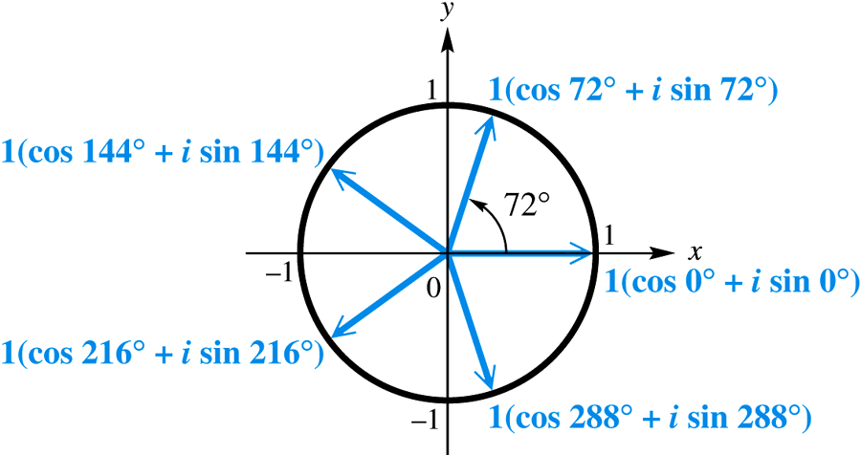

The graphs of the roots lie on a unit circle. The roots are equally spaced about the circle, 72° apart.

***Exercises Section* 8.7 – Trigonometric Form**

(**1 – 8**) Write complex form in trigonometric form

|  |  |  |  |
| --- | --- | --- | --- |
|  |  |  |  |

(**9 – 13**) Write in standard form

|  |  |  |
| --- | --- | --- |
|  |  |  |

1. Find the quotient . Write the result in rectangular form.
2. Divide . Write the result in rectangular form.

(**16 – 25**) Find and express the result in rectangular form

|  |  |  |  |
| --- | --- | --- | --- |
|  |  |  |  |

1. Find fifth complex roots of  and express the result in rectangular form.

(**27 – 30**) Find the fourth roots of

|  |  |  |  |
| --- | --- | --- | --- |
|  |  |  |  |

(**31 – 33**) Find the cube roots of

|  |  |  |  |
| --- | --- | --- | --- |
| 1. 27 |  |  |  |

1. Find all complex number solutions of .