***Section* R.3 − Applications and Model with Linear Equations**

**Solving an Applied Problem**

1. ***Read*** the problem carefully until you understand what is given and what is to be found
2. ***Assign a variable*** to represent the unknown value.
3. ***Write an equation*** using the variable expression(s).
4. ***Solve*** the equation.
5. ***State the answer*** to the problem. Does it seem reasonable?
6. ***Check*** the answer.

***Example***

According to the US Department of Education (2007 data), there is a gap between teaching salaries for men and women at private colleges and universities. The average salary for men exceeds the average salary for women by $14,037. Combined their average salaries are $130,015. Determine the average teaching salaries at private colleges for women and for men.

***Solution***

*The average salary for men exceeds the average salary for women by $14,037*

*m* = *w* + 14037 **(1)**

*Combined their average salaries are $130,015*

*m + w* = 130015 **(2)**

*w* + 14037 + *w* = 130015 *Substitute* ***m*** *with equation* **(1)**

2***w*** + 14037 = 130015

2***w*** = 130015 - 14037

2***w*** = 115978



*m* = 57989 + 14037

= $ 72,026.00

Average salary for women  and men 

***Example***

You are choosing between two long-distance telephone plans.

Plan A has a monthly fee of $15 with a charge of $0.08 per minute for all long distance calls.

Plan B has a monthly fee of $3 with a charge of $0.12 per minute for all long distance calls.

For how many minutes of long-distance calls will the costs for the two plans be the same?

***Solution***

*Plan A has a monthly fee of $15 with a charge of $0.08 per minute for all long distance calls.*

***A*** = 15 + .08*x*

*Plan B has a monthly fee of $3 with a charge of $0.12 per minute for all long distance calls.*

***B*** = 3 + .12*x*

*Costs for the two plans be the same*

***A = B***

15 + .08***x*** = 3 + .12***x***

.08***x*** – 0.12***x*** = 3 – 15

– 0.04***x*** = – 12





***Example***

You inherit $5000 with the stipulation that for the first year the money had to be invested in two funds paying 9% and 11% annual interest. How much did you invest at each rate if the total interest earned for the year was $487?

|  |  |  |  |
| --- | --- | --- | --- |
| ***Amount*** | ***Rate*** | ***Year*** | ***I = Prt*** |
| ***x*** | .09 | 1 | .09*x* |
| 5000 − ***x*** | .11 | 1 | .11(5000 − ***x***) |
| $5000 |  |  | $487 |

***Solution***

.09***x*** + .11(5000 – ***x***) = 487













*for* **11%**: 5000 – 3150 = $1,850.00

***Example***

After a 30% price reduction, you purchase a new computer for $840. What was the computer’s price before the reduction?

***Solution***

 ***Or* 70 % = $840**

.7 ***x*** = 840





***Example***

The length of a rectangular basketball court is 44 *feet* more than the width. If the perimeter of the basketball court is 288 *feet*. What are the dimensions?

***Solution***

*Length of a rectangular basketball court is 44 feet more than the width*

*l* = *w* + 44 **(1)**

P = 288 = 2*l* + 2*w* ***Divide by 2 both sides***

144 = *l* + *w*

*l* + *w =*144 **(2)**

From **(1)** → **(2)**: *w* + 44 + *w* = 144

2*w* = 100



→ *l* = 50 + 44



**Motion Problems**

  

***d***: *D*istance

***r***: *R*ate, speed, or velocity

***t***: *T*ime

***Example***

Maria and Eduardo are traveling to a business conference. The trip takes 2 *hr*. for Maria and 2.5 *hr*. for Eduardo, since he lives 40 *mi* farther away. Eduardo travels 5 *mph* faster than Maria. Find their average rates.

***Solution***

|  |  |  |  |
| --- | --- | --- | --- |
|  | ***r*** | ***t*** | ***d*** |
| ***Maria*** | *x* | 2 | 2*x* |
| ***Eduardo*** | *x* + 5 | 2.5 | 2.5(*x* + 5) |

He lives 40 *mi* farther away













*Maria’s* rate is 55 *mph*

*Eduardo’s* rate is 55 + 5 = 60 *mph*

***Exercises Section* R.3 − Applications & Model With Linear Eqns.**

1. When a number is decreased by 30% of itself, the result is 28. What is the number?
2. When 80% a number is added to the number, the result is 252. What is the number?
3. If the length of each side of a square is increased by 3 *cm*, the perimeter of the new square is 40 *cm* more than twice of each side of the original square. Find the dimensions of the origin square.
4. The length of a rectangular label is 2.5 *cm* less than twice the width. The perimeter is 40.6 *cm*. Find the width.
5. An Automobile repair shop charged a customer $448, listing $63 for parts and the remainder for labor. If the cost of labor is $35 per hour, how many hours of labor did it take to repair the car?
6. In the morning, Margaret drove to a business appointment at 50 *mph*. Her average speed on the return trip in the afternoon was 40 *mph*. The return trip took *hr.* longer because of heavy traffic. How far did she travel to the appointment?
7. Marie borrowed $5240 for new furniture. She will pay it off in 11 months at an annual simple interest rate of 4.5%. How much interest will she pay?
8. One of the most effective ways of removing contaminants such as carbon monoxide and nitrogen dioxide from the air while cooking is to use a vented range hood. If a range hood removes contaminants at a rate of *F* liters of air per second, then the percent *P* of contaminants that are also removed from the surrounding air can be modeled by the linear equation



Where  What flow *F* must a range hood have to remove 50% of the contaminants from the air?

1. Americans spent about $511 billion dining out in 2006. This was a 5.1% increase over the amount spent in 2005. How much was spent dining out in 2005?
2. For households with at least one credit card, the average U.S. credit-card debt per household was $9312 in 2004. This was $6346 more than the average credit-card debt in 1990. What was the average credit-card debt per household in 1990?
3. Morgan’s Seeds has a rectangular test plot with a perimeter of 322 *m*. The length is 25 *m* more than the width. Find the dimensions of the plot?
4. Together, a dog owner and a cat owner spend an average of $376 annually for veterinary-related expenses. A dog owner spends $150 more per year than a cat owner. Find the average annual veterinary-related expenses of a dog owner and of a cat owner.
5. America West Airlines fleet includes Boeing, each with a cruising speed of 500 *mph*, and Bombardier Dash each with a cruising speed of 302 *mph*. Suppose that a Dash takes off and travels at its cruising speed. One hour later, a Boeing takes off and follows the same route, traveling at its cruising speed. How long will it take the Boeing to overtake the Dash?
6. Two airline jets, jet ***A*** with a cruising speed of 517 *mph*, and jet ***B*** with a cruising speed of 290 *mph*. Suppose that jet ***B*** takes off and travels at it cruising speed. One hour later, jet ***A*** takes off and follows the same route, traveling at its cruising speed. How long will it take the jet ***A*** to overtake the jet ***B***?

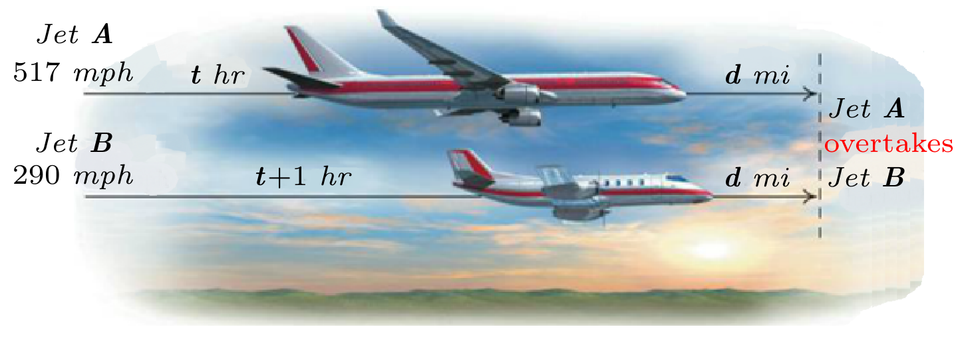

1. Two airline jets, jet ***A*** with a cruising speed of 900 *km/h*, and jet ***B*** with a cruising speed of 180 *km/h*. Suppose that jet ***B*** takes off and travels at it cruising speed. Two hours later, jet ***A*** takes off and follows the same route, traveling at its cruising speed. How long will it take the jet ***A*** to overtake the jet ***B***?

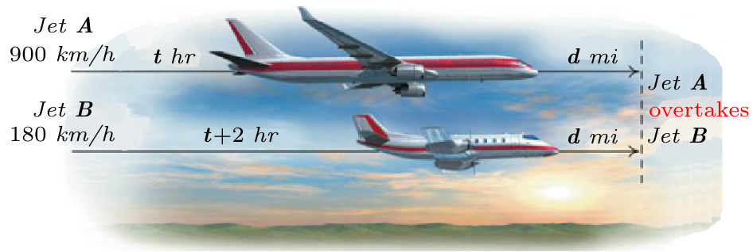

1. A central Railway freight train leaves a station and travels due north at a speed of 60 *mph*. One hour later, An Amtrak passenger train leaves the same station and travels due north on a parallel track at a speed of 80 *mph*. How long will it take the passenger train to overtake the freight train?
2. An airplane that travels 450 *mph* in still air encounters a 30-*mph* headwind. How long will it take the plane to travel 1050 *mi* into the wind?
3. An airplane that travels 375 *mph* in still air is flying with a 25-*mph* tailwind. How long will it take the plane to travel 700 *mi* with the wind?
4. A kayak moves at a rate of 12 *mph* in still water. If the river’s current flows at a rate of 4 *mph*, how long does it take the boat to travel 36 *miles* upstream?
5. A kayak travels at a rate of 14 *km/h* in still water. If the river’s current flows at a rate of 2 *km/h*, how long does it take the boat to travel 20 *km* downstream?
6. Ron’s two student loans total $28,000. One loan is at 5% simple interest and the other is at 3% simple interest. After 1 *year*, Ron owes $1,040 in interest. What is the amount of each loan?
7. You borrowed money at 5% simple interest rate to pay your tuition. At the end of 1 *year*, you owed a total of $1,365 in principal and interest. How much did you borrow?
8. You make an investment at 4% simple interest rate. At the end of 1 *year*, the total value of the investment is $1,560 in principal and interest. How much did you invest originally?
9. You invested a total of $5,000, part at 3% simple interest and a part at 4% simple interest. At the end of 1 *year* the investments had earned $176 interest. How much was invested at each rate?
10. You worked 48 *hr*. one week and earned a $1066 paycheck. You earn time and a half (1.5 times your regular hourly wage) for the number of hours you work in excess of 40. What is your regular hourly wage?
11. In 2010, 40.9% of federal tax returns had zero or negative tax liability. This amount is 15.7% more than the percentage of filers who had zero or negative tax liability in 2000. Find the percentage of tax filers in 2000 who had zero or negative tax liability.
12. The average annual salary of a restaurant manager is 24.8% less than the average annual salary of an office manager. The average annual salary of a restaurant manager is $48,533. Find the average annual salary of an office manager.
13. Jared’s two student loans total $12,000. One loan is at 5% simple interest and the other is at 8% simple interest. After 1 *yr*. Jared owes $750 in interest. What is the amount of each loan?
14. Cody wishes to sell a piece of property for $240,000. He wants the money to be paid off in two ways – a short-term note at 6% interest and a long-term note at 5%. Find the amount of each note if the total annual interest paid is $13,000.
15. You inherit $5000 with the stipulation that for the first year the money had to be invested in two funds paying 9% and 11% annual interest. How much did you invest at each rate if the total interest earned for the year was $487?
16. An artist has sold a painting for $410,000. He needs some of the money in 6 months and the rest in 1 yr. He can get a treasury bond for 6 months at 4.65% and for one year at 4.91%. His broker tells him the two investments will earn a total of $14,961. How much should be invested at each rate to obtain that amount of interest?
17. The number of steps needed to burn off a Cheeseburger exceeds the number needed to burn off a 12-*ounce* Soda by 4140. The number needed to burn off a Doughnut exceeds the number needed to burn off 12-*ounce* soda by 2300. If you chow down a cheeseburger, doughnut, and 12-*ounce* soda, a 16790 step walk is needed to burn off the calories (and perhaps alleviate the guilt). Determine the number of steps it takes to burn off a cheeseburger, a doughnut, and a 12-*ounce* soda.
18. Although organic milk accounts for only 12% of the market, consumption is increasing. In 2004, Americans purchased 40.7 million gallons of organic milk, increasing at a rate of 5.6 million gallons per year. If this trend continues, when will Americans purchase 79.9 million gallons of organic milk?
19. How many gallons of a 5% acid solution must be fixed with 5 *gal* of a 10% solution to obtain 7% solution?
20. In 1969, 88% of the women considered this objective essential or very important. Since then, this percentage has decreased by approximately 1.1 each year. If this trend continues, by which year will only 33% of female freshmen consider "developing a meaningful philosophy of life" essential or very important?
21. Charlotte is a chemist. She needs a 20% solution of alcohol. She has a 15% solution on hand, as well as a 30% solution. How many liters of the 15% solution should she add to 3 L of the 30% solution to obtain her 20% solution?
22. You are choosing between two texting plans. Plan ***A*** has a monthly fee of $20 with a charge of $0.05 per text. Plan ***B*** has monthly fee of $5 with charge of $0.10 per text.

Both plans include photo and video texts. For how many text messages will the costs for the two plans be the same?

1. A computer store is having a sale on digital cameras. After a 40% price reduction, your purchase a digital camera for $276. What was the camera’s price before the reduction?
2. In a triangle, the measure of the first angle is twice the measure of the second angle. The measure of the third angle is  less than the measure of the second angle. What is the measure of each angle?
3. In a triangle, the measure of the first angle is three times the measure of the second angle. The measure of the third angle is  less than the measure of the second angle. What is the measure of each angle?
4. In a triangle, the measures of the three angles are consecutive integers. What is the measure of each angle?
5. In a triangle, the measures of the three angles are consecutive ***even*** integers. What is the measure of each angle?
6. In a triangle, the measure of the first angle is *five* times the measure of the second angle. The measure of the third angle is  less than the measure of the second angle. What is the measure of each angle?
7. In a triangle, the measure of the first angle is *twice* as large as the second angle. The measure of the third angle is  more than the measure of the second angle. What is the measure of each angle?
8. In 2000, 31% of U.S. adults viewed a college education as essential for success. For the period 2000 through 2010, the percentage viewing a college education as essential for success increased on average by approximately 2.4 each year. If this trend continues, by which year will be 67% of all American adults view college education as essential for success?
9. Each day, the number of births in the world exceeds twice the number of deaths by 61 *thousand*.
10. If the population increase in a single day is 214 *thousand*, determine the number of births and deaths per day.
11. If the population increase in a single day is 214 *thousand*, by how many millions of people does the worldwide population increase each year?
12. Based on your answer to part (*b*), approximately how many years does it take for the population of the world to increase by an amount greater than the entire U.S. population (308 million)?
13. You are choosing between two health clubs. Club ***A*** offers membership for a fee of $40 plus a monthly fee of $25. Club ***B*** offers membership for a fee of $15 plus a monthly fee of $30. After how many months will the total cost at each health club be the same? What will be the total cost for each club?
14. Video Store ***A*** charges $9 to rent a video game for one week. Although only members can rent from the store, membership is free. Video Store ***B*** charges $4 to rent a video game for one week. Only members can rent from the store and membership is $50 per year. After how many video-game rentals will the total amount spent at each store be the same? What will be the total amount spent at each store?
15. The bus fare in a city is $1.25. people who use the bus have the option of purchasing a monthly discount pass for $15.00. with the discount pass, the fare is reduced to $0.75. Determine the number of times in a month the bus must be used so that the total monthly cost without the discount pass is the same as the total monthly cost with the discount pass.
16. A discount pass for a bridge costs $30 per month. The toll for the bridge is normally $5.00, but it is reduced to $3.50 for people who have purchased the discount pass. Determine the number of times in a month the bridge must be crossed so that the total monthly cost without the discount pass is the same as the total monthly cost with the discount pass.
17. After a 30% reduction, you purchase a dictionary for $30.80. What was the dictionary’s price before the reduction?
18. After a 20% reduction, you purchase a television for $336. What was the television’s price before the reduction?
19. Including 8% sales tax, an inn charges $162 per night. Find the inn’s nightly cost before the tax is added.
20. Including 5% sales tax, an inn charges $252 per night. Find the inn’s nightly cost before the tax is added.
21. The selling price of a refrigerator is $584. If the markup is 25% of the dealer’s cost, what is the dealer’s cost of the refrigerator?
22. The selling price of a scientific calculator is $15. If the markup is 25% of the dealer’s cost, what is the dealer’s cost of the calculator?
23. A job pays an annual salary of $33,150, which includes a holiday bonus of $750. If paychecks are issued twice a month, what is the gross amount for each paycheck?
24. The price of a coat is reduced by 40%. Where the coat still does not sell, it is reduced by 40% of the reduced price. If the price of the dress after both reductions is $72. What was the original price?
25. For an international call, a telephone company charges $0.43 for the first minute, $0.32 for each additional minute, and a $2.10 service charge. If the cost of a call is $5.73, how long did the person talk?
26. Metro taxi charges $2.50 pickup fee and $2 per mile traveled. The cab fare from the airport to his hotel is $32.50. how many miles did you travel in the cab?
27. The children at Tiny Tots Day Care plant a rectangular vegetable garden with a perimeter of 39 *m*. The length is twice the width. Find the dimensions of the garden.
28. A rectangular field is twice as long as it is wide. If the perimeter of the field is 300 *yards*, what are its dimensions?
29. A rectangular swimming pool is three times as long as it is wide. If the perimeter of the pool is 320 *feet*, what are its dimensions?
30. The length of the rectangular tennis court is 6 *feet* longer than twice the width. If the court’s perimeter is 228 *feet*, what are its dimensions?
31. The length of the rectangular pool is 6 *meters* less than twice the width. If the pool’s perimeter is 126 *meters*, what are its dimensions?
32. The rectangular painting measures 12 *inches* by 16 *inches* and contains a frame of uniform width around the four edges. The perimeter of the rectangle formed by the painting and its frame is 72 *inches*. Determine the width of the frame.

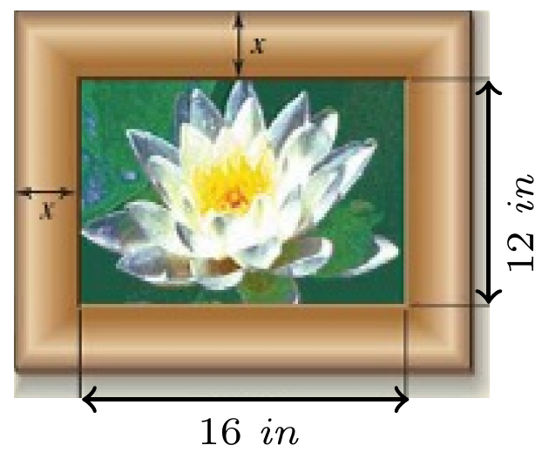

1. The rectangular swimming pool measures 40 *feet* by 60 *feet* and contains a path of uniform width around the four edges. The perimeter of the rectangle formed by the pool and the surrounding path is 248 *feet*. Determine the width of the path.

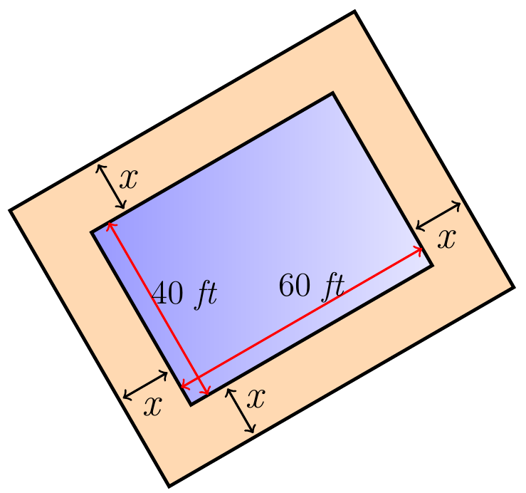

1. You paved your vegetable garden measuring 15 *meters* by 12 *meters* with stones. A path of uniform width is to surround the garden. If the perimeter of the garden and path combined is 70 *meters*, find the width of the path.

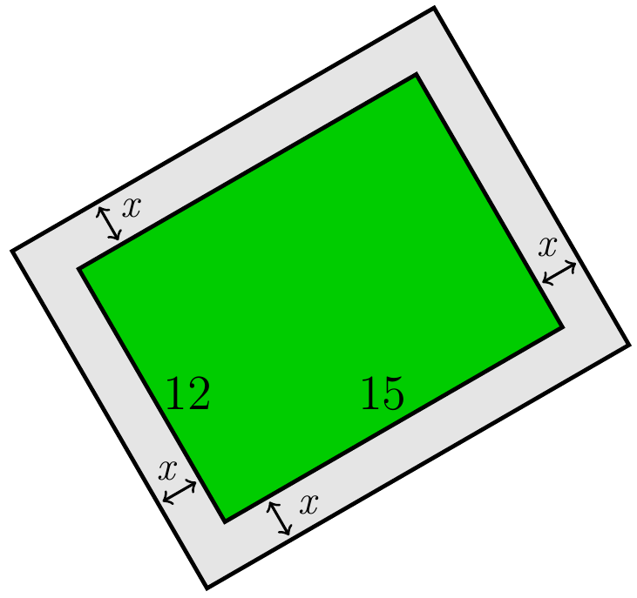

1. A pool measuring 10 *m* by 20 *m* is surrounded by a path of uniform width. If the perimeter of the pool and the path combined is 92 *m*, what is the width of the path?

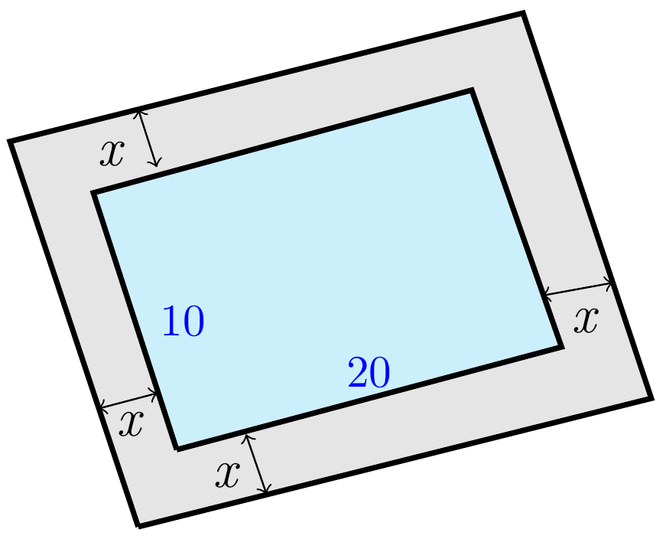

1. A thief steals a number of rare plants from a nursery. On the way out, the thief meets three security guards, one after another. To each security guard, the thief is forced to give one-half the plants that he still has, plus 2 more. Finally, the thief leaves the nursery with 1 lone palm. How many plants were originally stolen?