***Section* R.4 − Circles**

**The *Distance* Formula**

The distance, *d*, between the points and in the rectangular coordinate system is



To complete the distance between two points. Find the square of the difference between the *x*-coordinate plus the square of the difference between the *y*-coordinates. The principal square root of this sum is the distance.

***Example***

Find the distance between  and 

***Solution***









***Example***

Find the distance between (−4, 9) and (1, −3)

***Solution***







***Midpoint* Formula**

Consider a line segment whose endpoints are and . The coordinates of the segment’s midpoint are



To find the midpoint, take the average of the two *x*-coordinates and the average of the y-coordinates

***Example***

Find the midpoint of the line segment with endpoints (1, 2) and (7, −3)

***Solution***





The midpoint: 

***Example***

Find the midpoint *M* of the segment with endpoints  and 

***Solution***





***The Standard Form of the Equation of a Circle***

The *standard form of the equation of a circle* with center (*h, k*) and radius *r* is



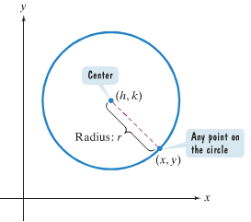

A circle with center (0, 0) and radius *r* has equation: 

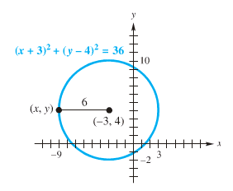***Example***

Find the center-radius form of the equation of each circle.

*a*) Center at , radius 6







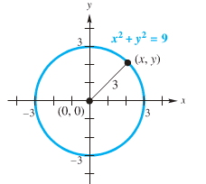*b*) Center at , radius 3





***Example***

Find the equation of a circle with center (−1, 4) that passes through (3, 7).

***Solution***













***Example***

Find an equation of the circle with endpoints ***A*** (1, −1) and ***B*** (2, −3)

***Solution***

Center = Midpoint: 











***Example***

Write in standard form: 

***Solution***









***Exercises*** ***Section* R.4 – Circles**

(**1 – 10**) Find the distance between the two given points

|  |  |
| --- | --- |
| 1. and 2. and 3. and 4. and 5. (−1, −5) and (−1, 2) | 1. (−4, 9) and (1, −3) 2. (−2, 2) and (3, −6) 3. and 4. and 5. and |

(**11 – 17**) Find the midpoint of the line segment with endpoints

|  |  |
| --- | --- |
| 1. (1, 2) and (7, −3) 2. and 3. and 4. (4, −9) and (−12, −3) | 1. (7, −2) and (9, 5). 2. and 3. and |

(**18 – 27**) Write the standard form of the equation of the circle

|  |  |
| --- | --- |
| 1. center , radius 2. center (0, 0) and radius 4. 3. center (5, −6) and radius 10. 4. center and . 5. center and . | 1. radius 5 and center (3, −7) 2. center (6, −5) that passes through (1, 7). 3. center (−2, −3) that passes through (−3, 2). 4. center (−5, 2) passing through (−1, 5) 5. diameter whose endpoints are (4, 4) and (−2, 3) |

(**28 – 31**) Find the center and the radius of

|  |  |
| --- | --- |
|  |  |