Math 2312: **Pre-Calculus** ***Homework Sec* 5.4**

*Professor*: Fred Khoury

A cross-section of a nuclear cooling tower is a hyperbola with equation



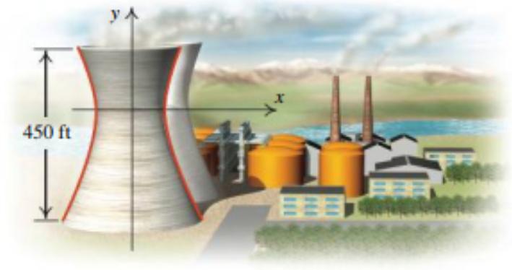

The tower is 450 *ft.* tall and the distance from the top of the tower to the center of the hyperbola is half the distance from the base of the tower to the center of the hyperbola.

Find the diameter of the ***top*** and the ***base*** of the tower.