***Solution Section* 1.3 - Quadratic Equations**

***Exercise***

Solve: 

***Solution***





***Exercise***

Solve: 

***Solution***



***Exercise***

Solve: 

***Solution***







***Exercise***

Solve: 

***Solution***









***Exercise***

Solve: 

***Solution***







***Exercise***

Solve: 

***Solution***

5*x*2 = 45

**

*x*2 = 9



***Exercise***

Solve: 

***Solution***



 



***Exercise***

Solve: 

***Solution***





***Exercise***

Solve: 

***Solution***





***Exercise***

Solve: 

***Solution***







***Exercise***

Solve 

***Solution***

 









***Exercise***

Solve 

***Solution***



 







***Exercise***

Solve: 

***Solution***



 









 

***Exercise***



***Solution***



 









***Exercise***

Solve: 

***Solution***



 







***Exercise***

Solve: 

***Solution***



 













***Exercise***

Solve: 

***Solution***

 









***Exercise***

Solve: 

***Solution***

 







***Exercise***

Solve: 

***Solution***

 





***Exercise***

Solve: 

***Solution***

 





***Exercise***

Solve: 

***Solution***

 







***Exercise***

Solve: 

***Solution***













***Exercise***

Solve: 

***Solution***













***Exercise***

Solve 

***Solution***

 





***Exercise***

Solve 

***Solution***



 





***Exercise***

Solve 

***Solution***

 





***Exercise***

Solve: 

***Solution***

 

 

 









The solution set is 

***Exercise***

Solve: 

***Solution***

 





***Exercise***

Solve: 

***Solution***

 





***Exercise***

Solve: 

***Solution***

 





***Exercise***

Solve: 

***Solution***

 





***Exercise***

Solve: 

***Solution***

 







***Exercise***

Solve: 

***Solution***

 







***Exercise***

Solve: 

***Solution***

 







***Exercise***

Solve: 

***Solution***

 







***Exercise***

Solve: 

***Solution***

 





***Exercise***

Solve: 

***Solution***

 







***Exercise***

Solve: 

***Solution***

 







***Exercise***

Solve: 

***Solution***

 









***Exercise***

Solve: 

***Solution***



 





***Exercise***

Solve: 

***Solution***



 





***Exercise***

Solve: 

***Solution***



 





***Exercise***

Solve: 

***Solution***



 





***Exercise***

Solve: 

***Solution***





 





***Exercise***

Solve: 

***Solution***





 





***Exercise***

Solve: 

***Solution***







***Exercise***

Solve: 

***Solution***





 





***Exercise***

Solve: 

***Solution***





 





***Exercise***

Solve: 

***Solution***



 

***Exercise***

Solve: 

***Solution***



 

***Exercise***

Solve: 

***Solution***



 

***Exercise***

Solve: 

***Solution***



 

***Exercise***

Solve: 

***Solution***



 

***Exercise***

Solve: 

***Solution***



 

***Exercise***

Solve: 

***Solution***



 

***Exercise***

Solve: 

***Solution***



 

***Exercise***

Solve: 

***Solution***



 

***Exercise***

Solve: 

***Solution***



 

***Exercise***

Solve: 

***Solution***



 

***Exercise***

Solve: 

***Solution***



 

***Exercise***

Solve for the specified variable 

***Solution***

 

 

 









***Exercise***

Solve for the specified variable 

***Solution***

 



***Exercise***

A rectangular park is 6 *miles* long and 2 *miles* wide. How long is a pedestrian route that runs diagonally across the park?

***Solution***









***Exercise***

What is the width of a 25-*inch* television set whose height is 15 *inches*?

***Solution***









***Exercise***

The length of a rectangular sign is 3 *feet* longer than the width. If the sign’s area is 54 square *feet*, find its length and width.

***Solution***









 







∴ the length of sign is **6** *feet* and width is **3** *feet*.

***Exercise***

A rectangular parking lot has a length that is 3 *yards* greater than the width. The area of the parking lot is 180 square *yards*, find the length and the width.

***Solution***









 







∴ the length of sign is **15** *feet* and width is **12** *feet*.

***Exercise***

Each side of a square is lengthened by 3 *inches*. The area of this new, larger square is 64 square *inches*. Find the length of a side of the original square.

***Solution***

The new length of each side of a square is 









∴ the length of the original square side is **5** *inches*.

***Exercise***

Each side of a square is lengthened by 2 *inches*. The area of this new, larger square is 36 square *inches*. Find the length of a side of the original square.

***Solution***

The new length of each side of a square is 









∴ the length of the original square side is **4** *inches*.

***Exercise***

One number is 5 greater than another. The product of the numbers is 36. Find the numbers.

***Solution***









 





 

∴ The numbers are **4** *&* **9****or** −**4** *&* −**9**

***Exercise***

One number is 6 less than another. The product of the numbers is 72. Find the numbers.

***Solution***









 





 

∴ The numbers are **6** *&* **12****or** −**6** *&* −**12**

***Exercise***

A vacant rectangular lot is being turned into a community vegetable garden measuring 15 *meters* by 12 *meters*. A path of uniform width is to surround the garden. If the area of the garden and path combined is 378 *square meters*, find the width of the path.

***Solution***





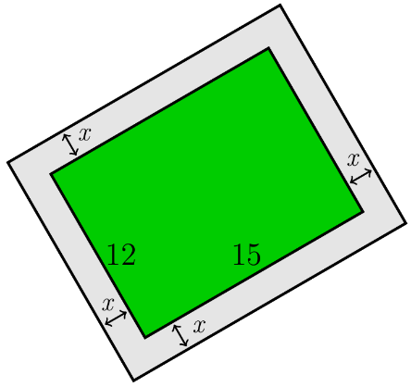















∴ the width of the path is **3** *meters*.

***Exercise***

A pool measuring 10 *m* by 20 *m* is surrounded by a path of uniform width. If the area of the pool and the path combined is 600 *m*2, what is the width of the path?

***Solution***

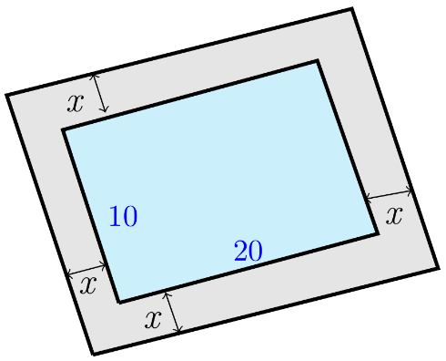



















∴ The width of the path is **5** *m*

***Exercise***

You put in flower bed measuring 10 *feet* by 12 *feet*. You plan to surround the bed with uniform border of low-growing plants.

1. Write a polynomial that describes the area of the uniform border that surrounds your flowers.
2. The low growing plants surrounding the flower bed require 1 square *foot* each when mature. If you have 168 of these plants, how wide a strip around the flower bed should you prepare for the border?

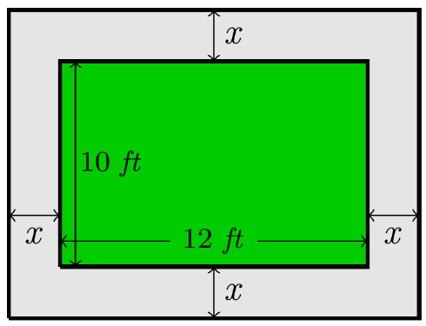***Solution***

1. 



1. 





 





∴ The width of the path is **3** *feet.*

***Exercise***

A rectangular garden measures 80 *feet* by 60 *feet*. A large path of uniform width is to be added along both shorter sides and one longer side of the garden. The landscape designer doing the work wants to double the garden’s area with the addition of this path. How wide should the path be?

***Solution***

Total Area 

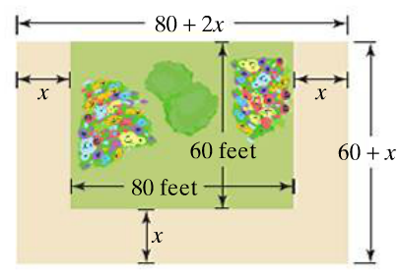















∴ the path should be **20** *feet*.

***Exercise***

The length of a rectangular poster is 1 *foot* more than the width, and a diagonal of the poster is 5 *feet*. Find the length and the width.

***Solution***

***Given***: 















∴ The length is **4** *feet* andthe width is **3** *feet*.

***Exercise***

One leg of a right triangle is 7 *cm* less than the length of the other leg. The length of the hypotenuse is 13 *cm*. find the lengths of the legs.

***Solution***

***Given***: 























∴ The length of the leg: **5** *&* **12** *cm*.

***Exercise***

A tent with wires attached to help stabilize it, as shown below. The length of each wire is 8 *feet* greater than the distance from the ground to where it is attached to the tent.

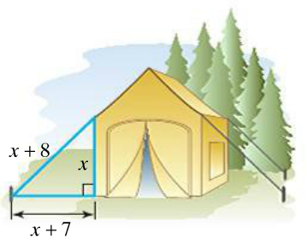The distance from the base of the tent to where the wire is anchored exceeds this height by 7 *feet*, Find the length of each wire used to stabilize the tent.

***Solution***









∴ The length of each wire: **5** *feet*, **12** *feet*, and **13** *feet*.

***Exercise***

A boat is being pulled into a dock with a rope attached to the boat at water level. Where the boat is 12 ft from the dock, the length of the rope from the boat to the dock is 3 ft longer than twice the height of the dock above the water. Find the height of the dock.

***Solution***



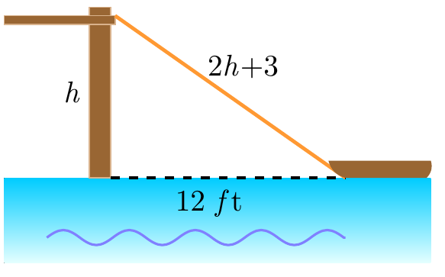











***Height*** = 5 *ft*.

***Exercise***

A piece of wire measuring 20 *feet* is attached to a telephone pole as a guy wire. The distance along the ground from the bottom of the pole to the end of the wire is 4 *feet* greater than the height where the wire is attached to the pole. How far up the pole does the guy wire reach?

***Solution***





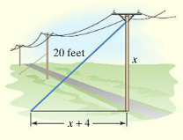











∴ the guy wire reaches the pole at **12** *feet* high.

***Exercise***

Logan and Cassidy leave a campsite, Logan biking due north and Cassidy biking due east. Logan bikes 7 *km/h* slower than Cassidy. After 4 *hr*, they are 68 *km* apart. Find the speed of each bicyclist.

***Solution***

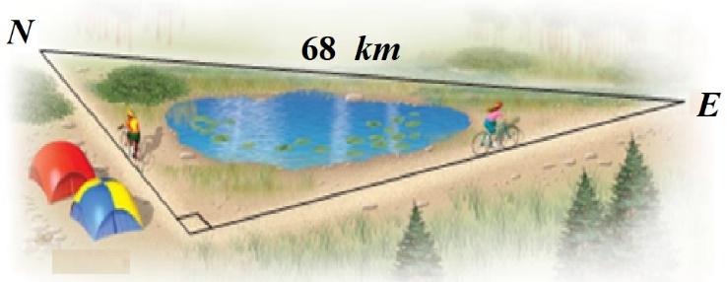

















***Exercise***

Two trains leave a station at the same time. One train travels due west, and the other travels due south. The train traveling west travels  faster than the train traveling south. After 2 *hr*., the trains are 200 *km* apart. Find the speed of each train.

***Solution***

***Given***: 



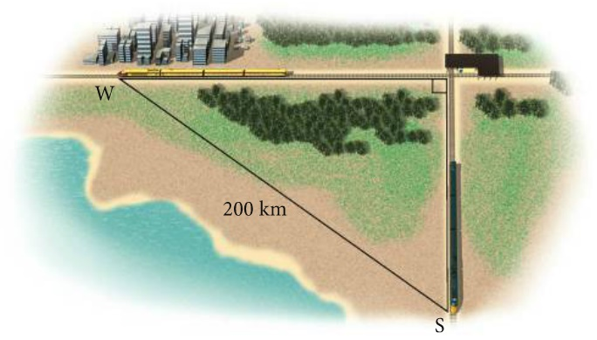









∴ Speed of south train: 

Speed of west train: 

***Exercise***

Towers are 1482 *feet* tall. How long would it take an object dropped from the top to reach the ground? Given 

***Solution***

1482 = 16t2









***Exercise***

The formula  models a woman's normal Point systolic blood pressure, *P*, an age *A*. Use this formula to find the age, to the nearest year, of a woman whose normal systolic blood pressure is 115 *mm* Hg.

***Solution***



A = 







***Exercise***

A rectangular piece of metal is 10 *in*. longer than it is wide. Squares with sides 2 ***in***. long are cut from the four corners, and the flaps folded upward to form an open box. If the volume of the box is 832 , what were the original dimensions of the piece of metal?

***Solution***



Bottom width: 

Bottom length: 















 

 

Width of the metal is 20 *in* by the length (20+10) 30 *in*.

***Exercise***

An astronaut on the moon throws a baseball upward. The astronaut is 6 *ft*., 6 *in*., tall, and the initial velocity of the ball is 30. The height *s* of the ball in feet is given by the equation



Where ***t*** is the number of seconds after the ball was thrown.

1. After how many seconds is the ball 12 *ft*. above the moon’s surface?
2. How many seconds will it take for the ball to return to the surface?

***Solution***

1. After how many seconds is the ball 12 ft above the moon’s surface*?*

**

**

**



 

 

1. How many seconds will it take for the ball to return to the surface*?*





 

 

It will take 11.32 *sec*.

***Exercise***

The bar graph shows of SUVs (sport utility vehicles in the US, in *millions*. The quadratic equation

 models sales of SUVs from 1992 to 2003, where *S* represents sales in *millions*, and  represents 1992,  represents 1993 and so on.

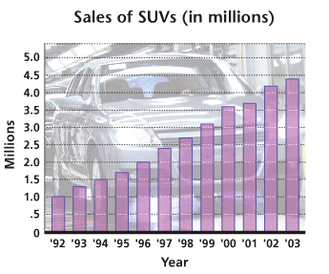

1. Use the model to determine sales in 2002 and 2003. Compare the results to the actual figures of 4.2 million and 4.4 million from the graph.
2. According to the model, in what year do sales reach 3.5 million? Is the result accurate?

***Solution***

1. For 2002 





For 2003 





1. 









 

 

According to the model, the number reached 3.5 *million* in the year 2000. The model closely matches the graph, so it is accurate

***Exercise***

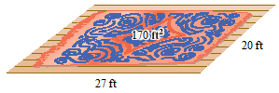Cynthia wants to buy a rug for a room that is 20 *feet.* wide and 27 *feet*. long. She wants to leave a uniform strip of floor around the rug. She can afford to buy 170 *square feet* of carpeting. What dimension should the rug have?

***Solution***

The area of the rug is:







 ***Solve for x***.







Therefore, the dimensions are: **10**, **20** *feet*.

***Exercise***

Erik finds a piece of property in the shape of a right triangle. He finds that the longer leg is 20 *m* longer than twice the length of the shorter leg. The hypotenuse is 10 *m* longer than the length of the longer leg. Find the lengths of the sides of the triangular lot.

***Solution***





Longer leg is 20 *m* longer than twice the length of the shorter leg



The hypotenuse is 10 *m* longer than the length of the longer leg



















 

 

The shorter length is 50 *m*.

The longer length is 



***Exercise***

An open box is made from a 10-*cm* by 20-*cm* piece of tin by cutting a square from each corner and folding up the edges. The area of the resulting base is 96 . What is the length of the sides of the squares?

***Solution***

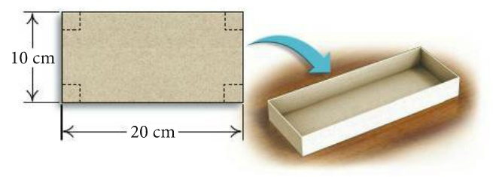 Area of the base = (10 – 2*x*)(20 – 2*x*)













 

***Exercise***

A square piece of cardboard is formed into a box by cutting out 3-*inch* squares from each of the corners and folding up the sides. If the volume of the box needs to be 126.75 cubic *inches*, what size square piece of cardboard is needed?

***Solution***





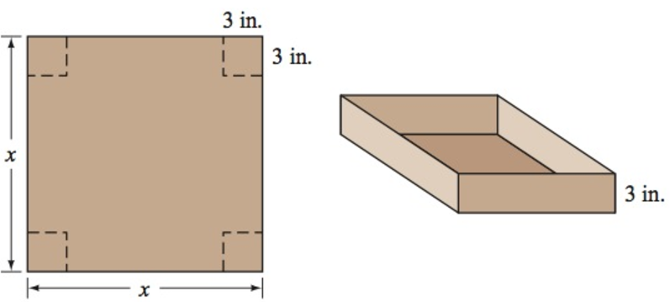









***Exercise***

You want to use 132 *feet* of chain-link fencing to enclose a rectangular region and subdivide the region into two smaller rectangular regions. If the total enclosed area is 576 *square feet*, find the dimensions of the enclosed region.

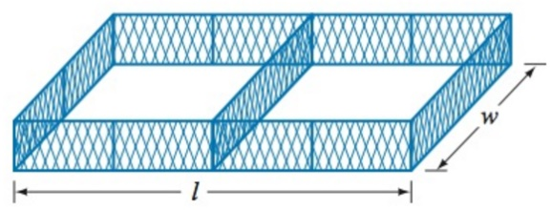***Solution***



























∴ the dimensions: Length 48 *feet*, width 12 *feet*.

***Or*** Length 18 *feet*, width 32 *feet*.

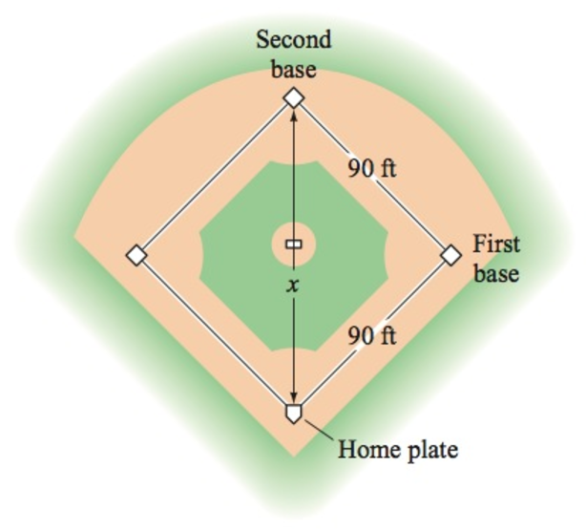***Exercise***

How far is it from home plate to second base on a baseball diamond?

***Solution***







∴ The distance between home plate and second base is



***Exercise***

Two equations can be used to track the position of a baseball *t* seconds after it is hit.

For instance, suppose  gives the height, in *feet*, of a baseball *t* seconds after it is hit and  gives the horizontal distance, in *feet*, of the ball from home plate *t* seconds after it is hit.

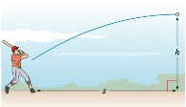

Use these equations to determine whether this particular baseball will clear a 10-*foot* fence positioned 360 *feet* from home plate.

***Solution***











Since the height is negative, then the ball hit the ground before the fence.

∴ The baseball will ***not*** clear the 10-*foot* fence.

***Exercise***

A ball is thrown downward with an initial velocity of 5 *feet* per *second* from the Golden Gate Bridge, which is 220 *feet* above the water. How long will it take for the ball to hit the water?

***Solution***

 









∴ It will take for the ball to hit the water 

***Exercise***

A television screen measures 60 *inches* diagonally, and its aspect ratio is 16 to 9. This means that the ratio of the width of the screen to the height of the screen is 16 to 9.

Find the width and height of the screen.

***Solution***

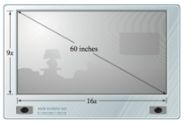











∴ The width of TV is 

The height of TV is 

***Exercise***

A company makes rectangular solid candy bars that measures 5 *inches* by 2 *inches* by 0.5 *inch*. Due to difficult financial times, the company has decided to keep the price of the candy bar fixed and reduce the volume of the bar by 20%. What should the dimensions be for the new candy bar if the company keeps the height at 0.5 *inch* and makes length of the candy bar 3 *inches* longer than the width?

***Solution***

The original volume is given:





Reduction the volume of the bar by 20% which leave 80% of the new candy.





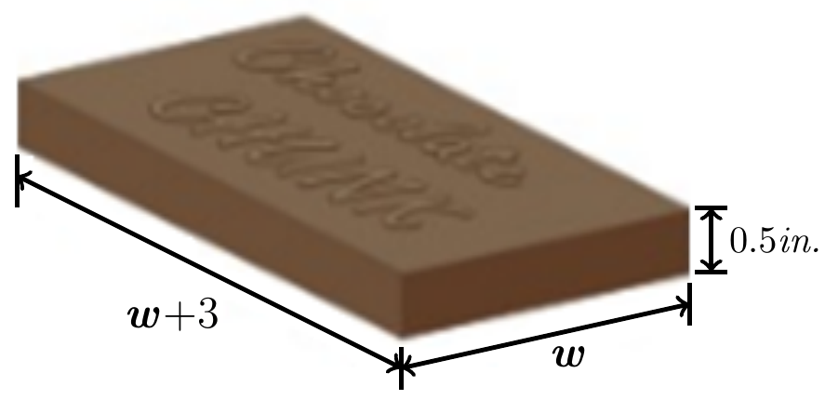











 

∴ The new width of the chocolate bar is 

The new length of the chocolate bar is 

***Exercise***

A company makes rectangular solid candy bars that measures 5 *inches* by 2 *inches* by 0.5 *inch*. Due to difficult financial times, the company has decided to keep the price of the candy bar fixed and reduce the volume of the bar by 20%. What should the dimensions be for the new candy bar if the company keeps the height at 0.5 *inch* and makes length of the candy bar 2.5 times as long as its width?

***Solution***

The original volume is given:





Reduction the volume of the bar by 20% which leave 80% of the new candy.



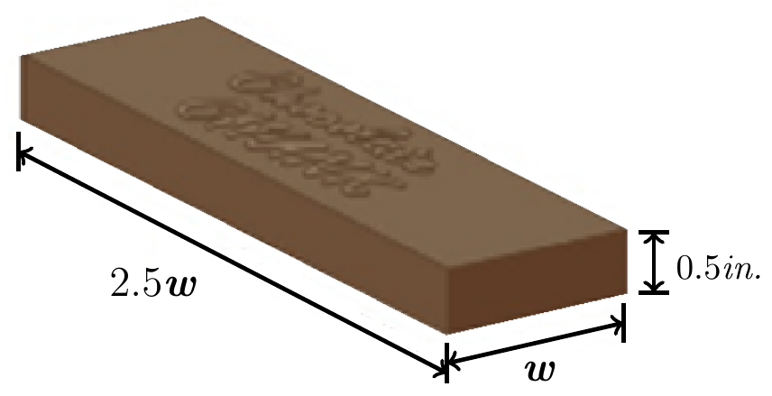 











∴ The new width of the chocolate bar is 

The new length of the chocolate bar is 