***Solution Section* 1.4- Other Types of Equations**

***Exercise***

Solve 

***Solution***







 

 

 

∴ Solutions: 

***Exercise***

Solve: 

***Solution***





|  |  |
| --- | --- |
|  |  |

∴ Solutions: 

***Exercise***

Solve: 

***Solution***





|  |  |
| --- | --- |
|  |  |

∴ Solutions: 

***Exercise***

Solve: 

***Solution***





|  |  |
| --- | --- |
|  |  |

∴ Solutions: 

***Exercise***

Solve: 

***Solution***





|  |  |
| --- | --- |
|  |  |

∴ Solutions: 

***Exercise***

Solve: 

***Solution***





|  |  |
| --- | --- |
|  |  |

∴ Solutions: 

***Exercise***

Solve: 

***Solution***







|  |  |
| --- | --- |
|  |  |

∴ Solutions: 

***Exercise***

Solve: 

***Solution***





|  |  |
| --- | --- |
|  |  |

∴ Solutions: 

***Exercise***

Solve: 

***Solution***







|  |  |
| --- | --- |
|  |  |

∴ Solutions: 

***Exercise***

Solve: 

***Solution***





|  |  |
| --- | --- |
|  |  |

∴ Solutions: 

***Exercise***

Solve: 

***Solution***





|  |  |
| --- | --- |
|  |  |

∴ Solutions: 

***Exercise***

Solve: 

***Solution***





∴ Solutions: 

***Exercise***

Solve: 

***Solution***





∴ Solutions: 

***Exercise***

Solve 

***Solution***





|  |  |
| --- | --- |
|  |  |

∴ Solutions: 

***Exercise***

Solve: 

***Solution***











|  |  |  |
| --- | --- | --- |
|  |  |  |

∴ Solutions: 

***Exercise***

Solve 

***Solution***

 











∴ Solutions: 

***Exercise***

Solve: 

***Solution***



















∴ Solutions: 

***Exercise***

Solve 

***Solution***

 







|  |  |
| --- | --- |
|  |  |

∴ Solutions: 

***Exercise***

Solve 

***Solution***



 

 

 

∴ Solutions: 

***Exercise***

Solve 

***Solution***



 

|  |  |
| --- | --- |
|  |  |

∴ Solutions: 

***Exercise***

Solve 

***Solution***





 

 

 



∴ Solutions: 

***Exercise***

Solve: 

***Solution***



|  |  |
| --- | --- |
|  |  |

∴ Solutions: 

***Exercise***

Solve: 

***Solution***



|  |  |
| --- | --- |
|  |  |

∴ Solutions: 

***Exercise***

Solve: 

***Solution***



|  |  |
| --- | --- |
|  |  |

∴ Solutions: 

***Exercise***

Solve: 

***Solution***



|  |  |
| --- | --- |
|  |  |

∴ Solutions: 

***Exercise***

Solve: 

***Solution***



|  |  |
| --- | --- |
|  |  |

∴ Solutions: 

***Exercise***

Solve: 

***Solution***



 

|  |  |
| --- | --- |
|  |  |

∴ Solutions: 

***Exercise***

Solve: 

***Solution***



 

|  |  |
| --- | --- |
|  |  |

∴ Solutions: 

***Exercise***

Solve: 

***Solution***



 

|  |  |
| --- | --- |
|  |  |

∴ Solutions: 

***Exercise***

Solve: 

***Solution***



 

|  |  |
| --- | --- |
|  |  |

∴ Solutions: 

***Exercise***

Solve: 

***Solution***



 

|  |  |
| --- | --- |
|  |  |

∴ Solutions: 

***Exercise***

Solve: 

***Solution***



 

|  |  |
| --- | --- |
|  |  |

∴ Solutions: 

***Exercise***

Solve: 

***Solution***



 

|  |  |
| --- | --- |
|  |  |

∴ Solutions: 

***Exercise***

Solve: 

***Solution***



 

|  |  |
| --- | --- |
|  |  |

∴ Solutions: 

***Exercise***

Solve 

***Solution***



 

  *Impossible*



∴ Solution: 

***Exercise***

Solve 

***Solution***









 

 

∴ Solutions: 

***Exercise***

Solve 

***Solution***









 

 

∴ Solutions: 

***Exercise***

Solve: 

***Solution***

 ***Reciprocal***





***Exercise***

Solve: 

***Solution***









***Exercise***

Solve: 

***Solution***









***Exercise***

Solve: 

***Solution***









***Exercise***

Solve: 

***Solution***











***Exercise***

Solve: 

***Solution***











***Exercise***

Solve: 

***Solution***









***Exercise***

Solve: 

***Solution***











***Exercise***

Solve: 

***Solution***











∴ Solution set is: 

***Exercise***

Solve: 

***Solution***











∴ Solution set is: 

***Exercise***

Solve: 

***Solution***









 

 

***Check***

 

 

 

 

∴ Solution set is: 

***Exercise***

Solve: 

***Solution***

 







***Check***: 

 ***√***

∴ Solution set is: 

***Exercise***

Solve: 

***Solution***



∴ ***No*** solution.

***Exercise***

Solve: 

***Solution***

 







***Check***: 

 ***√***

∴ Solution set is: 

***Exercise***

Solve: 

***Solution***

 







***Check***: 

 ***√***

∴ Solution set is: 

***Exercise***

Solve: 

***Solution***

 







***Check***: 

 ***√***

∴ Solution set is: 

***Exercise***

Solve: 

***Solution***



 







***Check***: 

 ***√***

∴ Solution set is: 

***Exercise***

Solve: 

***Solution***



∴ ***No*** solution.

***Exercise***

Solve: 

***Solution***



∴ ***No*** solution.

***Exercise***

Solve: 

***Solution***







 

***Check***:

|  |  |
| --- | --- |
|  | ***√*** |

∴ Solution set is: 

***Exercise***

Solve: 

***Solution***







 

***Check***:

|  |  |
| --- | --- |
|  | ***√*** |

∴ Solution is: 

***Exercise***

Solve: 

***Solution***











***Check***:

|  |  |
| --- | --- |
| ***√*** | ***√*** |

∴ Solutions are: 

***Exercise***

Solve: 

***Solution***











 

***Check***:

|  |  |
| --- | --- |
| ***√*** | ***√*** |

∴ Solutions are: 

***Exercise***

Solve: 

***Solution***













***Check***:

|  |  |
| --- | --- |
| ***√*** | ***√*** |

∴ Solution set is: 

***Exercise***

Solve: 

***Solution***













***Check***:

|  |  |
| --- | --- |
| ***√*** | ***√*** |

∴ Solutions are: 

***Exercise***

Solve 

***Solution***











 

 

***Check***  

 

 

*False True*

∴ Solution set is: 

***Exercise***

Solve: 

***Solution***













  ⇒ *x* = 1, 6

***Check***:

*x* = 1 ⇒  ⇒ 5 = 1 (*Not a solution*)

*x* = 6 ⇒  ⇒ 6 = 6 → *x* = 6 is the only solution

***Exercise***

Solve 

***Solution***

 ***Square both side***

 







 ***Solve for*** *x*

*x* = 5, −2

***Check:***

*x* = 5 ⇒ 

*x* = -2 ⇒ 

∴ Solution set is: 

***Exercise***

Solve: 

***Solution***













***Check***:

|  |
| --- |
| ***√*** |

∴ Solution set is: 

***Exercise***

Solve: 

***Solution***











***Check***:

|  |
| --- |
| ***√*** |

∴ Solution set is: 

***Exercise***

Solve: 

***Solution***







***Check***:

|  |
| --- |
| ***√*** |

∴ Solution set is: 

***Exercise***

Solve: 

***Solution***







***Check***:

|  |
| --- |
| ***√*** |

∴ Solution set is: 

***Exercise***

Solve: 

***Solution***





















***Check***:

|  |  |
| --- | --- |
|  | ***√*** |

∴ Solution is: 

***Exercise***

Solve: 

***Solution***















***Check***:

|  |
| --- |
| ***√*** |

∴ Solution is: 

***Exercise***

Solve: 

***Solution***















***Check***:

|  |
| --- |
| ***√*** |

∴ Solution is: 

***Exercise***

Solve: 

***Solution***



















***Check***:

|  |  |
| --- | --- |
| ***√*** | ***√*** |

∴ Solution is: 

***Exercise***

Solve: 

***Solution***



















***Check***:

|  |  |
| --- | --- |
|  | ***√*** |

∴ Solution is: 

***Exercise***

Solve: 

***Solution***













***Check***:

|  |  |
| --- | --- |
| ***√*** | ***√*** |

∴ Solution is: 

***Exercise***

Solve: 

***Solution***











 *Only* result.

***Check***:

|  |
| --- |
| ***√*** |

∴ Solution is: 

***Exercise***

Solve: 

***Solution***























*x* = 2, 6

*Check*





∴ Solution is: 

***Exercise***

Solve: 

***Solution***















1 = *x* – 3

⇒ *x* = 4

***Check***: 

3 – 1 = 2 (True statement)

∴ Solution is: 

***Exercise***

Solve: 

***Solution***

 

















 

 

***Check***

 

 

 

 

∴ Solution: 

***Exercise***

Solve: 

***Solution***















1 = *x* – 3

⇒ *x* = 4

***Check***: 

3 – 1 = 2 (True statement)

∴ Solution is: 

***Exercise***

Solve: 

***Solution***

 Not True

∴ ***No*** Solution

***Exercise***

Solve: 

***Solution***

∴ Solutions: 

***Exercise***

Solve: 

***Solution***

|  |  |
| --- | --- |
|  |  |

∴ Solutions: 

***Exercise***

Solve: 

***Solution***



∴ Solution: 

***Exercise***

Solve: 

***Solution***

|  |  |
| --- | --- |
|  |  |

∴ Solutions: 

***Exercise***

Solve: 

***Solution***

|  |  |
| --- | --- |
|  |  |

∴ Solutions: 

***Exercise***

Solve 

***Solution***









|  |  |
| --- | --- |
|  |  |

∴ Solution: 

***Exercise***

Solve 

***Solution***

  ***Distribute* 4**

 



|  |  |  |  |  |
| --- | --- | --- | --- | --- |
|  |  |  |  |  |

∴ Solutions: 

***Exercise***

Solve 

***Solution***





⇒ No solution or ∅, since the absolute value can't be equal to a negative.

***Exercise***

Solve equation: 

***Solution***

 

 

 

 

∴ Solutions: 

***Exercise***

Solve equation: 

***Solution***

 

 

 

∴ Solutions: 

***Exercise***

Solve: 

***Solution***



|  |  |
| --- | --- |
|  |  |

∴ Solutions: 

***Exercise***

Solve: 

***Solution***



|  |  |
| --- | --- |
|  |  |

∴ Solutions: 

***Exercise***

Solve: 

***Solution***



|  |  |
| --- | --- |
|  |  |

∴ Solutions: 

***Exercise***

Solve: 

***Solution***



|  |  |
| --- | --- |
|  |  |

∴ Solutions: 

***Exercise***

Solve: 

***Solution***



|  |  |
| --- | --- |
|  |  |

∴ Solutions: 

***Exercise***

Solve: 

***Solution***



|  |  |
| --- | --- |
|  |  |

∴ Solutions: 

***Exercise***

Solve: 

***Solution***





|  |  |
| --- | --- |
|  |  |

∴ Solutions: 

***Exercise***

Solve: 

***Solution***



∴ ***No*** Solution

***Exercise***

Solve: 

***Solution***



|  |  |
| --- | --- |
|  |  |

∴ Solutions: 

***Exercise***

Solve: 

***Solution***



∴ ***No*** Solution

***Exercise***

Solve: 

***Solution***



|  |  |
| --- | --- |
|  |  |

∴ Solutions: 

***Exercise***

Solve equation: 

***Solution***

 

 

 

 

 

 

 

∴ Solutions: 

***Exercise***

Solve equation: 

***Solution***

 

 

 

 



∴ Solutions: 

***Exercise***

Solve: 

***Solution***

|  |  |
| --- | --- |
|  |  |

∴ Solutions: 

***Exercise***

Solve: 

***Solution***

|  |  |
| --- | --- |
|  |  |

∴ Solutions: 

***Exercise***

Solve: 

***Solution***

|  |  |
| --- | --- |
|  |  |

∴ Solutions: 

***Exercise***

Solve: 

***Solution***

|  |  |
| --- | --- |
|  |  |

∴ Solutions: 

***Exercise***

Solve: 

***Solution***

|  |  |
| --- | --- |
|  |  |

∴ Solution: 

***Exercise***

Solve: 

***Solution***

|  |  |
| --- | --- |
|  |  |

∴ Solution: 

***Exercise***

Solve: 

***Solution***

|  |  |
| --- | --- |
|  |  |

∴ Solutions: 

***Exercise***

Solve: 

***Solution***

|  |  |
| --- | --- |
|  |  |

∴ Solutions: 

***Exercise***

Solve: 

***Solution***

|  |  |
| --- | --- |
|  |  |

∴ Solutions: 

***Exercise***

Solve: 

***Solution***

|  |  |
| --- | --- |
|  |  |

∴ Solutions: 

***Exercise***

Two vertical poles of lengths 4 *feet* and 10 *feet* stand 15 *feet* apart. A cable reaches from the top of one pole to some point on the ground between the poles and then to the top of the other pole. Where should this point be located to use 24 *feet* of cable?

***Solution***

 

 







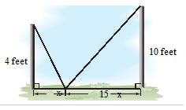





















***Exercise***

Towns ***A*** and ***B*** are located 6 *miles* and 3 *miles*, respectively, from a major expressway. The point on the expressway closet to town ***A*** is 12 *miles* from the point on the expressway closet to town ***B***. Two new roads are to be built from ***A*** to the expressway and then to ***B***.

1. Express the combined lengths of the new road in terms of *x*.
2. If the combined lengths of the new roads is 15 miles, what distance does *x* represent?

***Solution***

1. 





1. 















 Solve for *x*:



***Exercise***

A solid silver sphere has a diameter of 8 *millimeters*, and a second silver has a diameter of 12 *millimeters*. The spheres are melted down and recast to form a single cube. What is the length *s* of each edge of the cube?

***Solution***

 











***Exercise***

The period *T* of the pendulum is the time it takes the pendulum to complete one swing from left to right and back. For a pendulum near the surface of Earth



Where *T* is measured in *seconds* and *L* is the length of the pendulum in *feet*. Find the length of a pendulum that has a period of 4 *seconds*.

***Solution***











***Exercise***

A power station is on one side of a river that is 1 *mile* wide, and a factory is 6 *miles* down-stream on the other side of the river, the cost is $0.125 *million* per *mile* to run power lines over land and $0.2 *million* per *mile* to run power lines under water. How far over the land should the power line be run if the total cost of the project is to be $1 *million*?

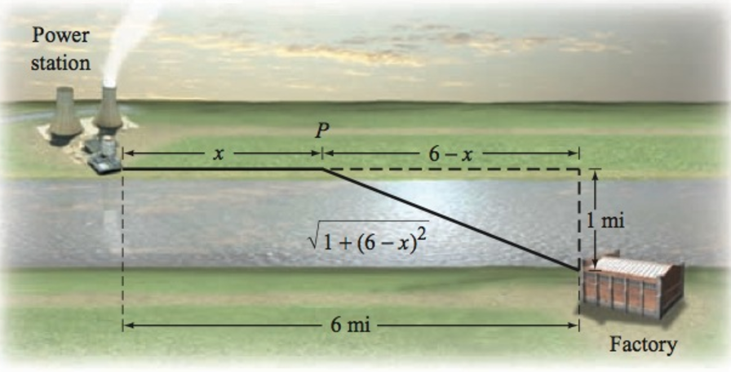

***Solution***

Let *x* be the distance the power lines overland.

 the distance the power lines underwater.

The total cost is given:





















∴ Distance of the power lines overland is **3.11** *km*.

***Exercise***

A cabin is located in a meadow at the end of a straight driveway 2 *km* long. A post office is located 5 *km* from the driveway along a straight road. A woman walks 2  through the meadow to point ***P*** and then 5 along the road to the post office. If it takes the woman 2.25 *hours* to reach the post office, what is the distance *x* of point ***P*** from the end of the driveway?

***Solution***



Time to walk from cabin to *P* 

Time to walk from *P* to Post Office 

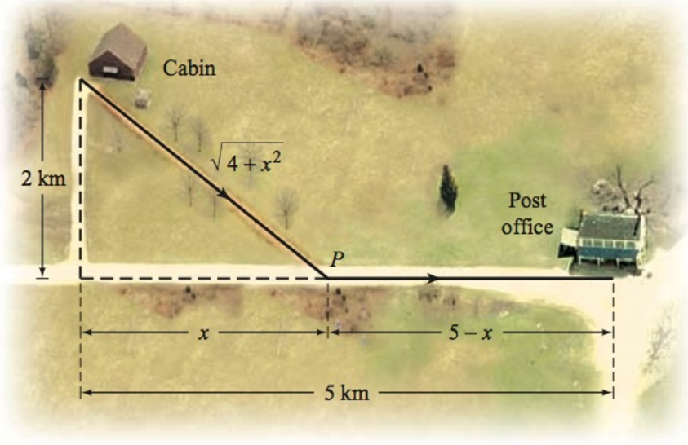



















∴ Distance of point ***P*** from the end of the driveway is  *km*.

***Exercise***

To prepare for a triathlon, a person swims across a river to point ***P*** and then runs along a path.

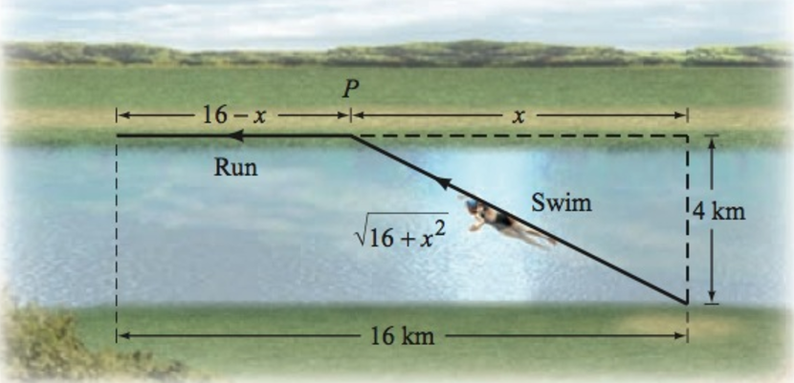

The person swims at 7  and runs at 22 . For what distance *x* is the total time for swimming and running 2 *hours*?

***Solution***



Time swimming 

Time runs 





















∴ The total distance is  *km*.

***Exercise***

The depth *s* from the opening of a well to the water below can be determined by measuring the total time between the instant you drop a stone and the moment you heat it hit the water. The time, in *seconds*, it takes the stone to hit the water is given by , where s is measured in *feet*. The time, also in seconds, required for the sound of the impact to travel up to your ears is given by . Thus, the total time *T*, in *seconds*, between the instant you drop the stone and the moment you hear its impact is



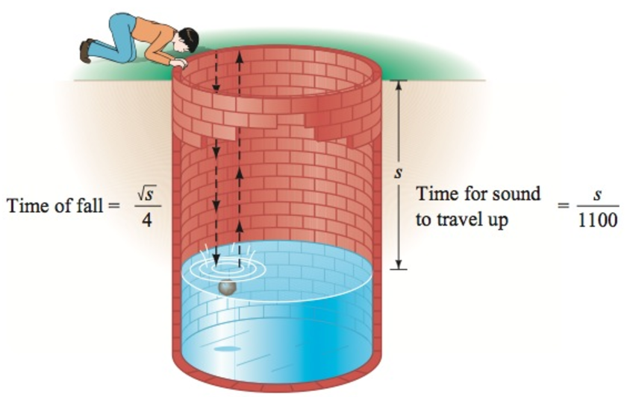

1. One of the world’s deepest water wells is 7,320 *feet* deep. Find the time between the instant you drop a stone and the time you hear it hit the water if the surface of the water if the surface of the water is 7,100 *feet* below the opening of the well.
2. Find the depth from the opening of a well to the water level if the time between the instant you drop a stone and the moment you heat its impact is 3 *seconds*.

***Solution***

1. ***Given***: 







1. ***Given***: 



















∴ The depth from the opening of a well to the water level is about **133** *feet*.

***Exercise***

On a ship, the distance *d* that you can see to the horizon is given by , where *h* is the height of your eye measured in *feet* above the sea level and *d* is measured in *miles*. How high is the eye level of a navigator who can see 14 *miles* to the horizon?

***Solution***

***Given***: 









