***Lecture Two* − Functions**

***Section* 2.1– Functions and Graphs**

***Relations***

A ***relation*** is any set of ordered pairs. The set of all first components of ordered pairs is called the domain of the relation and the set of second components is called the range of the relation.

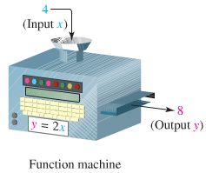

**Definition of a Function**

A ***function*** is a relation between two variables such that to matches each element of a first set (called ***domain***) to an element of a second set (called ***range***) in such way that no element in the first set is assigned to two different elements in the second set.

The ***domain*** of the function is the set of all values of the independent variable for which the function is defined.

The ***range*** of the function is the set of all values taken on by the dependent variable.

***Example***

Determine whether each relation is a function and *find the domain and the range*.

***a***) 

Function: Yes

Domain: 

Range: 

***b***) 

Function: No

Domain: {1, 2}

Range: {1, 2, 3}

***c***) 

Function: No

Domain: 

Range: {0, 1}

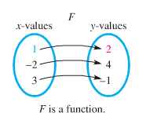 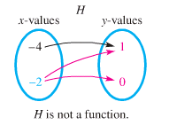

***Example***

Give the domain and range of each relation

|  |  |
| --- | --- |
|  | ***Domain***: {-1, 0, 1, 4}  ***Range***: {-3, -1, 1, 2} |
|  | ***Domain***:  ***Range***: |

**Functions as Equations** 

*x*: independent

*y*: depend on *x*

***Notation for Functions***

 read “ *f* of *x* ” or “ *f* at *x* ” represents the value of the function at the number *x*.

***Example***

Let 

1. 









1. 





***Example***

If , evaluate each of the following:

1. 
2. 

***Solution***

1. 





= 25 + 10 + 7



1. 



 







***Example***

Let , find 

***Solution***









***Example***

Given: , find the following.

1. 
2. 
3. 

***Solution***

1. 



1. 



1. 



**Increasing and Decreasing Functions**

* A function *rises from left to right (x-coordinate)*, the function *f* is said to be ***increasing*** on an open interval I (*a, b*) (*x*-coordinate)



* A function *f* is said to be ***decreasing*** on an open interval I



* A function *f* is said to be ***constant*** on an open interval I



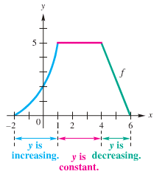

***Example***

Determine the intervals over which the function is increasing, decreasing, or constant

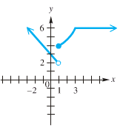

*Increasing*: [1, 3]

*Decreasing*: 

*Constant*: 

**Relative *Maxima*** *(um)* **and *Minima*** *(um)*

*f(a)* is a relative maximum if there exists an open interval I about *a* such that *f(a)* > *f(x),* for all *x* in I.

*f(a)* is a relative minimum if there exists an open interval I about *a* such that *f(a)* < *f(x),* for all *x* in I.



π/2

**−1**

**1**

−π/2

The relative minimum value of the function is −1 @ *x* = −π/2

The relative maximum value of the function is 1 @ *x* = π/2

***Example***

State the intervals on which the given function  is increasing, decreasing, or constant, and determine the extreme values



***Increasing***  ***RMIN*** 

***Decreasing***  ***RMAX*** 

***Piecewise*-Defined Functions**

Function are sometimes described by more than one expression, we call such functions ***piecewise-defined functions***.

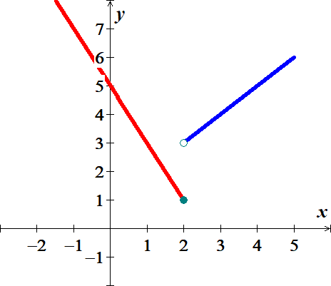***Example***

Graph function



Find: 





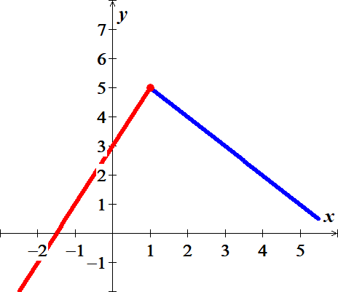

***Example***

Graph function



***Example***



Find *C*(40), *C*(80), and *C*(60)

***Solution***

1. *C*(40) = 20
2. *C*(80) = 20 + 0.40(80 – 60) = 28
3. *C*(60) = 20

***Exercise Section* 2.1– Functions and Graphs**

(**1 − 7**) Determine whether each relation is a function and *find the domain and the range*.

1. 
2. 
3. 
4. 
5. 
6. 
7. 
8. Let , find , , , and 
9. Let , find , , and 
10. Let , find 
11. Given: , find.
12. Given: , find 
13. Given: , find 
14. Given that . Find 
15. If , evaluate each of the following: 
16. Find 
17. For , determine

|  |  |  |  |
| --- | --- | --- | --- |
|  |  |  |  |

1. For , determine

|  |  |  |  |
| --- | --- | --- | --- |
|  |  |  |  |

1. For , determine

|  |  |  |  |
| --- | --- | --- | --- |
|  |  |  |  |

1. For , determine

|  |  |  |  |
| --- | --- | --- | --- |
|  |  |  |  |

1. For , determine

|  |  |  |  |
| --- | --- | --- | --- |
|  |  |  |  |

1. For , determine

|  |  |  |
| --- | --- | --- |
|  |  |  |

1. For , determine

|  |  |  |
| --- | --- | --- |
|  |  |  |

1. For , determine

|  |  |  |
| --- | --- | --- |
|  |  |  |

1. For , determine

|  |  |  |  |
| --- | --- | --- | --- |
|  |  |  |  |

1. For , determine

|  |  |  |  |
| --- | --- | --- | --- |
|  |  |  |  |

1.  Find: 
2.  Find: 
3.  Find: 
4.  Find: 
5.  Find

|  |  |  |  |  |
| --- | --- | --- | --- | --- |
|  |  |  |  | 1. Graph |

1.  Find

|  |  |  |  |  |
| --- | --- | --- | --- | --- |
|  |  |  |  | 1. Graph |

1.  Find

|  |  |  |  |  |
| --- | --- | --- | --- | --- |
|  |  |  |  | 1. Graph |

1. Graph the piecewise function defined by 
2. Sketch the graph 
3. Sketch the graph 

(**37 − 42**) Determine any ***relative maximum*** or ***minimum*** of the function, determine the intervals on which the function ***increasing*** or ***decreasing***, and then find the ***domain*** and the ***range***.

|  |  |
| --- | --- |
|  |  |
|  |  |
|  |  |
|  |  |
|  |  |
|  |  |

1. The elevation *H*, in *meters*, above sea level at which the boiling point of water is in ***t*** *degrees* *Celsius* is given by the function



At what elevation is the boiling point 99.5°.

1. A hot-air balloon rises straight up from the ground at a rate of 120 *ft./min*. The balloon is tracked from a rangefinder on the ground at point *P*, which is 400 *feet*. from the release point *Q* of the balloon. Let *d* be the distance from the balloon to the rangefinder and*t* – the time, in *minutes*, since the balloon was released. Express *d* as a function of *t*.

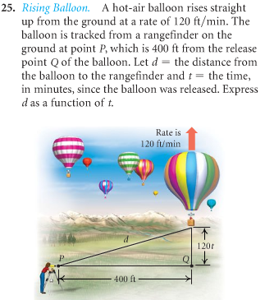

1. An airplane is flying at an altitude of 3700 *feet*. The slanted distance directly to the airport is *d* *feet*. Express the horizontal distance *x* as a function of *d*.

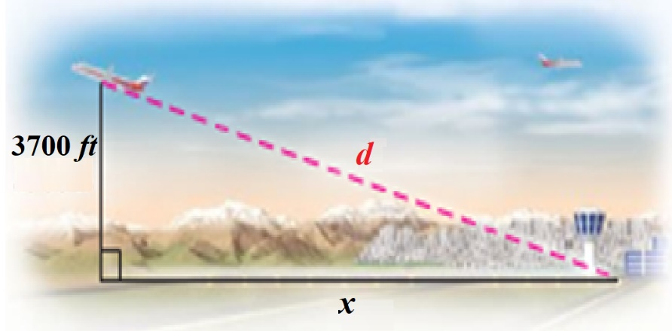

1. For the first minute of flight, a hot air balloon rises vertically at a rate of 3 *m/sec*. If *t* is the time in *seconds* that the balloon has been airborne, write the distance *d* between the balloon and a point on the ground 50 *meters* from the point to lift off as a function of *t*.

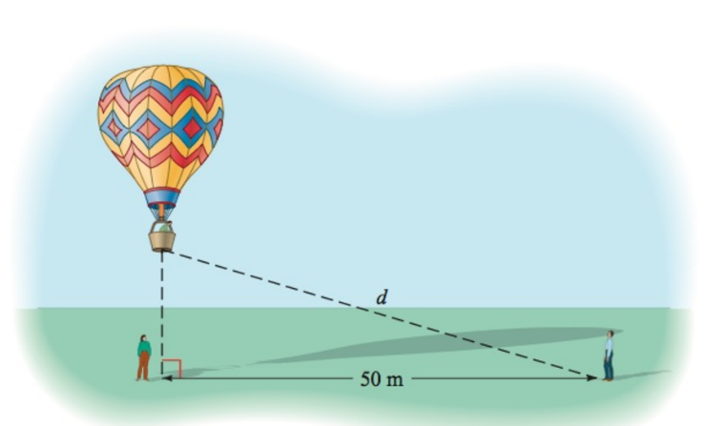

1. A light house is 2 *miles* south of a port. A ship leaves port and sails east at a rate of 7 *miles* per *hour*. Express the distance *d* between the ship and the lighthouse as a function of time, given that the ship has been sailing for *t* *hours*.

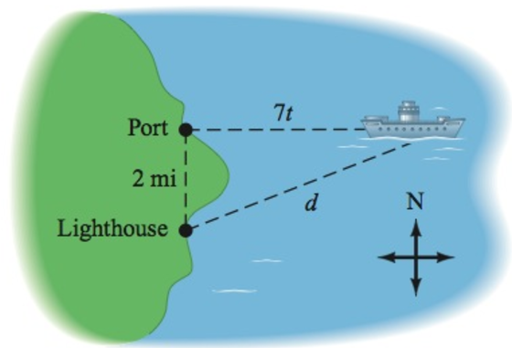

1. A cone has an altitude of 15 *cm* and a radius of 3 *cm*. A right circular cylinder of radius *r* and height *h* is inscribed in the cone. Use similar triangles to write *h* as a function of *r*.

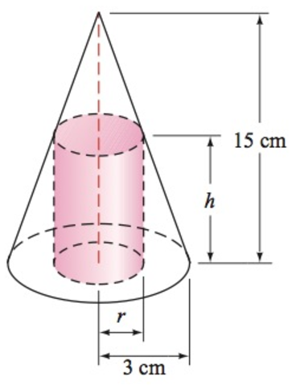

1. Water is flowing into a conical drinking cup with an altitude of 4 *inches* am a radius of 2 *inches*.

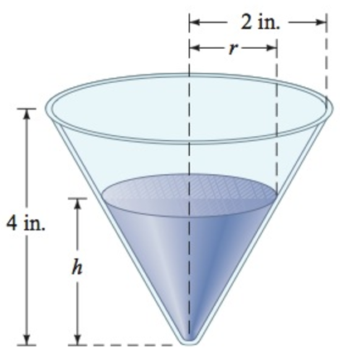

1. Write the radius *r* of the surface of the water as a function of its depth *h*.
2. Write the volume *V* of the water as a function of its depth *h*.

1. A water tank has the shape of a right circular cone with height 16 *feet* and radius 8 *feet*. Water is running into the tank so that the radius *r* (in *feet*) of the surface of the water is given by , where *t* is the time (in *minutes*) that the water has been running.

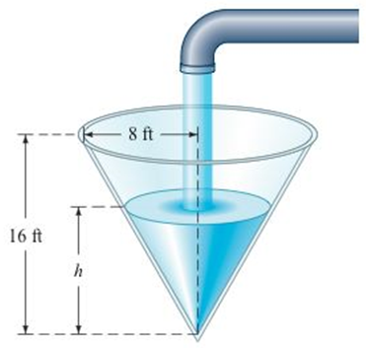

1. The area *A* of the surface of the water is . Find  and use it to determine the area of the surface of the water when .
2. The volume *V* of the water is given by . Find  and use it to determine the volume of the water when 
3. An athlete swims from point ***A*** to point ***B*** at a rate of 2 *miles* per *hour* and runs from point ***B*** to point ***C*** at a rate of 8 *miles* per *hour*. Use the dimensions in the figure to write the time *t* required to reach point ***C*** as a function of *x*.

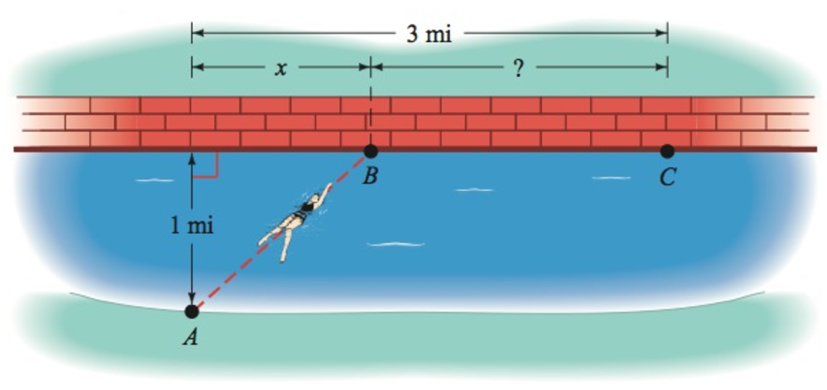

1. A device used in golf to estimate the distance ***d***, in *yards*, to a hole measures the size ***s***, in *inches*, that the 7-*feet* pin appears to be in a viewfinder. Express the distance ***d*** as a function of ***s***.

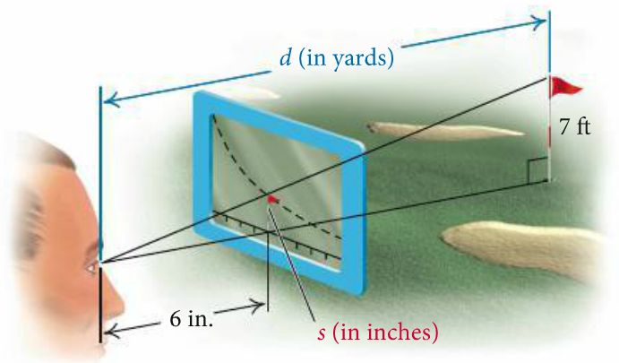

1. A rhombus is inscribed in a rectangle that is ***w*** *meters* wide with a perimeter of 40 *m*. Each vertex of the rhombus is a midpoint of a side of the rectangle. Express the area of the rhombus as a function of the rectangle’s width.

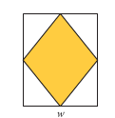

1. The surface area *S* of a right circular cylinder is given by the formula  . if the height is twice the radius, find each of the following.

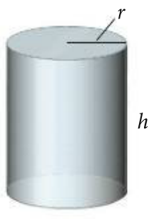

1. A function  for the surface area as a function of *r*.
2. A function  for the surface area as a function of *h*.
3. A boat is towed by a rope that runs through a pulley that is 4 *feet* above the point where the rope is tied to the boat. The length (in *feet*) of the rope from the boat to the pulley is given by , where *t* is the time in *seconds* that the boat has been in tow. The horizontal distance from the pulley to the boat is *d*.

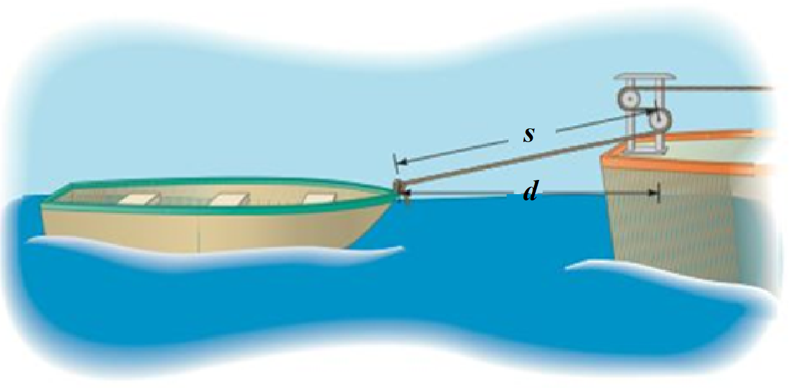

1. Find 
2. Evaluate  and 
3. The light from a lamppost casts a shadow from a ball that was dropped from a height of 22 *feet* above the ground. The distance *d*, in *feet*, the ball has dropped *t* *seconds* after it is released is given by . Find the distance *x*, in *feet*, of the shadow from the base of the lamppost as a function of time *t*.

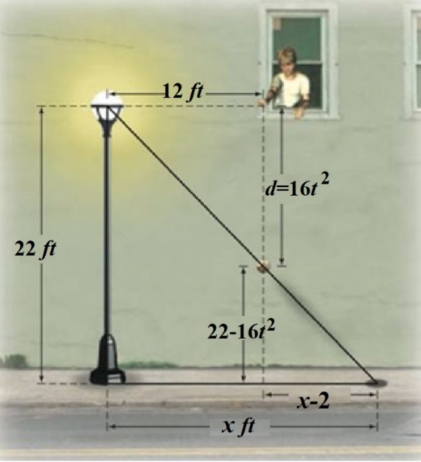

1. A right circular cylinder of height *h* and a radius *r* is inscribed in a right circular cone with a height of 10 *feet* and a base with radius 6 *feet*.

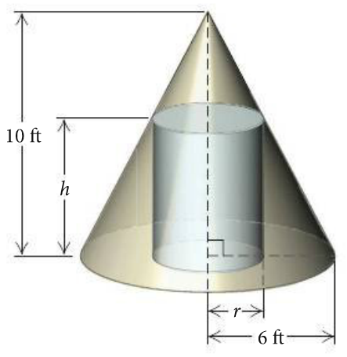

1. Express the height *h* of the cylinder as a function of *r*.
2. Express the volume *V* of the cylinder as a function of *r*.
3. Express the volume *V* of the cylinder as a function of *h*.

***Section* 2.2 – Function Operations**

**The *Domain* of a Function**

1. ***Rational*** function:  ⇒ ***Domain***: 

***Example***: 

***Domain***:  

*Or*  *Interval Notation*

*Or* 

1. ***Irrational*** function:  ⇒ ***Domain***: 

***Example***: 

3 – *x* ≥ 0

– *x* ≥ −3

***Domain***:  

1. ***Otherwise***: Domain all real numbers 

***Example***: 

***Domain***: All real numbers 



**(1) *&* (2 )→**  Find the domain: 

*x* > 3

***Domain***: 

***Example***

Find the domain

1. 

***Domain***: 

1. 





***Domain:*** 

1. 





***Domain*:**  

**The *Algebra* of Functions**

**

**

**

**

***Example***

Let  and . Find each of the following , , , and 

***Solution***





























***Example***

Let and. Find each of the following and give the domain

, , , 

***Solution***

***Domain*** of *f*: 

***Domain*** of *g*:  

1. 

***Domain***:  

1. 

***Domain***:  

1. 

***Domain***:  

1. 

***Domain***:  

***Example***

Let  and 

Find  and its domain,  and its domain

***Solution***

 

1. 

−1 3

1. 
2. 



 

***Difference Quotients***



The difference quotient is given by: 

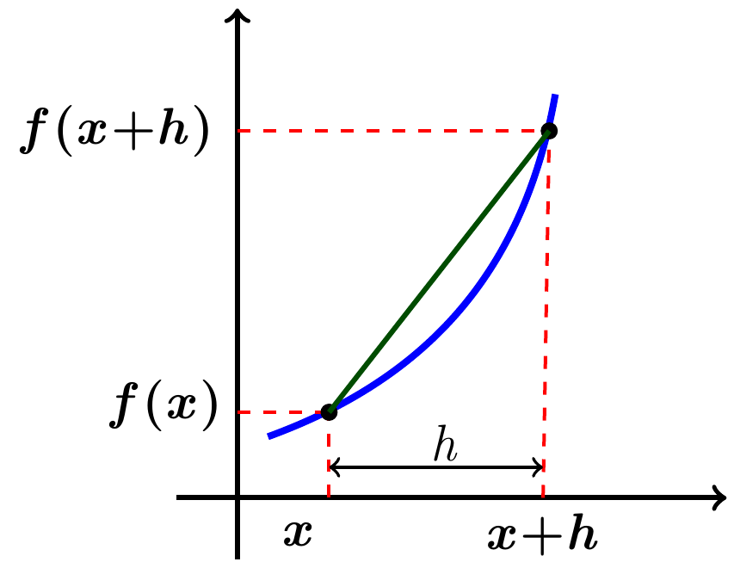

***Example***

For the function *f* given by , find the difference quotient 

***Solution***















***Example***

For the function *f* given by ****, find the difference quotient 

***Solution***



 















***Example***

Tracy and Graham drive away from a camp-ground at right angles to each other. Tracy’s speed is 65 mph and Graham’s is 55 *mph*.

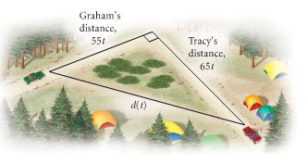

1. Express the distance between the cars as a function of time.
2. Find the domain of the function.

***Solution***

***a*)** *Distance* = *velocity* * *time*

Use Pythagorean Theorem:















***b*)** ***Domain***: *t* ≥ 0

***Example***: (storage area)

The sound Shop has 20 *feet*. of dividers with which to set off a rectangular area for the storage of overstock. If a corner of the store is used for the storage area, the partition need only form two sides of a rectangle.

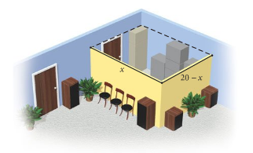

1. Express the floor area of the storage space as a function of the length of the partition.
2. Find the domain of the function.

***Solution***

Let *x* = the length

*width* + *length* = 20

*width* = 20 − *length*

***a***) ***Area*** = *length* * *width*





***b***) ***Domain***: *x* value varies from 0 to 20 ⇒ (0, 20)

***Exercises Section* 2.2 – Function Operations**

(**1 − 80**) Find the Domain

|  |  |  |
| --- | --- | --- |
|  |  |  |

|  |  |  |
| --- | --- | --- |
|  |  |  |

1. Let  and . Find each of the following and give the domain

|  |  |  |  |
| --- | --- | --- | --- |
|  |  |  |  |

1. Let  and . Find each of the following and give the domain

|  |  |  |  |
| --- | --- | --- | --- |
|  |  |  |  |

1. Let  and . Find each of the following and give the domain

|  |  |  |  |
| --- | --- | --- | --- |
|  |  |  |  |

1. Let  and . Find each of the following and give the domain

|  |  |  |  |
| --- | --- | --- | --- |
|  |  |  |  |

1. Given that  and 
2. Find 
3. Find the domain of 
4. Find: 
5. Given that  and 
6. Find  and its domain
7. Find  and its domain
8. Let  and . Find , ,, and 
9. Find  and the domain of 
10. Find  and the domain of 
11. Find  of  and 

(**88 − 103**) Find and simplify the difference quotient  for the given function

|  |  |  |
| --- | --- | --- |
|  |  |  |

1. An open box is to be made from a square piece of cardboard that measures 40 *inches* on each side, to construct the box, squares that measure *x* *inches* on each side are cut from each corner of the cardboard.

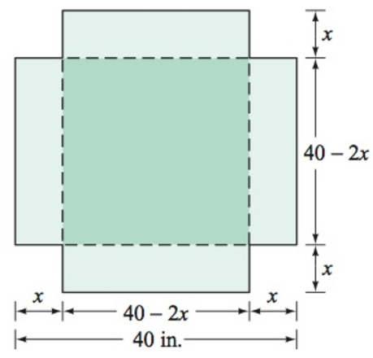 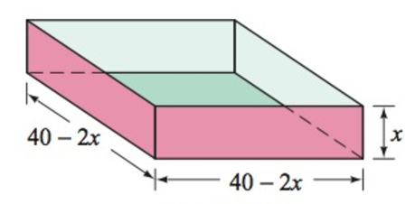

1. Express the volume *V* of the box as a function of *x*.
2. Determine the domain of *V*.
3. A child 4 *feet* tall is standing near a street lamp that is 12 *feet* high. The light from the lamp casts a shadow.

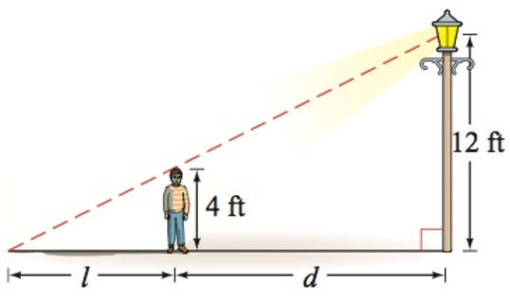

1. Find the length *l* of the shadow as a function of the distance *d* of the child from the lamppost.
2. What is the domain of the function?
3. What is the length of the shadow when the child is 8 *feet* from the base of the lamppost?
4. An open box is to be made from a square piece of cardboard with the dimensions 30 *inches* by 30 *inches* by cutting out squares of area  from each corner.

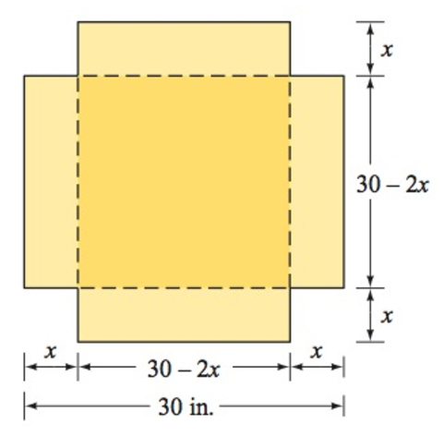

1. Express the volume *V* of the box as a function of *x*.
2. Determine the domain of *V*.
3. Two guy wires are attached to utility poles that are 40 *feet* apart.

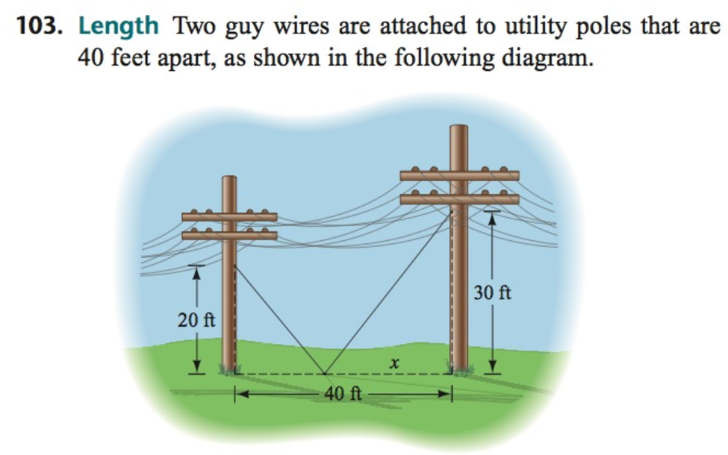

1. Find the total length of the two guy wires as a function of *x*.
2. What is the domain of this function?
3. A rancher has 360 *yard*s. of fencing with which to enclose two adjacent rectangular corrals, one for sheep and one for cattle. A river forms one side of the corrals. Suppose the width of each corral is *x* *yards*.

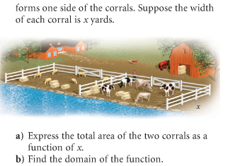

1. Express the total area of the two corrals as a function of *x*.
2. Find the domain of the function.
3. A rectangle is bounded by the *x*- and *y-axis* of 

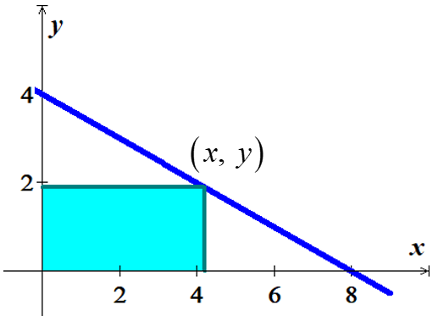

1. Find the area of the rectangle as a function of *x*.
2. What is the domain of this function.

***Section* 2.3 – Composition Functions**

***Composition* of Functions**

The composite function, the composite of *f* and *g*, is defined as



Where *x* is in the domain of *f*

andis in the domain of *f*

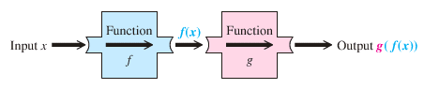

***Example***

Given that  and, find  and 

***Solution***

  ***Domain:*** All real numbers







 ***Domain:*** All real numbers



 ***Domain:*** All real numbers









 ***Domain:*** All real numbers

***Example***

Let  and , find each of the following and its domain.

1. 
2. 

***Solution***

1. 

 









***Domain:***  

1. 

 

 

***Domain:*** 

***Example***

Let  and  Find:

1. 
2. 

***Solution***

1. 









1. 











***Example***

Given that  and, find

1. 
2. Domain of 

***Solution***

1. 

=  ***Domain:***: *x* ≠ 0









 ***Domain:***: *x* ≠ 

1. Domain: 

***Exercises Section* 2.3 – Composition Functions**

1. Given that  and, find ,  and their domain then find 
2. Given that  and, find
3. 
4. 
5. 
6. Given that  and, find
7. 
8. 
9. 
10. Find : 
11. Find : 
12. Find : 

(**7 − 36**) For the given function; find:

1. Find  and the ***domain*** of 
2. Find  and the ***domain*** of 

|  |  |
| --- | --- |
|  |  |

|  |  |
| --- | --- |
|  |  |

(**37 − 48**) Evaluate each composite function, where 

|  |  |  |  |
| --- | --- | --- | --- |
|  |  |  |  |