***Section* 2.4 – Quadratic Functions and Models**

***Quadratic Function***

A function *f* is a ***quadratic function*** if

***Vertex* of a Parabola** 

|  |  |
| --- | --- |
| The ***vertex*** of the graph of  is | Vertex point: |

***Axis of Symmetry***:  Axis of Symmetry: *x* = 2

***Minimum or Maximum Point***

|  |  |
| --- | --- |
| If *a* > 0 ⇒*f(x)* has a ***minimum*** point  If *a* < 0 ⇒*f(x)* has a ***maximum*** point  @ vertex point | Minimum point @ |

***Range***

|  |  |
| --- | --- |
| If *a* > 0 ⇒  If *a* < 0 ⇒ |  |

***Domain***: 



***x-intercept***

***Symmetry Line***

***Minimum / Vertex point***

***Example***

For the graph of the function 

1. **Find the vertex point**





***Vertex*** point (−1, 9)

1. **Find the line of symmetry:** *x* = −1
2. **State whether there is a maximum or minimum value *and* find that value**

Minimum point, value (−1, 9)

1. **Find the *x*-intercept**



1. **Find the y-intercept**

*y* = 8

1. **Find the range and the domain of the function.**

*Range*: (−∞, 9] *Domain*: (−∞, ∞)

1. **Graph the function and label, show part *a thru d* on the plot below**

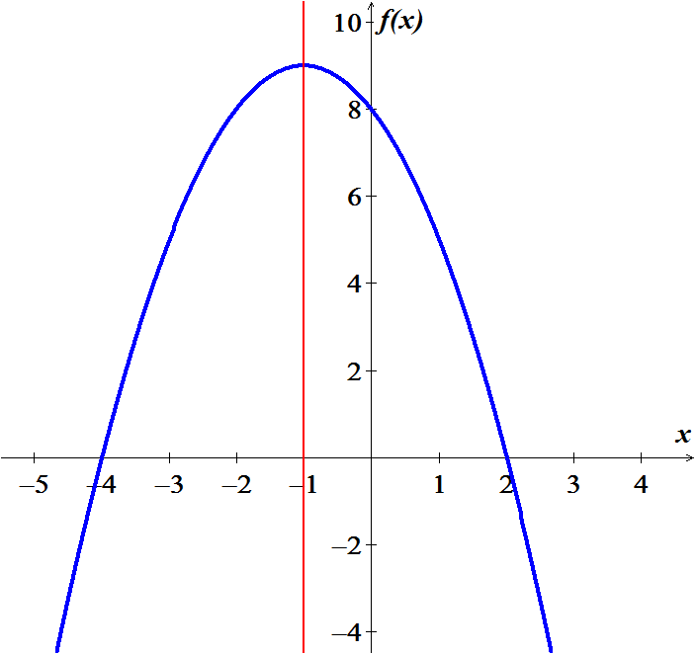

**Symmetry: *x* = −1**

**Vertex Point / Max** (−1, 9)



***x*-intercept**

1. **On what intervals is the function increasing? Decreasing?**

*Increasing*: (−∞, −1) *Decreasing*: (−1, ∞)

***Example***

Find the axis and vertex of the parabola having equation 

***Solution***







Axis of the parabola: 







Vertex point: 

***Maximizing Area***

You have 120 *feet* of fencing to enclose a rectangular region. Find the dimensions of the rectangle that maximize the enclosed area. What is the maximum area?

***Solution***





 









***Vertex***: 







***Example***

A stone mason has enough stones to enclose a rectangular patio with 60 *feet* of stone wall. If the house forms one side of the rectangle, what is the maximum area that the mason can enclose? What should the dimensions of the patio be in order to yield this area?

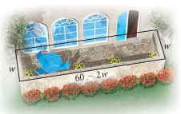***Solution***























*Area* = (15)(30) = 450 *ft*2

**Position Function (*Projectile Motion*)**

***Example***

A model rocket is launched with an initial velocity of 100 *ft/sec* from the top of a hill that is 20 *feet* high. Its height *t* seconds after it has been launched is given by the function . Determine the time at which the rocket reaches its maximum height and find the maximum height.

***Solution***











***Exercises Section* 2.4 – Quadratic Functions and Models**

(**1 − 21**) For the Given functions

1. Find the vertex point
2. Find the line of symmetry
3. State whether there is a *maximum* or *minimum* value *and* find that value
4. Find the zeros of 
5. Find the *y*-intercept
6. Find the *range* and the *domain* of the function.
7. Graph the function and label, show part *a thru d*
8. On what intervals is the function *increasing*? *decreasing*?

|  |  |  |
| --- | --- | --- |
|  |  |  |

1. A picture frame measures 28 *cm* by 32 *cm* and is of uniform width. What is the width of the frame if 192 *cm*2 of the picture shows?

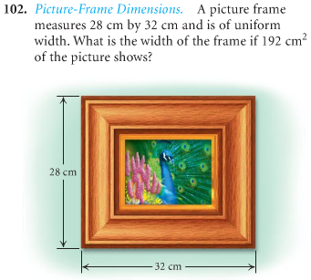

1. An open box is made from a 10-*cm* by 20-*cm* of tin by cutting a square from each corner and folding up the edges. The area of the resulting base is 96 *cm*2. What is the length of the sides of the squares?

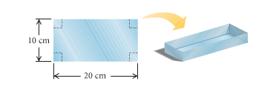

1. You have 600 *feet.* of fencing to enclose a rectangular plot that borders on a river. If you do not fence the side along the river.
2. Find the length and width of the plot that will maximize the area.
3. What is the largest area that can be enclosed?
4. You have 60 *yards* of fencing to enclosed a rectangular region.
5. Find the dimensions of the rectangle that maximize the enclosed area.
6. What is the maximum area?
7. You have 80 *yards* of fencing to enclosed a rectangular region.
8. Find the dimensions of the rectangle that maximize the enclosed area.
9. What is the maximum area?
10. The sum of the length *l* and the width *w* of a rectangle tangular area is 240 *meters*.
11. Write *w* as a function of *l*.
12. Write the area *A* as a function of *l*.
13. Find the dimensions that produce the greatest area.
14. You use 600 *feet* of chainlink fencing to enclose a rectangular region and to subdivide the region into two smallerrectangular regions by placing a fence parallel to one of the sides.

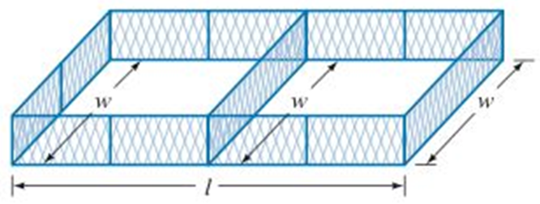

1. Write *w* as a function of *l*.
2. Write the area *A* as a function of *l*.
3. Find the dimensions that produce the greatest area.
4. You use 1,200 *feet* of chainlink fencing to enclose a rectangular region and to subdivide the region into three smallerrectangular regions by placing a fence parallel to one of the sides.

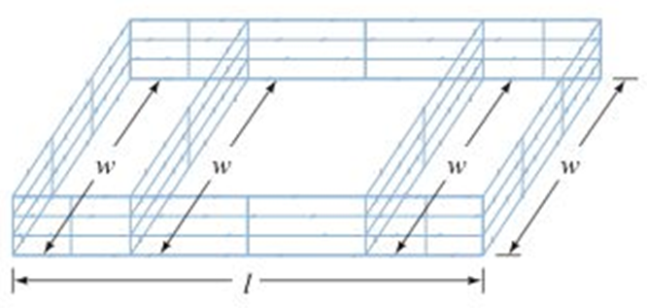

1. Write *w* as a function of *l*.
2. Write the area *A* as a function of *l*.
3. Find the dimensions that produce the greatest area.
4. A landscaper has enough stone to enclose a rectangular pond next to exiting garden wall of the house with 24 *feet* of stone wall. If the garden wall forms one side of the rectangle.

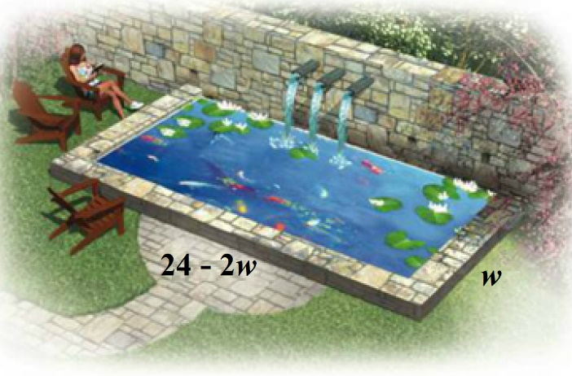

1. What is the maximum area that the landscaper can enclose?
2. What dimensions of the pond will yield this area?
3. A berry former needs to separate and enclose two adjacent rectangular fields, one for strawberries and one for blueberries. If a lake forms one side of the fields and 1,000 *feet* of fencing is available, what is the largest total area that can be enclosed?

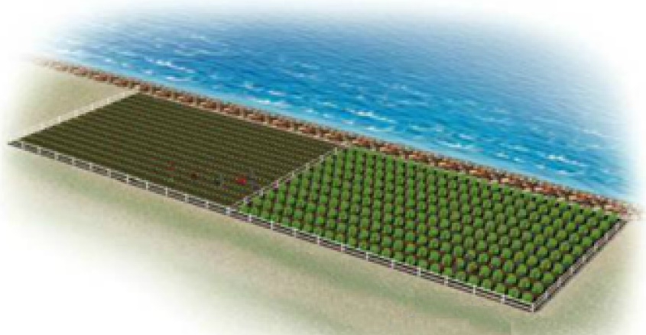

1. A fourth-grade class decides to enclose a rectangular garden, using the side of the school as one side of the rectangle. What is the maximum area that the class can enclose with 32 *feet* of fence? What should the dimensions of the garden be in order to yield this area?



1. A rancher needs to enclose two adjacent rectangular corrals, one for cattle and one for sheep. If a river forms one side of the corrals and 240 *yard* of fencing is available, what is the largest total area that can be enclosed?



1. A Norman window is a rectangle with a semicircle on top. Sky Blue Windows is designing a Norman window that will require 24 *feet* of trim on the outer edges. What dimensions will allow the maximum amount of light to enter a house?

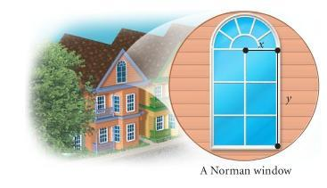

1. A Norman window has the shape of a rectangle surmounted by a semicircle. The exterior perimeter of the window is 48 *feet*.

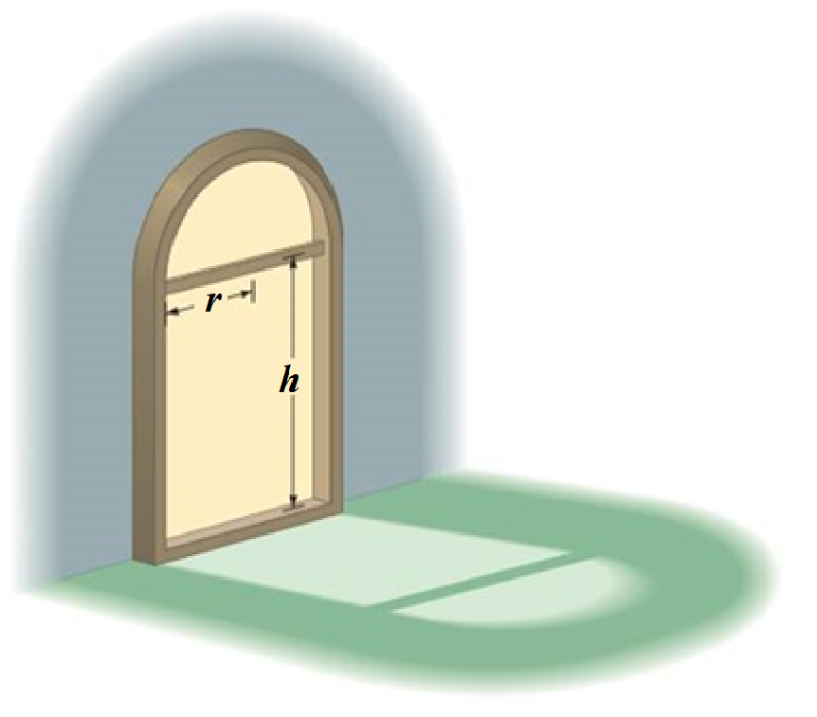

Find the height *h* and the radius *r* that will allow the maximum amount of light to enter the window?

1. A Norman window has the shape of a rectangle surmounted by a semicircle. It requires 24 *feet* of trim on the outer edges.

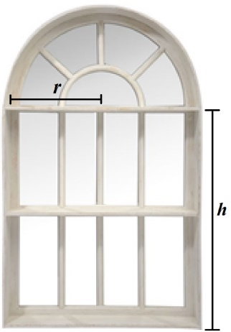

What dimensions will allow the maximum amount of light to enter a house?

1. The temperature , in degrees Fahrenheit, during the day can be modeled by the equation , where *t* is the number of hours after 6:00 AM.
2. At what time the temperature a maximum?
3. What is the maximum temperature?
4. When a softball player swings a bat, the amount of energy , in *joules*, that is transferred to the bat can be approximated by the function



Where  and *t* is measured in *seconds*. According to this model, what is the maximum energy of the bat?

1. Some softball fields are built in a parabolic mound shape so that water will drain off the field. A model for the shape of a certain field is given by



Where  is the height, in *feet*, of the field at a distance of *x* *feet* from one sideline. Find the maximum height of the field.

1. The fuel efficiency for a certain midsize car is given by



Where  is the fuel efficiency in *miles* per *gallon* for a car traveling *v* in *miles* per *hour*.

1. What speed will yield the maximum fuel efficiency?
2. What is the maximum fuel efficiency for this car?
3. If the initial velocity of a projectile is 128 *feet* per *second*, then the height *h*, in *feet*, is a function of time *t*, in *seconds*, given by the equation



1. Find the time *t* when the projectile achieves its maximum height.
2. Find the maximum height of the projectile.
3. Find the time *t* when the projectile hits the ground.
4. If the initial velocity of a projectile is 64 *feet* per *second* and an initial height of 80 *feet*, then the height *h*, in *feet*, is a function of time *t*, in *seconds*, given by the equation



1. Find the time *t* when the projectile achieves its maximum height.
2. Find the maximum height of the projectile.
3. Find the time *t* when the projectile hits the ground.
4. If the initial velocity of a projectile is 100 *feet* per *second* and an initial height of 20 *feet*, then the height *h*, in *feet*, is a function of time *t*, in *seconds*, given by the equation



1. Find the time *t* when the projectile achieves its maximum height.
2. Find the maximum height of the projectile.
3. Find the time *t* when the projectile hits the ground.
4. A frog leaps from a stump 3.5 *feet* high and lands 3.5 *feet* from the base of the stump.

It is determined that the height of the frog as a function of its distance, *x*, from the base of the stump is given by the function  where *h* is in feet.

1. How high is the frog when its horizontal distance from the base of the stump is 2 *feet*?
2. At what two distances from the base of the stump after is jumped was the frog 3.6 *feet* above the ground?
3. At what distance from the base did the frog reach its highest point?
4. What was the maximum height reached by the frog?
5. The height of an arch is given by



Where  is the horizontal distance in *feet* from the center of the arch to the ground.

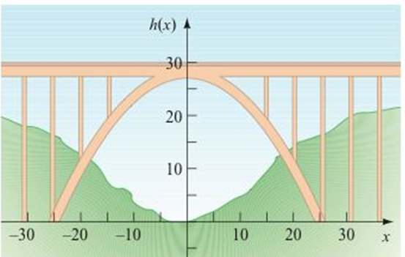

1. What is the maximum height of the arch?
2. What is the height of the arch 10 *feet* to the right of center?
3. How far from the center is the arch 8 *feet* tall?
4. A weightless environment can be created in an airplane by flying in a series of parabolic paths. This is one method that NASA uses to train astronauts for the experience of weightlessness. Suppose the height *h*, in *feet*, of NASA’s airplane is modeled by



Where *t* is the time, in *seconds,* after the plane enters its parabolic path.

Find the maximum height of the plane.

1. You drop a screwdriver from the top of an elevator shaft. Exactly 5 *seconds* later, you hear the sound of the screwdriver hitting the bottom of the shaft. The speed of sound is . How tall is the elevator shaft?

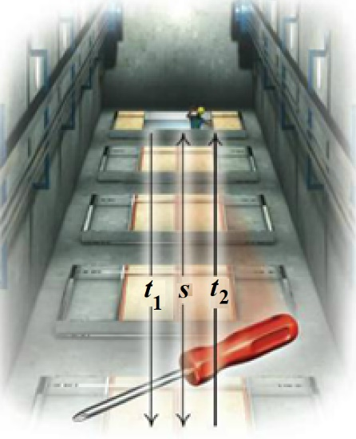

1. A company plans to produce a one- compartment vertical file by bending the long side of a 10-*in*. by 18-*in*. sheet of metal along two lines to form a − shape. How tall should the file be in order to maximize the volume that it can hold?

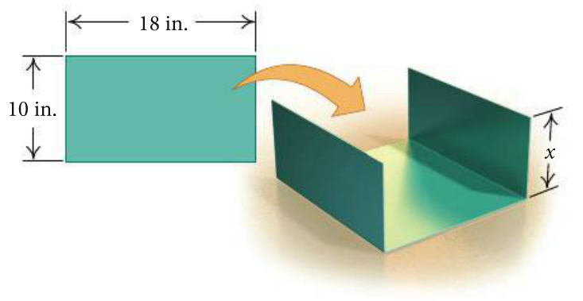

1. The sum of the base and the height of a triangle is 20 *cm*. Find the dimensions for which the area is a maximum.
2. The sum of the base and the height of a parallelogram is 14 *inches*. Find the dimensions for which the area is a maximum.

***Section* 2.5 – Polynomial Functions**

**Polynomial Function**

A *Polynomial function* *P*(*x*) in *x* is a sum of the form is given by:



Where the coefficients are real numbers and the exponents are whole numbers.

***Degree***



***Leading Term***

***Leading Coefficient***

Non-polynomial Functions: 

|  |  |  |
| --- | --- | --- |
| ***Degree of f*** | ***Form of f(x)*** | ***Graph of f(x)*** |
| 0 |  | A horizontal line |
| 1 |  | A line with slope |
| 2 |  | A parabola with a vertical axis |

All polynomial functions are ***continuous functions***.

*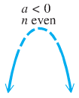****End Behavior*** 

If *n* (degree) is ***even***:

If  (in front  is negative).

Then the function falls from the left and right side

***Falls left***



***Falls right***

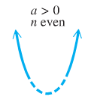 

***Rises right***

If  (in front  is positive).

***Rises left***

Then the function rises from the left and right side





***Rises left***

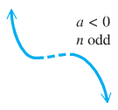If *n* (degree) is ***odd***:

If  (negative).

Then the function rises from the left side and falls from the right side



***Falls right***



***Rises right***

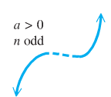If  (positive).

Then the function falls from the left side and rises from the right side



***Falls left***



***Example***

Determine the end behavior of the graph of the polynomial function 

***Solution***

Leading term:  with 5th degree (*n* is odd)

  rises left

  falls right

**The Intermediate Value *Theorem***

For any polynomial function  with real coefficients and  for , then  takes on every value between  and  in the interval .

∴  and are the ***opposite signs***. Then the function has a real zero between *a* and *b*.

***Example***

Using the intermediate value theorem, determine, if possible, whether the function has a real zero between *a* and *b*.

1. 
2. 

***Solution***

1. 









∴ ** has a zero between −4 and −2

1. 









∴ * zeros* ***can’t be determined***

***Example***

Show that  has a zero between 1 and 2.

***Solution***









Since  have opposite signs.

Therefore,  for at least one real number *c* between 1 and 2.

***Exercises*** ***Section* 2.5 – Polynomial Functions**

Determine the end behavior of the graph of the polynomial function

|  |  |
| --- | --- |
|  |  |

Use the Intermediate Value Theorem to show that each polynomial has a real zero between the given integers.

1. 
2. 
3. 
4. 
5. 
6. 
7. 
8. 
9. 
10. 
11. 
12. 
13. 
14. 
15. 
16. 
17. 
18. 
19. 
20. 

***Section* 2.6 – Properties of Division**

***Long Division***

Divide 

*Quotient*

 *Dividend*

*Remainder*

*Divisor*





***Example***

Use the long division to find the quotient and the remainder: 

***Solution***







**Remainder *Theorem***

If a number *c* is substituted for *x* in the polynomial *,* then the result  is the remainder that would be obtained by dividing by *x* – *c*.

That is, if 

***Example***

If , use the remainder theorem to find 

***Solution***





**Factor *Theorem***

A polynomial  has a factor  if and only if 

***Example***

Show that  is a factor of .

***Solution***

Since 

From the factor theorem;  is a factor of .

***Synthetic Division***

Use synthetic division to find the quotient and the remainder of

 

***Example***

If , use the synthetic division to find .

***Solution***





***Example***

Show that −11 is a zero of the polynomial 

***Solution***

 Thus, , and −11 is a zero of .

**The Rational Zeros *Theorem***

If the polynomial  coefficients and if  is a rational zero of  such that ***c*** and ***d*** have no common prime factor, then

1. The numerator *c* of the zero is a factor of the constant term 
2. The denominator *d* of the zero is a factor of the leading coefficient 



***Example***

Find all rational solutions of the equation: 

***Solution***

|  |  |
| --- | --- |
|  |  |
|  |  |
|  |  |

Using the calculator, the result will show that −2 is a zero.



We have the factorization of: 

For 

 is another solution.



We have the factorization of: 

By applying quadratic formula to solve:  ⇒ 

Hence, the polynomial has two rational roots  and two irrational roots .

***Exercises*** ***Section* 2.6 – Properties of Division**

1. Find the quotient and remainder if  is divided by  

Find the quotient and remainder if  is divided by 

1. 
2. 
3. 
4. Use the remainder theorem to find  
5. Use the remainder theorem to find  
6. Use the factor theorem to show that  is a factor of  
7. Use the synthetic division to find the quotient and remainder if the first polynomial is divided by the second: 
8. Use the synthetic division to find the quotient and remainder if the first polynomial is divided by the second: 
9. Use the synthetic division to find the quotient and remainder if the first polynomial is divided by the second: 

Use the synthetic division to find 

1. 
2. 
3. 
4. Use the synthetic division to show that *c* is a zero of  
5. Use the synthetic division to show that *c* is a zero of  
6. Find all values of *k* such that  is divisible by the given linear polynomial: 

(**17 − 62**) Find all solutions of the equation

|  |  |
| --- | --- |
|  |  |

1. Glasses can be stacked to form a triangular pyramid. The total number of glasses in one of these pyramids is given by



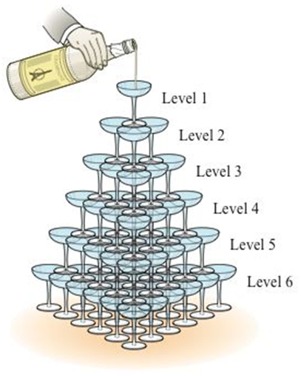

Where *k* is the number of levels in the pyramid. If 220 glasses are used to form a triangle pyramid, how many levels are in the pyramid?

1. Glasses can be stacked to form a triangular pyramid. The total number of glasses in one of these pyramids is given by





Where *k* is the number of levels in the pyramid. If 140 glasses are used to form a triangle pyramid, how many levels are in the pyramid?

1. A carbon dioxide cartridge for a paintball rifle has the shape of a right circular cylinder with a hemisphere at each end. The cylinder is 4 *inches* long, and the volume of the cartridge is .

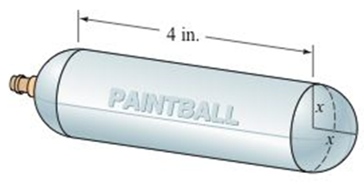

The common interior radius of the cylinder and the hemispheres is denoted by *x*. Estimate the length of the radius *x*.

1. A propane tank has the shape of a circular cylinder with a hemisphere at each end. The cylinder is 6 *feet* long and the volume of the tank is . Find the length of the radius *x*.

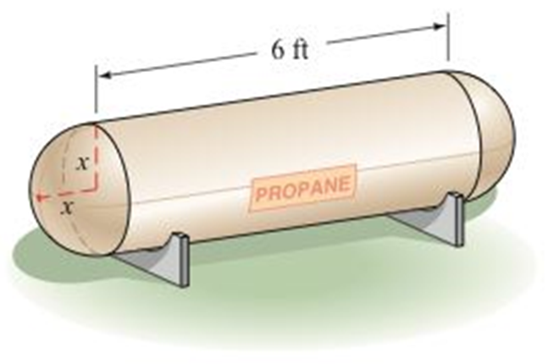

1. A cube measures *n* inches on each edge. If a slice 2 *inches* thick is cut from one face of the cube, the resulting solid has a volume of . Find *n*.

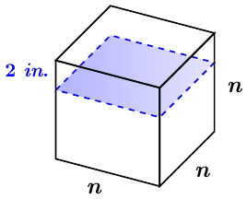

1. A cube measures *n* inches on each edge. If a slice 1 *inch* thick is cut from one face of the cube and then a slice 3 inches thick is cut from another face of the cube, the resulting solid has a volume of . Find the dimensions of the original cube.

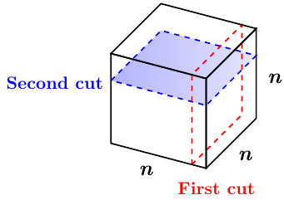

1. For what value of *x* will the volume of the following solid be 

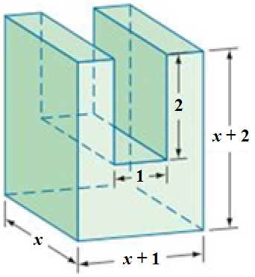

1. For what value of *x* will the volume of the following solid be 

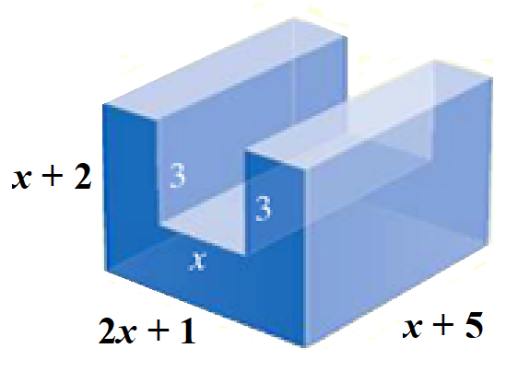

1. The length of rectangular box is 1 *inch* more than twice the height of the box, and the width is 3 *inches* more than the height. If the volume of the box is , find the dimensions of the box.

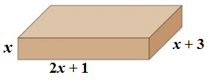

1. One straight cut through a thick piece of cheese produces two pieces. Two straight cuts can produce a maximum of four pieces. Two straight cuts can produce a maximum of four pieces. Three straight cuts can produce a maximum of eight pieces.

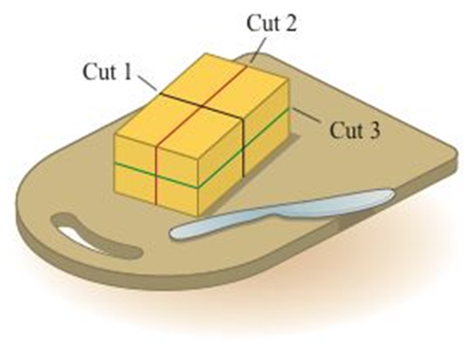

You might be inclined to think that every additional cut doubles number of pieces. However, for four straight cuts, you get a maximum of 15 pieces. The maximum number of pieces *P* that can be produced by *n* straight cuts is given by



1. Determine number of pieces that can be produces by five straight cuts.
2. What is the fewest number of straight cuts that are needed to produce 64 pieces?
3. The number of ways one can select three cards from a group of *n* cards (the order of the selection matters), where , is given by . For a certain card trick, a magician has determined that there are exactly 504 *ways* to choose three cards from a given group. How many cards are in the group?
4. A nutrition bar in the shape of a rectangular solid measure 0.75 *in*. by 1 *in*. by 5 *inches*.

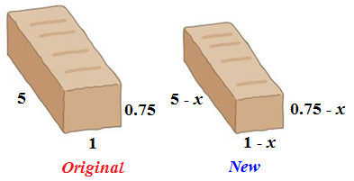

To reduce costs, the manufacturer has decided to decrease each of the dimensions of the nutrition bar by *x* *inches*, what value of *x* will produce a new bar with a volume that is  less than the present bar’s volume.

1. A rectangular box is square on two ends and has length plus girth of 81 *inches*. (Girth: distance *around* the box). Determine the possible lengths *l*  of the box if its volume is .

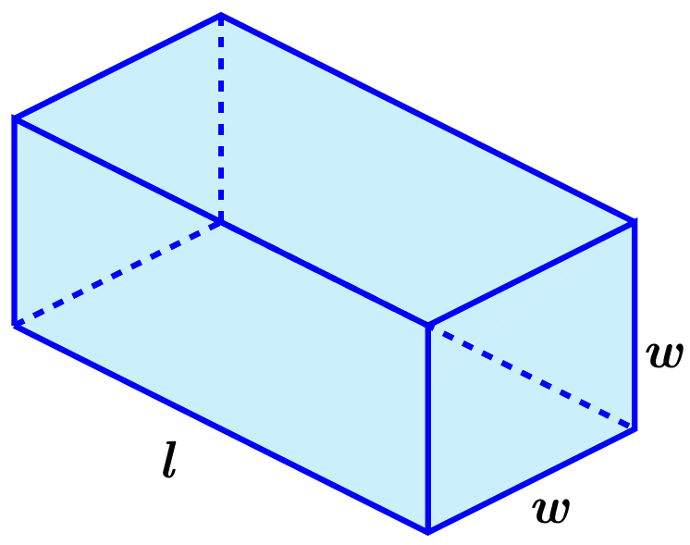

***Section* 2.7 – Rational Functions**

|  |  |  |
| --- | --- | --- |
|  |  |  |
|  |  |  |
|  |  |  |
|  |  |  |

**Rational Function**

A rational function is a function  that is a quotient of two polynomials, that is,



Where  and  are polynomials. The domain of  consists of all real numbers ***except*** the zeros of the denominator .

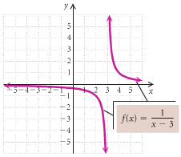**The Domain of a Rational Function**

***Example***

Consider: 

Find the domain and graph *f*.

***Solution***



Thus the domain is: 

|  |  |  |
| --- | --- | --- |
| ***Function*** | ***Domain*** | |
|  |  |  |
|  |  |  |
|  |  |  |
|  |  |  |

***Asymptotes***

**Vertical Asymptote (*VA*) - *Think Domain***

The line  is a ***vertical asymptote*** for the graph of a function  if



As ***x*** approaches ***a*** from either the left or the right

***Example***

Find the vertical asymptote of , and sketch the graph.

***Solution***

***VA***: 





**Horizontal Asymptote (*HA*)**

The line  is a ***horizontal asymptote*** for the graph of a function  if



Let  be a rational function.

1. If the degree of numerator is less than of denominator (*n* < *m*) ⇒ y = 0



1. If the degree of numerator is equal of denominator (*n* = *m*) ⇒



1. If the degree of numerator is greater than of denominator (*n* > *m*)⇒ No horizontal asymptote



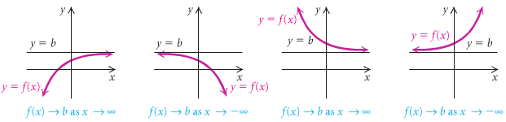

***Example***

Determine the horizontal asymptote of .

***Solution***



Therefore, the horizontal asymptote (***HA***) is: 

***Example***

Find the vertical and the horizontal asymptote for the graph of , if it exists

1. 
2. 
3. 

***Solution***

1. 



***VA***: 

***HA***: 

1. 



***VA***: 

***HA***: 

1. 



***VA***: *n/a*

***HA***: *n/a*

***Slant* or *Oblique* Asymptotes**

When the degree of the numerator is one greater than the degree of the numerator, the graph has a slant or oblique asymptote and it is a line . To find the slant asymptote, divide the fraction using long division. The quotient (not remainder) is the slant asymptote.





The ***oblique*** ***asymptote*** is the line ***y* = 3*x* − 6**

***Example***

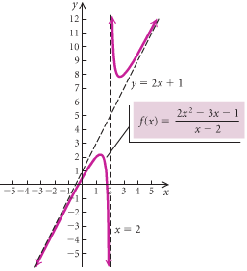Find all the asymptotes of 

***Solution***





The ***oblique*** ***asymptote*** is the line 

***VA***:: 

**Graph That Has a *Hole***

***Example***

Sketch the graph of if 

***Solution***



***VA***: 

***HA***: 

The only different between the graphs that  has a ***hole*** at 

|  |  |
| --- | --- |
| ***x*** | ***y*** |
| −4 | .6 |
| 1.3 | 0 |
| 0 | −.8 |
| 4 | 5.3 |
| 6 | 3.1 |

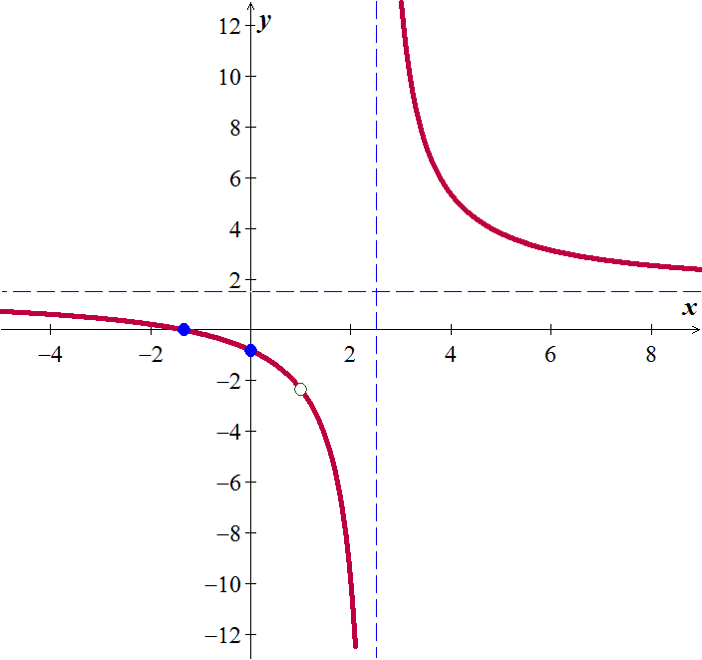

***Exercises Section* 2.7 – Rational Functions**

(**1 − 21**) Determine all asymptotes of the function

|  |  |  |
| --- | --- | --- |
|  |  |  |

(**22 − 53**) Determine all asymptotes (if any) (*Vertical Asymptote, Horizontal Asymptote*; *Hole*; *Oblique Asymptote*) and sketch the graph of

|  |  |  |
| --- | --- | --- |
|  |  |  |

|  |  |  |
| --- | --- | --- |
|  |  |  |

(**54 − 59**) Find an equation of a rational function  that satisfies the given conditions

|  |  |
| --- | --- |
|  |  |