***Solution Section* 2.4 – Quadratic Functions**

***Exercise***

For the function 

1. Find the vertex point
2. Find the line of symmetry
3. State whether there is a *maximum* or *minimum* value *and* find that value
4. Find the zeros of 
5. Find the *y*-intercept
6. Find the *range* and the *domain* of the function.
7. Graph the function
8. On what intervals is the function *increasing*? *decreasing*?

***Solution***

1. 

 ***Vertex point*** (−3, −6)

1. Line of *symmetry*: *x* = −3
2. *Minimum* point, value (−3, −6)
3. 



1. *y*-intercept 
2. *Range*: [−6, ∞) *Domain*: (−∞, ∞)





**Zero’s**

**Vertex Point / Min** (−3, −6)

**Symmetry: *x* = −3**

1. *Decreasing*: (−∞, −3) *Increasing*: (−3, ∞)

***Exercise***

For the function 

1. Find the vertex point
2. Find the line of symmetry
3. State whether there is a *maximum* or *minimum* value *and* find that value
4. Find the zeros of 
5. Find the *y*-intercept
6. Find the *range* and the *domain* of the function.
7. Graph the function
8. On what intervals is the function *increasing*? *decreasing*?

***Solution***

1.  







*Vertex point*: 

1. Axis of *symmetry*: 
2. *Minimum* point @ 
3. 



1. 
2. *Domain*:  *Range*: 

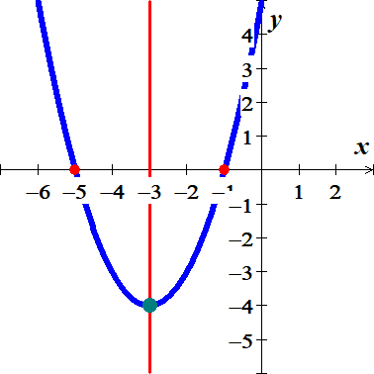

1. *Increasing: * Decreasing: 

***Exercise***

For the function 

1. Find the vertex point
2. Find the line of symmetry
3. State whether there is a *maximum* or *minimum* value *and* find that value
4. Find the zeros of 
5. Find the *y*-intercept
6. Find the *range* and the *domain* of the function.
7. Graph the function
8. On what intervals is the function *increasing*? *decreasing*?

***Solution***

1.  







*Vertex point:* 

1. Axis of *symmetry*: 
2. *Maximum* point @ 
3. 



1. 
2. *Domain*:  *Range*: 

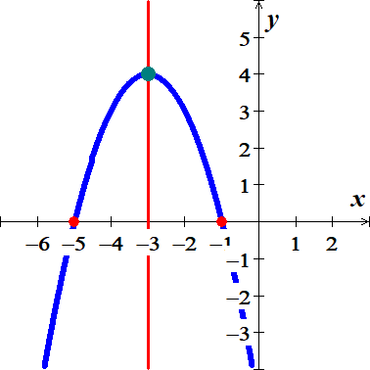

1. *Increasing:*  *Decreasing*: **

***Exercise***

For the function 

1. Find the vertex point
2. Find the line of symmetry
3. State whether there is a *maximum* or *minimum* value *and* find that value
4. Find the zeros of 
5. Find the *y*-intercept
6. Find the *range* and the *domain* of the function.
7. Graph the function
8. On what intervals is the function *increasing*? *decreasing*?

***Solution***

1.  







*Vertex point:* 

1. Axis of *symmetry*: 
2. *Minimum* point @ 
3. 





1. 
2. *Domain*:  *Range*: 

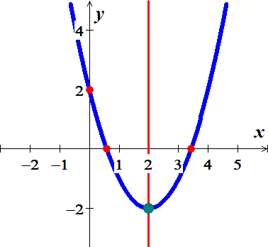

1. *Increasing: * *Decreasing*: 

***Exercise***

For the function 

1. Find the vertex point
2. Find the line of symmetry
3. State whether there is a *maximum* or *minimum* value *and* find that value
4. Find the zeros of 
5. Find the *y*-intercept
6. Find the *range* and the *domain* of the function.
7. Graph the function
8. On what intervals is the function *increasing*? *decreasing*?

***Solution***

1.  







*Vertex point:* 

1. Axis of *symmetry*: 
2. *Maximum* point @ 
3. 





1. 
2. *Domain*:  *Range*: 

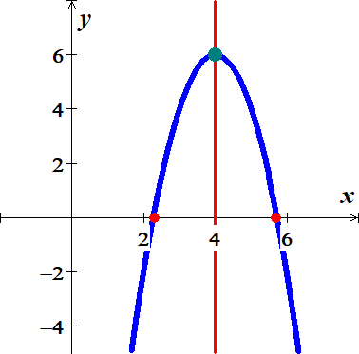

1. *Increasing:*  *Decreasing*: **

***Exercise***

For the function 

1. Find the vertex point
2. Find the line of symmetry
3. State whether there is a *maximum* or *minimum* value *and* find that value
4. Find the zeros of 
5. Find the *y*-intercept
6. Find the *range* and the *domain* of the function.
7. Graph the function
8. On what intervals is the function *increasing*? *decreasing*?

***Solution***

1.  







*Vertex point:* 

1. Axis of *symmetry*: 
2. *Minimum* point @ 
3. 





1. 
2. *Domain*:  *Range*: 

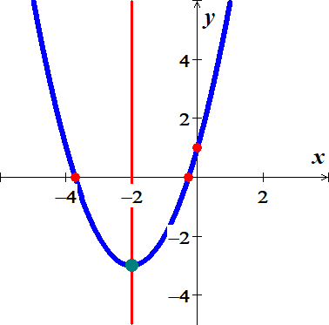

1. *Increasing: * *Decreasing*: 

***Exercise***

For the function 

1. Find the vertex point
2. Find the line of symmetry
3. State whether there is a *maximum* or *minimum* value *and* find that value
4. Find the zeros of 
5. Find the *y*-intercept
6. Find the *range* and the *domain* of the function.
7. Graph the function
8. On what intervals is the function *increasing*? *decreasing*?

***Solution***

1.  







*Vertex point:* 

1. Axis of *symmetry*: 
2. *Minimum* point @ 
3. 





1. 
2. *Domain*:  *Range*: 

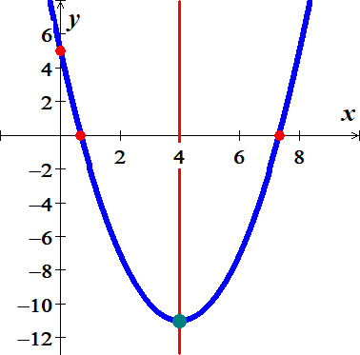

1. *Increasing: * *Decreasing*: 

***Exercise***

For the function 

1. Find the vertex point
2. Find the line of symmetry
3. State whether there is a *maximum* or *minimum* value *and* find that value
4. Find the zeros of 
5. Find the *y*-intercept
6. Find the *range* and the *domain* of the function.
7. Graph the function
8. On what intervals is the function *increasing*? *decreasing*?

***Solution***

1.  







*Vertex point:* 

1. Axis of *symmetry*: 
2. *Minimum* point @ 
3. 





1. 
2. *Domain*:  *Range*: 

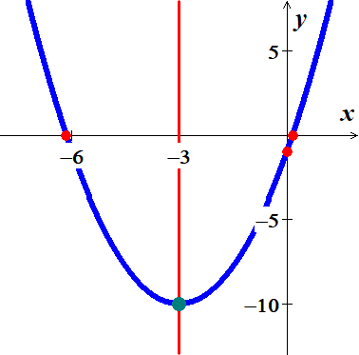

1. *Increasing: * *Decreasing*: 

***Exercise***

For the function 

1. Find the vertex point
2. Find the line of symmetry
3. State whether there is a *maximum* or *minimum* value *and* find that value
4. Find the zeros of 
5. Find the *y*-intercept
6. Find the *range* and the *domain* of the function.
7. Graph the function
8. On what intervals is the function *increasing*? *decreasing*?

***Solution***

1.  







*Vertex point:* 

1. Axis of *symmetry*: 
2. *Minimum* point @ 
3. 





1. 
2. *Domain*:  *Range*: 

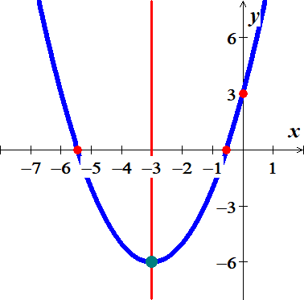

1. *Increasing: * *Decreasing*: 

***Exercise***

For the function 

1. Find the vertex point
2. Find the line of symmetry
3. State whether there is a *maximum* or *minimum* value *and* find that value
4. Find the zeros of 
5. Find the *y*-intercept
6. Find the *range* and the *domain* of the function.
7. Graph the function
8. On what intervals is the function *increasing*? *decreasing*?

***Solution***

1.  







*Vertex point:* 

1. Axis of *symmetry*: 
2. *Minimum* point @ 
3. 





1. 
2. *Domain*:  *Range*: 

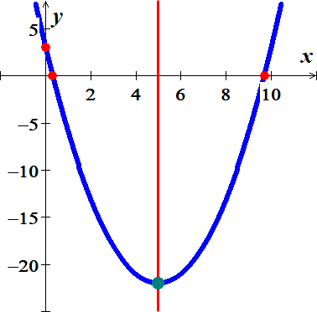

1. *Increasing: * *Decreasing*: 

***Exercise***

For the function 

1. Find the vertex point
2. Find the line of symmetry
3. State whether there is a *maximum* or *minimum* value *and* find that value
4. Find the zeros of 
5. Find the *y*-intercept
6. Find the *range* and the *domain* of the function.
7. Graph the function
8. On what intervals is the function *increasing*? *decreasing*?

***Solution***

1.  





*Vertex point:* 

1. Axis of *symmetry*: 
2. *Minimum* point @ 
3. 



1. 
2. *Domain*:  *Range*: 

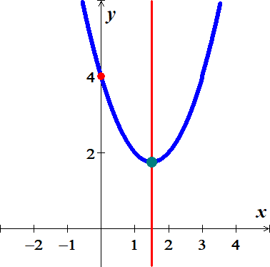

1. *Increasing: * *Decreasing*: 

***Exercise***

For the function 

1. Find the vertex point
2. Find the line of symmetry
3. State whether there is a *maximum* or *minimum* value *and* find that value
4. Find the zeros of 
5. Find the *y*-intercept
6. Find the *range* and the *domain* of the function.
7. Graph the function
8. On what intervals is the function *increasing*? *decreasing*?

***Solution***

1.  





*Vertex point:* 

1. Axis of *symmetry*: 
2. *Minimum* point @ 
3. 



1. 
2. *Domain*:  *Range*: 

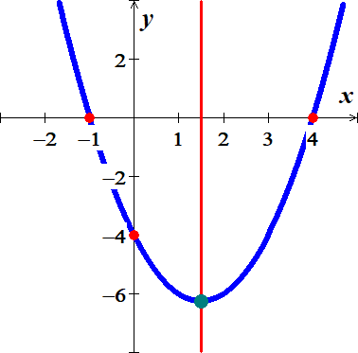

1. *Increasing: * *Decreasing*: 

***Exercise***

For the function 

1. Find the vertex point
2. Find the line of symmetry
3. State whether there is a *maximum* or *minimum* value *and* find that value
4. Find the zeros of 
5. Find the *y*-intercept
6. Find the *range* and the *domain* of the function.
7. Graph the function
8. On what intervals is the function *increasing*? *decreasing*?

***Solution***

1.  





*Vertex point:* 

1. Axis of *symmetry*: 
2. *Minimum* point @ 
3. 



1. 
2. *Domain*:  *Range*: 

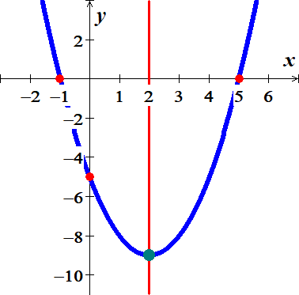

1. *Increasing: * *Decreasing*: 

***Exercise***

For the function 

1. Find the vertex point
2. Find the line of symmetry
3. State whether there is a *maximum* or *minimum* value *and* find that value
4. Find the zeros of 
5. Find the *y*-intercept
6. Find the *range* and the *domain* of the function.
7. Graph the function
8. On what intervals is the function *increasing*? *decreasing*?

***Solution***

1.  





*Vertex point:* 

1. Axis of *symmetry*: 
2. *Minimum* point @ 
3. 



1. 
2. *Domain*:  *Range*: 

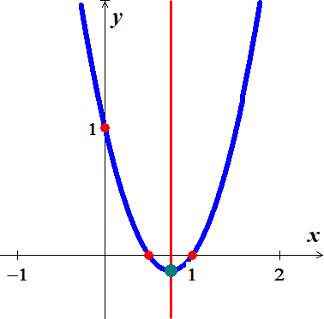

1. *Increasing: * *Decreasing*: 

***Exercise***

For the function 

1. Find the vertex point
2. Find the line of symmetry
3. State whether there is a *maximum* or *minimum* value *and* find that value
4. Find the zeros of 
5. Find the *y*-intercept
6. Find the *range* and the *domain* of the function.
7. Graph the function
8. On what intervals is the function *increasing*? *decreasing*?

***Solution***

1.  





*Vertex point:* 

1. Axis of *symmetry*: 
2. *Maximum* point @ 
3. 



1. 
2. *Domain*:  *Range*: 

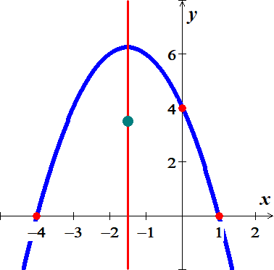

1. *Increasing:*  *Decreasing*: **

***Exercise***

For the function 

1. Find the vertex point
2. Find the line of symmetry
3. State whether there is a *maximum* or *minimum* value *and* find that value
4. Find the zeros of 
5. Find the *y*-intercept
6. Find the *range* and the *domain* of the function.
7. Graph the function
8. On what intervals is the function *increasing*? *decreasing*?

***Solution***

1.  





*Vertex point:* 

1. Axis of *symmetry*: 
2. *Maximum* point @ 
3. 



1. 
2. *Domain*:  *Range*: 

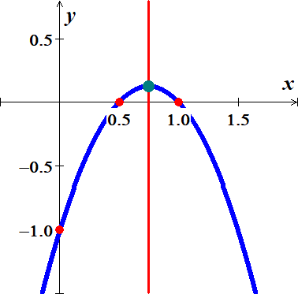

1. *Increasing:*  *Decreasing*: **

***Exercise***

For the function 

1. Find the vertex point
2. Find the line of symmetry
3. State whether there is a *maximum* or *minimum* value *and* find that value
4. Find the zeros of 
5. Find the *y*-intercept
6. Find the *range* and the *domain* of the function.
7. Graph the function
8. On what intervals is the function *increasing*? *decreasing*?

***Solution***

1.  





*Vertex point:* 

1. Axis of *symmetry*: 
2. *Maximum* point @ 
3. 



1. 
2. *Domain*:  *Range*: 

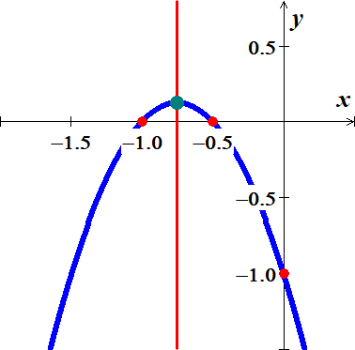

1. *Increasing:*  *Decreasing*: **

***Exercise***

For the function 

1. Find the vertex point
2. Find the line of symmetry
3. State whether there is a *maximum* or *minimum* value *and* find that value
4. Find the zeros of 
5. Find the *y*-intercept
6. Find the *range* and the *domain* of the function.
7. Graph the function
8. On what intervals is the function *increasing*? *decreasing*?

***Solution***

1.  





*Vertex point:* 

1. Axis of *symmetry*: 
2. *Maximum* point @ 
3. 



1. 
2. *Domain*:  *Range*: 

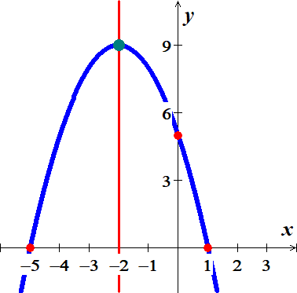

1. *Increasing:*  *Decreasing*: **

***Exercise***

For the function 

1. Find the vertex point
2. Find the line of symmetry
3. State whether there is a *maximum* or *minimum* value *and* find that value
4. Find the zeros of 
5. Find the *y*-intercept
6. Find the *range* and the *domain* of the function.
7. Graph the function
8. On what intervals is the function *increasing*? *decreasing*?

***Solution***

1.  





*Vertex point:* 

1. Axis of *symmetry*: 
2. *Maximum* point @ 
3. 





1. 
2. *Domain*:  *Range*: 

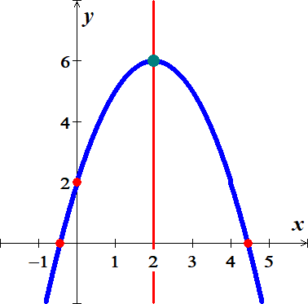

1. *Increasing:*  *Decreasing*: **

***Exercise***

For the function 

1. Find the vertex point
2. Find the line of symmetry
3. State whether there is a *maximum* or *minimum* value *and* find that value
4. Find the zeros of 
5. Find the *y*-intercept
6. Find the *range* and the *domain* of the function.
7. Graph the function
8. On what intervals is the function *increasing*? *decreasing*?

***Solution***

1.  

 

*Vertex point:* 

1. Axis of *symmetry*: 
2. *Maximum* point @ 
3. 





1. 
2. *Domain*:  *Range*: 

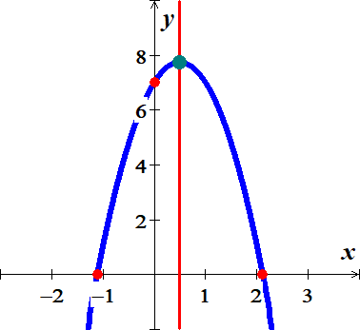

1. *Increasing:*  *Decreasing*: 

***Exercise***

For the function 

1. Find the vertex point
2. Find the line of symmetry
3. State whether there is a *maximum* or *minimum* value *and* find that value
4. Find the zeros of 
5. Find the *y*-intercept
6. Find the *range* and the *domain* of the function.
7. Graph the function
8. On what intervals is the function *increasing*? *decreasing*?

***Solution***

1.  





*Vertex point:* 

1. Axis of *symmetry*: 
2. *Maximum* point @ 
3. 



1. 
2. *Domain*:  *Range*: 

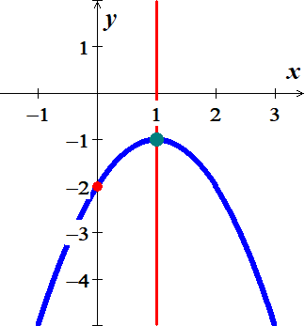

1. *Increasing:*  *Decreasing*: **

***Exercise***

A picture frame measures 28 *cm* by 32 *cm* and is of uniform width. What is the width of the frame if 192 *cm*2 of the picture shows?

***Solution***

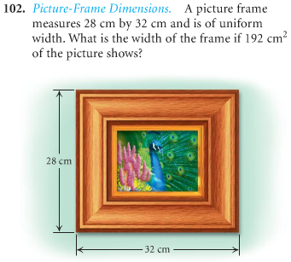Area of the picture = 











***Exercise***

An open box is made from a 10-*cm* by 20-*cm* of tin by cutting a square from each corner and folding up the edges. The area of the resulting base is 96 *cm*2. What is the length of the sides of the squares?

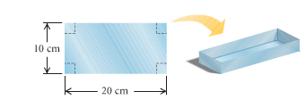

***Solution***

Area of the base 





 ***Solve for x***



The length of the sides of the squares is 3-*cm*

***Exercise***

You have 600 *feet* of fencing to enclose a rectangular plot that borders on a river. If you do not fence the side along the river.

1. Find the length and width of the plot that will maximize the area.
2. What is the largest area that can be enclosed?

***Solution***

1. 

 









 







1. 



***Exercise***

You have 60 *yards* of fencing to enclosed a rectangular region.

1. Find the dimensions of the rectangle that maximize the enclosed area.
2. What is the maximum area?

***Solution***

1. 











 







The dimensions of the rectangle 

1. 



***Exercise***

You have 80 *yards* of fencing to enclosed a rectangular region.

1. Find the dimensions of the rectangle that maximize the enclosed area.
2. What is the maximum area?

***Solution***

1. 











 







The dimensions of the rectangle 

1. 



***Exercise***

The sum of the length *l* and the width *w* of a rectangle tangular area is 240 *meters*.

1. Write *w* as a function of *l*.
2. Write the area *A* as a function of *l*.
3. Find the dimensions that produce the greatest area.

***Solution***

1. 







1. 



1.  







The dimensions of the rectangle 

***Exercise***

You use 600 *feet* of chainlink fencing to enclose a rectangular region and to subdivide the region into two smallerrectangular regions by placing a fence parallel to one of the sides.

1. Write *w* as a function of *l*.
2. Write the area *A* as a function of *l*.
3. Find the dimensions that produce the greatest area.

***Solution***

1. 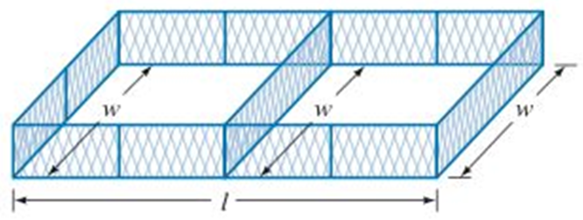





1. 



1.  







***Exercise***

You use 1,200 *feet* of chainlink fencing to enclose a rectangular region and to subdivide the region into three smallerrectangular regions by placing a fence parallel to one of the sides.

1. Write *w* as a function of *l*.
2. Write the area *A* as a function of *l*.
3. Find the dimensions that produce the greatest area.

***Solution***

1. 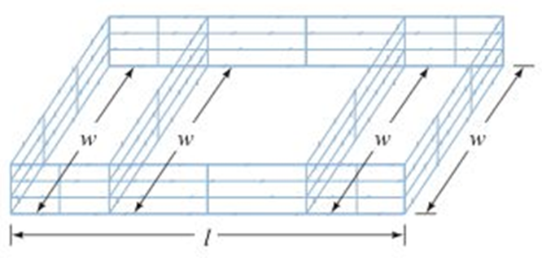





1. 



1.  





***Exercise***

A landscaper has enough stone to enclose a rectangular pond next to exiting garden wall of the house with 24 *feet* of stone wall. If the garden wall forms one side of the rectangle.

1. What is the maximum area that the landscaper can enclose?
2. What dimensions of the pond will yield this area?

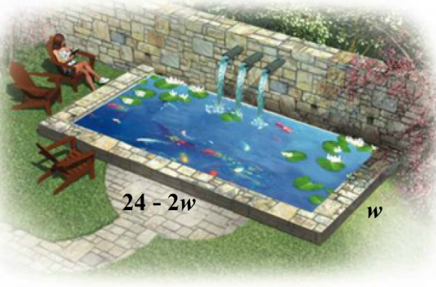***Solution***

1. 









 











1. The dimensions of the rectangle  *feet*

***Exercise***

A berry former needs to separate and enclose two adjacent rectangular fields, one for strawberries and one for blueberries. If a lake forms one side of the fields and 1,000 *feet* of fencing is available, what is the largest total area that can be enclosed?

***Solution***

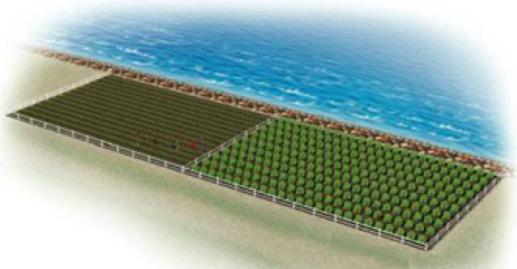









 











***Exercise***

A fourth-grade class decides to enclose a rectangular garden, using the side of the school as one side of the rectangle. What is the maximum area that the class can enclose with 32 *feet* of fence? What should the dimensions of the garden be in order to yield this area?

***Solution***

Perimeter: 



Area: 







 











***Exercise***

A rancher needs to enclose two adjacent rectangular corrals, one for cattle and one for sheep. If a river forms one side of the corrals and 240 *yards* of fencing is available, what is the largest total area that can be enclosed?

***Solution***

**Perimeter**: 

 

*Area*: 







 











***Exercise***

A Norman window is a rectangle with a semicircle on top. Sky Blue Windows is designing a Norman window that will require 24 *feet* of trim on the outer edges. What dimensions will allow the maximum amount of light to enter a house?

***Solution***

Perimeter of the semi-circle 

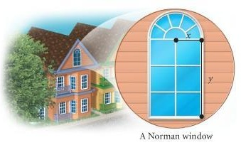Perimeter of the rectangle 

Total perimeter: 





Area 









 











***Exercise***

A Norman window has the shape of a rectangle surmounted by a semicircle. The exterior perimeter of the window is 48 *feet*.

Find the height *h* and the radius *r* that will allow the maximum amount of light to enter the window?

***Solution***

Perimeter of the semi-circle 

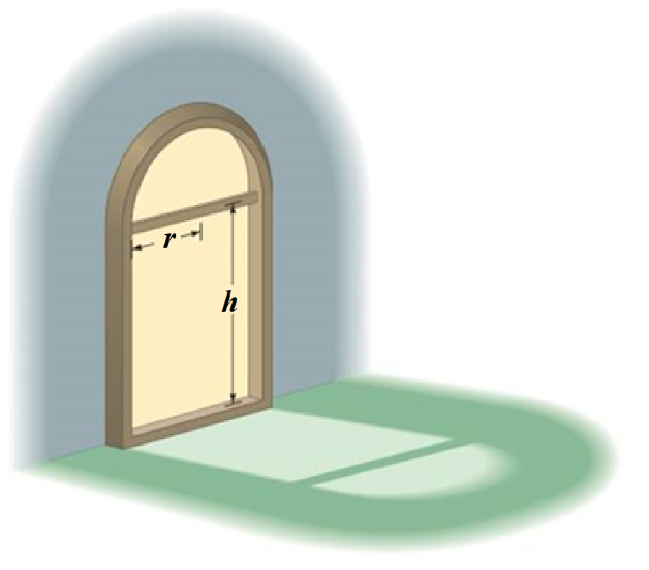 

Perimeter of the rectangle 

Total perimeter:















 













***Exercise***

A Norman window has the shape of a rectangle surmounted by a semicircle. It requires 36 *feet* of trim on the outer edges. What dimensions will allow the maximum amount of light to enter a house?

***Solution***

Perimeter of the semi-circle 



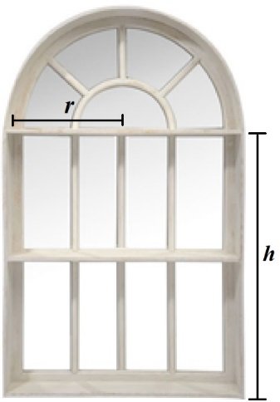Perimeter of the rectangle 

Total perimeter:















 













***Exercise***

The temperature , in degrees Fahrenheit, during the day can be modeled by the equation , where *t* is the number of hours after 6:00 AM.

1. At what time the temperature a maximum?
2. What is the maximum temperature?

***Solution***

1. 



















The maximum temperature is around 

1. 











***Exercise***

When a softball player swings a bat, the amount of energy , in *joules*, that is transferred to the bat can be approximated by the function



Where  and *t* is measured in *seconds*. According to this model, what is the maximum energy of the bat?

***Solution***

 







The maximum energy is





***Exercise***

Some softball fields are built in a parabolic mound shape so that water will drain off the field. A model for the shape of a certain field is given by



Where  is the height, in *feet*, of the field at a distance of *x* *feet* from one sideline. Find the maximum height of the field.

***Solution***

 



The maximum height of the field is





***Exercise***

The fuel efficiency for a certain midsize car is given by



Where  is the fuel efficiency in *miles* per *gallon* for a car traveling *v* in *miles* per *hour*.

1. What speed will yield the maximum fuel efficiency?
2. What is the maximum fuel efficiency for this car?

***Solution***

1.  



1. 



***Exercise***

If the initial velocity of a projectile is 128 *feet* per *second*, then the height *h*, in *feet*, is a function of time *t*, in *seconds*, given by the equation



1. Find the time *t* when the projectile achieves its maximum height.
2. Find the maximum height of the projectile.
3. Find the time *t* when the projectile hits the ground.

***Solution***

1.  



1. 



1. 





The projectile hits the ground in 

***Exercise***

If the initial velocity of a projectile is 64 *feet* per *second* and an initial height of 80 *feet*, then the height *h*, in *feet*, is a function of time *t*, in *seconds*, given by the equation



1. Find the time *t* when the projectile achieves its maximum height.
2. Find the maximum height of the projectile.
3. Find the time *t* when the projectile hits the ground.

***Solution***

1.  



1. 



1. 









The projectile hits the ground in 

***Exercise***

If the initial velocity of a projectile is 100 *feet* per *second* and an initial height of 20 *feet*, then the height *h*, in *feet*, is a function of time *t*, in *seconds*, given by the equation



1. Find the time *t* when the projectile achieves its maximum height.
2. Find the maximum height of the projectile.
3. Find the time *t* when the projectile hits the ground.

***Solution***

1.  





1. 



1. 







The projectile hits the ground in 

***Exercise***

A frog leaps from a stump 3.5-*foot*-high and lands 3.5 *feet* from the base of the stump.

It is determined that the height of the frog as a function of its distance, *x*, from the base of the stump is given by the function  where *h* is in feet.

1. How high is the frog when its horizontal distance from the base of the stump is 2 *feet*?
2. At what two distances from the base of the stump after is jumped was the frog 3.6 *feet* above the ground?
3. At what distance from the base did the frog reach its highest point?
4. What was the maximum height reached by the frog?

***Solution***

1. At 





1. 





Solve for *x*: 

1. The distance from the base for the frog to reach the highest point is



1. Maximum height:



***Exercise***

The height of an arch is given by



Where  is the horizontal distance in *feet* from the center of the arch to the ground

1. What is the maximum height of the arch?
2. What is the height of the arch 10 *feet* to the right of center?
3. How far from the center is the arch 8 *feet* tall?

***Solution***

1.  



1. 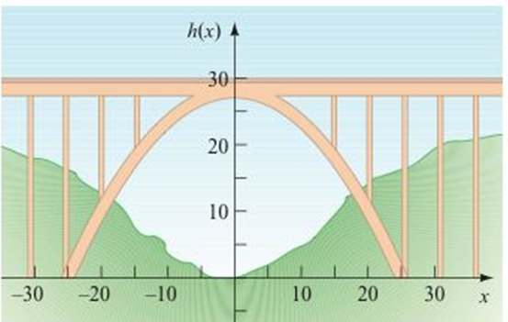







1. 











***Exercise***

A weightless environment can be created in an airplane by flying in a series of parabolic paths. This is one method that NASA uses to train astronauts for the experience of weightlessness. Suppose the height *h*, in *feet*, of NASA’s airplane is modeled by



Where *t* is the time, in *seconds,* after the plane enters its parabolic path.

Find the maximum height of the plane.

***Solution***

 











***Exercise***

You drop a screwdriver from the top of an elevator shaft. Exactly 5 *seconds* later, you hear the sound of the screwdriver hitting the bottom of the shaft. The speed of sound is . How tall is the elevator shaft?

***Solution***



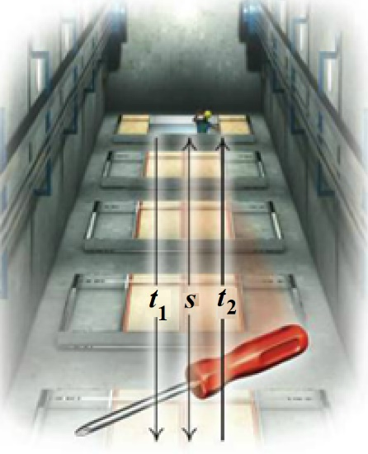



















***Exercise***

A company plans to produce a one- compartment vertical file by bending the long side of a 10-*in*. by 18-*in*. sheet of metal along two lines to form a − shape. How tall should the file be in order to maximize the volume that it can hold?

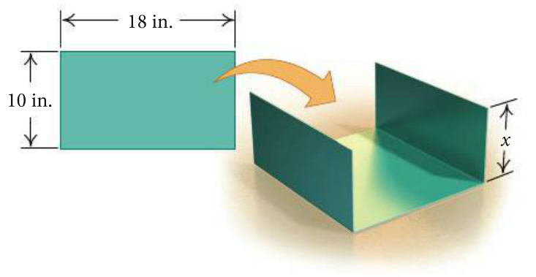

***Solution***

Height = *x*

If the length is 18 *in*.

Width of the base 





 









If the length is 10 *in*.

Width of the base 





 









To maximize the volume, the length should be 10 *in*. and bent on 18 *in*. side with 4.5 *in*. height to give a volume of 

***Exercise***

The sum of the base and the height of a triangle is 20 *cm*. Find the dimensions for which the area is a maximum.

***Solution***











 





The triangle dimensions for the maximum area is 

***Exercise***

The sum of the base and the height of a parallelogram is 14 *in*. Find the dimensions for which the area is a maximum.

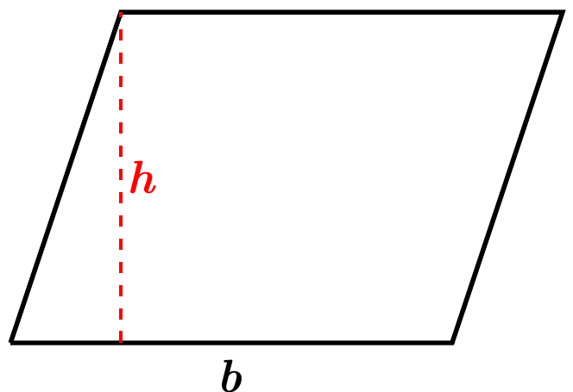***Solution***











 





The parallelogram dimensions for the maximum area is 